**Job Search Plan**

**For**

**COMM3700**

Author: Mason Fraser

Date: 18-Nov-19

Table of Contents

1. Project Overview 1

2. Project Requirements 1

3. Required Content 2

3.1. Geographic Location(s) 2

3.2. NOC Classification(s) 2

3.3. LMI Wages 2

3.4. LMI Outlook and Projection 3

3.5. Companies 3

3.5.1. Self – Fraser Technologies 3

3.5.2. Chapman Brothers Construction 3

3.5.3. HB Studios 3

3.5.4. CloudCab Inc 3

3.5.5. Advantage communications 4

4. The Plan 4

4.1. Dates 4

4.2. Contact Methods 4

4.3. Company Requests 4

5. Citations 5

List of Figures

Figure 1: Wages 2

# Project Overview

*Conduct research on employment opportunities in the IT field, both local and more distant. This research will consist of searches on the internet, personal interviews, networking opportunities, and other relevant sources. From this research students will develop a personal job search plan to help in securing employment upon graduation. Students will be required to submit a detailed plan.*

# Project Requirements

*Prepare a report (cover page, table of contents, headings and sections, page numbers, images, tables, references, etc.) which includes your detailed job search plan – see required information below.*

*1. The geographic location(s) in which you are willing to work and where you plan to explore employment opportunities.*

*2. The 2016 National Occupational Classification (NOC) for the kind of work you expect to be doing (you may find more than one classification fits). This information is available on the Government of Canada website.*

*3. The Labour Market Information (LMI) for the classifications and the geographic regions you have identified. This is also available on the Government of Canada website. Include in the LMI the Wages (Low – Median – High) and the Occupational Outlook and Projection. Information from other sites which provide similar information should also be included.*

*4. Identify five companies, located in the geographic location(s) in which you are willing to work, you would like to focus on. Research the companies: what they do, what they pay, how people like working there. Find the name and title of at least one person who works there that you could connect with.*

*5. Develop a plan to connect with these people and companies. Provide specific details with respect to dates, methods of contact, and what you will be asking for (e.g. an informational interview, upcoming employment opportunities, recommendations about the company, etc.)*

# Required Content

*Provide whatever level of detail makes sense. Note the paragraph numbering, and stay in the 1.x paragraphs for Requirements, if you wish.*

# Geographic Location(s)

* *Charlottetown*
* *Halifax*
* *Moncton*

# NOC Classification(s)

*2174 Computer programmers and interactive media developers*

*Computer programmers write, modify, integrate and test computer code for software applications, data processing applications, operating systems-level software and communications software. Interactive media developers write, modify, integrate and test computer code for Internet and mobile applications, computer-based training software, computer games, film, video and other interactive media. They are employed in computer software development firms, information technology consulting firms, and in information technology units throughout the private and public sectors.*

# LMI Wages

Figure : Wages

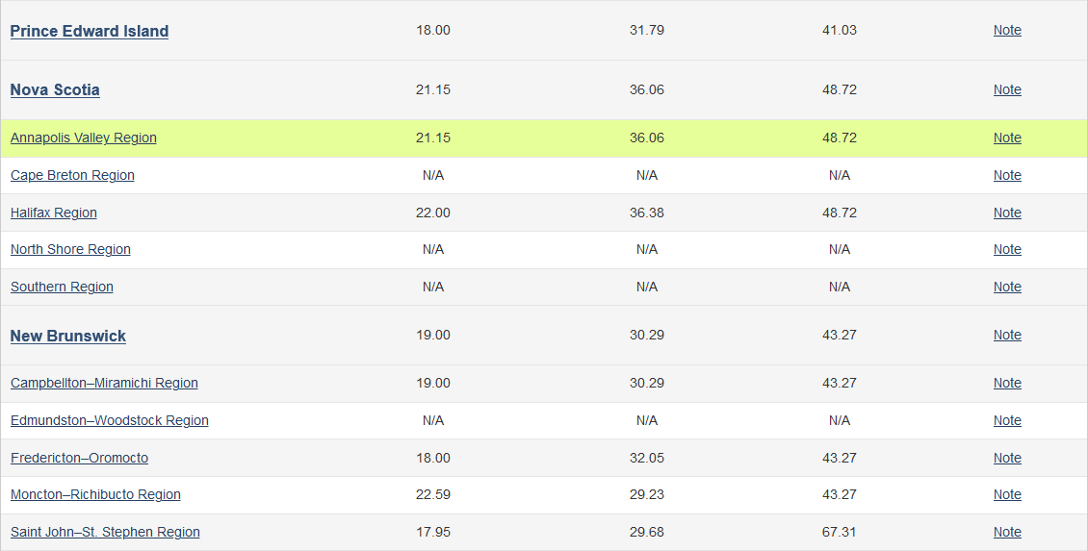

# LMI Outlook and Projection

*The employment outlook will be good for Computer programmers and interactive media developers (NOC 2174) in Prince Edward Island for the 2018-2020 period.*

*The employment outlook will be good for Computer programmers and interactive media developers (NOC 2174) in the Halifax region for the 2018-2020 period.*

*The employment outlook will be good for Computer programmers and interactive media developers (NOC 2174) in the Moncton - Richibucto region for the 2018-2020 period.*

# Companies

# Self – Fraser Technologies

* Work for myself.

# Chapman Brothers Construction

* Construction Company Lacking IT Department
* Primarily Paving and Road Construction
* Contact: Jamie Chapman
  + Owner – Boss
  + Currently in discussions for implementing an IT. Department for the company

# HB Studios

* Sports Games development based in Lunenburg
* Contact: Nicola Barker
  + Hiring Manager
  + Contact via HB Studios website hiring page

# CloudCab Inc

* Dispatch software company
* Focused on Fleet Management
* Contact: Jonathan McNally
  + Vice President of Business Development
  + Contact via LinkedIn

# Advantage communications

* Customer Relations Call Centre
* IT Department in Charlottetown
* Contact: Barry O’Brien
  + Human Resources Manager
  + Contact via In-person or Phone Call

# The Plan

The plan is specific and includes measurable goals.

# Dates

* Discussions have already happened for Chapman Brothers and negotiations are underway.
* Early Monday mornings to show initiative and willingness to work, as well as providing lots of time for a response.
* Follow-up as soon as possible to keep the interest with the potential employer.

# Contact Methods

* Phone – Call and ask directly for a hiring manager.
* Email – A quick and convenient method for a hiring manager to respond at their leisure
* In-Person – If possible, talk directly to a person with a cover letter and resume.

# Company Requests

* Quick and Timely responses of all requests.

# Citations

*Again, break down the subparagraphs in a way that makes sense. Include diagrams and tables as needed.*

* <https://noc.esdc.gc.ca/English/noc/QuickSearch.aspx?ver=16&val65=2174>
* <https://www.jobbank.gc.ca/wagereport/occupation/22540>
* <https://www.indeed.ca/jobs?q=Programmer&l=Charlottetown%2C+PE>
* <https://advantage.hiringplatform.com/list/Canada?__hstc=&__hssc=&hsCtaTracking=d46c10f3-1408-4d7d-b3b1-bb15931336b5%7C627ccacf-476b-4c90-b1d2-a35cdd9c0a17>
* <http://www.hb-studios.com/contact/>
* https://www.indeed.ca/jobs?q=cloudcab&l&advn=1670782229136152&vjk=c6658e7b3a235316