Project
Documentation
For
My Project

Author: me
Date: On Time

Table of Contents
1. Project Overview 1
2. Project Requirements 1
2.1. Requirements (stated by Customer or Teacher) 1
2.2. Derived Requirements 1
3. Design Plans 2
3.1. Design Sub-Paragraphs 2
3.1.1. Design Sub-Sub-Paragraphs 2
3.1.2. Design Sub-Sub-Paragraphs 2
3.2. Design Sub-Paragraphs 3
3.3. Design Sub-Paragraphs 3
3.4. Design Sub-Paragraphs 4
4. Implementation Paragraphs 5
4.1. Implementation Sub-Paragraphs 5
4.2. Implementation Sub-Paragraphs 5
5. Testing Paragraphs 6
5.1. Testing Sub-Paragraphs 6
5.2. Testing Sub-Paragraphs 6
Appendix A. Requirements Traceability 7

List of Tables
Table 1: HTML of Web Page 2
Table 2: Another Sample Table 4
Table 3: Sample Fixed Font Data 5

List of Figures
Figure 1: Visio Design Diagram 3
Figure 2: Java UML Class Diagram 3
Figure 3: Proof that Cross-references can be Selected in Word 6

Project Overview

Describe the overview of the project.

Project Requirements

Describe the requirements. As a start, repeat the assignment instructions. As you improve, you can use the assignment descriptions as a starting point for this paragraph, but write your own requirements.

Requirements (stated by Customer or Teacher)

If you wish, break out the requirements into subparagraphs, to make the requirements easier to track in the requirements matrix.

Derived Requirements

What is a derived requirement? http://en.wikipedia.org/wiki/Requirements_analysis

Design Plans
Provide whatever level of detail makes sense. Note the paragraph numbering, and stay in the 1.x paragraphs for Requirements, if you wish.

Design Sub-Paragraphs
Break down the subparagraphs in a way that makes sense. Include diagrams and tables as needed.

Design Sub-Sub-Paragraphs
Again, break down the subparagraphs in a way that makes sense. Include diagrams and tables as needed.

Design Sub-Sub-Paragraphs
Use “courier new” font (or some other fixed-spaced font) inside a 1x1 table to display short segments of logs or scripts.

Table 1: HTML of Web Page
<!DOCTYPE html>
<html>
<body>

<h1>My First Heading</h1>

<p>My first paragraph.</p>

</body>
</html>

Design Sub-Paragraphs
Include diagrams, and remember, you must mention the diagram within your text, to state what the diagram shows. Refer to Figure 1: Visio Design Diagram for network details. This cross-reference makes the text hot-clickable (jumps to the diagram when clicked), but currently Word does not check if the caption was on the top or bottom and just assumes the caption was on the top.

Figure 1: Visio Design Diagram
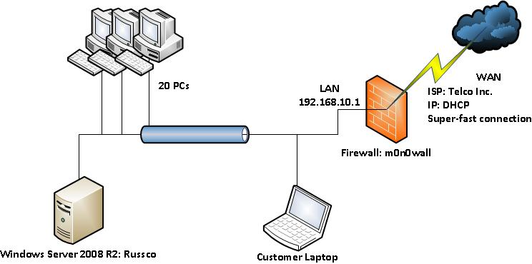

Design Sub-Paragraphs
Include diagrams, ….

Figure 2: Java UML Class Diagram
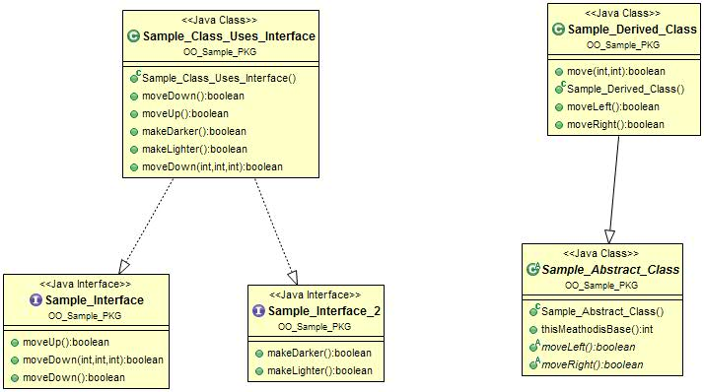

Design Sub-Paragraphs
Again, break down the subparagraphs in a way that makes sense. Include diagrams and tables as needed.

Table 2: Another Sample Table
Heading 1 | Heading 2 | Heading 3

Implementation Paragraphs
Implementation uses Java and SQLite, or Windows Server 2008 with IIS installed, or whatever.

Implementation Sub-Paragraphs
Again, break down the subparagraphs in a way that makes sense. Include diagrams and tables as needed.

Implementation Sub-Paragraphs
Again, break down the subparagraphs in a way that makes sense. Include diagrams and tables as needed.

Table 3: Sample Fixed Font Data
REM *** Sample Batch File that only has comments ***
REM
REM Sample code in currier new font
REM And placed inside a 1x1 table (just one cell)
REM Will line up
REM Nicely
REM ..and be readable (well, more readable than if it wasn’t lined up).
REM
REM Use this method for scripts,
REM Configuration files
REM And any other data file that is convenient to read
REM With the text lined up

Testing Paragraphs
Again, break down the subparagraphs in a way that makes sense. Include diagrams and tables as needed.

Testing Sub-Paragraphs
Again, break down the subparagraphs in a way that makes sense. Include diagrams and tables as needed.

Figure 3: Proof that Cross-references can be Selected in Word
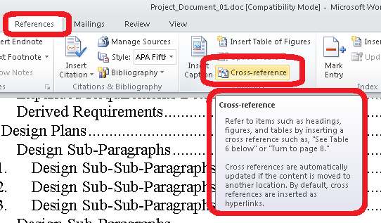

Testing Sub-Paragraphs
Again, break down the subparagraphs in a way that makes sense. Include diagrams and tables as needed.

Requirements Traceability
Introduce the appendix and what it contains.
Paragraph Defined | Requirements Text | Paragraph Implemented | Paragraph Tested

