Project
Documentation
For
Django Models

Author: Mason Fraser
Date: 16 October 2019

Table of Contents
1. Project Overview 2
2. Project Requirements 2
3. Index Page 4
3.1. View 4
3.2. HTML 4
3.3. Result 5
4. Class and Student List 5
4.1. View 5
4.2. HTML 6
4.3. Result 7
4.4. Nav Bar 8
5. Detail Pages 8
5.1. View 8
5.2. HTML 9
5.3. Result 10

Project Overview

Create a class lit and have data display.

Project Requirements

Refer to your earlier assignment using class schedule for hints, where the class schedule is embedded in an HTML page. The intent is to use some of that approach and material to use here.
Create a new Django Project/App
Create a database that contains students taking courses, and courses have scheduled time-entries, and so different students have different schedules).
Use the Django Admin account to update your schedule (DB tables) appropriately.
Web Pages (HTML):
Home page: Navigation to Class_list, Student list, or Student_search. (Navigation bar of each page also allows navigation to Home, Class_list, Student_list, Student_search.
Student_list: list all students as links to their student_detail.
[10%] Student_search: form entry for a student name, matches show students as links to student_details.
NOTE...that student_list and Student_search can be merged, to list all students, or just those matching text...if you wish.
Student_detail: Show a student's name, contact info, and schedule (using an HTML Table (calendar or list)).
Class_list: list all classes, as links to their class detail.
Class_detail: Show class data for this class (name, description, start times for at most 3 classes per week (use another table if you wish)

Index Page
Simple index page with links to deeper directories.

View
Here is the view associated with the index page.
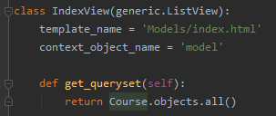

HTML
The HTML here builds the simple webpage linking to the deeper pages
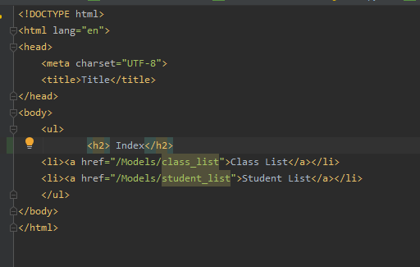

Result
This is what it looks like
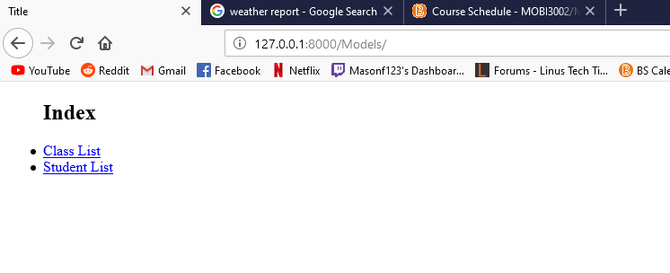

Class and Student List
The Following shows the class and student list, they’re similar in design so I’ll slim the document down and include them both in here.

View
Views for referencing and directing.
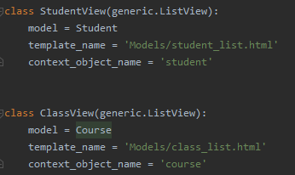

HTML
Student HTML which shows a list of students, sets hyper links to each students details which shows what classes they’re enrolled in.
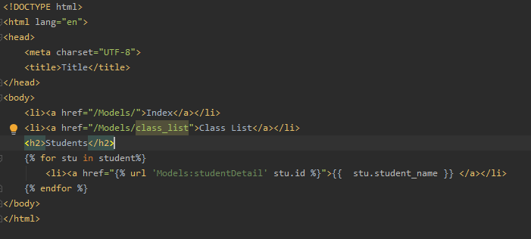

This is the Class list html, very similar to the student. Same concept, shows a list of classes and links to their individual detail views.
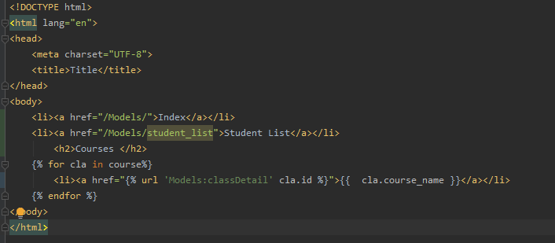

Result
This is what the lists look like

Students
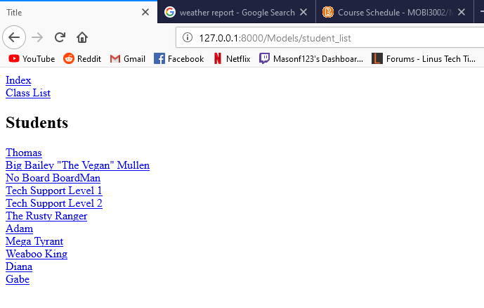
And Classes:
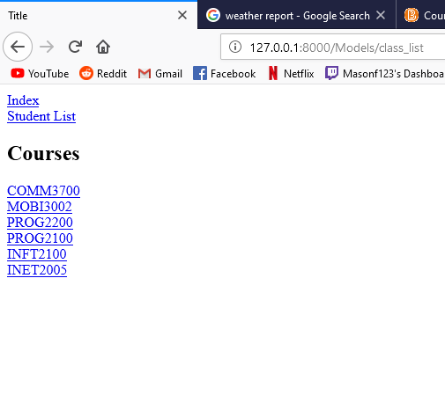

Nav Bar
Every page has a nav bar linking other pages directly above the header.
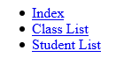
This will bring you back to wherever you would like to be.

Detail Pages
Here we go over the detail pages and what’s happening.

View
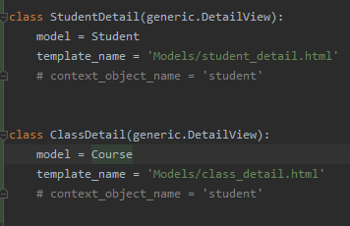.
Simple views for accessing the individual portions of the Model and linking to the page associated with that Model.

HTML
Once you’ve clicked into the course you’d like to have more detail on, this will print a list of what days the course is on and at what times that course is taken.
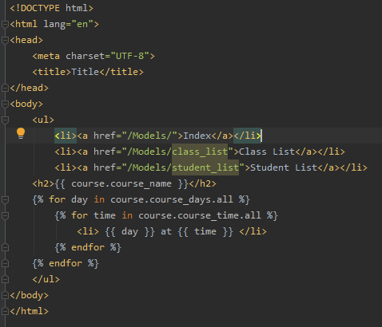
And this shows you what courses a student is taking, which links back to the course details, as shown in the above.
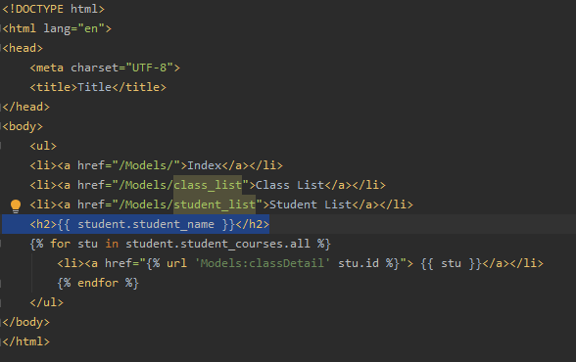

Result
This is the result of the detail view for the Course
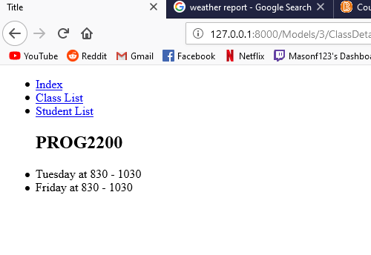
And this is the result for the detail page for the student, it shows the students name, I would have it showing contact information, however it’s not included in the Model. Will fix this for frontend.

This also shows what courses the student is enrolled in, directly linking to that courses detail page as seen above.
