Project
Documentation
For
Django#5 Recap

Author: Mason Fraser
Date: 18 October 2019

Table of Contents
1. Project Overview 1
2. Project Requirements 1
3. Design Plans 2
3.1. Nav-Bar 2
3.2. Database Data 2
3.3. Base Template 2 3
3.4. Chart 4
3.4.1. Chart Code 5

Project Overview
Apply Django Template Inheritance, and Use a utility like Bootstrap to support your layout

Project Requirements

Add 2 variations of web look by trying 2 types of base template
Child templates need not change (or change minimally)
The base template would be different by using 2 different layouts (say, one layout is horizontal, the other is vertical).
Continue to re-use your HTML/CSS from the first assignment, but now you are changing the layout location. Note that you cannot use the Django template without HTML/CSS layout controls for this last assignment...the client side must have a proper view. This might be your last Django assignment, so it's a good idea to make it as presentable as possible.
You have:
Nav-bar
text about school (maybe modified), and
separately the DB Data (students, courses, schedule, chart (see below)
...in 2 different layouts, depending which base template is used
Add a chart that shows the number of students in different courses, fit that chart into one of your pages

Design Plans
Here I cover what has been done for the project.

Nav-Bar
The navbar is implemented and working with bootstrap, you can navigate between pages via this.
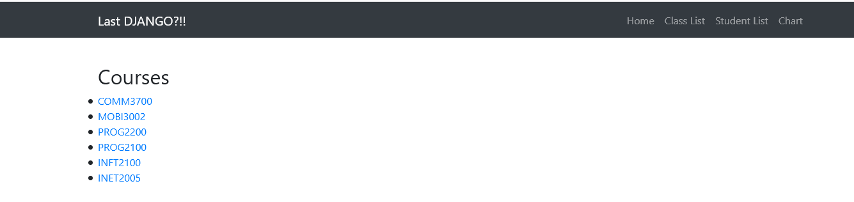

Database Data
Database data is changed dynamically via the base overlay keeping the navbar and footer in place at all times.
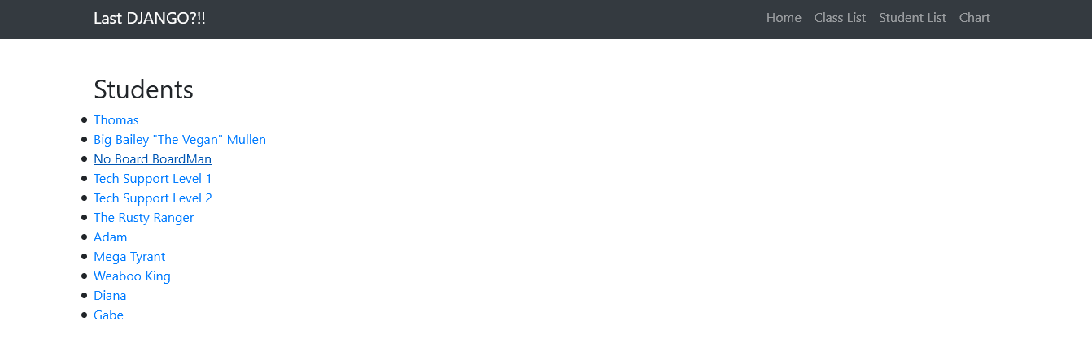

Base Template 2
We can use two different templates without the need to modify all of our data, this is template two!

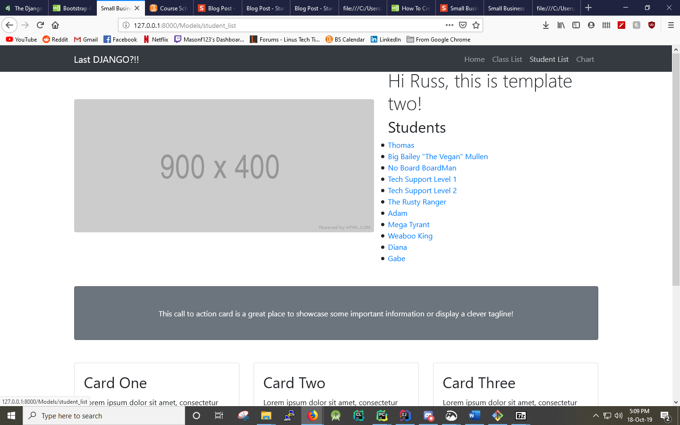

Chart
Added a chart, included in the nav bar, and shows all the classes, scaled to a reasonable size, with colour! Looks good.

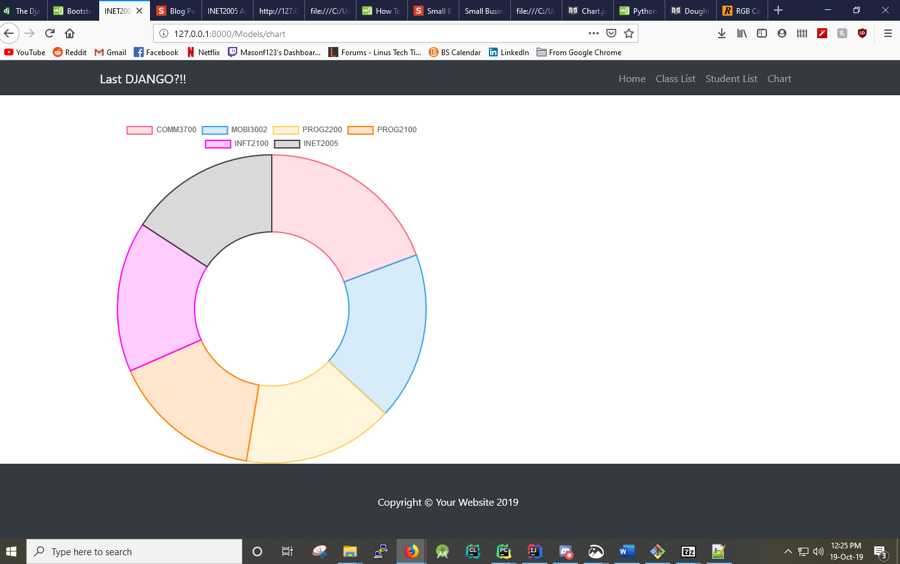

Chart Code
Data is displayed by looping through a dictionary and grabbing the values for the total number of students and the name of the course.
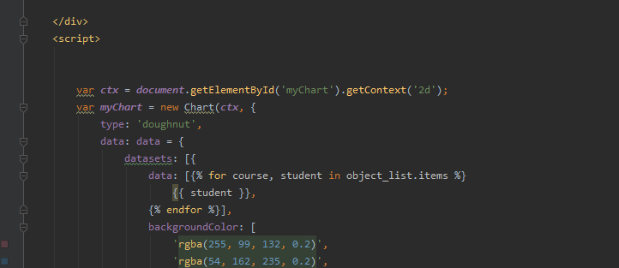

And this is the code behind how the data is pulled from the database.

