Mortar Assembly

Objective:

- Wing Knob Assembly 13015690 Rev C

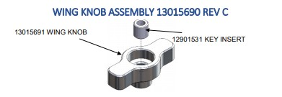
Figure 1 Wing Knob Assembly

  - Assemble 12901531 Key Insert into 13015691 Wing Knob until inserted to 0.3 + 0.5
mm below surface as shown on drawing 13015690 Wing Knob Assembly. (Figure 1)
  - Insert pins flush with 12901531 Key Insert body to permanently lock in
place. (Figure 1)
- Cross Leveling Clamp Assembly 13017550 Rev E

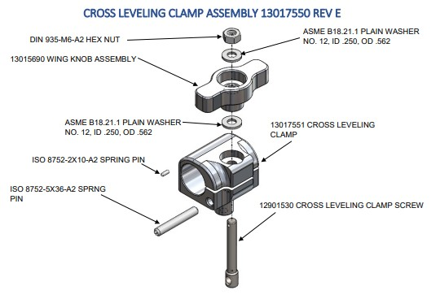
Figure 2 Cross Leveling Clamp Assembly

  - Insert 12901530 Cross Leveling Clamp Screw into 13017551 Cross Leveling Clamp and rotate until hole in Screw aligns with hole in Clamp. (Figure 2) (procedurereference?file=cross-leveling-clamp-assembly-13017550-rev-e.png)
  - Press ISO 8752-5x36-A2 Spring Pin into 13017551 Cross Leveling Clamp and through hole in Cross Leveling Clamp Screw, until seated below surface of Clamp. (Figure 2)

  - Place one ASME B18.21.1 Plain Washer over the 12901530 Cross Leveling Clamp Screw. Then thread 13015690 Wing Knob Assembly on until lightly seated. (Figure 2)

  - Place second ASME B18.21.1 Plain Washer over Screw and top with DIN 935-M6-A2 Hex Nut. Thread on until lightly seated. (Figure 2)
  - Turn Hex Nut counter clock wise until slot in Nut lines up with hole in Screw. Press ISO 8752-2X10-A2 through slot in Hex Nut and into hole in Screw until flush with Hex Nut. (Figure 2)
- Left Leg Foot Installation

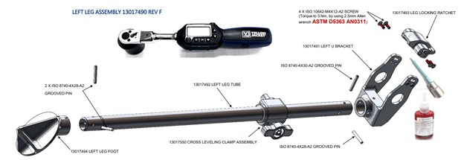
Figure 3 Left Leg Foot Installation

  - Apply ASTM D5363 AN0421 Retaining Compound to the inside diameter of 13017494 Left Leg Foot and install onto 13017492. (Figure 3)
  - Consult drawing 13017490 to ensure correct orientation and drilling instructions. (Figure 3)
  - Press 2 X ISO 8740-4X28-A2 Grooved Pins into drilled holes until fully seated. (Figure 3)
  - Install 13017550 Cross Leveling Clamp Assembly over 13017492 Left Leg Tube. (Figure 3)
  - Insert 13017493 Leg Locking Ratchet into 13017491 Left U Bracket in orientation as shown. Ensure to engage tabs on sides of Ratchet into slots in U Bracket. (Figure 3)
  - Apply ASTM D5363 AN0311 Anaerobic Adhesive to 4 X ISO10642-M4X12-A2 Countersunk Screws and install in four holes in 13017493 Leg Locking Ratchet. (Figure 3)
  - Torque to 3 Nm, by using 2.5mm Allen wrench. (Figure 3)
- Left U Bracket installation

  - Apply ASTM D5363 AN0421 Retaining Compound to inside diameter of 13017491 Left U Bracket and install over 13017492 Left Leg Tube.

  - Consult drawing 13017490 to ensure correct orientation and drilling instructions.

  - After drilling press ISO 8740-4X30-A2 Grooved Pin and ISO 8740-4X28-A2 Grooved Pin into holes until fully seated.
- Step Title

  - Place the assembled leg into the model

  - Expand the model as a whole to see all components

  - Exit Procedure

Results:
Additional Notes:

