Title for a Sample Paper for Western Users of SAS® Software 2015

Author1 name, ABC Corporation, City, State (or Country)

Author2 name, ABC Corporation, City, State (or Country)

**[Note2Author**: This paragraph style, with yellow highlighting, shows notes and instructions to authors.

Formatting and editing notes:

1. Check your margins. The paper should print so that both the left and right margins are 1 inch each.
2. Please use the edited (final) title and abstract that you submitted online at https://www.softconf.com/d/wuss2013/ in your paper.
3. **Paragraphs**: This template incorporates white space as part of the paragraph style. You do not need to add an extra paragraph or press the ENTER key to create extra white space between paragraphs.
4. Figures, displays, outputs, and tables should have captions. See page 5 for instructions about inserting captions. Please use initial capitalization for the captions. The example captions in this sample have initial capitalization.
5. Page 5 of this paper sample has examples of formatted lists, tables, output, and displays that you can copy to use as a starting point. Page 5 also shows some simple instructions for inserting captions, cross-references, and graphics.

**Note**: Delete any text highlighted in yellow and page 5 before submitting the paper.

# Abstract <heading 1>

A brief abstract at the beginning summarizes and highlights the major points of your paper. Please use the present tense in the abstract.

This paragraph is used for the abstract. This is the paper body. This is the paper body. This is the paper body. This is the paper body. This is the paper body.

# Introduction <heading 1>

The introduction explains the purpose and scope of your paper and provides readers with any general information they need to understand your paper.

This is the paper body. This is the paper body. This is the paper body. This is the paper body. This is the paper body. This is the paper body. This is the paper body.

# First Main Topic <heading 1>

This is a main topic in the body of the paper. This is the paper body. This is the paper body. This is the paper body. This is the paper body. This is the paper body. This is the paper body. This is the paper body. This is the paper body. This is the paper body. This is the paper body. This is the paper body. This is the paper body.

If you need to include source code:

data one;

set two;

if mix(var1, var2) > 0 then do;

Continuation of paper body—after source code. This is the paper body. This is the paper body. This is the paper body. This is the paper body. This is the paper body. This is the paper body. This is the paper body.

Figure 1 is a sample figure.

Figure . Caption for Sample Figure

Use captions for figures.

## Subhead A Level <heading 2>

This heading level is for a subtopic of a main topic. This is the paper body. This is the paper body. This is the paper body. This is the paper body. This is the paper body. This is the paper body. This is the paper body. This is the paper body. This is the paper body.

Table 1 is a sample table:

| **SAS Variable Format** | **DB2 Data Type** |
| --- | --- |
| $*w*.  $CHAR*w*. | CHARACTER |
| any date format | DATE |

Table . DBLOAD Procedure: Default DB2 Data Types for SAS Variable Formats

Use captions for tables.

# Second Main Topic <heading 1>

This is a main topic in the paper body. This is the paper body. This is the paper body. This is the paper body. This is the paper body. This is the paper body. This is the paper body. This is the paper body. This is the paper body. This is the paper body. This is the paper body. This is the paper body. This is the paper body.

If you need to include a numbered or an ordered list:

1. This is a sample numbered or ordered list item. This is list item text. This is list item text. This is list item text. This is list item text. This is list item text.
2. This is a sample numbered or ordered list item. This is list item text.

This is the paper body. This is another sample paragraph. This is another sample paragraph. This is another sample paragraph. This is another sample paragraph. This is another sample paragraph. This is another sample paragraph. This is another sample paragraph. This is another sample paragraph. This is another sample paragraph.

If you need to include a bulleted or an unordered list:

* This is a sample bulleted list item. This is list item text. This is list item text. This is list item text. This is list item text. This is list item text. This is list item text. This is list item text. This is list item text.
* This is a sample bulleted list item. This is list item text.

Continuation of paper body—after an unordered list. This is the paper body. This is the paper body. This is the paper body. This is the paper body. This is the paper body.

Display 1 is an example of a display or screen capture.

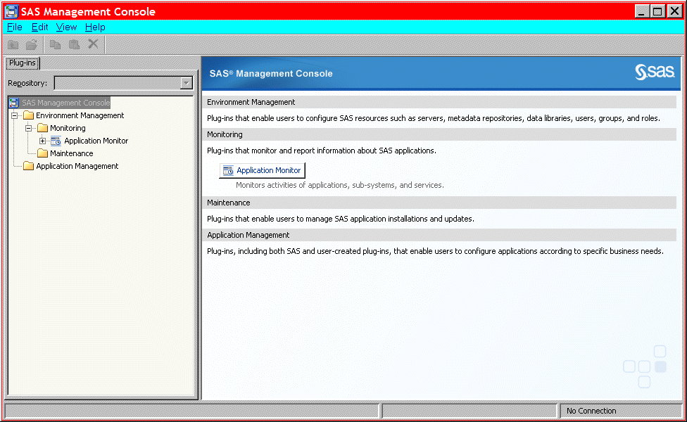

Display . Former Main Interface for SAS Management Console

Use captions for displays.

## Subhead A Level <heading 2>

This is subtopic for the above. This is the paper body. This is the paper body. This is the paper body. This is the paper body. This is the paper body. This is the paper body. This is the paper body.

If you need to include SAS output, this is an example of how to present it:

Output 1 shows an example of how to present output.

CREATE TABLE ALLACCTX(SourceSystem varchar(4),

cctnum numeric(18,5) CONSTRAINT "ALLACCT_PK" PRIMARY KEY,

ccttype numeric(18,5),balance numeric(18,5),clientid numeric(18,5),

losedate date,opendate date,primary_cd numeric(18,5),status varchar(1))

Output . Output from a CREATE TABLE Statement

Use captions for output. Note that output is the same font as source code, but it is in a box. (Not a Text box.)

Continuation of paper body—after output.

## Subhead A Level <heading 2>

This is the paper body. This is the paper body. This is the paper body. This is the paper body. This is the paper body. This is the paper body. This is the paper body. This is the paper body. This is the paper body. This is the paper body.

### Subhead B Level <Heading 3>

This heading level is for a subtopic of a secondary topic. This is the paper body. This is the paper body. This is the paper body. This is the paper body. This is the paper body. This is the paper body. This is the paper body. This is the paper body. This is the paper body. This is the paper body.

#### Subhead C Level <Heading 4>

This is the paper body. This is the paper body. This is the paper body. This is the paper body. This is the paper body. This is the paper body. This is the paper body. This is the paper body. This is the paper body. This is the paper body.

# Conclusion <heading 1>

The conclusion summarizes your paper and ties together any loose ends. You can use the conclusion to make any final points such as recommendations, predictions, or judgments.

This is the text for the paper’s conclusion. This is the paper body. This is the paper body. This is the paper body. This is the paper body. This is the paper body. This is the paper body.

# References <heading 1>

This section is not required. Use a bulleted list if you have more than one reference. The references below are examples and do not cover the spectrum of examples that might be included. The important thing is to be consistent in the formatting and organization of your references. If you prefer, you can follow a bibliographic approach such as the American Psychological Association (<http://www.apastyle.org/manual/index.aspx> ) or the American Statistical Association (<http://pubs.amstat.org/page/styleguide> ).

This is the text for the references.

Book <Author name: last name, first name>. <Copyright date>. <*Book title*>. <page numbers>. <City, State of Publisher>: <Publisher name>

Journal article <Author name: last name, first name>. <Copyright date>. “<Article title>.” <*Journal title*>. <page numbers>. <City, State of Publisher>: <Publisher name>

Article in conference proceeding <Author name: last name, first name>. <Copyright date>. “<Article title>.” <*Title of proceedings such as Proceedings of the SAS Global 2010 Conference*>. <City, State of Publisher>: <Publisher name> Optional: You can add a URL to access available online copies. For example: Available at <http://support.sas.com/resources/papers/proceedings09/TOC.html>.

Web site <Author name: last name, first name>. “<Title>.” <*Source*>. <Date>. Available at <URL>.

# Acknowledgments <heading 1>

This section is not required.

This is the text for the acknowledgments. This is the paper body. This is the paper body. This is the paper body. This is the paper body. This is the paper body.

# Recommended Reading <heading 1>

This section is not required. Use a bulleted list if you have more than one reference. This is the format for recommended reading.

* Base SAS® Procedures Guide
* SAS® For Dummies®

# Contact Information <heading 1>

In case a reader wants to get in touch with you, please provide your contact information.

Your comments and questions are valued and encouraged. Contact the author at:

Name:

Enterprise:

Address:

City, State ZIP:

Work Phone:

Fax:

E-mail:

Web:

The next two paragraphs are **required** and need to remain in the paper.

SAS and all other SAS Institute Inc. product or service names are registered trademarks or trademarks of SAS Institute Inc. in the USA and other countries. ® indicates USA registration.

Other brand and product names are trademarks of their respective companies.

Page of Formatted Samples

This page has samples that you can copy into the body of your paper and adapt as necessary for your content.

**Note**: Delete this page before submitting your paper.

**Source Code Sample**

data one;

set two;

if mix(var1, var2) > 0 then do;

**List: Numbered or Ordered**

1. numbered list item
2. numbered list item
3. numbered list item

**List: Bulleted or Unordered**

* This is a sample bulleted list item.
* This is a sample bulleted list item.

**Output Sample**

CREATE TABLE ALLACCTX(SourceSystem varchar(4),

cctnum numeric(18,5) CONSTRAINT "ALLACCT_PK" PRIMARY KEY,

ccttype numeric(18,5),balance numeric(18,5),clientid numeric(18,5),

losedate date,opendate date,primary_cd numeric(18,5),status varchar(1))

Output . Output from a CREATE TABLE Statement

**Table Sample**

| **Heading for Column 1** | **Heading for Column 2** | **Heading for Column 3** | **Heading for Column 4** |
| --- | --- | --- | --- |
|  |  |  |  |
|  |  |  |  |
|  |  |  |  |

Table . Sample Table

Basic Instructions to Insert Captions, Cross-References, and Graphics

These instructions are written for MS Word 2007 and 2010. The steps are similar for MS Word 2003.

To insert a caption:

1. Click **References** on the main Word menu.
2. Click **Insert Caption**.
3. Select the **Label** type you want.
4. Click **OK**.

To insert a cross-reference:

1. Click **References** on the main Word menu.
2. Click **Cross-reference**.
3. In the **Reference type** list box, select Figure, Table, Display, or Output.
4. In the **For which caption** list, select the caption you want.
5. From the **Insert reference to** list, select **Only label and number**.

To insert a graphic from a file:

1. Click **Insert** on the main Word menu.
2. Click **Picture**.
3. In the Insert Picture dialog box, navigate to the file you want to insert.
4. When the name of the file you want to insert is displayed in the **File name** box, click **Insert**.