Student ID: 101722004

Name: Mason Veljan

# Setup Screenshot

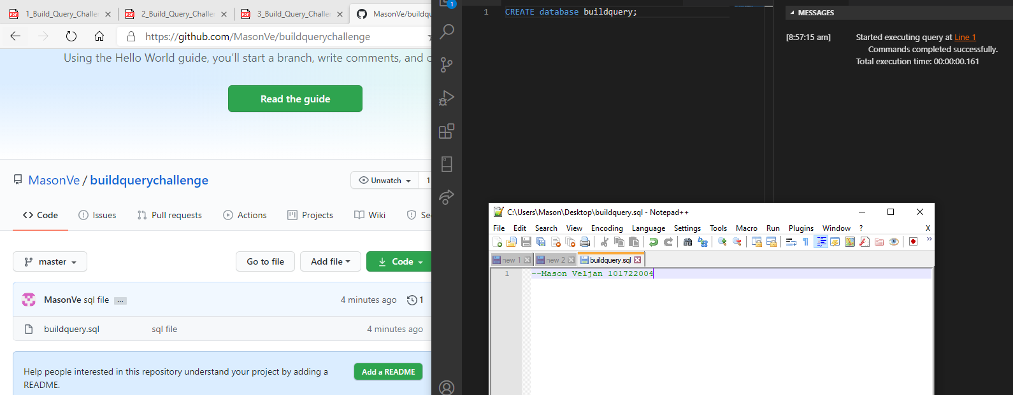

# Task 2 Screenshot





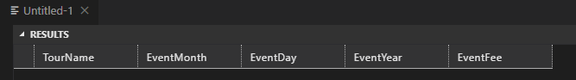



# Task 3 Screenshot

