**LS reconstruction soma proofreading**

**Ming Yan (last update: 03-01-2023)**

**For example, for the current 6x6 striatum ROI, a complete workflow would be:**

Recut soma detection (~ 30 min) 🡪

Convert recut markers to terafly .apo file 🡪

Use terafly to 1) only batch delete somas in cortical region (~1000+ somas within 2min), just keep somas in striatal region or 2) proofread all somas at once🡪

Convert terafly .apo file to recut markers and generate a consolidated .SWC file for Imaris soma proofreading 🡪

Use Imaris for soma proofreading by Z-slice 🡪

Export proofread somas as a .SWC file 🡪

Convert the .SWC file to recut markers 🡪

Recut reconstruction on proofread somas 🡪

TMD filtering on non-multi-components 🡪

Organize files 🡪

Human proofreading

**Step by step soma proofreading**

1. **The marker files from recut soma inferencing**

Grab the recut generated marker files from soma inferencing

1. **Convert to Terafly readable format (ano, apo, eswc files)**

Open Powershell window where the scripts are located

Run <convert_recut_to_terafly.py> *

*python convert_recut_to_terafly.py -s <path to recut marker files> \**

3 new files (ano file, apo file and eswc file) are generated for Terafly

* FYI: the complete arguments for this script are:

- s: seeds, Path folder containing all seed files generated by recut

- r: red intensity value between 0 to 255

- g: green intensity value between 0 to 255

- b: blue intensity value between 0 to 255

- dx: voxel size on x-axis in um, default 0.4

- dy: voxel size on y-axis in um, default 0.4

- dz: voxel size on z-axis in um, default 0.4

* Modified version of the original script written by Keivan Moradi

1. **Open ano file in Terafly and batch delete somas in cortical region**

Only keep somas in the striatal region

1. **Save/export the ano file**

If finished all soma proofreading in Terafly, then just export the .ano file and run the <convert_terafly_apo_to_recut.py> in step 5 and the generated marker files are ready for recut reconstruction

If just deleted cortical somas and the striatal somas are to be proofread in Imaris, then continue the steps

1. **Convert apo file to Imaris readable format (single SWC)**

In the Powershell window, run <convert_terafly_apo_to_recut.py> *

*python conver_terafly_apo_to_recut.py -a <path and name of the apo file>*

A folder named <recut_seeds_from_marker> is generated

The folder contains all recut markers that are ready for reconstruction, and the <seeds_for_Imaris_proofread.swc> file contains all soma locations, use this file to import to Imaris for proofreading by Z-slice*.

* Modified version of the original script written by Keivan Moradi

* Soma radii is set to 10 um consistent for each soma (15x MSN somas have radii roughly between 7~14 um, setting radii = 10 um for now is a reasonable choice, could change it later according to the feedback from reconstructions)

1. **Import somas to Imaris for proofreading**

Open the image, go to Image Processing 🡪 Import SWC as Filament 🡪 Choose the <seeds_for_Imaris_proofread.swc> that was generated in step 5

* The import script will automatically flip the axis for the soma coordinates based on the min and max value of each axis in Imaris

1. **Proofread in Imaris**

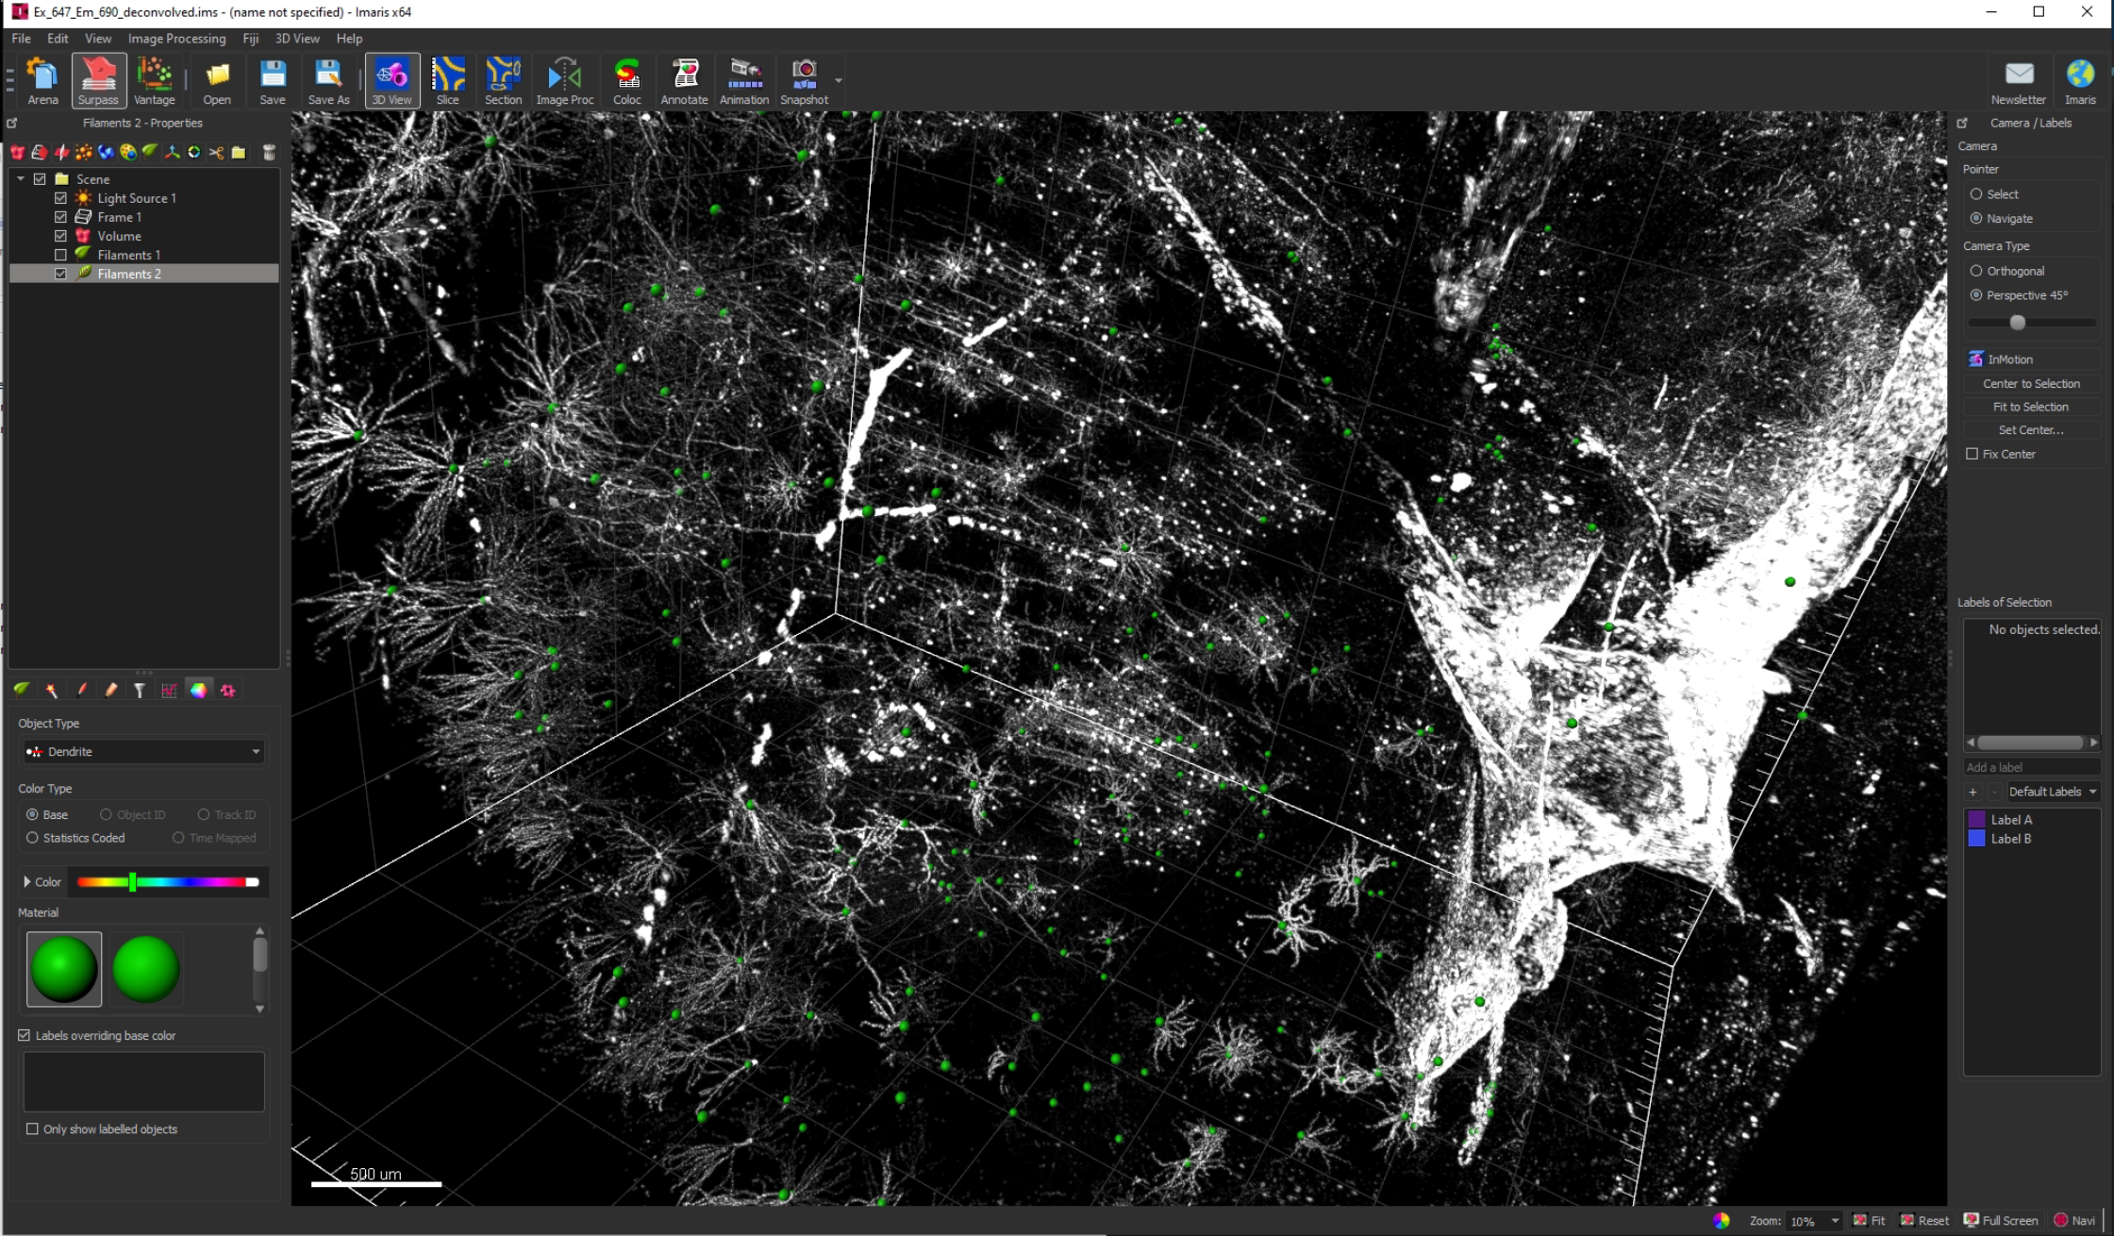

In the left panel you could choose color for the filaments.

To select and delete soma, choose ‘Filament’ in the ‘Edit’ panel on the bottom left, and choose ‘Select’ in the upper right panel, then click on the soma and hit ‘Delete’ button on the keyboard.

To select multiple somas, just hold ‘ctrl’ and click all the somas you want to delete

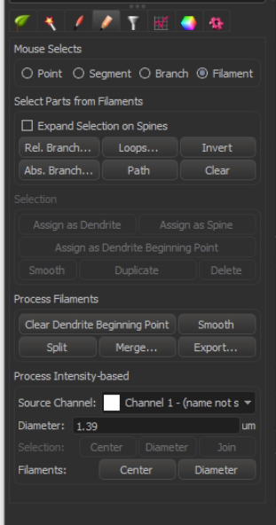

1. **Export Filament into SWC file as proofread somas**

Left click to select the Filament object in Imaris you want to export, go to Image Processing 🡪 Export Filament as SWC 🡪 Choose where you want to export and specify file name (for example, Imaris_proofread_somas.swc)

1. **Convert the proofread soma from single SWC file to marker files**

Open Powershell in the directory where the scripts are located

Run convert_imaris_soma_to_markers.py

*Python convert_imaris_soma_to_markers.py -s <Path to the Imaris_proofread_somas.swc created in step 8>*

Default voxel size is 0.4, 0.4, 0.4, could change by specifying:

* -vx <vx>
* -vy <vy>
* -vz <vz>

A folder called <IMS_proofread_soma_seeds> will be generated in the same directory as the <Imaris_proofread_somas.swc> file, which contains all the recut readable marker files for further reconstruction

