Internship Assignment: Backend for main analytics dashboard
Email: masudurrehman2000@gmail.com
Github Repo Link: https://github.com/Masood2000/backend-analytics-dashboard
Note: Repository is private but one jetbrains internship evaluator is assigned as collaborator of this repo.
Task # 1:
This document outlines the design and implementation of a Spring Boot application that provides REST API endpoints for storing and executing analytical SQL queries against a dataset.

My Assumptions:
About the Data:
- The Titanic dataset never changes (it's historical data)
- Only need to read data, never modify it.
- Dataset is small enough to fit in memory.
- Users will run similar queries multiple times.
About Usage:
- This is for development/testing, not production.
- Users can wait a few seconds for query results.
- Queries won't be extremely complex.
About Performance:
- It's okay to cache results in memory.
- Multiple users might use it at the same time.

Design Decisions:
1. How I Load the Dataset
What I did: Automatically load Titanic dataset from CSV file on application startup using a DataLoader class
Why this approach:
- DataLoader: It runs automatically when Spring Boot starts.
- CSV Loading: Parses the Titanic CSV file and converts each row into a Passenger entity.
- Error Handling: Skips invalid rows and continues loading the rest of the data.
- Clean Startup: Every application restart gives you a fresh, consistent dataset.

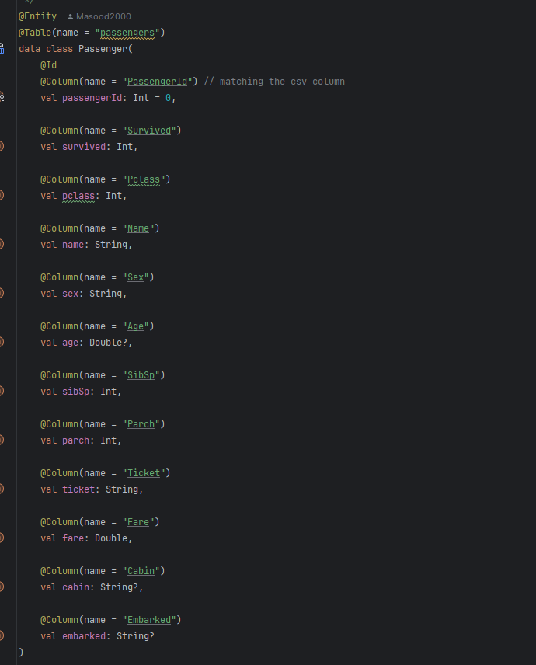
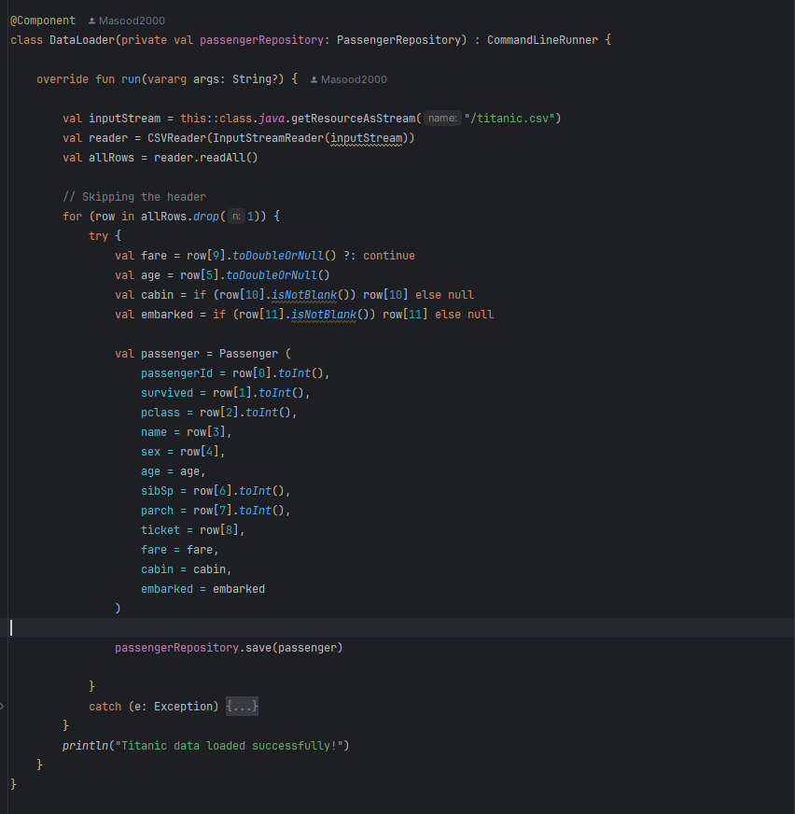

2. How I Store Queries

What I did: Store queries using JPA entity with auto-generated IDs.

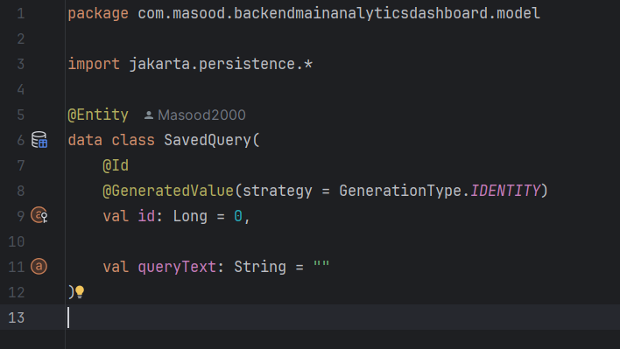

Why:
- Simple JPA entity with auto-generated primary keys.
- Clean separation using repository pattern.
- Easy to implement with Spring Boot's auto-configuration.
Trade-off: Queries are lost when application restarts.
Alternative considered: Could have used in-memory storage or Relational Database for persistent storage of queries.

3. How I Keep It Safe
What I did: Checked for dangerous keywords like INSERT, UPDATE, DELETE , etc before saving queries.
Why:
- Meets the assignment requirement for read-only queries.
- Easy to implement and test.
- Good enough for a controlled environment.

Problems with this approach:
- Could miss sophisticated SQL injection attacks.
- Might block legitimate queries that mention these words in strings.

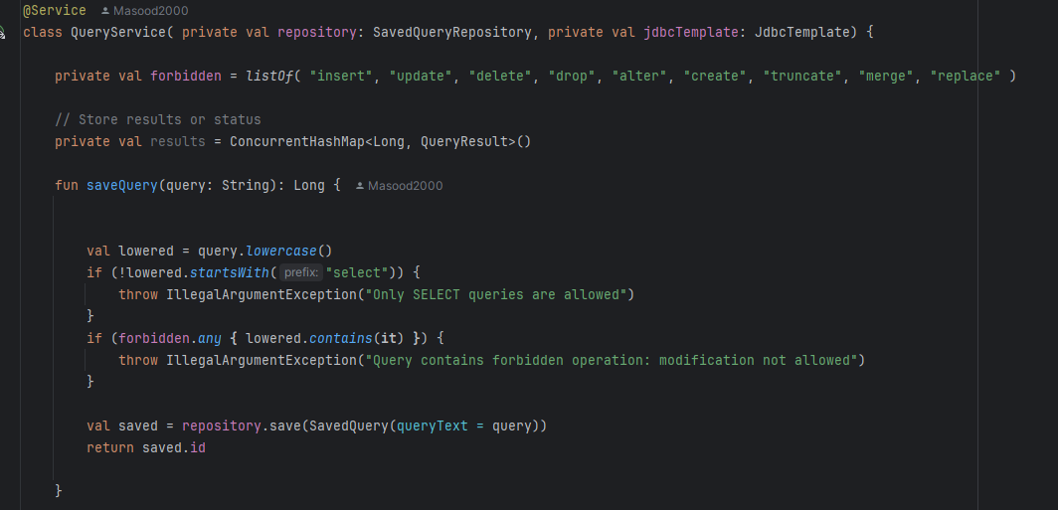

How I could improve this:
- Use SQL Parser: Parse the query structure instead of just checking keywords.
- Whitelist approach: Only allow specific safe SQL functions in database (SELECT, WHERE, ORDER BY, GROUP BY)

4. How I Handle Long-Running Queries
What I did: Used Kotlin coroutines with the IO dispatcher
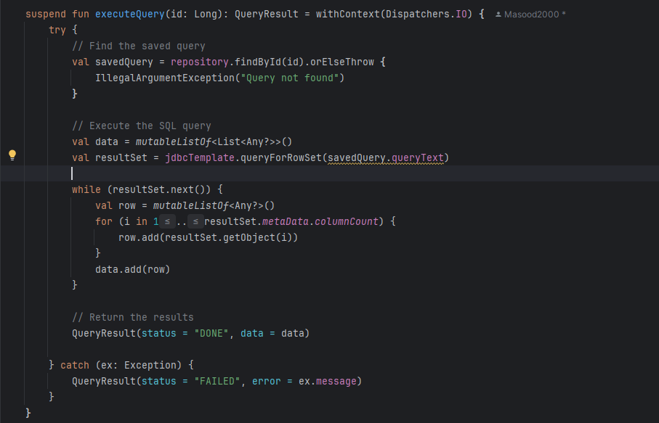
Why:
- Doesn't block the main application threads
- Client gets results immediately when done
Trade-off: Client has to wait for the query to finish (which is okay for this assignment)

How I could improve this (Approach 2): Create separate endpoints for async execution with job tracking:

Job Creation: POST /queries/{id}/execute returns a job ID immediately
Status Checking: GET /jobs/{jobId}/status to check if query is still running
Result Retrieval: GET /jobs/{jobId}/results to get the results when ready

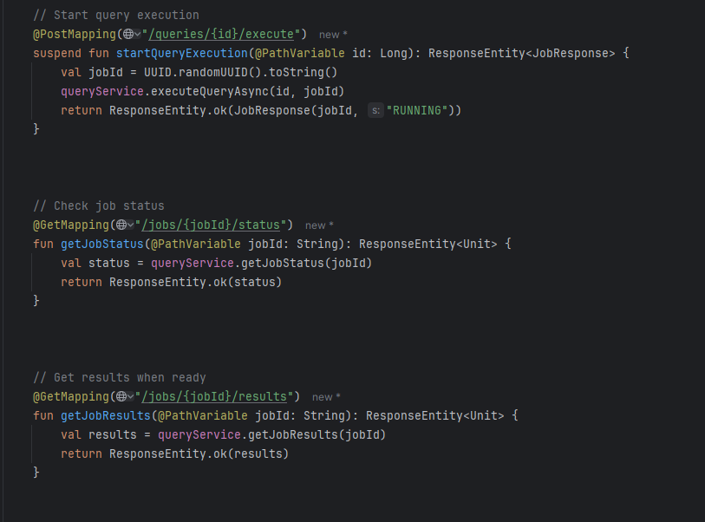

Benefits of this approach:
- Client doesn't have to wait - gets immediate response with job ID
- Can handle very long-running queries
- Client can check status periodically or do other work

Trade-off: I have to create a separate endpoints in the api to get the status and data when its available.

5. How to Improve Performance
What can be did: Cache query results in memory
Why:
- Since the dataset never changes, cached results are always valid
- Same queries run multiple times get instant results
- Simple to implement
Limitation: Cache is lost when the application restarts, but the Titanic dataset gets automatically reloaded from CSV on startup.

Current Limitations
Security Issues
- SQL Injection: My keyword checking could be bypassed with clever SQL
- No Query Limits: Users could run expensive queries that slow down the system
Performance Problems
- Memory Usage: Large query results use lots of memory
- No Pagination: All results returned at once
Scalability Issues
- Single Database: Only works with one H2 database
- In-Memory Cache: Won't work with multiple application instances
- No Monitoring: Hard to tell if the system is having problems

Why I Made These Choices
Kept It Simple: This is an internship assignment, not a production system. I focused on making it work correctly rather than handling every edge case.
Used Modern Tools: Kotlin coroutines are much easier than traditional threading, and Spring Boot handles most of the setup.
Documented Problems: I know my approach has limitations, but they're acceptable for the assignment scope. In a real project, I'd spend more time on improving these things.
Focused on Learning: The assignment was about understanding REST APIs, database integration, and async programming.

Testing Approach
What I Tested
- Saving queries works correctly
- Listing queries returns the right data
- Executing queries returns proper results
- Security validation blocks dangerous queries (not all but basic ones)
- Coroutines don't block the application
How to Test
- Save a query: POST /queries with SQL text
- List queries: GET /queries to see all saved queries
- Execute query: GET /execute?query=1 to run query ID 1

API Endpoints & Postman Testing

You can test all endpoints using Postman or any API client. Make sure the application is running at:
http://localhost:8080

Add a Query (POST `/queries`)

- URL: `http://localhost:8080/queries`
- Method: `POST`
- Body: Raw → Text (text/plain)

Example:
SELECT * FROM passengers;

Response:

{ "id": 1 }

List All Queries (GET /queries)
URL: http://localhost:8080/queries
Method: GET
Response Example:
[
{ "id": 1, "queryText": "SELECT * FROM passengers;" },
{ "id": 2, "queryText": "SELECT name, age FROM passengers;" }
]

Execute a Query (GET /queries/execute)
URL: http://localhost:8080/queries/execute?query=1
Method: GET
Query Parameter:
query → The ID of the query to execute (e.g., 1)
Response (Success):
{
"status": "DONE",
"data": [
[1, "Braund, Mr Owen Harris", 22, "male", "S", 7.25, 0]
]
}
Response (Error):
{
"status": "FAILED",
"error": "Query not found"
}
Notes
In Postman, ensure the POST body is sent as raw text/plain.
GET requests for execute query require query ID as a URL parameter: ?query=1.

