**Name : MASOOD KHAN**

**Reg no: FA21-BSE-028**

**ELECTRICITY THEFT DETECTION SYSTEM**

USE CASE: MONITOR-LINE

MAIN SUCCESS SCENERIO:

|  |  |
| --- | --- |
| LINEMAN | SYSTEM |
| 1. Line Man starts the shift and logs into the system.  2. Line Man receives allocated area information for monitoring.  3. Line Man monitors the assigned area's electricity lines for energy consumption.  4. lineman check for any new line request  5. add new line to data  6. Line Man verifies that energy consumption for each output line is within normal parameters.  7. Line Man detects no irregularities or suspicious activities during the shift.  8. Line Man ensures proper functioning of the electricity distribution network within the assigned area.  9. Line Man reports any identified theft lines to the appropriate authorities.  unauthorized connections or tampered meters.  10. Line Man logs out of the system at the end of the shift | 1. System assigns the Line Man an allocated area to monitor.  2. System provides real-time data and status updates from digital meters.  3. System ensures accurate mapping of output lines to customers or digital meters for splitting.  4. System checks energy consumption against the threshold value for digital meters.  5. file the case or report line if any theft line detected |

**SSD for MONITOR LINE:**

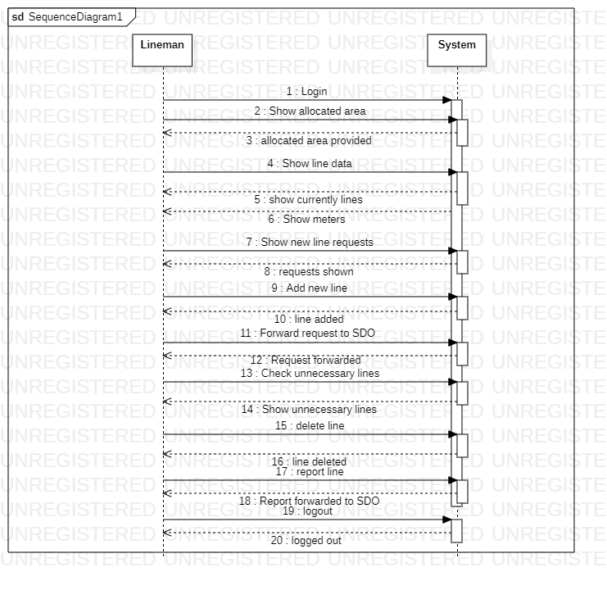

1. 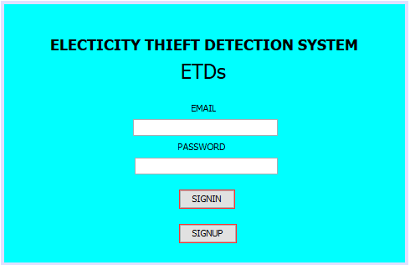**LOGIN PAGE:**

Line man must login to the ETDs to do operations

1. **LINEMAN OPERATIONS**

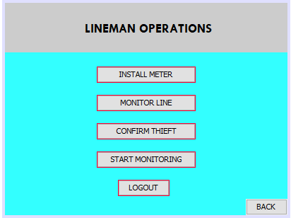When lineman is logged in so he will go on the page operations so he will go to monitor lines page.

1. **LINES DATA**

When lineman enter to monitor line page then system will show the allocated area to the LINEMAN so lineman will see his/her area

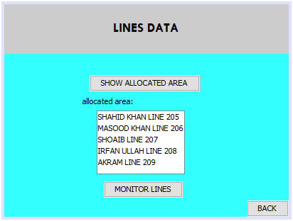

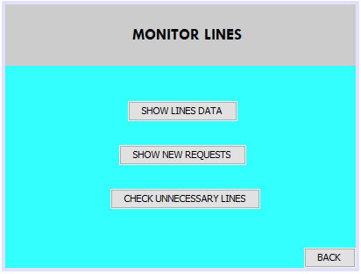

1. **MONITOR LINES**

When lineman see their location so they will no perform actions on lines and can check unnecessary lines

1. 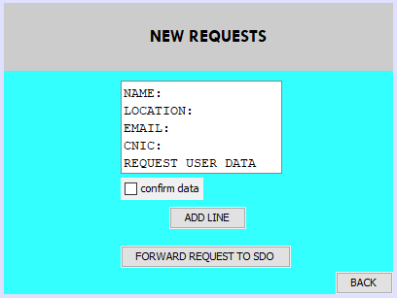**NEW REQUESTS**

When new users requested line so lineman will see the lines and will check the lines and forward the line to SDO for confirmation

1. **UNNECESSARY LINES**

When any unnecessary lines are detected so lineman can delete and can report line

