NAME : MUHAMMAD MASOOD KHAN

REGNO: FA21-BSE-028

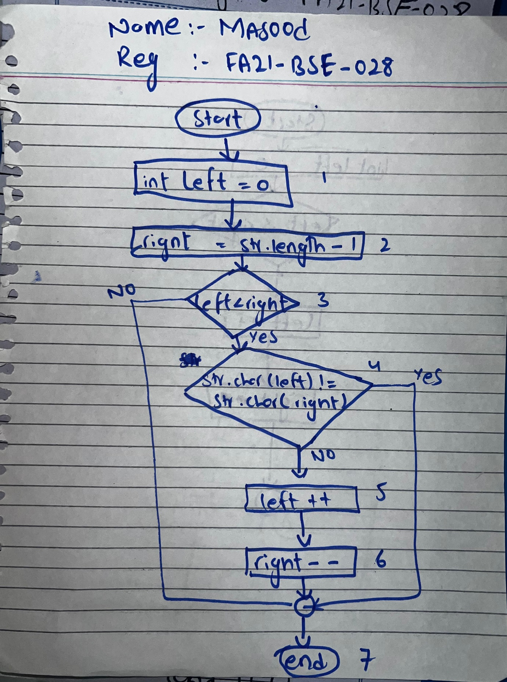

**PATHS:**

|  |  |
| --- | --- |
| PATH | Data |
| 1,2,3 | x |
| 1,2,3,4 | xy |
| 1,2,3,4,5,6 | dad |

Q2) DERIVE THE TESTS AND WRITE IN TABULAR FORM

|  |  |  |  |  |  |
| --- | --- | --- | --- | --- | --- |
| **Test Case ID** | **Test Case Description** | **Input Data** | **Expected Output** | **Actual Output** | **Verdict** |
| TC_001 | To check if the input string is a palindrome ("x") | "x" | true | true | Pass |
| TC_002 | To check if the input string is not a palindrome ("xy") | "xy" | false | false | Pass |
| TC_003 | To check if the input string is a palindrome ("DAD") | "DAD" | true | true | Pass |
| TC_004 | To check if an empty string is considered a palindrome ("") | "" | true | true | Pass |

# **ALGORITHM2:**

I tested it in both INTELLIj IDEA and APACHE NETBEANS

package org.example;

/**** @author masoo*/

# package org.example;

# public class PalindromeCheck {

# public static String reverseString(String str) {

# StringBuilder reversed = new StringBuilder();

# for (int i = str.length() - 1; i >= 0; i--) {

# reversed.append(str.charAt(i));

# }

# return reversed.toString();

# }

# public static void main(String[] args) {

# String str = "madam";

# String reversedStr = reverseString(str);

# System.out.println("Reversed string: " + reversedStr);

# }

# }

# **JUINT TEST CODE:**

package org.example;

import org.junit.Test;

import static org.junit.Assert.*;

public class PalindromeCheckTest {

@Test

public void test1() {

String str = "x";

boolean result = PalindromeCheck.isPlaindrome(str);

assertTrue(result);

}

@Test

public void test2() {

String str = "xy";

boolean result = PalindromeCheck.isPlaindrome(str);

assertFalse(result);

}

@Test

public void test3() {

String str = "DAD";

boolean result = PalindromeCheck.isPlaindrome(str);

assertTrue(result);

}

@Test

public void test4() {

String str = "";

boolean result = PalindromeCheck.isPlaindrome(str);

assertTrue(result);

}

}

# **TEST RESULT:**

