Name: Masooma Zia EE-272L Digital Systems Design

Reg. No. : 2021-EE-1 Marks Obtained: ____________

**Lab Manual 4a**

**Combinational Circuit Design using K-maps**

|  |  |  |  |  |  |  |
| --- | --- | --- | --- | --- | --- | --- |
| **a[0]** | **a[1]** | **b[0]** | **b[1]** | **Red** | **Green** | **Blue** |
| 0 | 0 | 0 | 0 | 1 | 0 | 1 |
| 0 | 0 | 0 | 1 | 1 | 1 | 0 |
| 0 | 0 | 1 | 0 | 1 | 1 | 0 |
| 0 | 0 | 1 | 1 | 1 | 1 | 0 |
| 0 | 1 | 0 | 0 | 0 | 1 | 1 |
| 0 | 1 | 0 | 1 | 1 | 0 | 1 |
| 0 | 1 | 1 | 0 | 1 | 1 | 0 |
| 0 | 1 | 1 | 1 | 1 | 1 | 0 |
| 1 | 0 | 0 | 0 | 0 | 1 | 1 |
| 1 | 0 | 0 | 1 | 0 | 1 | 1 |
| 1 | 0 | 1 | 0 | 1 | 0 | 1 |
| 1 | 0 | 1 | 1 | 1 | 1 | 0 |
| 1 | 1 | 0 | 0 | 0 | 1 | 1 |
| 1 | 1 | 0 | 1 | 0 | 1 | 1 |
| 1 | 1 | 1 | 0 | 0 | 1 | 1 |
| 1 | 1 | 1 | 1 | 1 | 0 | 1 |

**RED:**

|  |  |  |  |  |
| --- | --- | --- | --- | --- |
|  | **00** | **01** | **11** | **10** |
| **00** | 1 | 1 | 1 | 1 |
| **01** | 0 | 1 | 1 | 1 |
| **11** | 0 | 0 | 1 | 0 |
| **10** | 0 | 0 | 1 | 1 |

red = (~a[1] | b[1]) & (~a[0] | b[0]) | (~a[0] & b[1]);

|  |  |  |  |  |
| --- | --- | --- | --- | --- |
|  | **00** | **01** | **11** | **10** |
| **00** | 0 | 1 | 1 | 1 |
| **01** | 1 | 0 | 1 | 1 |
| **11** | 1 | 1 | 0 | 1 |
| **10** | 1 | 1 | 1 | 0 |

**GREEN:**

green = (a[0] & ~b[0]) | (~a[0] & b[0]) | (~a[1] & b[1]) | (a[1] & ~b[1])

**BLUE:**

|  |  |  |  |  |
| --- | --- | --- | --- | --- |
|  | **00** | **01** | **11** | **10** |
| **00** | 1 | 0 | 0 | 0 |
| **01** | 1 | 1 | 0 | 0 |
| **11** | 1 | 1 | 1 | 1 |
| **10** | 1 | 1 | 0 | 1 |

blue = (~b[0] | a[0]) & (~b[1] | a[1]) | (a[0] & ~b[0])

**Circuit Diagram:**

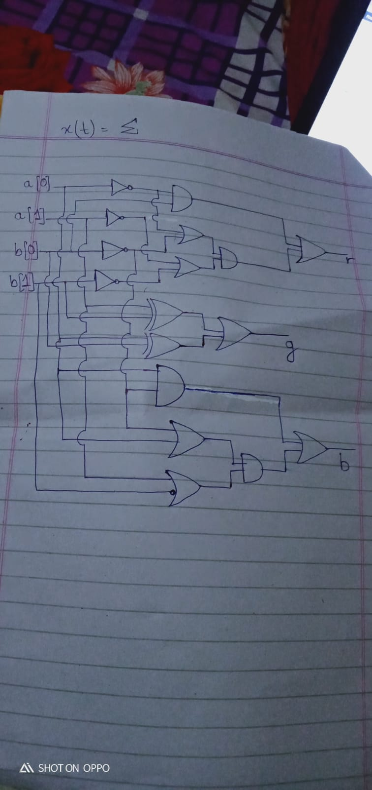

**Elaborated Circuit Schematic:** 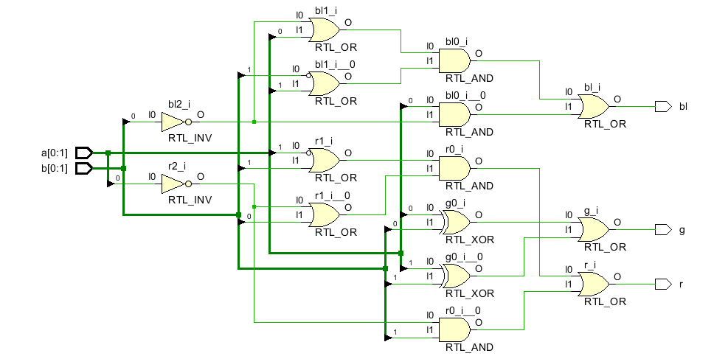

**Maximum Delay:**



