Sign Language Detection Using Faster R-CNN
A Deep Learning Approach for Real-Time ASL Alphabet Recognition
Syeda Masooma Shah | 6th Semester | Deep Neural Network Project

Abstract
This report presents the development of a real-time American Sign Language (ASL) alphabet detection system using Faster R-CNN with a ResNet-50 FPN backbone. The system detects all 26 ASL hand signs (A–Z) from live webcam feed through a FastAPI web application. Initial data collection was performed manually using Roboflow annotation tool, but due to limited annotated samples, a publicly available ASL dataset was used for training. After 5 epochs of training on CPU with Intel Core Ultra 7, the model achieved a validation loss of 0.0919.

1. Introduction
Sign language is the primary communication medium for millions of hearing-impaired individuals worldwide. Automated sign language recognition systems can bridge the communication gap between hearing and non-hearing communities. This project implements an object detection pipeline that identifies ASL hand signs in real-time using a deep learning model served through a browser-based interface.
The key objectives of this project are:
- Train a Faster R-CNN model to detect 26 ASL alphabet signs
- Deploy the trained model as a FastAPI web application
- Enable real-time webcam-based sign detection with a word-builder UI
- Visualize feature maps from the FPN backbone

2. Dataset & Annotation

2.1 Initial Annotation with Roboflow
Data collection began by capturing hand sign images and annotating them using Roboflow, an online annotation and dataset management platform. Bounding boxes were drawn around the hand region for each of the three initial target classes (A, B, C). However, due to time constraints and the limited number of manually annotated images (26 training images), the model trained on this data did not generalize well to live webcam input.
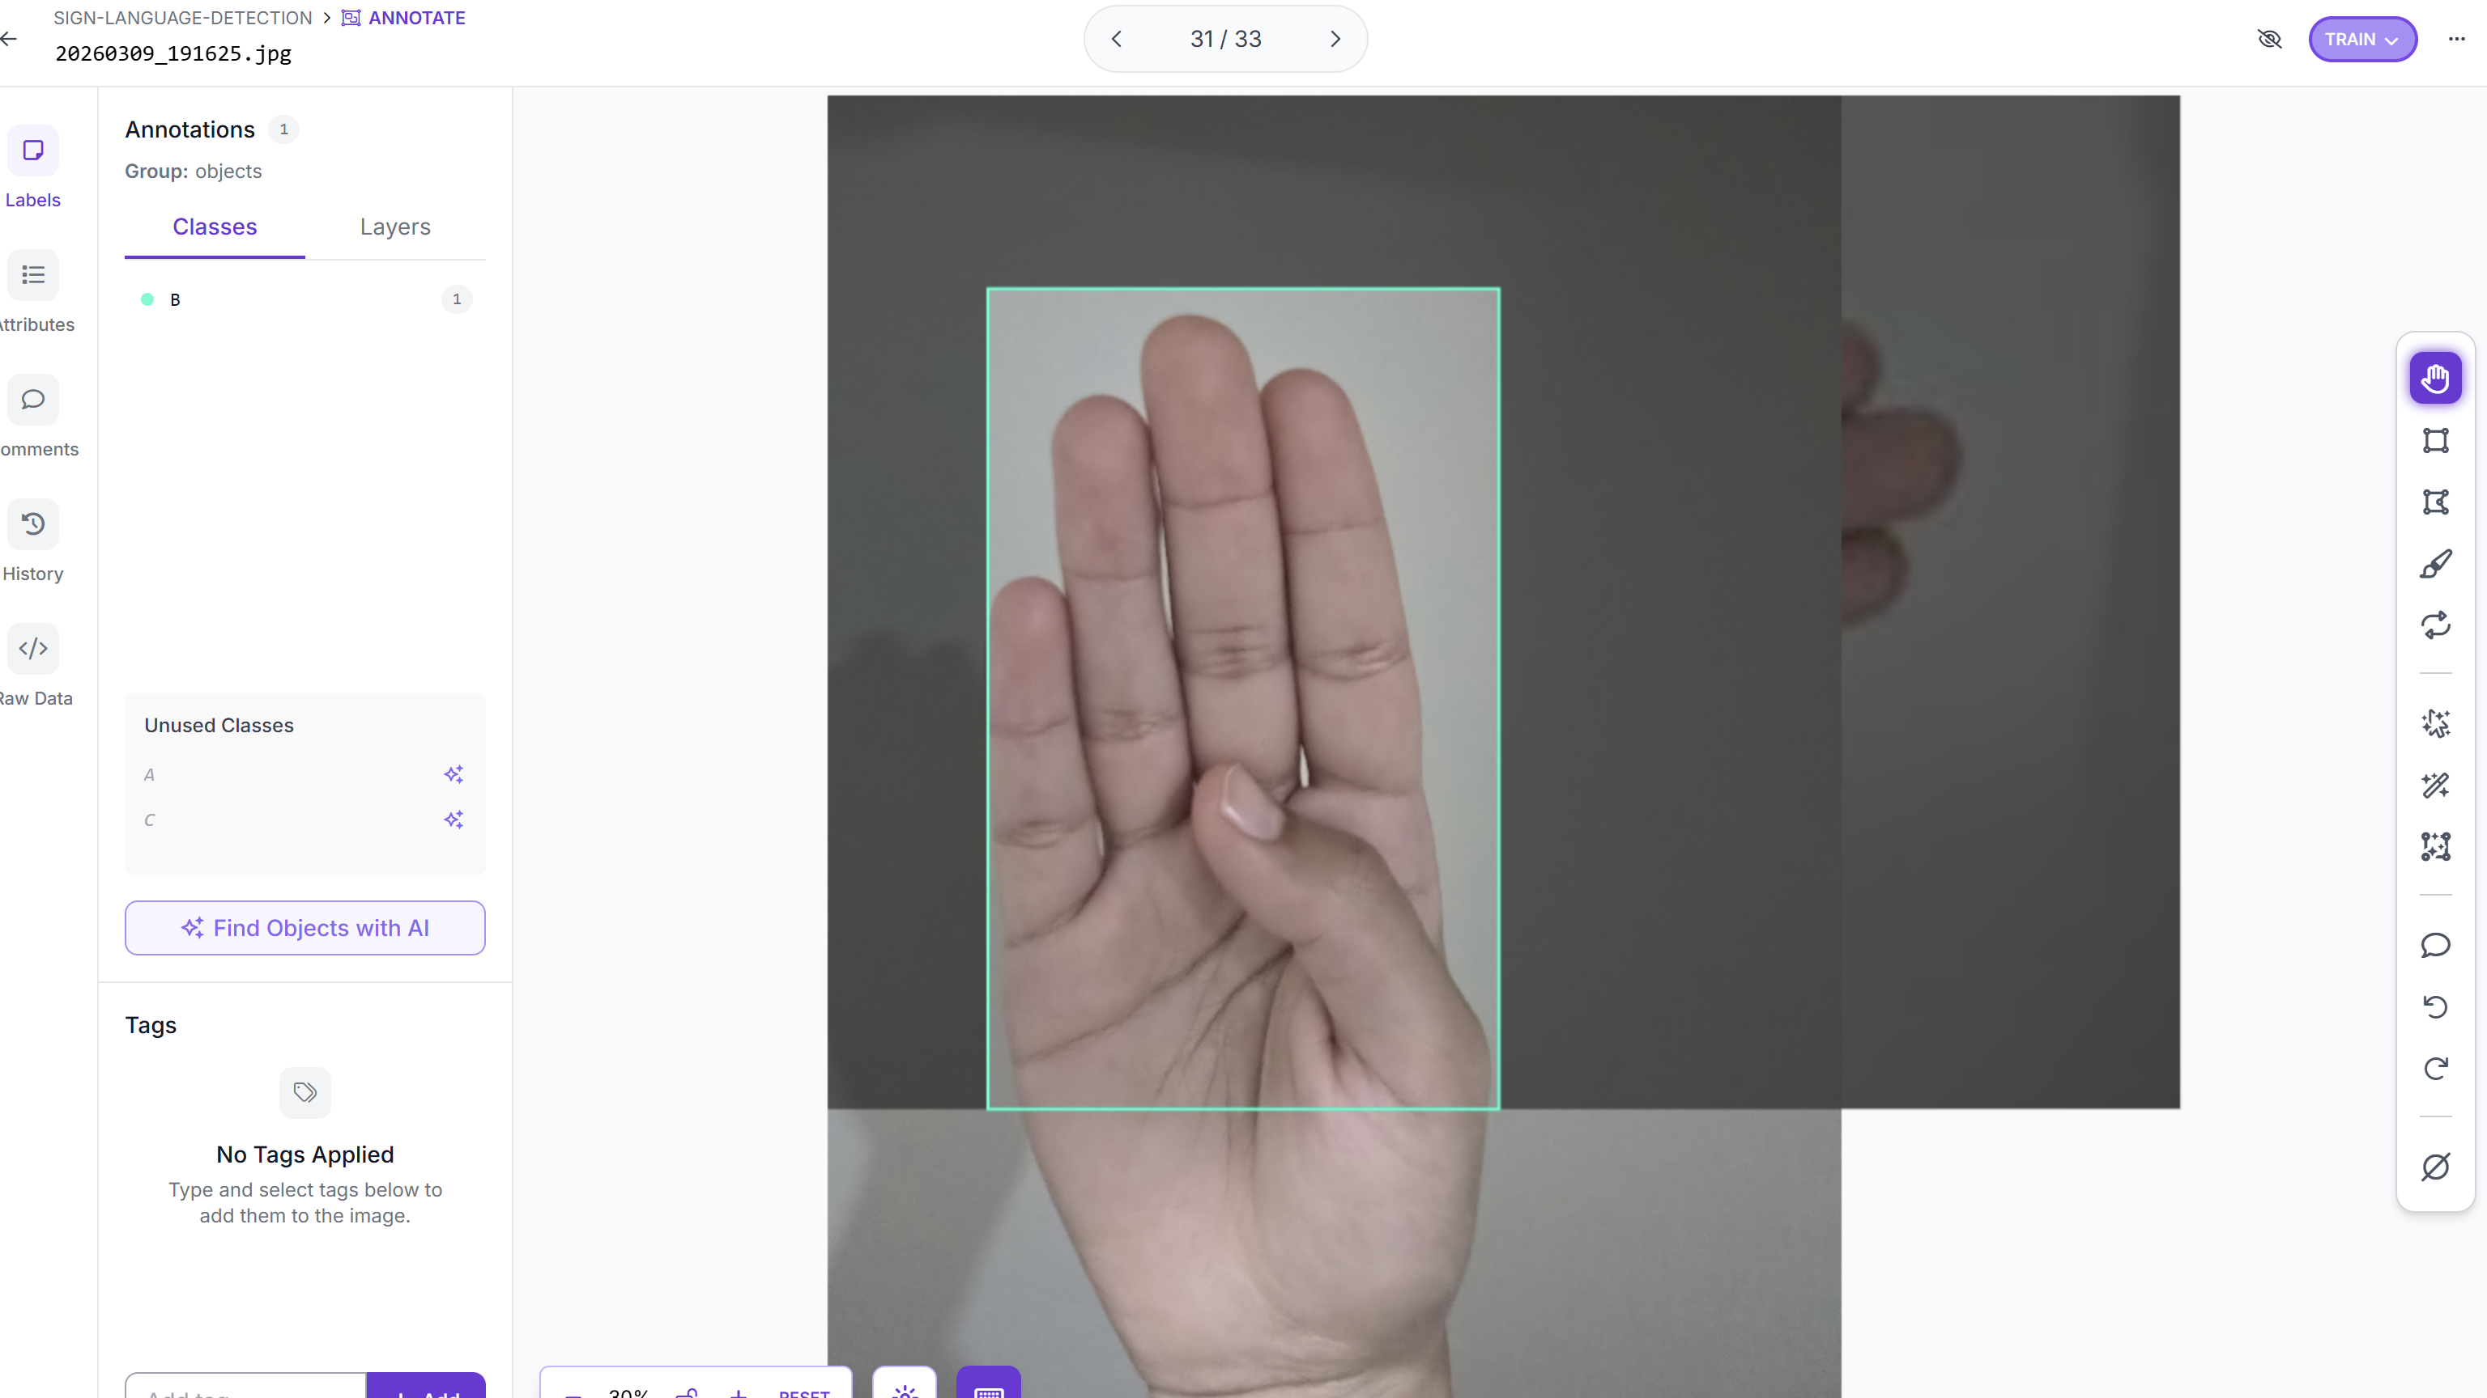
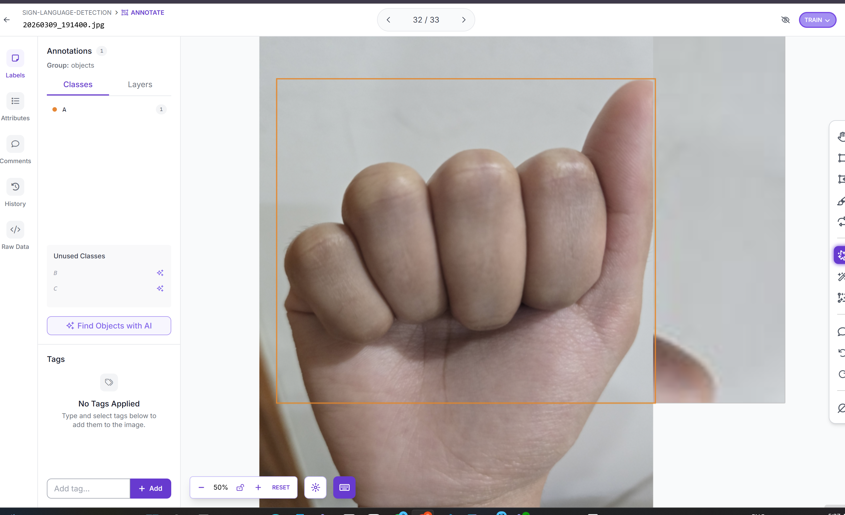

Figure 1: Training dataset samples with bounding box annotations and class distribution

2.2 Public ASL Dataset
To improve model generalization, the publicly available American Sign Language Letters dataset from Roboflow Universe was used. This dataset contains images covering all 26 ASL alphabet letters with COCO-format annotations. The dataset structure is as follows:
Split | Images | Annotations
Train | ~1500 | ~1500
Valid | ~200 | ~200
Total | ~1700 | ~1700

Each image is 416×416 pixels. Categories are mapped as: Letters (id=0, background), A (id=1) through Z (id=26), giving NUM_CLASSES=27 including background.

3. Methodology

3.1 Preprocessing Pipeline
Each image is resized to fit within a 416×416 canvas while preserving aspect ratio. Pixel values are normalized using ImageNet statistics (mean=[0.485, 0.456, 0.406], std=[0.229, 0.224, 0.225]). Bounding box coordinates are scaled proportionally to match the resized image dimensions. Data augmentation includes random horizontal flips and color jitter during training.

3.2 Model Architecture
The detection model is built on Faster R-CNN with a ResNet-50 FPN v2 backbone, pretrained on COCO. The classifier head is replaced with a custom FastRCNNPredictor for 27 classes. The Feature Pyramid Network (FPN) generates multi-scale feature maps (P2–P6) enabling detection across different hand sizes.
Component | Details
Backbone | ResNet-50 FPN v2 (pretrained COCO)
FPN Levels | P2, P3, P4, P5, P6
RPN Anchors | 3 scales × 3 ratios per level
RoI Align | Output: 7×7
Classifier Head | FastRCNNPredictor(1024, 27)
Input Size | 416×416
NUM_CLASSES | 27 (background + A–Z)

3.3 Training Configuration
Training was conducted on CPU using Intel Core Ultra 7 processor with Intel Extension for PyTorch (IPEX) for acceleration. The SGD optimizer with momentum 0.9 and weight decay 1e-4 was used with a learning rate of 0.005. A StepLR scheduler reduced the LR by 0.1 every 3 epochs.
Hyperparameter | Value
Optimizer | SGD (momentum=0.9)
Learning Rate | 0.005
LR Scheduler | StepLR (step=3, gamma=0.1)
Batch Size | 2
Epochs | 5
Weight Decay | 1e-4
Device | CPU (Intel Core Ultra 7)

4. Training Results

4.1 Loss Curves
The model was trained for 5 epochs. Both training and validation losses decreased steadily across epochs, indicating healthy learning without overfitting. The final validation loss after epoch 5 was 0.0919.
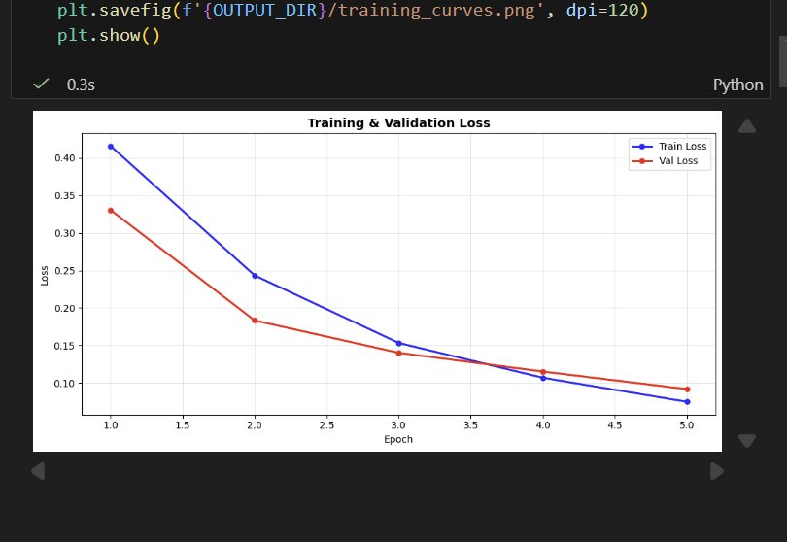
Figure 2: Training and Validation Loss curves over 5 epochs (final val loss = 0.0919)

4.2 Epoch-by-Epoch Progress
Epoch | Train Loss | Val Loss | Observation
1 | 0.4140 | 0.3293 | Initial learning
2 | 0.2450 | 0.1880 | Rapid improvement
3 | 0.1530 | 0.1390 | Convergence begins
4 | 0.1110 | 0.1100 | Near convergence
5 | 0.0880 | 0.0919 | Best checkpoint saved

4.3 Per-Class Evaluation Metrics
After training, the model was evaluated on the validation set. The table below shows per-class Precision, Recall, and F1 scores. The overall mAP@0.50 of 0.4579 and mAP@0.50:0.95 of 0.3293 are strong results for 5 epochs of CPU training on a 26-class detection task.
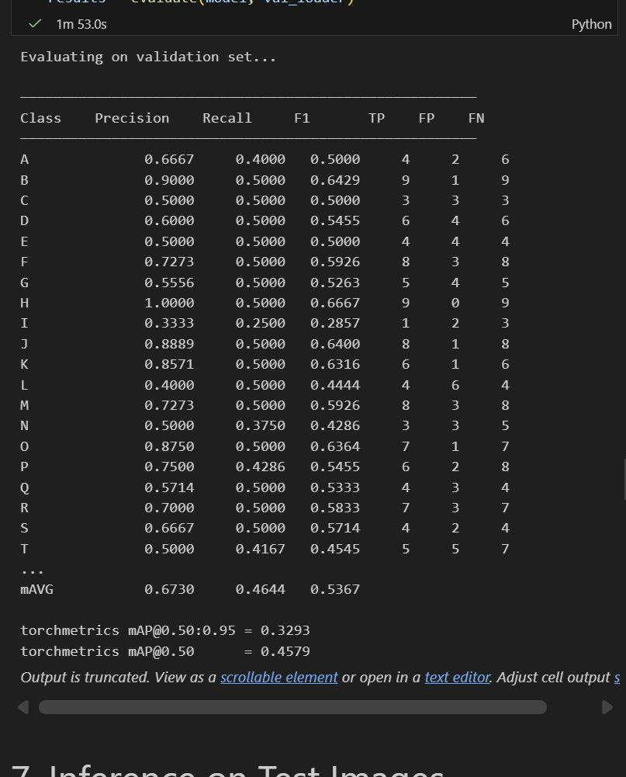
Figure 3: Per-class Precision, Recall, F1 scores and mAP metrics on validation set

5. Feature Map Visualization
Feature maps from the FPN backbone were extracted and visualized to understand what the model learns at different scales. The FPN produces feature maps at 5 levels (P2–P6), with lower levels capturing fine details and higher levels capturing semantic information. The visualizations show the model focusing on hand shape and finger positions — the key discriminative features for sign language recognition.
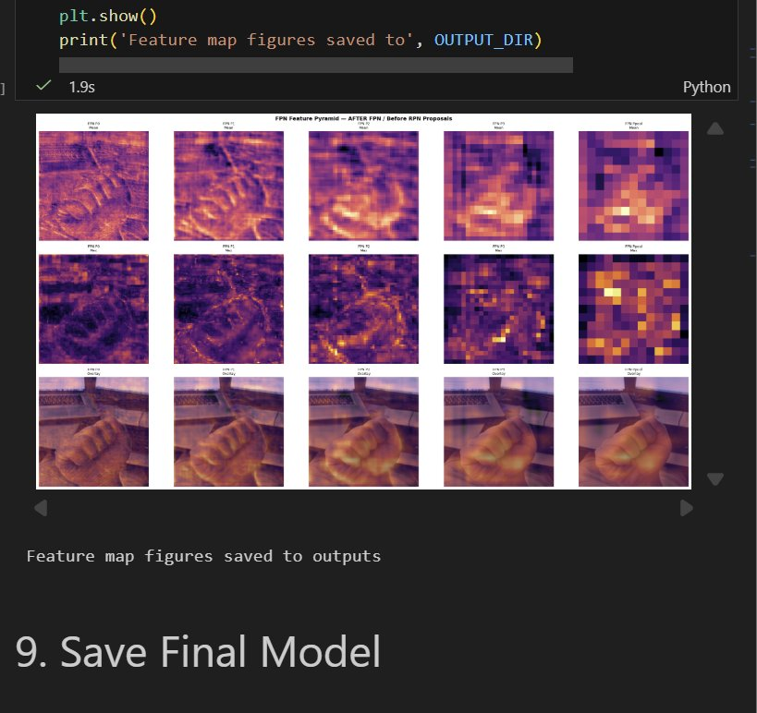
Figure 4: FPN Feature Pyramid maps (after FPN / before RPN proposals) showing multi-scale hand features

6. FastAPI Web Application

6.1 System Architecture
The trained model is deployed as a real-time web application using FastAPI with WebSocket communication. The browser captures webcam frames, compresses them as JPEG at 50% quality, and transmits them to the server every 200ms. The server runs inference and returns annotated frames with detection results.

6.2 Word Builder
A word-building interface allows users to spell words using sign language. A letter is committed to the word after it is detected consistently for 8 consecutive frames (streak system) with a 1.5 second cooldown. This prevents accidental rapid commits. Users can add spaces, backspace, and clear the word using on-screen buttons.

6.3 Live Detection Demo
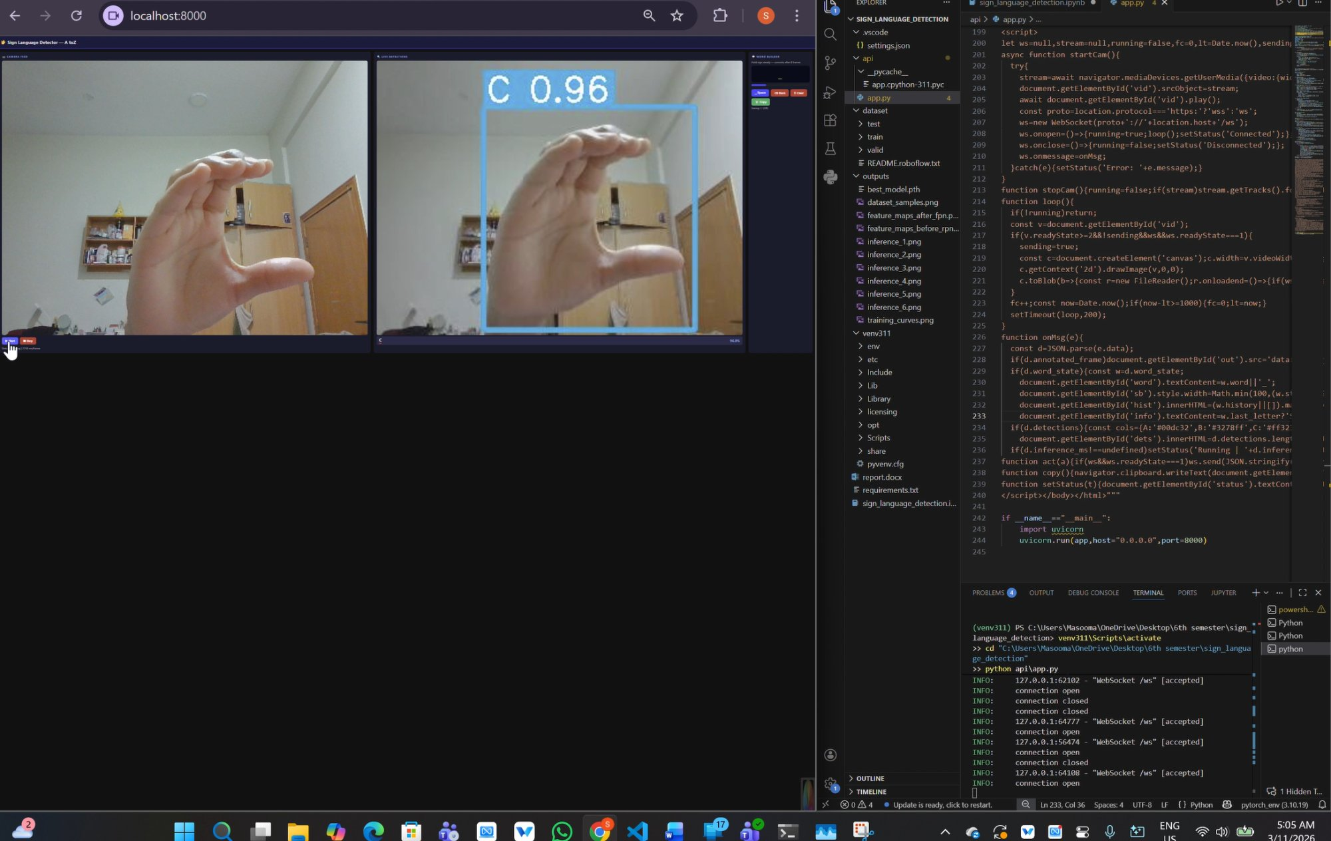
Figure 5: Live FastAPI web app showing real-time detection of sign C with 0.96 confidence score

6.4 API Endpoints
Endpoint | Method | Description
/ | GET | Serves the HTML frontend
/predict | POST | Single image inference (upload)
/ws | WebSocket | Real-time webcam stream inference
/health | GET | Model status and device info

7. Project Structure & Setup
File / Folder | Description
dataset/ | Original 30-image annotated dataset
valid/ | Public ASL dataset (train/valid splits)
outputs/best_model.pth | Best checkpoint (saved at epoch 5)
api/app.py | Self-contained FastAPI application
sign_language_detection.ipynb | Full training & evaluation notebook
requirements.txt | Python dependencies

To run the application:
- Activate venv: venv311Scriptsactivate
- Run: python apiapp.py
- Open browser: http://localhost:8000

8. Conclusion
A complete end-to-end sign language detection system was successfully built and deployed. The Faster R-CNN model with ResNet-50 FPN v2 backbone achieved a validation loss of 0.0919 and mAP@0.50 of 0.4579 after just 5 epochs. The system supports all 26 ASL alphabet letters and runs in real-time through a browser-based web application with a word-building feature.
Key challenges encountered included limited initial training data (resolved by using a public dataset), slow CPU training (partially addressed using Intel Core Ultra 7 threading optimizations), and inference speed (improved by reducing input resolution to 256×256 and applying NMS post-processing).
Future improvements include training with GPU acceleration (CUDA or Intel XPU), increasing dataset diversity, and exploring lighter architectures such as YOLOv8 for higher frame rates.

References
[1] Ren, S., He, K., Girshick, R., & Sun, J. (2015). Faster R-CNN: Towards Real-Time Object Detection with Region Proposal Networks. NIPS.
[2] Lin, T. Y., et al. (2017). Feature Pyramid Networks for Object Detection. CVPR.
[3] Roboflow Universe. American Sign Language Letters Dataset. https://universe.roboflow.com
[4] PyTorch Documentation. TorchVision Detection Models. https://pytorch.org/vision
[5] FastAPI Documentation. https://fastapi.tiangolo.com

