Morteza Kazemi | 97243054

Amir Masoud Shaker | 97243081

10/31/2021

Homework #1

1-1 : Input and Output in programs:

| Name | Syntax | Description |
| --- | --- | --- |
| input | x = input(prompt) | This function displays the text in prompt and waits for the user to input a value and press the **Return** key. The user can enter expressions, like pi/4or rand(3), and can use variables in the workspace.  Note: If the user presses the **Return** key without entering anything, then input returns an empty matrix.  Note: If the user enters an invalid expression at the prompt, then MATLAB® displays the relevant error message, and then redisplays the prompt. |
| str = input(prompt, 's') | This function returns the entered text, without evaluating the input as an expression. |

| Name | Syntax | Description |
| --- | --- | --- |
| disp | disp(X) | This function displays the value of variable X without printing the variable name. Another way to display a variable is to type its name, which displays a leading “X =” before the value.  If a variable contains an empty array, disp returns without displaying anything. |

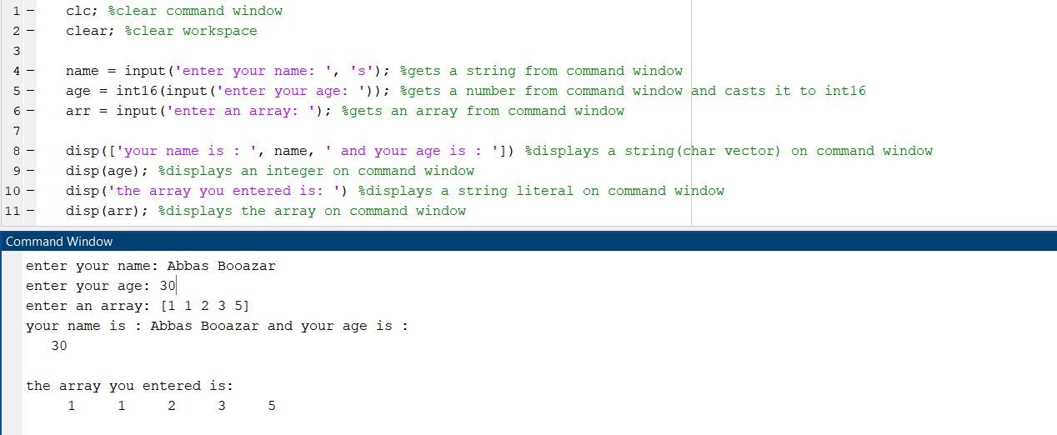

1-2 : String comparison:

| Name | Syntax | Description |
| --- | --- | --- |
| strcmp | tf = strcmp(s1, s2) | This function compares s1 and s2 and returns 1 (true) if the two are identical and 0 (false) otherwise. Text is considered identical if the size and content of each are the same. The return result tf is of data type logical.  The input arguments can be any combination of string arrays, character vectors, and cell arrays of character vectors. |

| Name | Syntax | Description |
| --- | --- | --- |
| strncmp | tf = strncmp(s1, s2, n) | This function compares up to n characters of s1 and s2. The function returns 1 (true) if the two are identical and 0 (false) otherwise. Text is considered identical if the content of each is the same up to the end or the first n characters, whichever comes first. The return result tf is of data type logical.  The first two input arguments can be any combination of string arrays, character vectors, and cell arrays of character vectors. |

| Name | Syntax | Description |
| --- | --- | --- |
| strcmpi | tf = strcmpi(s1, s2) | This function compares up to n characters of s1 and s2, ignoring any differences in letter case. The function returns 1 (true) if the two are identical and 0 (false) otherwise. Text is considered identical if the content of each is the same up to the end or the first n characters, whichever comes first, ignoring case. The return result tf is of data type logical.  The first two input arguments can be any combination of string arrays, character vectors, and cell arrays of character vectors. |

| Name | Syntax | Description |
| --- | --- | --- |
| strncmpi | tf = strncmpi(s1, s2) | This function compares up to n characters of s1 and s2, ignoring any differences in letter case. The function returns 1 (true) if the two are identical and 0 (false) otherwise.  Text is considered identical if the content of each is the same up to the end or the first n characters, whichever comes first, ignoring case. The return result tf is of data type logical.  The first two input arguments can be any combination of string arrays, character vectors, and cell arrays of character vectors. |

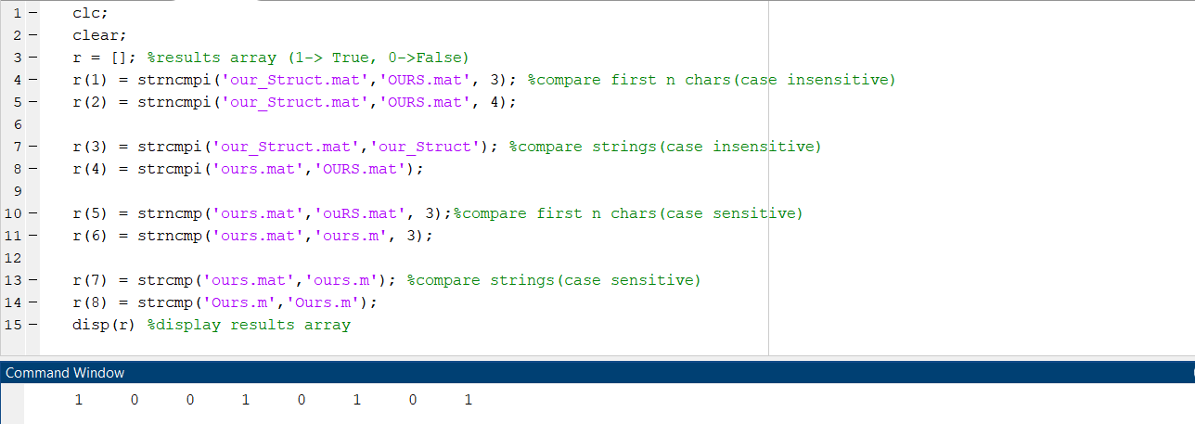

1-3 : Character categorization in strings:

| Name | Syntax | Description |
| --- | --- | --- |
| isletter | TF = isletter(A) | This function returns a logical array TF. If A is a character array or string scalar, then the elements of TF are logical 1(true) where the corresponding characters in A are letters, and logical 0(false) elsewhere. If A is not a character array or string scalar, then isletter returns logical 0 (false). |

| Name | Syntax | Description |
| --- | --- | --- |
| isspace | TF = isspace(A) | This function returns a logical array TF. If A is a character array or string scalar, then the elements of TF are logical 1(true) where corresponding characters in A are space characters, and logical 0(false) elsewhere. isspace recognizes all Unicode® whitespace characters.  If A is not a character array or string scalar, then isspace returns logical 0 (false). |

| Name | Syntax | Description |
| --- | --- | --- |
| upper | newStr = upper(str) | This function converts all lowercase characters in str to the corresponding uppercase characters and leaves all other characters unchanged. |

| Name | Syntax | Description |
| --- | --- | --- |
| lower | newStr = lower(str) | This function converts all uppercase characters in str to the corresponding lowercase characters and leaves all other characters unchanged. |

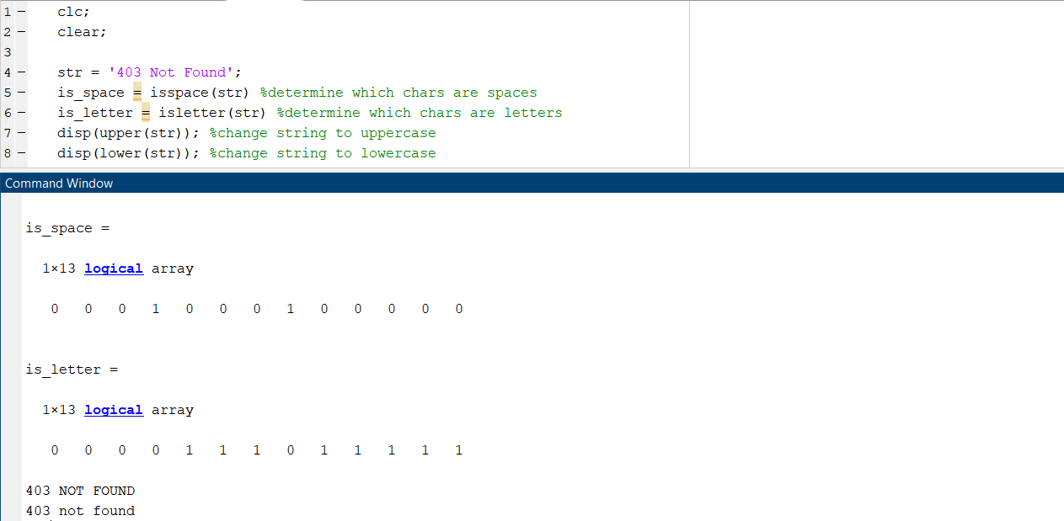

1-4 : Searching and replacing strings:

| Name | Syntax | Description |
| --- | --- | --- |
| strrep | newStr = strrep(str, old, new) | This function replaces all occurrences of old in str with new. If any input argument is a nonscalar string array or cell array of character vectors, then the other input arguments must have compatible sizes. |

| Name | Syntax | Description |
| --- | --- | --- |
| findstr | K = findstr(str1, str2) | This function searches the longer of the two input arguments for any occurrences of the shorter argument, returning the starting index of each such occurrence in the double array k. If no occurrences are found, then findstr returns the empty array, []. The input arguments str1 and str2 can be character vectors or string scalars. |

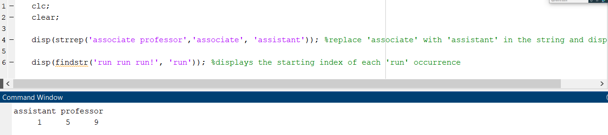

1-5 : Number to string conversion:

| Name | Syntax | Description |
| --- | --- | --- |
| num2str | s = num2str(A) | This function converts a numeric array into a character array that represents the numbers. The output format depends on the magnitudes of the original values. num2str is useful for labeling and titling plots with numeric values. |
| num2str(A, precision) | This function returns a character array that represents the numbers with the maximum number of significant digits specified by precision. |
| num2str(A, formatSpec) | This function pplies a format specified by formatSpec to all elements of A. |

| Name | Syntax | Description |
| --- | --- | --- |
| int2str | K = findstr(str1, str2) | This function treats N as a matrix of integers and converts it to a character array that represents the integers. If N contains floating-point values, int2str rounds them before conversion. |

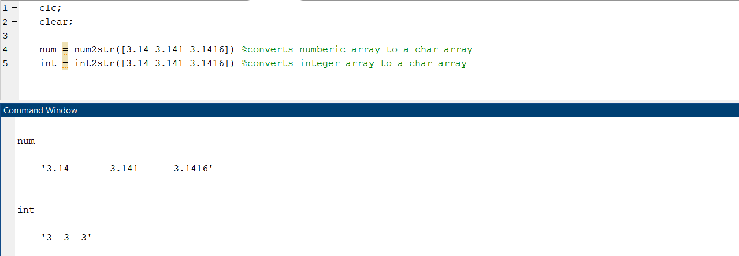

1-6 : Date and time:

| Name | Syntax | Description |
| --- | --- | --- |
| date | c = date | This function returns the current date as a character vector in the format dd-MMM-yyyy. This format represents the day of the month (dd) as a number, the month name (MMM) as its three-letter abbreviation, and the year (yyyy) as a number. |

| Name | Syntax | Description |
| --- | --- | --- |
| now | c = now | This function returns the current date and time as a serial date number. A serial date number represents the whole and fractional number of days starting from a fixed, preset date ([January 0, 0000](https://www.mathworks.com/help/matlab/ref/now.html#mw_4b99c589-f2e5-4d3c-ae43-871e569fb595)). |

| Name | Syntax | Description |
| --- | --- | --- |
| clock | c = clock | This function returns a six-element date vector containing the current date and time in decimal form: [year month day hour minute seconds] |
| [c tf] = clock | This function returns a second output argument that is 1 (true) if the current date and time occur during Daylight Saving Time (DST) in your system's time zone, and 0 (false) otherwise. |

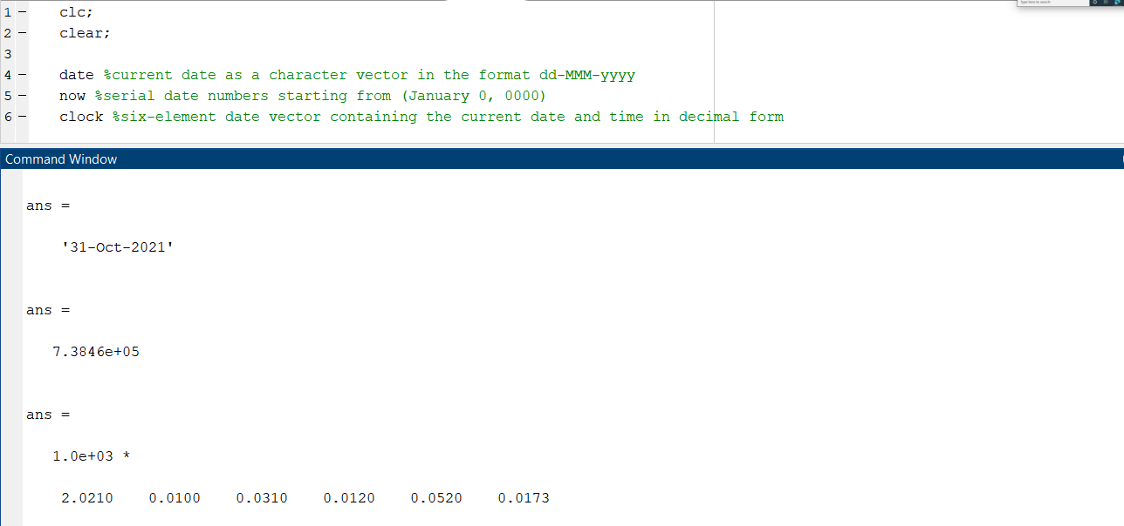

1-7 : Conditions:

| Name | Syntax | Description |
| --- | --- | --- |
| if, elseif, else | *If expression*  *statements e*lseif *expression*  *statements* else  *statements*  end | This structure evaluates an [expression](https://de.mathworks.com/help/matlab/ref/if.html#bt_csfy), and executes a group of statements when the expression is true. An expression is true when its result is nonempty and contains only nonzero elements (logical or real numeric). Otherwise, the expression is false.  The elseif and else blocks are optional. The statements execute only if previous expressions in the if...end block are false. An if block can include multiple elseif blocks. |
| switch, case, otherwise | *Switch switch_expression*  case *case_expression*  *statements*  case *case_expression*  *statements*  ...  otherwise  *statements*  end | This structure evaluates an expression and chooses to execute one of several groups of statements. Each choice is a case.  The switch block tests each case until one of the case expressions is true.  evaluated *case_expression* must be a scalar, a character vector, or a cell array of scalars or character vectors.  The otherwise block is optional. MATLAB executes the statements only when no case is true. |

| Name | Syntax | Description |
| --- | --- | --- |
| input | x = input(prompt) | This function displays the text in prompt and waits for the user to input a value and press the **Return** key. The user can enter expressions, like pi/4or rand(3), and can use variables in the workspace.  Note: If the user presses the **Return** key without entering anything, then input returns an empty matrix.  Note: If the user enters an invalid expression at the prompt, then MATLAB® displays the relevant error message, and then redisplays the prompt. |
| str = input(prompt, 's') | This function returns the entered text, without evaluating the input as an expression. |

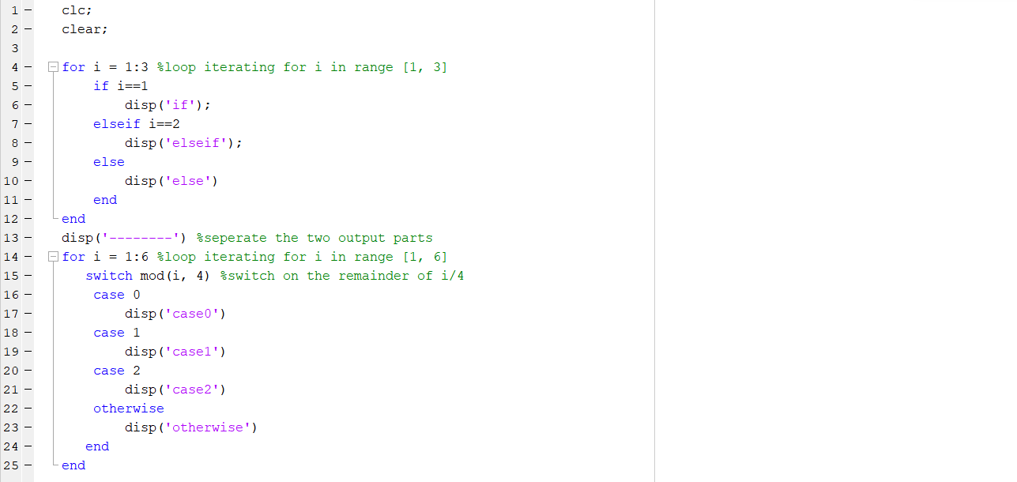

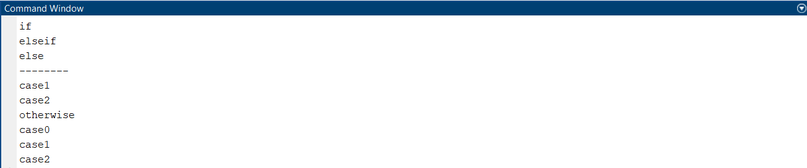

1-8 : Loops:

| Name | Syntax | Description |
| --- | --- | --- |
| for | *For index* = *values*  *statements*  end | *This structure* executes a group of statements in a loop for a specified number of times. |
| while | *while expression*  *statements*  end | *This structure* Evaluates an [expression](https://de.mathworks.com/help/matlab/ref/while.html#bub68r7-4), and repeats the execution of a group of statements in a loop while the expression is true. An expression is true when its result is nonempty and contains only nonzero elements (logical or real numeric). Otherwise, the expression is false |

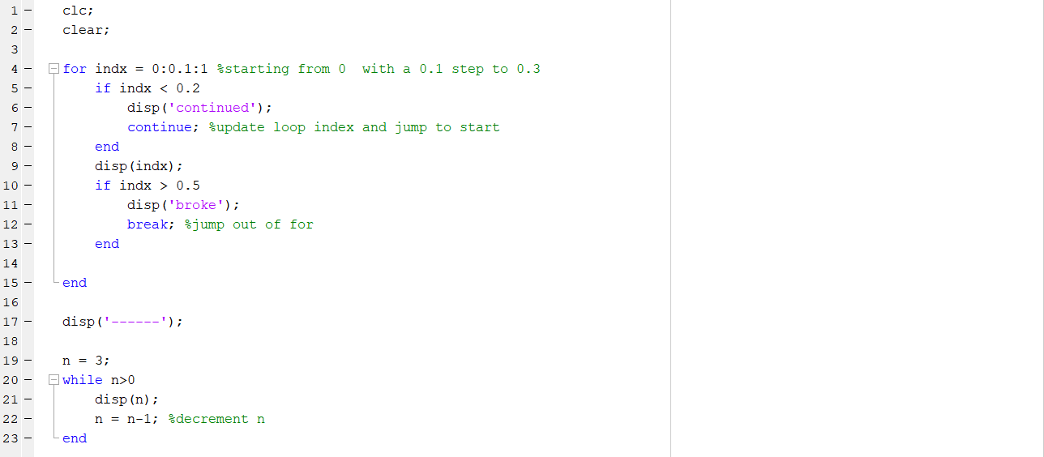

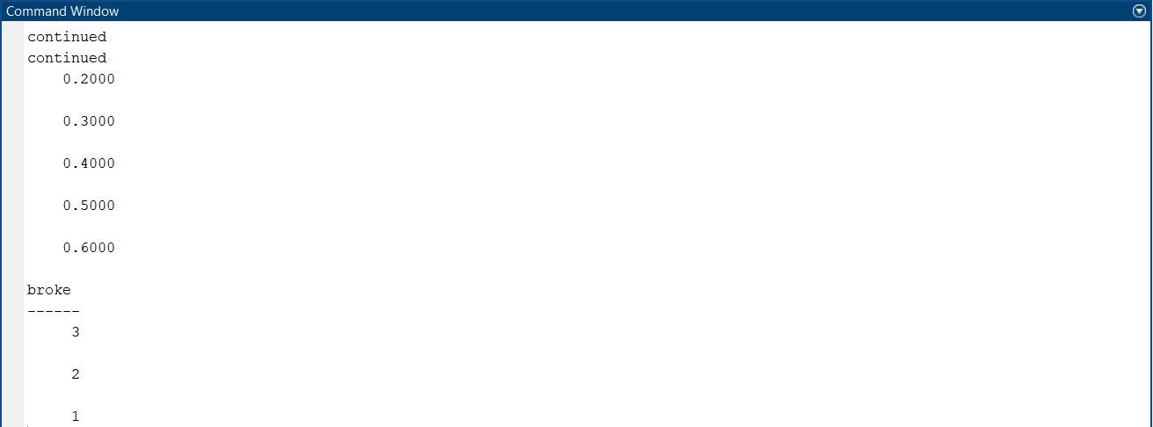

1-9 : Structure array:

| Name | Syntax | Description |
| --- | --- | --- |
| structure array | s = struct | This function returns the current date and time as a serial date number. A serial date number represents the whole and fractional number of days starting from a fixed, preset date ([January 0, 0000](https://www.mathworks.com/help/matlab/ref/now.html#mw_4b99c589-f2e5-4d3c-ae43-871e569fb595)). |

| Name | Syntax | Description |
| --- | --- | --- |
| cell array | cell | This structure is a data type with indexed data containers called cells, where each cell can contain any type of data. |

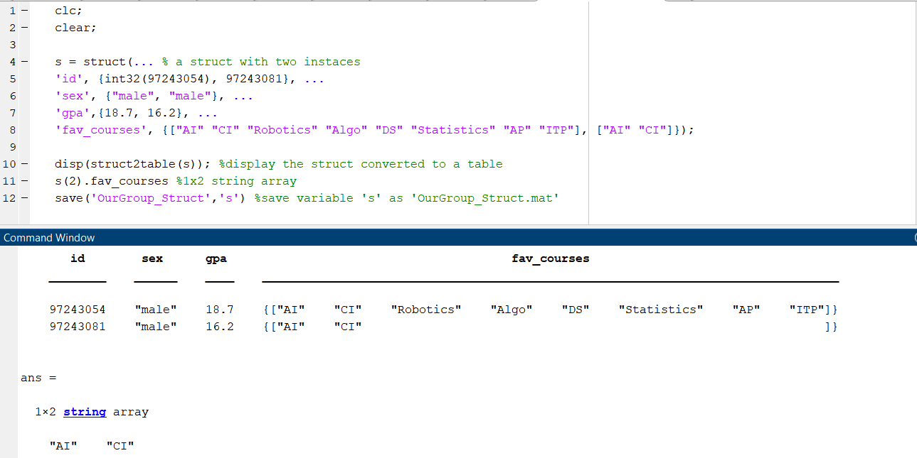



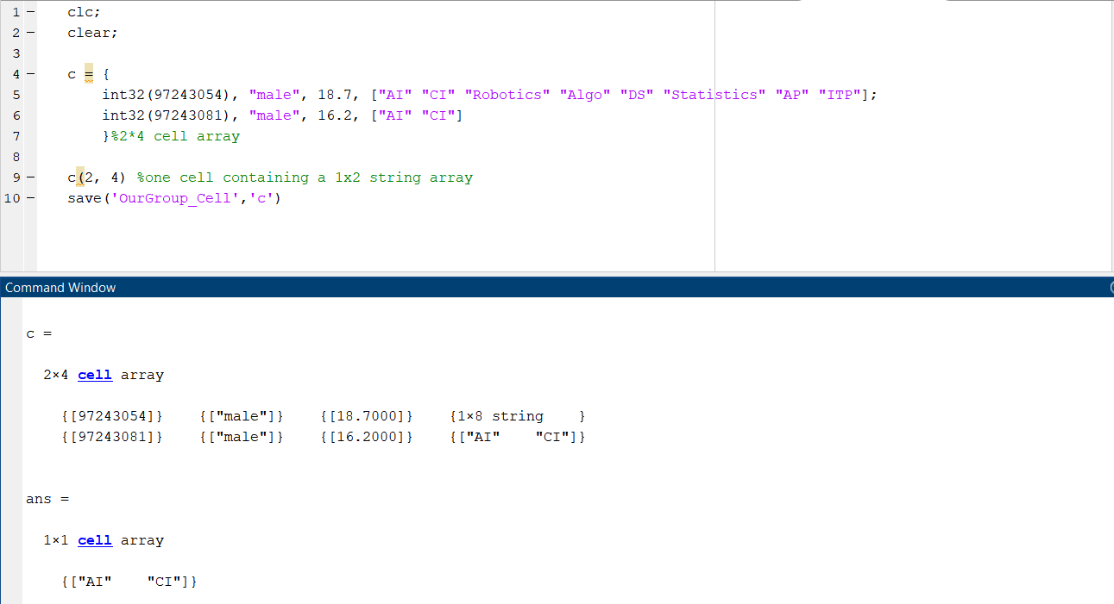

1-10:

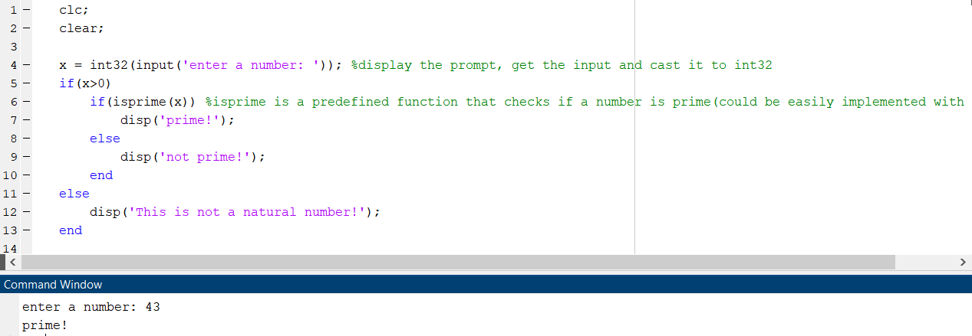

1-11:

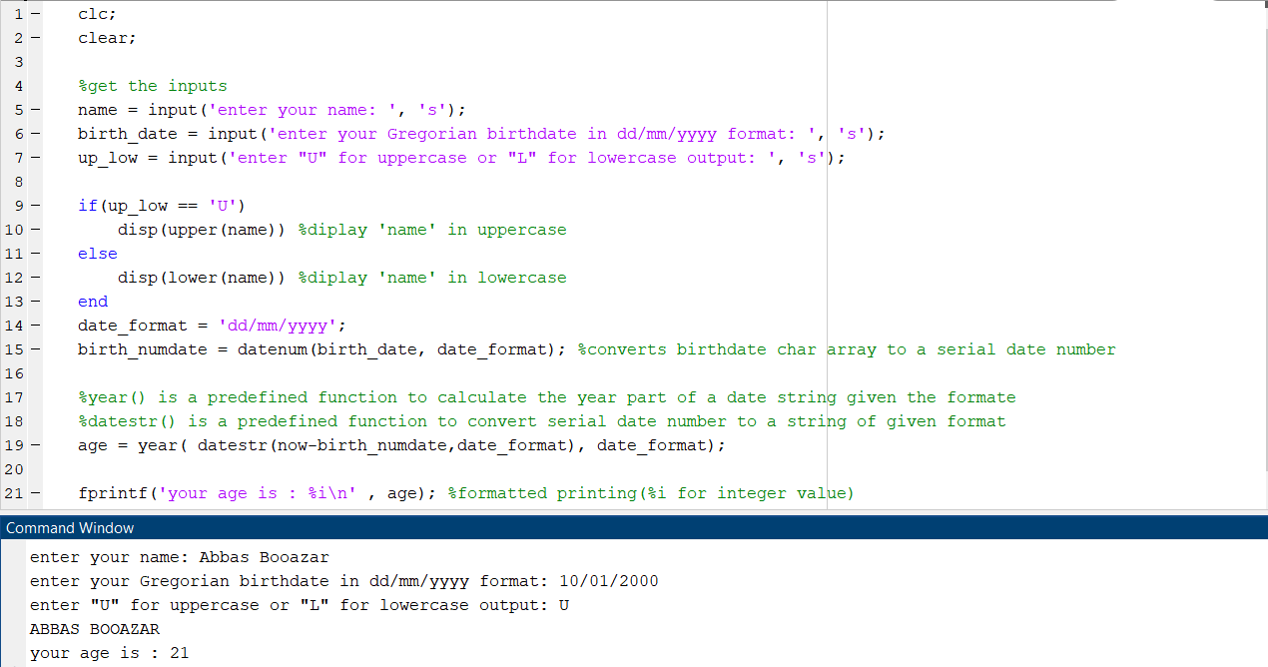

1-12:

