Visualization of Biographical Data Chronologically on Map
Masoumeh Seydi Gheranghiyeh, University of Leipzig, m.seydi@uni-leipzig.de
Maxim Romanov, University of Leipzig, maxim.romanov@uni-leipzig.de

Biographical Data Connected to Time and Space
Biographical collections are a huge part of the Islamic pre-modern literature. They partially or entirely cover the information about individuals and groups, location and time periods, and historical events. A suitable visualization of biographical data related to their location and time leads to a better understanding of the geography and social history. Here, we present an infrastructure in which the user can explore the chronological and biographical data interactively on the map.

To mount biographic and chronological data on geospatial data, we gathered several data from various sources. Georgette Cornu’s Atlas of the Islamic world (Brill, 1985) is our primary source for the cities and the route network in that time. Our focus was mainly on the major cities which were leading centers in the Islamic world. On the other hand; we have extracted data from the different literature to categorize scholars and their movements through the Islamic world. These biographical data are a set of triples like (p,t,c) which represents that the scholar p was in the city c at the time t. These triplets make many-to-many relations. That means a scholar can be in various places in different years and many scholars can visit a place in a specific year. Since this structure is not sufficient for visualization, we generate new structures from these triplets to accelerate the calculations. We made three indexes as follows:

- An index of year values to scholars who have a triple in that year
- Each scholar to the cities that he has traveled
- Each scholar to the years that he has traveled

These newly generated structures help directly access the time values and places associated with one person or to access the people to which a particular year is assigned.

Visualization
The idea is to visualize how people are related to the cities and how people of different cities and time are linked. Therefore, we use all the places and routes information. We can also keep the other places away and just stick to the places in the biographical data set, which gives us another functionality and we will talk about it later.

First, we visualize the Cornu’s data including the cities and their route network on a map. The leading cities are highlighted and the other points are simply invisible. This help not to lose the route network information and have pathfinding functionality from/to a place without showing those additional places on the map. The Dijkstra algorithm (Robert B. Dial. 1969) is the basis of the pathfinding feature.

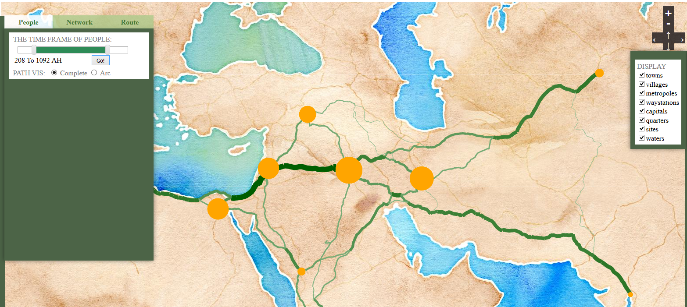

Our goal is to facilitate the user with visual features by which they can study particular people move or which places they were during the time, how places are connected to each other regarding the people being there or visiting there during the time, or how places are connected to the people during the time.
As we see in the figure, the user can select the desired time span and then see places with multiple radii, showing how significant is the number of people related to this place for the chosen era. The larger the circles are, the more people are associated with during the chosen period.

Also, we see the thickness of routes connecting the places changes. This means the thicker routes are more demanded or available or even the only way to travel from/to a place based on the data we have.
The routes and how often they are used for travels, is nor included in the data neither in the features that the user can select to have. This is only a way to show more information derived from the pathfinding algorithm [] we have implemented for the routes graph. The routes here can be an extra information shown to see the connections of places in time regarding the biographical information.
However, there might be the cases that the user would not care about the routes and prefers to see just the connections between places. Hence, we have implemented another feature to show the direct connections of places as arcs. This requires additional analysis on the geospatial data to create a structure for direct connections between the few places we study. To have this structure we analyze the possible paths between two places and omit the intermediate places and stops. This will give us a new abstract route network derived from the original atlas. Using the new route network, we have implemented new pathfinding algorithm to do the same calculations and visualizations.
The time sidebar activates a function which goes through the indexes and find the places relevant to people in the selected period of time. Some places found in this stage can be duplicated or multiplied. That means multiple places are associated with people during a specific time span. The number a place is repeated in the resulting array is used to draw radius of the circles. The same strategy can be applied to calculate a value which an arc or a path needs as its thickness. The number of time a route is passed to connect the places in a particular time span will give us the value for the thickness or a route.

Bibliography

Cyrus Alai, 1985: General Map of Persia 1477 - 1925
Robert B. Dial. 1969. Algorithm 360: shortest-path forest with topological ordering [H]. Communication of ACM 12, 11 (November 1969), 632-633.

