**FINAL STUDY GUIDE**

The final is cumulative.

The final is closed book. Do not log into your computers. No calculators, iPods, iPads or notes.

The final will be a mix of questions below and questions that you have not seen before.

Here is the schedule leading up to the final..

Dec 2 - Lecture and lab;

Dec. 4 - Single threaded Needlman-Wunsch implentation due; multi-threaded for extra-credit

Dec 7,9 - Last lectures and labs; use lab for final review (review this study guide)

Dec. 16 - Final exam - In classroom - 9:00-10:30

-------------

Review the midterm study guide:

http://afodor.github.io/classes/prog2015/StudyGuideMidterm.docx

----------------------------

Exercises:

Using FastaSequenceOneAtATime, use BlockingQueue to read a large Fasta file and output a file with the GC content of each sequence. Does the performance improve with multiple threads on your machine?

Change the program so that instead of using a BlockingQueue, it uses a Semaphore

(You can substitute any other task to run in parallel if you don't want to parse sequences and calculate GC content).

Resources:

FastaSequenceOneAtATime: https://github.com/afodor/metagenomicsTools/blob/master/src/parsers/FastaSequenceOneAtATime.java

A Fasta file with a bunch of sequences in it:

http://fodorlab.uncc.edu/sites/fodorlab.uncc.edu/files/media/Hamp_Fodor_090810.tar.gz

------------------------------

New questions:

(0) This code is designed to count the number of times each character occurs in a string. It throws a null pointer exception. Why? Modify the code so that it works correctly. 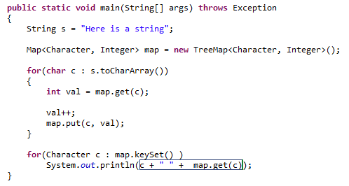

1. What is the difference between implementing interface Runnable and extending class Thread. How do you start threads in both cases? Write an example of starting multiple threads in both cases.
2. How many threads are run in parallel in the following code:

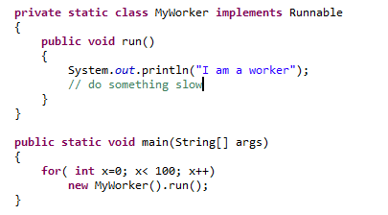

How would you modify the code to make it run more threads in parallel?

1. Why is the code below not thread safe? Modify the code so that it is thread safe

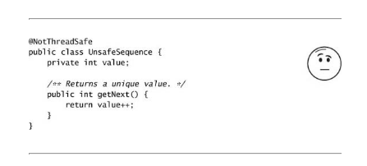

1. Is the following code thread safe? Why or why not? 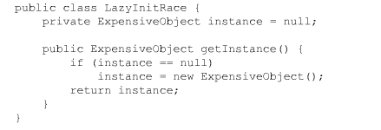If it is not thread safe, modify it is so that is thread safe
2. Why is the following code not thread safe? Write a version that is thread safe. 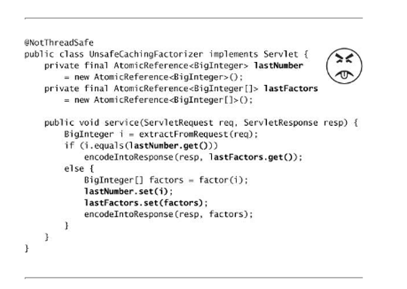
3. What is the AWT thread. Why are you not supposed to put slow operations on the AWT thread. If you are not on the AWT thread, how do you place a non-thread safe GUI operation on the AWT thread? What is the difference between invokeLater() and invokeAndWait()?
4. Define the term race condition. What does the phrase “race conditions remove determinism” mean?
5. True or false: Stateless objects are always thread safe. Why or why not?
6. True or false: Immutable objects are always thread safe. Why or why not?
7. True or false: Mutable objects are never thread safe. Why or why not?
8. What is the difference between guarding mutable state with “synchronized” and having the keyword “volatile” modify mutable variables? What guarantees are made with synchronized vs. “volatile”?
9. What is the output of this program?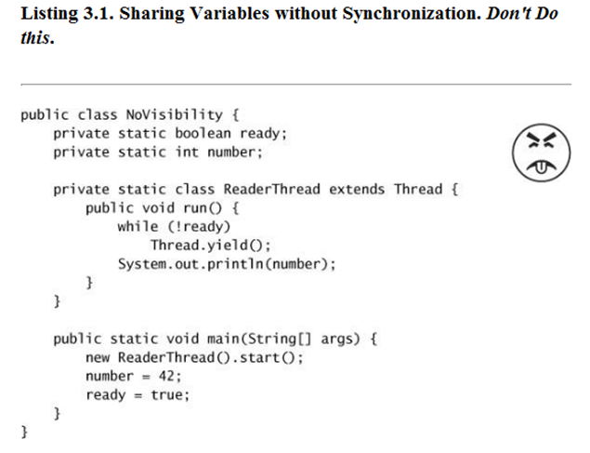
10. Why is this code not thread safe?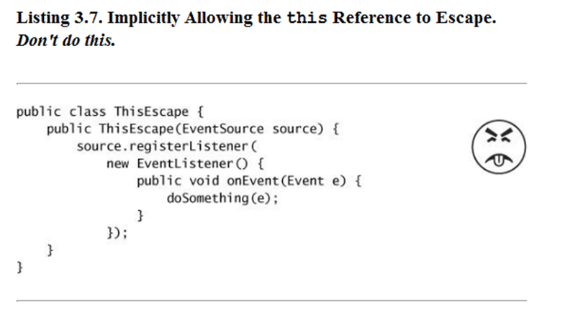
11. Why is this code not thread safe?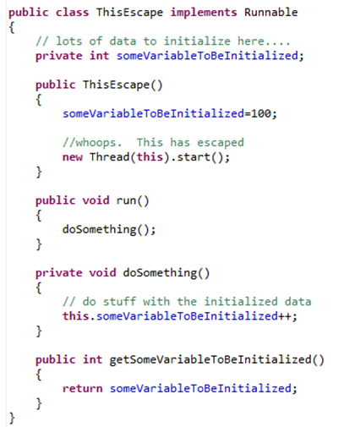
12. Why is this code not thread safe? Fix the code so that it is thread-safe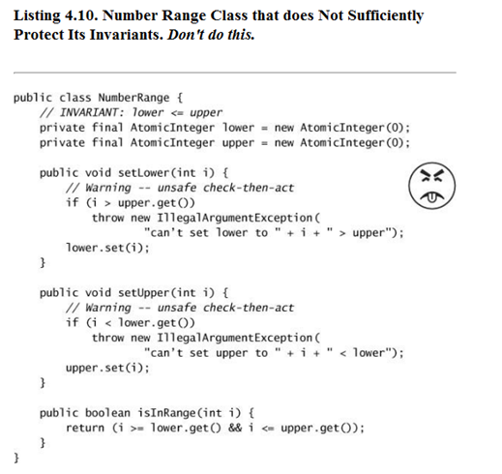
13. Why is this code not thread safe? Fix the code so that it is threadsafe.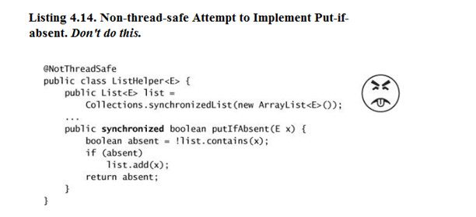
14. What object is locked in this code?

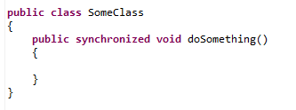

1. What object is locked in this code?

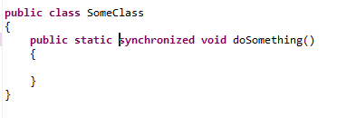

1. Is this code thread safe? What is the potential problem with this code?

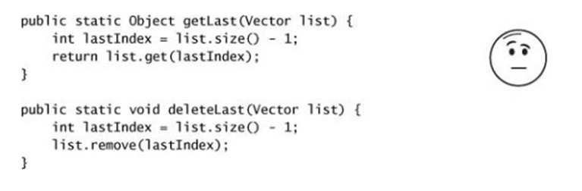

(20) Why is this code not thread safe? Modify the code so that it is thread safe.

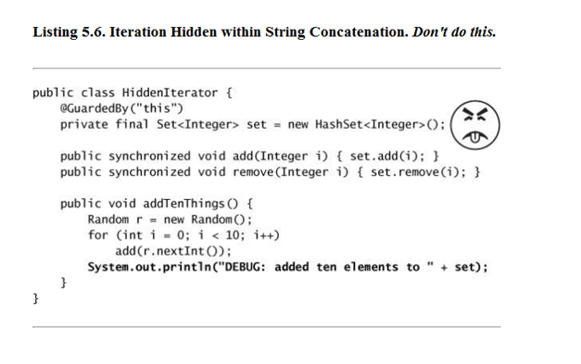

(21) In your own words, what is the difference between a HashMap created with Collections.syncrhonizedMap() and a ConcurrentHashMap. Why is .size() on a concurrent hash map only approximate?

(22) In your own words, what is the difference between a List created with Collections.syncrhonizedList() and a CopyOnWriteArrayList(). Why is .size() on a CopyOnWriteArrayList only approximate? Why can the CopyOnWriteArrayList() be slow?

(23) What is the semaphore class? How does it work?

(24) In lecture, we demonstrated a multi-threded FastaSequence parser and ran it on an 8 core machine, but we only saw a ~5.5X fold speedup. What are some possible reasons we didn't see an 8 fold speedup?

(25) Is this Servlet threadsafe:

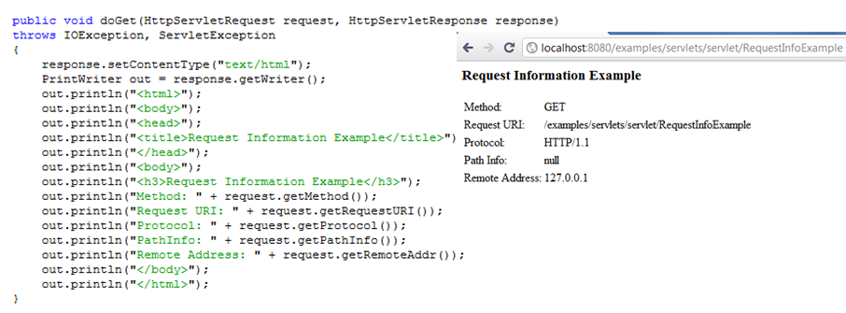

(26) Why should you avoid starting threads from constructors?

(27) Define the monitor pattern. Does the ConcurrentHashMap use the monitor pattern?

(28) Define the decorator pattern.

(29) What is the run time of the Needleman-Wunsch global alignment algorithm?

(30) With a match score of 1, a mismatch of -3 and a gap penalty of -1, draw the Needlman-Wunsch grid for DNA sequences “ACG” and “AG”. What is the score of the final alignment?

(31) As an alternative to the Needlman-Wunsch algorithm, why not just evaluate every possible alignment between two sequences of length ~100 basepairs?

(32) What is deadlock? Give an example of code that can deadlock? What are some solutions that will allow you to avoid deadlock?