# Teamwork Project Documentation for the [JavaScript Basics Course @ SoftUni](https://softuni.bg/courses/javascript-basics/)

**Snake Game**

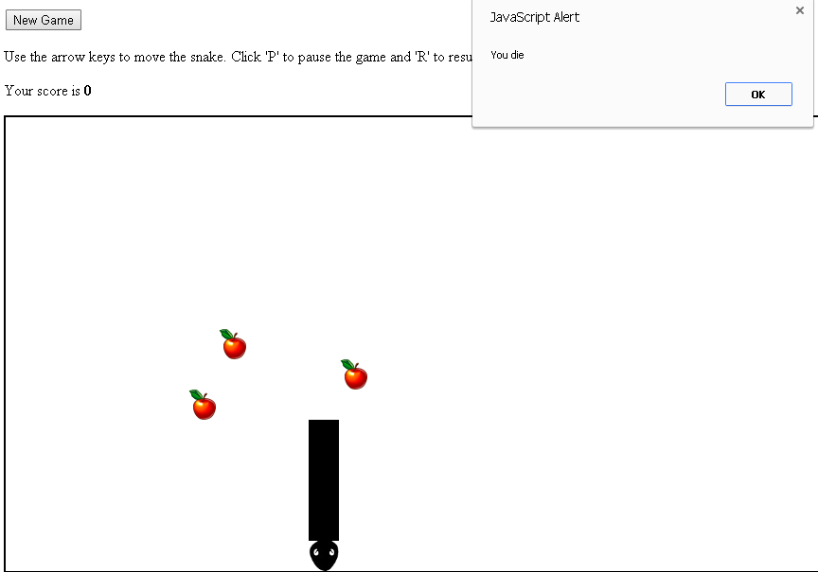

## General Requirements

* **Use JavaScript** – the entire work should be implemented in JavaScript
* **Client-side JavaScript application**, running in Internet
* Ensure your application **works correctly** in the **latest versions of browsers**: Chrome, Firefox, IE, Opera, Safari
* You **do not need to support** old browsers like IE9
* **Work in team** – all team members should contribute
* **Do not** use **engines** or **tools** that generate JavaScript code!

## Additional Requirements

* Follow the **best practices** for producing **high-quality code**: correct naming, correct formatting, etc.

## Optional Requirements

If you have a chance, time and a suitable situation, you might add some of the following to your project:

* Use the **HTML5 canvas** – or a Canvas framework like KineticJS, paper.js or other
* Use **SVG** – or a SVG framework like Raphael JS or other
* Create **animations** – either for the canvas, SVG or both
* Use **DOM** **manipulations** like DOM API or jQuery

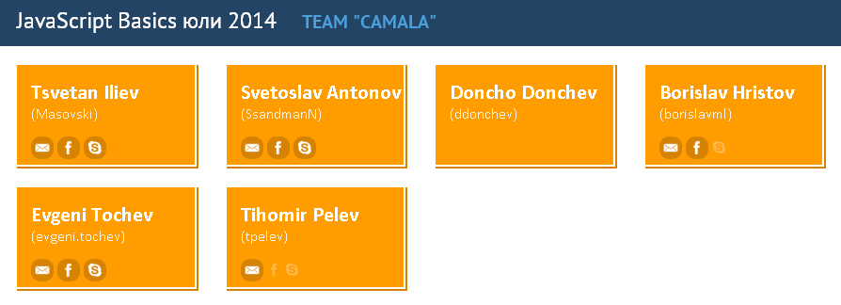

<https://github.com/Masovski/TeamCAMALA/>