
DEVELOPMENT AND FUNCTIONAL TEST REPORT
OMMHA FRONTEND DASHBOARD
Dashboard Feature Documentation for Managing and Analysing Data
for the Kebumen Mental Health Service Atlas

Frontend Dashboard OMMHA — Alpha Version
Historical baseline: 29 June 2026
Repository revision: fbc83cc

Pusat Rehabilitasi YAKKUM
One Map for Mental Health Atlas (OMMHA)

Table of Contents
Update this field in Microsoft Word to display the table of contents.
This report is an English, historical Alpha-version counterpart to the later Beta report. It is based on repository evidence and screenshots captured from an isolated checkout.

A. Executive Summary
This report documents the OMMHA web frontend as it existed at revision fbc83cc on 29 June 2026. This revision is the direct predecessor of the 8 July 2026 dashboard redesign that introduced a blue background across the desktop sidebar. The Alpha interface shown here retains the light sidebar identified as the historical boundary.
The historical frontend was launched from an isolated archive on port 3100 and connected to the local YAKKUM backend on port 8001. The current source tree, the existing Beta report, and application records were not edited. Testing was limited to authentication, route loading, navigation, and read-only interface interactions.

Figure 1. Alpha-version OMMHA login page

B. Purpose and Scope

1. Purpose
- Identify the dashboard functions present in the Alpha baseline.
- Preserve visual evidence of the light-sidebar interface.
- Verify that representative frontend routes render against a local backend.
- Record the boundary between verified behaviour and functions not exercised.
- Provide an auditable historical counterpart to the Beta-version report.

2. Scope
The scope is the web frontend reachable through the authenticated dashboard navigation. The backend, database, mobile applications, deployment infrastructure, and production environment are integration context only and are not independently certified by this report.
Functional group | Documented Alpha coverage
Dashboard | Summary, indicators, map, submissions, and verification entry points
Survey Management | Records, new entry, status views, bulk upload, models, templates, and audit
Service Management | Service lists, creation entry point, and classification references
Users and Roles | Accounts, roles, login history, enumerator functions
Data, Maps, and Reports | Tables, matrices, coverage, gaps, geospatial views, and exports
System and Help | Settings, logs, user guidance, DESDE-LTC reference, FAQ, and support

C. Historical Baseline and Safety Controls
Item | Value
Alpha source revision | fbc83cc920625c84ed4afaf9cae80bf4ca4a5957
Revision date | 29 June 2026, 08:11:59 UTC+07:00
Reason for boundary | Direct predecessor of the full blue-sidebar change in a395566
Screenshot date | 24 July 2026
Historical frontend | Isolated archive, http://127.0.0.1:3100
Local YAKKUM backend | http://127.0.0.1:8001
Viewport | 1440 × 900 pixels
Mutation boundary | No create, edit, delete, approve, import, or export action executed

Because screenshots were captured on 24 July, live dates and aggregate values visible in the interface reflect the local database at capture time. The component structure, routes, navigation, and light-sidebar styling come from the 29 June Alpha revision.

D. Alpha Interface Overview
The Alpha desktop layout uses a narrow icon rail, a light secondary navigation panel, and a wide content area. Selecting a primary icon changes the submenu group. Breadcrumbs and page headings identify the current context, while cards, tables, forms, graphs, and maps occupy the main workspace.
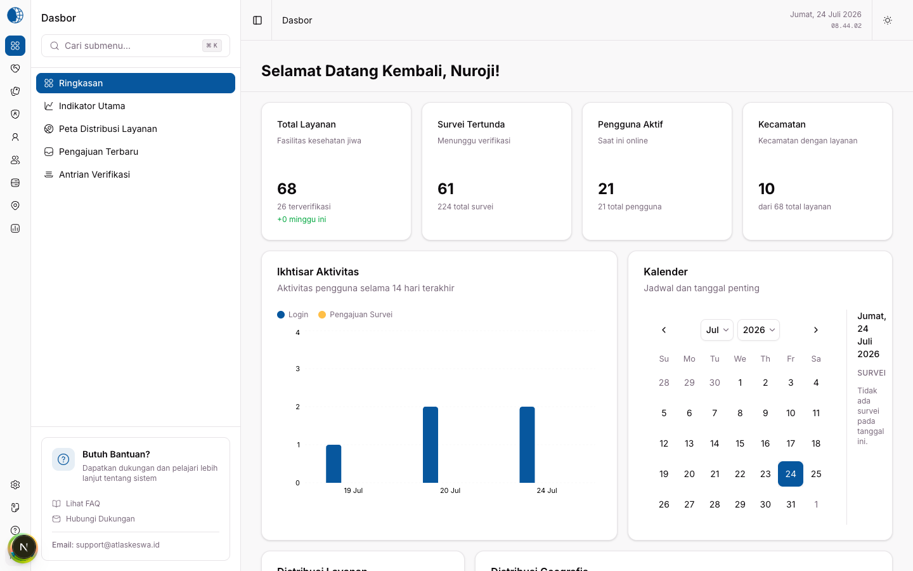
Figure 2. Alpha dashboard summary with the light sidebar
- The left navigation background is light rather than the later Beta blue.
- Summary cards show services, pending surveys, active users, and district coverage.
- The activity overview and calendar provide time-oriented monitoring.
- Role-aware navigation exposes operational and administrative groups.

E. Dashboard and Indicators
The summary is the post-login landing page. The Indicators page expands the overview into analytical cards and charts intended to support programme monitoring and comparison.
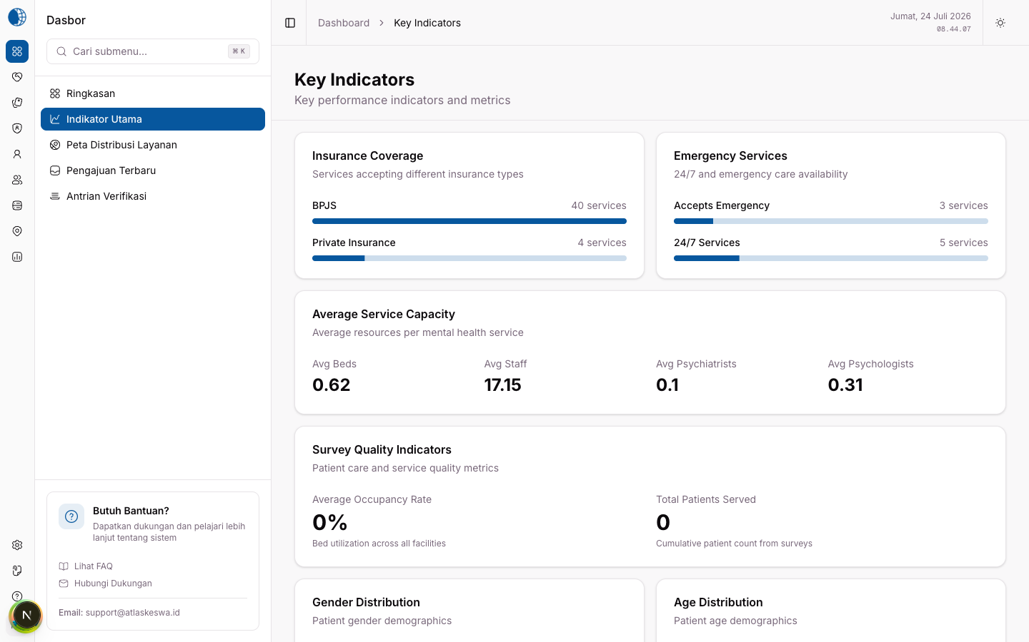
Figure 3. Alpha main indicators page
Visible capability | Alpha purpose
Metric cards | Provide an immediate view of aggregate values
Activity chart | Show recent activity over time
Calendar | Relate activity and submissions to dates
Analytical visualisations | Summarise distribution and coverage
Sidebar navigation | Move between dashboard, map, and submission contexts

F. Survey Management
  - Primary documented workflow
Survey Management is the most detailed Alpha module. It links captured records to status views, questionnaire models, templates, and audit information.
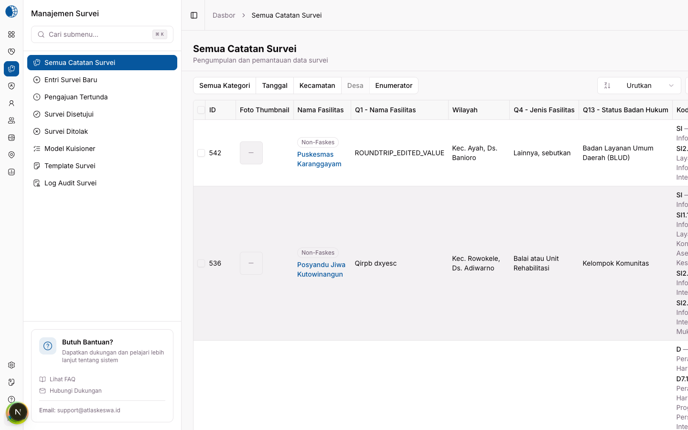
Figure 4. Alpha list of all survey records
- The table presents facility, geographic, questionnaire, and status information.
- Category, date, district, village, and enumerator filters are visible.
- The category filter was opened successfully during read-only verification.
- The sorting control was visible, but its expected accessible name could not be located; this check is Limited.

1. New survey entry
The new-entry route rendered the historical questionnaire workflow. No field was submitted and no draft record was created during verification.
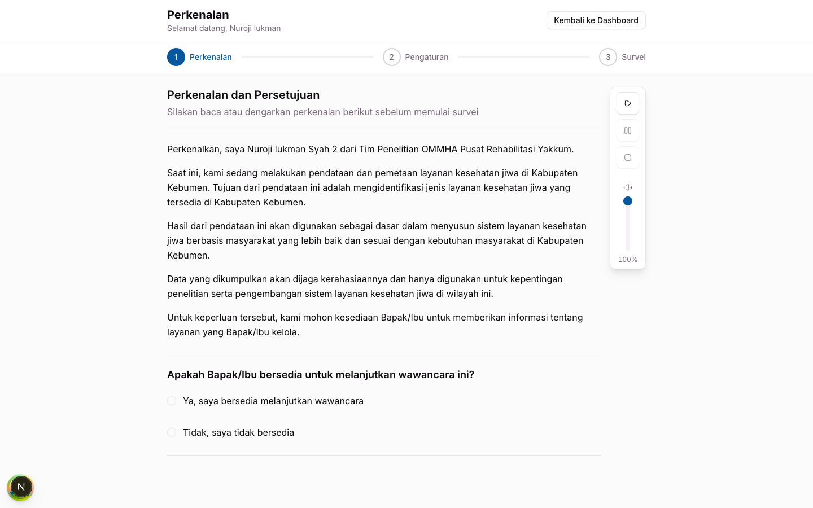
Figure 5. Alpha new-survey entry route

2. Pending submissions
The Pending Submissions view isolates records awaiting review. The page loaded and rendered; approval, rejection, and record-editing actions were deliberately excluded.
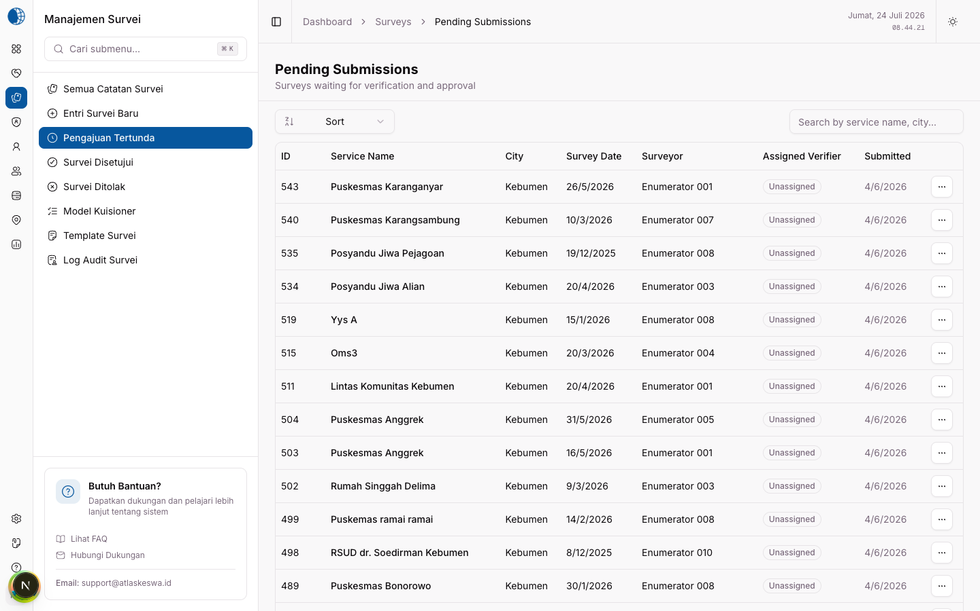
Figure 6. Alpha pending-submissions view

3. Bulk upload
The bulk-upload page provides a file-based intake path. The interface rendered, but no file was selected or uploaded.
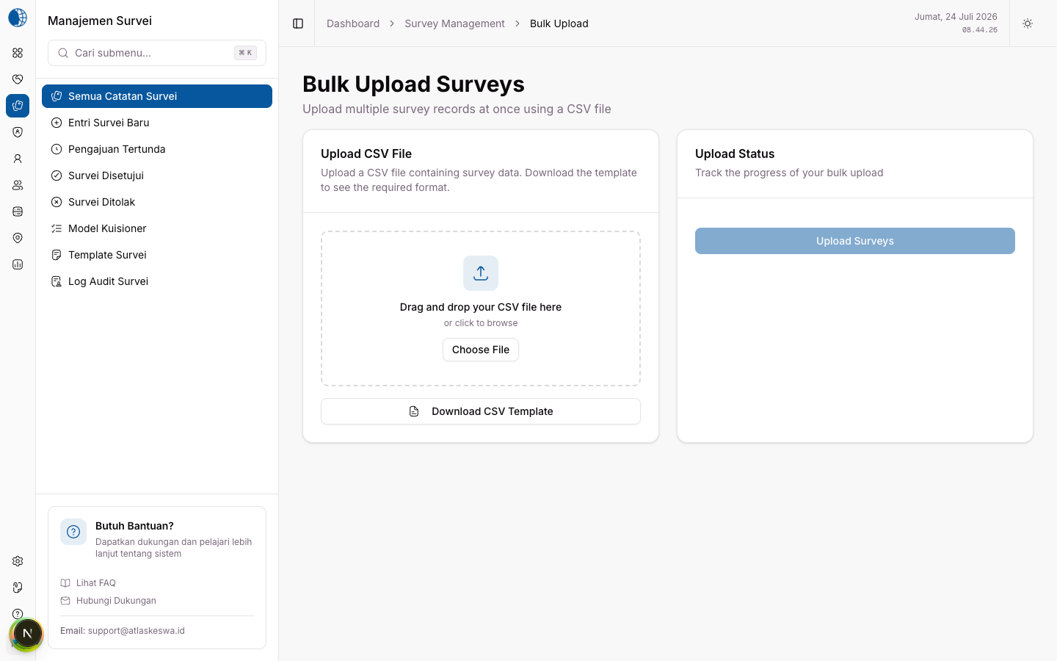
Figure 7. Alpha bulk-upload interface

G. Questionnaire Models, Templates, and Audit
Questionnaire models define survey structure. During testing, the model page loaded and its search input accepted text without submitting a change.
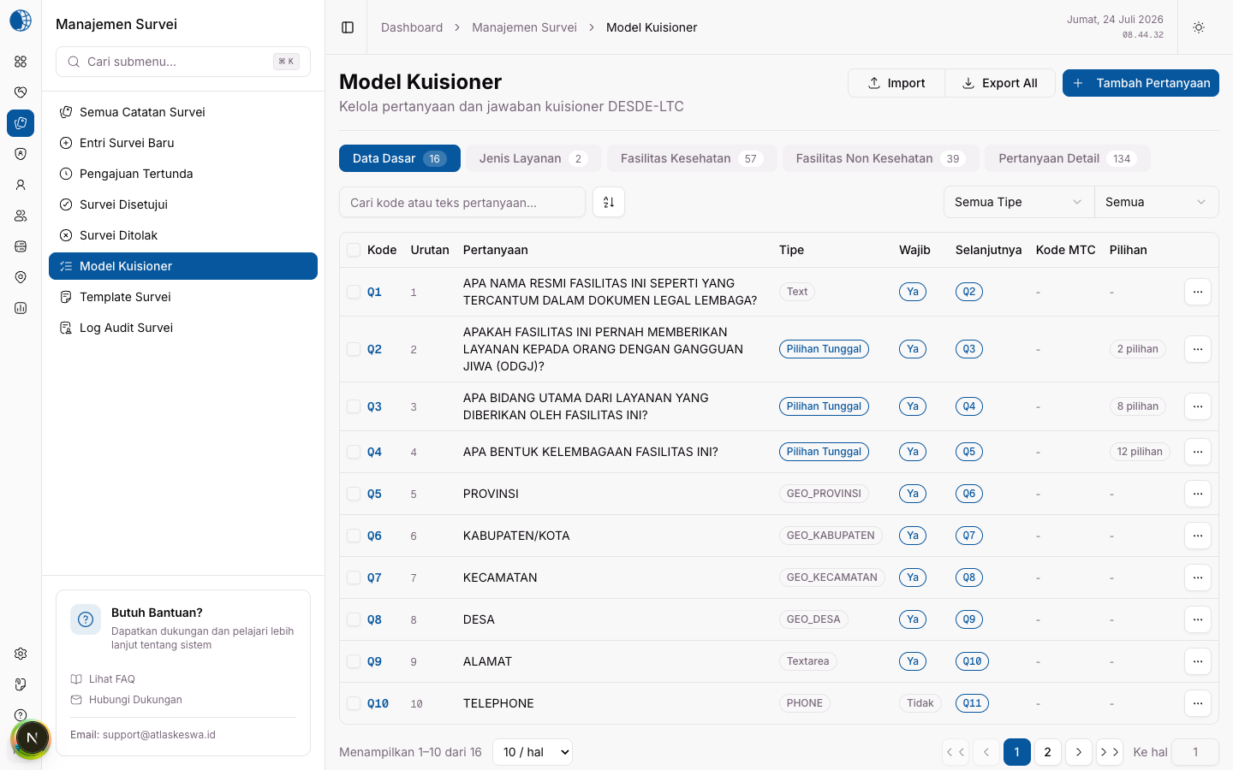
Figure 8. Alpha questionnaire-model list
The template route redirected to the available template detail and rendered the question map for OMMHA_V1 version 1.0. This verifies route resolution and visualisation rendering only.
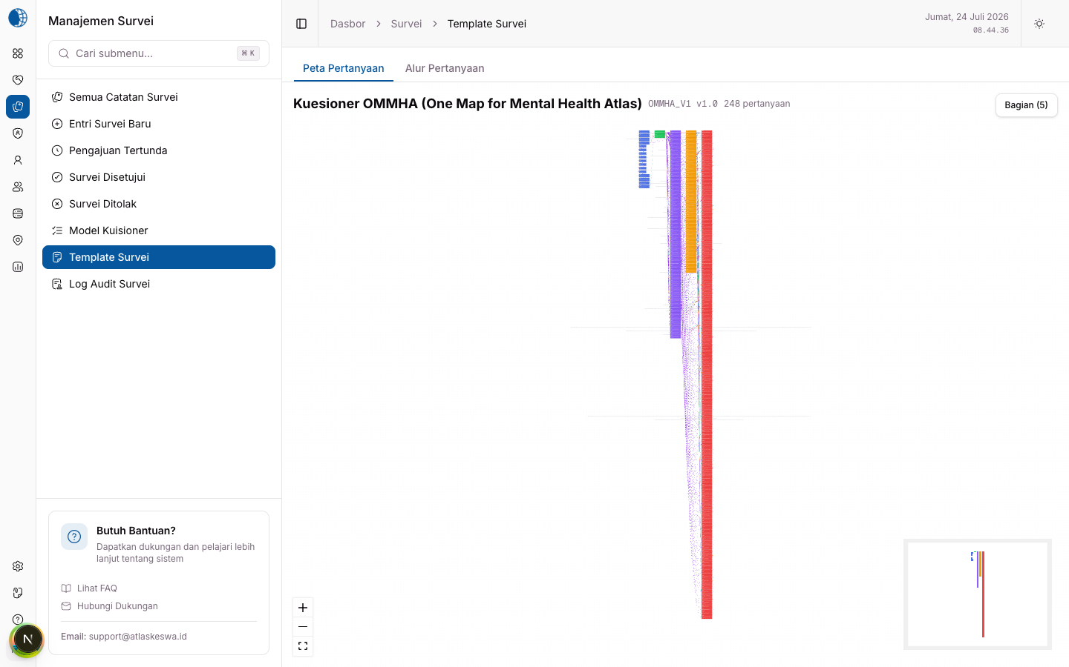
Figure 9. Alpha survey-template question map
The survey audit page rendered historical activity information. No audit entry was modified.
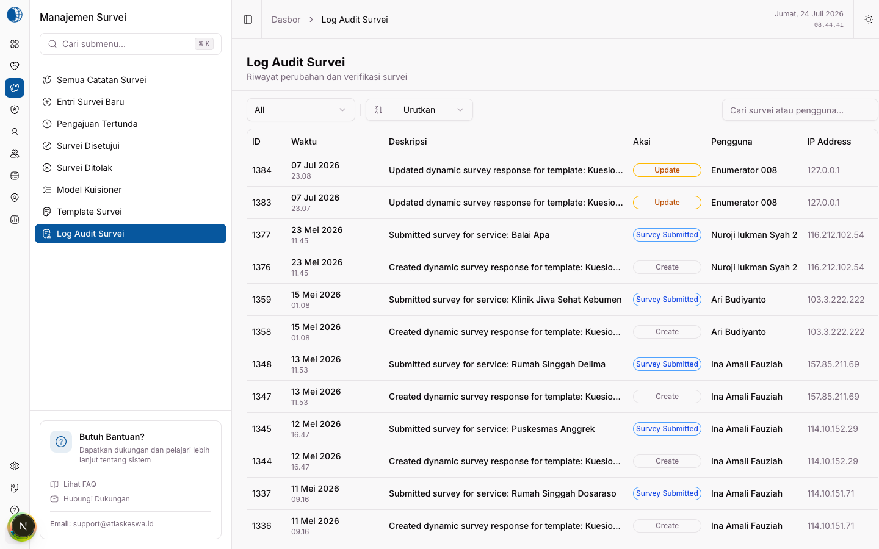
Figure 10. Alpha survey audit log

H. Supporting Modules

1. Service Management
Service Management provides access to service records and reference classifications, including BSIC, MTC, service types, geographic units, and target populations.
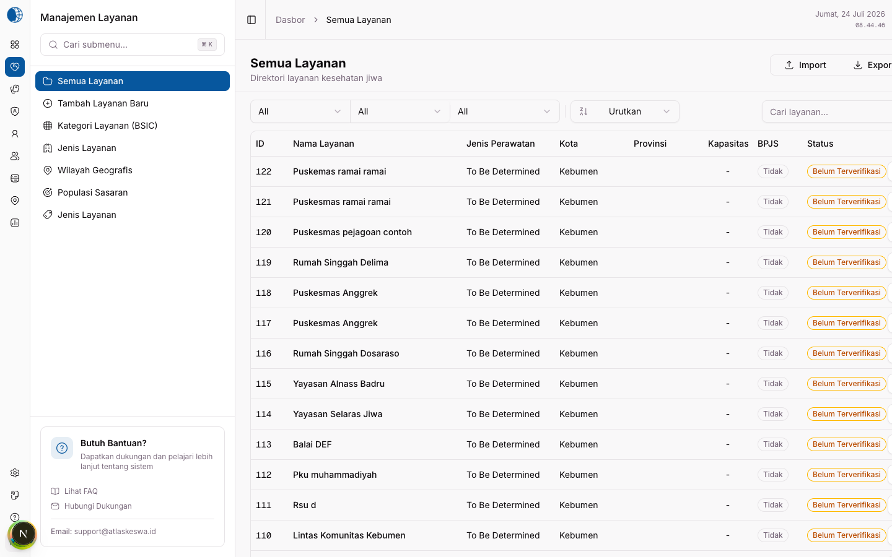
Figure 11. Alpha Service Management page

2. Map and Geospatial Functions
The map route rendered and the map zoom control responded. Heatmap, MTC-layer, regional comparison, and geospatial-upload routes were identified from the Alpha navigation but were not used to mutate or upload data.
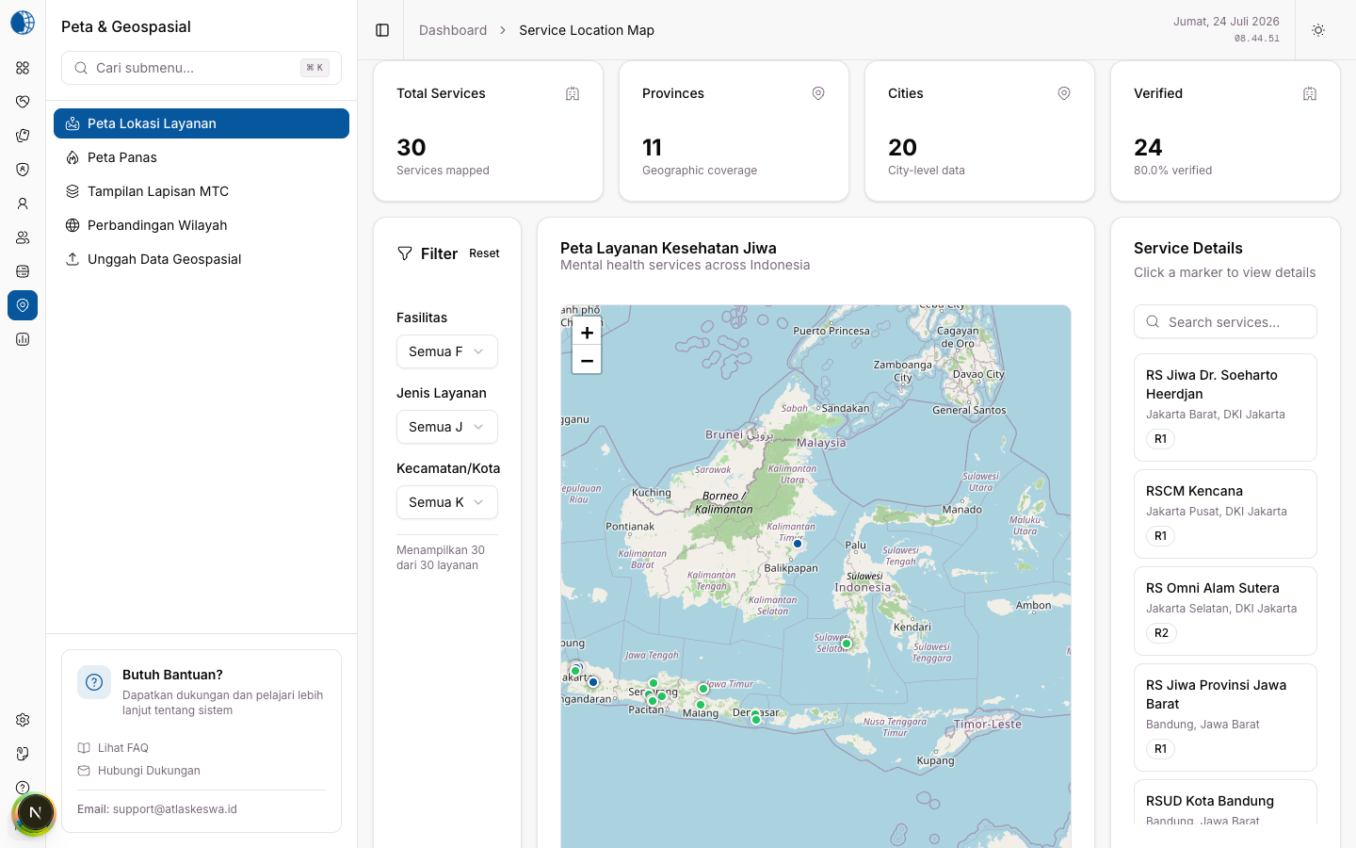
Figure 12. Alpha service-location map

3. Users and Roles
The users page rendered account and role information. Account creation, role changes, password changes, and deactivation were excluded from testing.
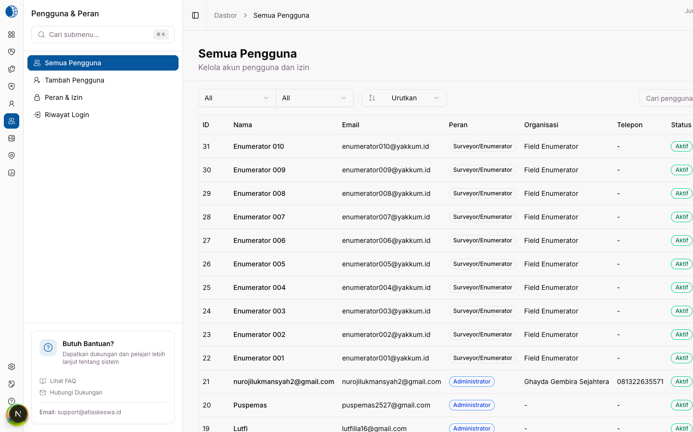
Figure 13. Alpha user-management page

4. Reports and Export
The report-export page rendered its format and scope controls. No export was initiated because that action can create files and activity-log records.
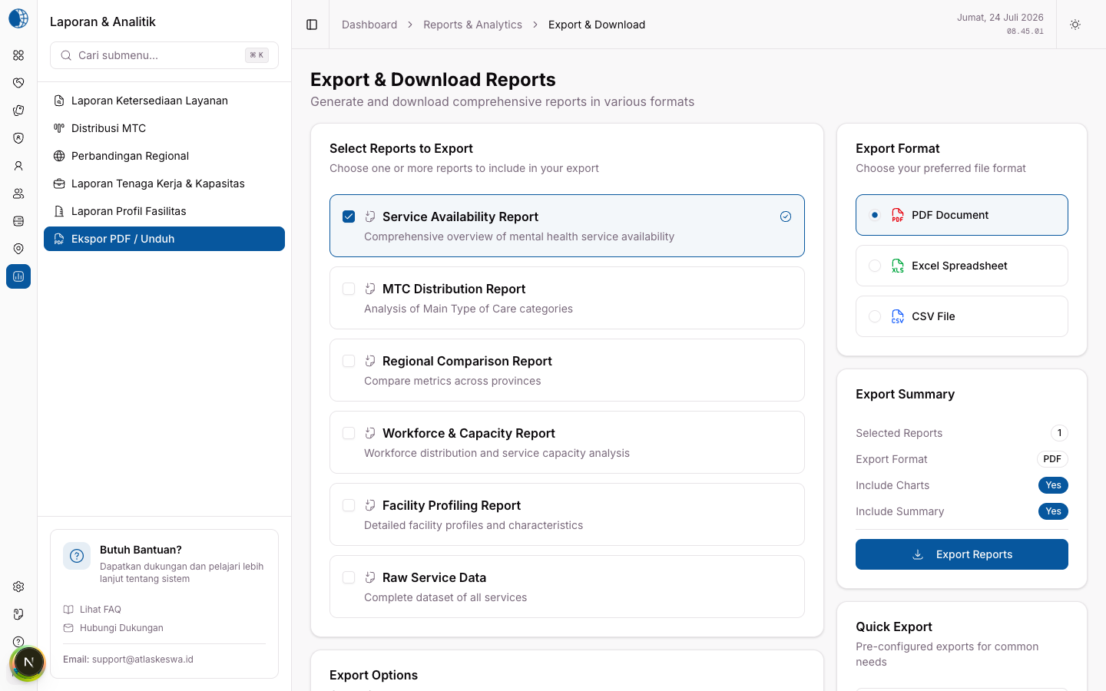
Figure 14. Alpha report and export interface

5. Help and Documentation
The embedded user guide rendered successfully. The Alpha navigation also exposes DESDE-LTC reference material, enumerator guidance, frequently asked questions, and technical support.
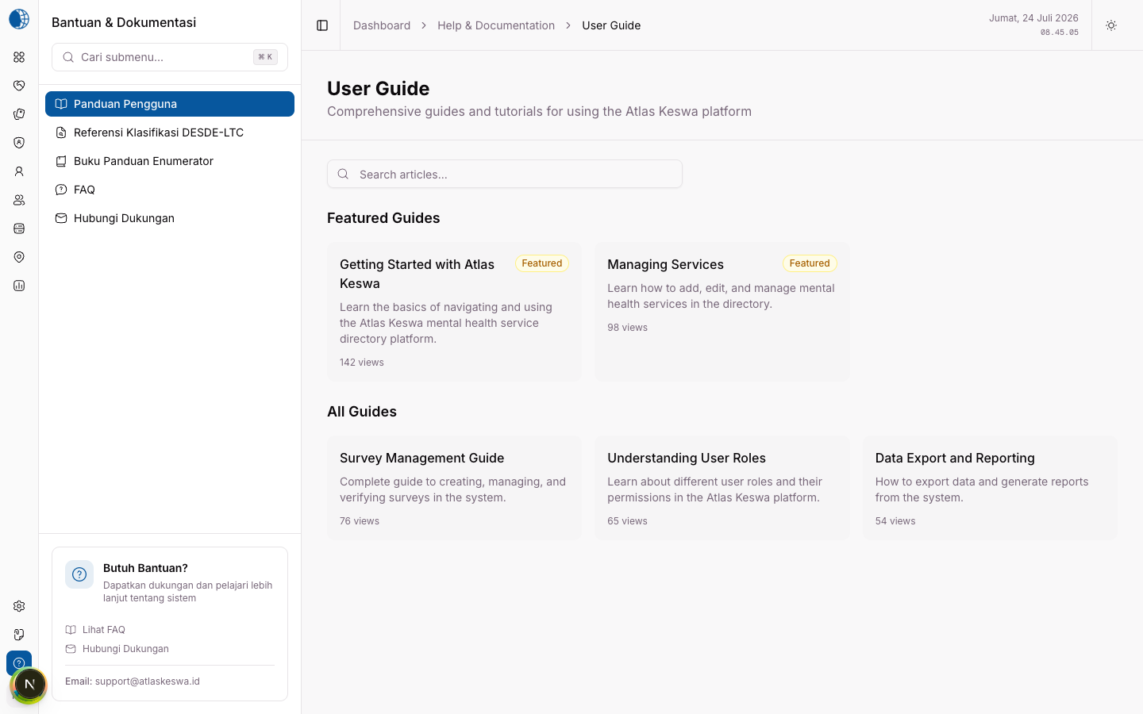
Figure 15. Alpha embedded user guide

I. Functional Verification Results
Fourteen authenticated routes were loaded after a successful login. Each returned HTTP 200, remained on the intended application route (except the expected template-detail redirect), and produced no recorded frontend page error or failed local API response during capture.
Check | Result | Evidence/constraint
Login and redirect | PASS | Existing account authenticated and reached /dashboard
Dashboard summary | PASS | Rendered with live cards, chart, calendar, and light sidebar
Sidebar navigation | PASS | Navigation to Indicators completed
Indicators | PASS | Route rendered without recorded page/API errors
Survey list | PASS | Table and filter controls rendered with data
Survey category filter | PASS | Filter menu opened
Survey sorting interaction | LIMITED | Expected accessible control name not located
New survey route | PASS | Form route rendered; no submission attempted
Pending surveys | PASS | Route rendered; no approval/rejection attempted
Bulk upload | PASS | Interface rendered; no file uploaded
Question-model search | PASS | Search input accepted text
Template visualisation | PASS | Redirected to template 1 and rendered question map
Survey audit | PASS | Route rendered; no record changed
Services | PASS | List route rendered with local data
Map zoom | PASS | Map rendered and zoom control responded
Users | PASS | User list rendered; no account action attempted
Export interface | PASS | Route rendered; no download initiated
Help content | PASS | User-guide content rendered

J. Limitations and Interpretation
- PASS means the historical frontend route or named read-only interaction worked in the isolated local test; it is not a production certification.
- The backend and database were current local copies, not a full database snapshot from 29 June 2026.
- Authentication naturally updates security metadata such as login time and token records; no domain record was intentionally created or changed.
- Create, edit, delete, upload, import, export, approve, reject, password, permission, and settings changes were not exercised.
- Values and dates visible in screenshots reflect the local dataset at capture time.
- Responsive/mobile browser layouts, performance, security, accessibility conformance, and cross-browser compatibility were outside this report.

Appendix 1. Alpha Frontend Feature Matrix
No. | Group | Page or feature | Historical evidence
1 | Dashboard | Summary | Route and screenshot verified
2 | Dashboard | Main Indicators | Route, navigation, and screenshot verified
3 | Dashboard | Service Distribution Map | Present in Alpha navigation
4 | Dashboard | Recent Submissions | Present in Alpha navigation
5 | Dashboard | Verification Queue | Present in Alpha navigation
6 | Survey | All Survey Records | Route, data table, filter, and screenshot verified
7 | Survey | New Survey Entry | Route and screenshot verified; no submission
8 | Survey | Pending Submissions | Route and screenshot verified
9 | Survey | Approved Surveys | Present in Alpha navigation
10 | Survey | Rejected Surveys | Present in Alpha navigation
11 | Survey | Bulk Upload | Route and screenshot verified; no upload
12 | Survey | Questionnaire Models | Route, search input, and screenshot verified
13 | Survey | Survey Templates | Detail redirect, visualisation, and screenshot verified
14 | Survey | Survey Audit Log | Route and screenshot verified
15 | Services | All Services | Route and screenshot verified
16 | Services | Reference Data | BSIC, MTC, types, geography, and target population in navigation
17 | Users | Users and Roles | User-list route and screenshot verified
18 | Data | Tables and Matrices | Present in Alpha navigation
19 | Map | Service Locations | Route, zoom interaction, and screenshot verified
20 | Reports | Report and Export | Route and screenshot verified; no export
21 | System | Settings and Logs | Present in Alpha navigation
22 | Help | User Guide | Route, content, and screenshot verified

K. Conclusion
The OMMHA Alpha frontend at revision fbc83cc provided an integrated dashboard for survey management, service information, analytics, maps, user administration, reporting, system monitoring, and embedded help. Its distinguishing visual characteristic is the light desktop sidebar that preceded the full blue-sidebar redesign.
The isolated historical build authenticated and rendered all representative routes selected for this report. Read-only navigation and interaction checks were successful except for the survey sorting control, which remains Limited. No application-code rollback was performed, and the current Beta report was preserved.
— End of report —

