|  |  |  |  |  |
| --- | --- | --- | --- | --- |
| Method | accuracy | loss | val_accuracy | val_loss |
| resnet50 | 0.5446 | 0.9168 | 0.5492 | 0.9345 |
| vgg19 | 0.8259 | 0.4568 | 0.7951 | 0.5094 |
| Mobilenet | 0.9314 | 0.1625 | 0.9508 | 0.1235 |
| Efficientnet | 0.4292 | 1.0749 | 0.4180 | 1.0731 |
| R-CNN | 0.9730 | 0.0814 | 0.9180 | 0.5545 |

Resnet50:

Classification Report: resnet50

precision recall f1-score support

Crack 0.00 0.00 0.00 54

Pothole 0.71 0.65 0.68 46

Surface Erosion 0.57 0.93 0.71 92

accuracy 0.60 192

macro avg 0.43 0.53 0.46 192

weighted avg 0.45 0.60 0.50 192

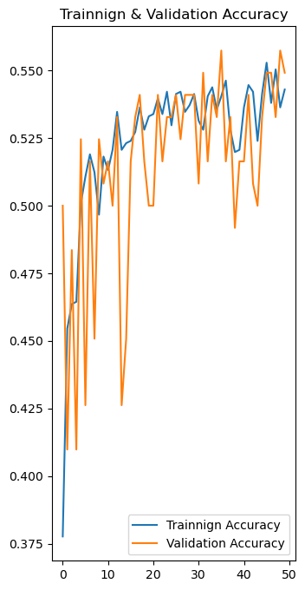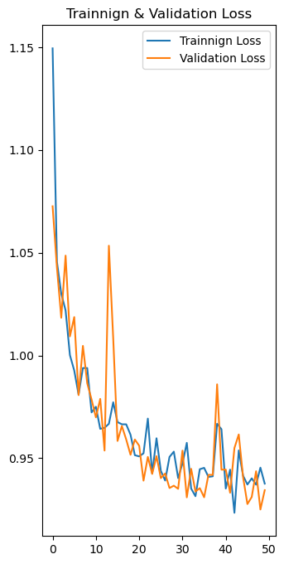

Vgg19:

Classification Report: vgg19

precision recall f1-score support

Crack 0.95 0.78 0.85 68

Pothole 1.00 0.63 0.78 49

Surface Erosion 0.69 0.96 0.80 75

accuracy 0.81 192

macro avg 0.88 0.79 0.81 192

weighted avg 0.86 0.81 0.81 192

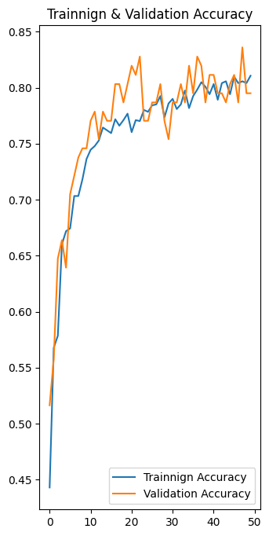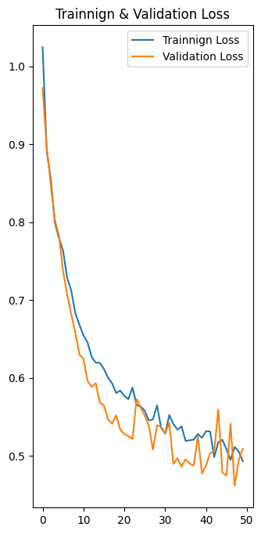

Mobilenet:

Classification Report:

precision recall f1-score support

Crack 0.92 0.95 0.94 63

Pothole 0.89 0.89 0.89 37

Surface Erosion 0.92 0.90 0.91 92

accuracy 0.92 192

macro avg 0.91 0.92 0.91 192

weighted avg 0.92 0.92 0.92 192

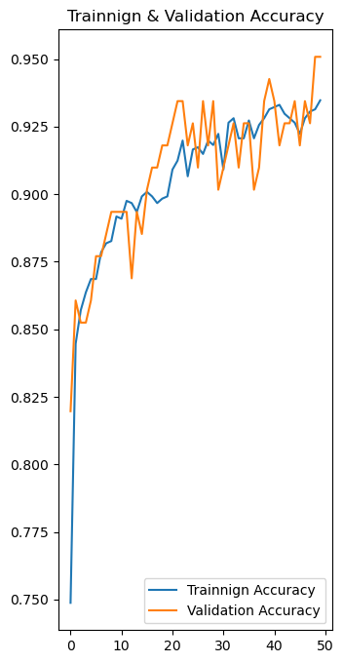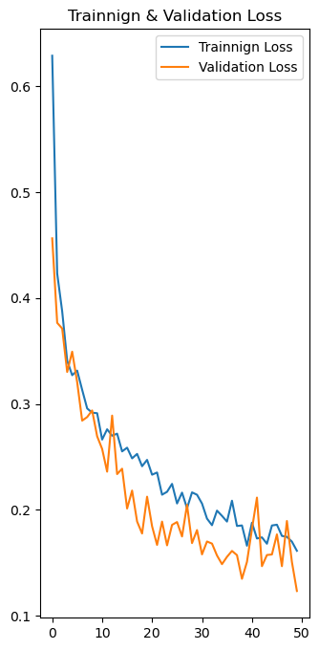

Efficientnet:

Classification Report:

precision recall f1-score support

Crack 0.00 0.00 0.00 65

Pothole 0.00 0.00 0.00 53

Surface Erosion 0.39 1.00 0.56 74

accuracy 0.39 192

macro avg 0.13 0.33 0.19 192

weighted avg 0.15 0.39 0.21 192

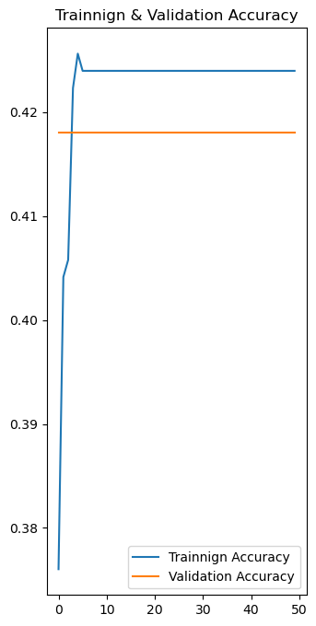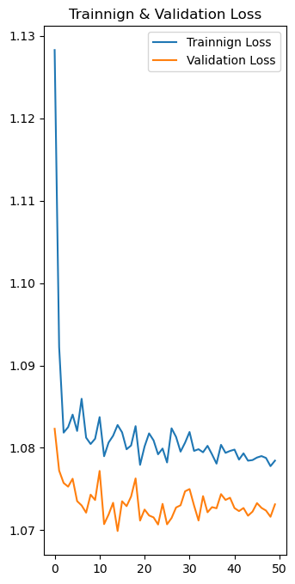

RCNN:

Classification Report:

precision recall f1-score support

Crack 0.97 0.97 0.97 60

Pothole 0.96 0.94 0.95 54

Surface Erosion 0.95 0.96 0.96 78

accuracy 0.96 192

macro avg 0.96 0.96 0.96 192

weighted avg 0.96 0.96 0.96 192

