TECHNICAL REPORT
SAP2000 Model of a 40 m Module of the Muelle de Trasmallo
Port of Cullera (Valencia, Spain) — Independent verification of the CYPECAD analysis reported in Anejo 10 (Cálculos estructurales)
Scope: pile-supported RC deck — 14 precast piles 40×40, 7 inverted-T transverse beams, alveoplaca 25+5 slab
Software: SAP2000 v27.1 (linear static), PyNite (independent check), CYPECAD (reference)
Repository: Masrhalsp/MarshalSp, branch claude/add-drive-file-report-3rybju
September 2026

Contents
Executive summary
1. Introduction and scope
2. Source documents
3. Structural description
4. Back-calculation of the CYPECAD assumptions
5. SAP2000 model idealisation
6. Loads and combinations
7. Sign conventions
8. Verification before SAP2000 execution
9. SAP2000 execution
10. Results and comparison with Anejo 10
11. Discrepancies and limitations
12. Conclusions
Appendix A. Project files

Executive summary
A 40 m structural module of the Muelle de Trasmallo (Port of Cullera) was modelled in SAP2000 v27.1 in order to verify, independently, the CYPECAD analysis documented in Anejo 10 of the project (Apéndice 1 contains the full CYPECAD listing). The model was generated from a single Python parameter file and delivered as a native SAP2000 text import file (.$2k) and as an OAPI script; an identical model was also solved with the open-source PyNite solver before SAP2000 was run.
Reproducing the CYPECAD numbers required identifying four assumptions that CYPECAD actually used but that differ from, or are absent in, the report text. Each was proven numerically from the listing:
- Pile length to fixity 7.25 m (text: 7.00 m), from the global moment balance of Apéndice 1 §3.7 and the head-to-foot moment gradient of each pile.
- Concrete unit weight 24.525 kN/m³ (2.5 t/m³ × 9.81; text: 25 kN/m³), from the self-weight axial increment along the piles.
- Superimposed dead load 1.75 kN/m² (printed as 1.8), from the constant ratio CM/Qa = 0.1167 at every pile.
- The head load of pile P16 is omitted in the CYPECAD load table (confirmed by the ΣQy = −691 kN resultant).
In addition, the deck geometry (4.30 m wide, Y = −0.50 to +3.80 m) and slab continuity over interior frames were back-calculated from the load resultants and the reaction pattern.
Result. After import with zero errors and analysis in SAP2000 v27.1, pile forces agree with CYPECAD within 0.5–3.2 % for all governing ULS, foundation and SLS envelopes; equilibrium totals within 0–1.2 %; transverse-beam bending moments within 0.2–4.9 %; beam shear within 0.2–8.5 % (SAP higher on the land-side face, i.e. conservative). The only notable outlier is the small longitudinal moment Mx at end piles (36 vs 21 kN·m), explained by the rotational continuity of shell elements and again conservative.
Conclusion: the SAP2000 model reproduces the CYPECAD analysis of Anejo 10 to engineering accuracy and can be used as an independent check or as a basis for further design studies.

1. Introduction and scope
The Muelle de Trasmallo is a pile-supported reinforced-concrete quay at the Port of Cullera, Valencia. The structural design (Anejo 10, «Cálculos estructurales») was carried out with CYPECAD on a representative 40 m module separated from neighbouring modules by expansion joints. The objective of this work was to:
- Build an equivalent 3-D model of that module in SAP2000, respecting the true geometry of the beam cross-sections (not a plain 50×55 rectangle).
- Apply exactly the loads and load combinations used in CYPECAD.
- Compare SAP2000 results (reactions, pile forces, beam forces) against the CYPECAD values in Apéndice 1 of Anejo 10.
- Document every assumption and discrepancy.
The analysis is linear-elastic and static. Seismic action is not considered (basic acceleration 0.07g < 0.08g threshold of NCSE-02), nor thermal action (expansion joints). Reinforcement design is outside the scope.

2. Source documents
Document | Content used
Anejo 10 (A10_CALC_ESTRUCTURAS.docx) | §2 description, §6 materials, §7 loads, §9 calculation model, §10 checks
Apéndice 1 of Anejo 10 | Full CYPECAD listing: pile coordinates (§1.8–1.9), head loads (§1.4.5), combinations (§1.6.2), pile forces per load case (§3.3–3.4), resultants (§3.7), beam and slab results (§2)
Figures inside Anejo 10 | Reinforcement drawings used to measure deck width and edge-beam position (pixel scaling against known pile spacing)
Project PDF (1367 pages, Google Drive) | Not machine-readable due to size; dimensions taken from the Anejo figures instead

Every reference value used in the comparison was transcribed from Apéndice 1 together with its source line number and stored in sap2000/ref/cype_reference.json.

3. Structural description

3.1 Geometry
Global axes follow the CYPECAD model: X along the quay, Y across (negative towards the sea), Z upwards.
Item | Value
Frames (transverse axes) | 7, at X = 0, 6.5, 13, 19.5, 26, 32.5, 39 m
Piles | 14 precast 40×40 cm, two rows: Y = 0 (sea) and Y = 3.45 m (land)
Deck | 40.0 × 4.30 m (X = −0.50–39.50; Y = −0.50–+3.80)
Transverse beams | Inverted T 50x55+15x30+15x30 (interior); inverted L 80x55+15x30 (end frames)
Edge beams | 25×30 at Y = −0.375 (sea) and Y = 3.675 (land)
Slab | Precast hollow-core «alveoplaca» 25 + 5 cm topping (PRENOR P-25+5), spanning 6.5 m along X
Pile fixity | Full fixity 7.25 m below deck level (see §4.1)
Bollards | X = 0, 13, 26, 39 on the sea edge
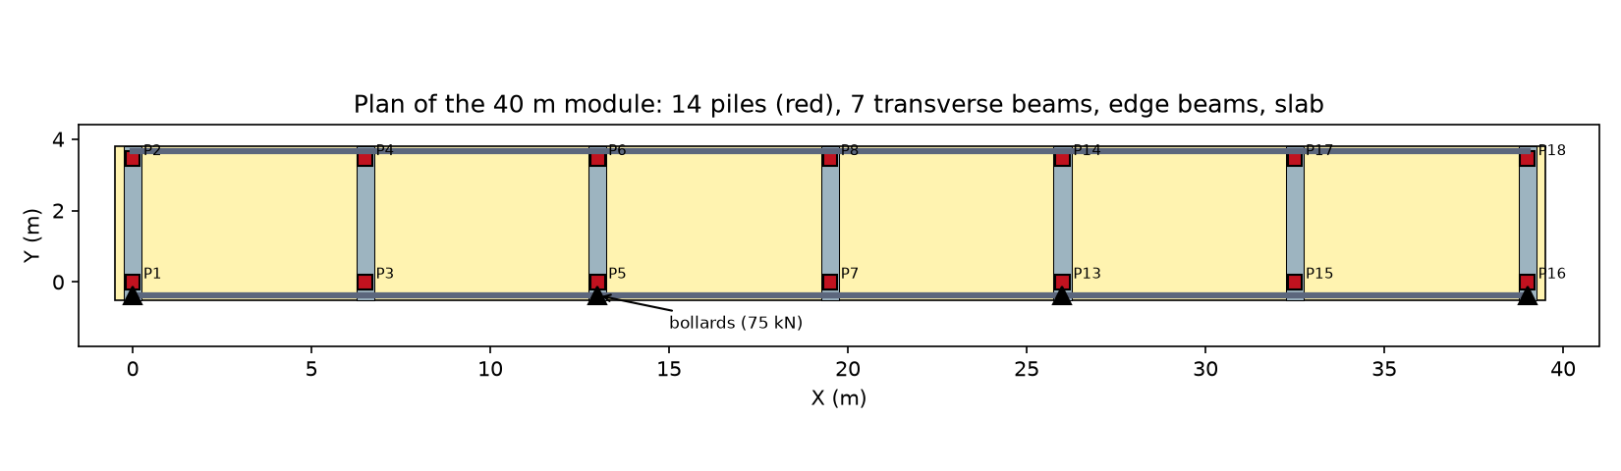
Figure 1 – Plan of the 40 m module: piles, transverse and edge beams, slab mesh and bollards.

3.2 Materials
Material | Use | Ec (MPa) | Note
HA-50 | Precast piles | 33 550 | fck = 50 MPa
HA-35 | Beams, in-situ concrete, topping | 30 669 | fck = 35 MPa
B500SD | Reinforcement | — | Not used in linear analysis

Nominal cover 5 cm. Elastic moduli are those of the CYPECAD listing, which match Ec = 0.9 × 22 000·(fcm/10)^0.3 MPa with fcm = fck + 8 (Eurocode 2 Ecm reduced by 10 % for limestone aggregate): 30 669 MPa for HA-35 and 33 550 MPa for HA-50.

3.3 Basic load cases
Case | Description | Value
PP | Self weight | RC members γ = 24.525 kN/m³ + alveoplaca 4.10 kN/m²
CM | Superimposed dead load | 1.75 kN/m² (see §4.3)
Qa | Uniform live load | 15 kN/m²
TB1 | Bollard pull (horizontal) + wind on stored goods | 75 kN at each bollard; pile-head loads of §1.4.5
TB2 / TB3 | Bollard pull, vertical component | 53 kN down / up

4. Back-calculation of the CYPECAD assumptions
A first model built strictly from the report text gave differences of 10–20 % at several piles. Because the objective is a like-for-like verification, the CYPECAD listing itself was used to identify the assumptions the program actually applied. Each finding below is supported by at least one closed-form check.

4.1 Pile length to fixity: 7.25 m
Section 9.1 of Anejo 10 states a fixity depth of 7.00 m below the deck. However, static equilibrium of the §3.7 resultants for load case TB1 (moments about the X axis at pile-foot level) reads:
My = Σ(Ni·yi) + ΣMy,i + ΣQy,i·z (1)
With ΣN·y = −703.8 kN·m, ΣMy = −150 kN·m, ΣQy = −691 kN and the reported resultant My = −5864 kN·m:
z = (5864 − 703.8 − 150) / 691 = 7.25 m (2)
Two further confirmations: the listing prints «Tramo 0.000/7.250 m» and «Altura libre 6.70 m»; and, for pile P1 under TB1, the linear moment diagram M(z) = Mfoot − Q·z gives a distance between the foot and head sections of (177.9 + 169.7)/51.9 = 6.70 m. The top 0.55 m of the pile (= beam depth) is therefore a rigid zone inside the beam. The model uses PILE_LENGTH = 7.25 with a 0.55 m rigid end offset.

4.2 Concrete unit weight: 24.525 kN/m³
The self-weight axial force increases by 26.2–26.3 kN between head and foot of every pile. This is the weight of a 6.70 m length of a 0.16 m² section:
γ = W / (A·L) = 26.3 / (0.16 × 6.70) = 24.5 kN/m³ (3)
i.e. 2.5 t/m³ × 9.81 m/s² = 24.525 kN/m³; the text value of 25 kN/m³ would give 26.8 kN.

4.3 Superimposed dead load: 1.75 kN/m²
CM and Qa are applied over the same area, so their pile reactions must be proportional. The ratio N(CM)/N(Qa) is 0.1167 at every pile (e.g. P3: 27.5/235.7), hence qCM = 0.1167 × 15 = 1.75 kN/m². Consistently, ΣCM/qCM = 297.5/1.75 = 170.0 m² = ΣQa/qQa = 2550.1/15. The parameter Q_CM can be set to 1.80 for design (+0.3 % on ULS loads).

4.4 Missing head load at pile P16
The pile-head load table (§1.4.5, wind on stored goods, 34 kN per pile and 17 kN at end piles plus a ±34 kN vertical couple) has no entry for P16, whereas its symmetric counterpart P1 carries 17 kN. The §3.7 resultant ΣQy = −691 kN is only obtained without it. The omission is reproduced (ADD_MISSING_P16_LOAD = False) for comparison purposes.

4.5 Deck width and eccentricity
For Qa, the centroid of the loaded area lies at y = My/N = 4193.6/2550.1 = 1.644 m, which matches a deck from Y = −0.50 to +3.80 m (centre 1.65 m) and not the narrower deck initially assumed (centre ≈ 1.50 m). Measurements on the reinforcement drawings confirmed this extent, with the land edge beam at Y = 3.675 m. With this geometry the land-row pile reactions moved from −10 % to within 1–3 %.

4.6 Slab continuity
With a simply-supported slab the end frames attracted about 20 % more load than in CYPECAD. The pile reactions follow instead the pattern of a continuous multi-span beam (end support ≈ 0.394·qL, first interior ≈ 1.132·qL, others ≈ 1.0·qL), and the alveoplaca listing reports a hogging support moment of −100.32 kN·m/m. The slab was therefore modelled continuous over interior beams and pinned at the end beams.

5. SAP2000 model idealisation
All data are defined once in sap2000/model/trasmallo.py. The same object feeds the .$2k writer, the OAPI script and the PyNite verification model, which guarantees that the three are identical.

5.1 Mesh and connectivity
Entity | Count | Remarks
Joints | 1134 | 14 pile feet at Z = 0; deck grid at Z = 7.25
Piles | 14 | 40×40, fixed base (6 DOF restrained)
Transverse beam segments | 105 | 7 frames × 15 segments
Edge beam segments | 156 | 2 × 78
Shell elements (slab) | 1014 | Shell-Thin, 0.5 m along X

Mesh lines in Y: −0.375 (edge beam), −0.20 (pile face), 0 (pile axis), 0.20 (pile face), 0.25, six divisions to 3.20, 3.25 (pile face), 3.45 (pile axis), 3.675 (edge beam). Lines at the pile faces are required to read beam moments and shears at the design sections.

5.2 Rigid zones and modifiers
- Pile: rigid end offset 0.55 m at the top (flexible length 6.70 m).
- Transverse beams: 0.20 m rigid zone on each side of a pile axis; segments wholly inside a pile have stiffness modifiers ×100.
- Edge beams: rigid zone equal to half the web width of the transverse beam at intersections.
- Pile axial stiffness modifier AMod = 2 (CYPECAD «coeficiente de rigidez axil 2.00», simulating construction sequence).
- Weight modifiers to avoid double counting of concrete: piles 6.70/7.25 = 0.924; edge beams (39 − 5×0.50 − 2×0.295)/39 = 0.921.
- Rigid diaphragm constraint on all deck-level joints (CYPECAD «forjado rígido»).

5.3 Beam cross-sections
The CYPECAD designation 50x55+15x30+15x30 describes an inverted T: a 50 cm wide, 55 cm deep web with a 15 × 30 cm ledge on each side at the bottom, on which the alveoplaca units bear. Properties were computed by decomposition into rectangles:
A = 0.80·0.30 + 0.50·0.25 = 0.365 m² (4)
ȳ = ΣAi·yi / ΣAi = (0.240·0.15 + 0.125·0.425)/0.365 = 0.244 m (5)
I33 = Σ(bi·hi³/12 + Ai·di²) = 0.00393 + 0.00474 = 0.00867 m⁴ (6)
Equation (6) is the parallel-axis (Steiner) theorem. The inverted T is 25 % stiffer than a 50×55 rectangle (I = 0.00693 m⁴), which is why the plain rectangle was rejected.
The torsion constant was obtained by solving the Prandtl stress-function problem ∇²φ = −2 in the section with φ = 0 on the boundary, by finite differences on a 2.5 mm grid, and J = 2∫φ dA. The method reproduces the exact value for a 40×40 square (0.1406a⁴ = 0.0035994 m⁴) to within 0.01 %. The shear area follows from the energy (Jourawski) method, As = I² / ∫(Q(y)/b(y))² dA, which returns exactly 5A/6 for a rectangle.
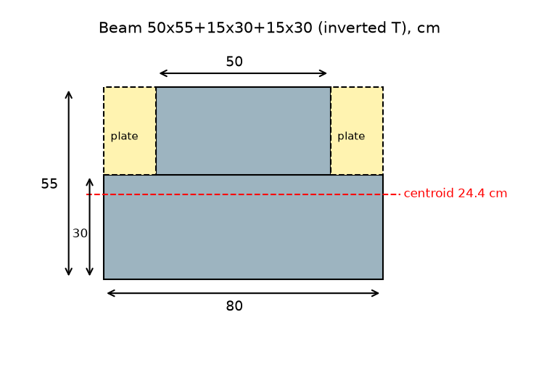
Figure 2 – Inverted-T transverse beam with alveoplaca units bearing on the ledges.
Section | CYPECAD name | A (m²) | I33 (m⁴) | I22 (m⁴) | J (m⁴)
Inverted T (interior frames) | 50x55+15x30+15x30 | 0.365 | 0.008667 | 0.015404 | 0.015461
Inverted L (end frames) | 80x55+15x30 | 0.485 | 0.012067 | 0.032762 | 0.028245
Edge beam | 25x30 | 0.075 | 0.000563 | 0.000391 | 0.000779
Pile | 40x40 | 0.160 | 0.002133 | 0.002133 | 0.003599

5.4 Alveoplaca slab
The slab is represented by Shell-Thin elements of 0.30 m thickness in HA-35 with local axis 1 along X (span direction). The manufacturer’s flexural stiffness EI = 63 550 kN·m²/m is matched through a bending modifier:
D = E·t³/12 = 30 669 000 × 0.30³/12 = 69 005 kN·m²/m; m11 = 63 550/69 005 = 0.921 (7)
Precast units have practically no transverse bending or twisting stiffness, so m22 = m12 = 0.01 (one-way behaviour). The first and last strip of elements (0.5 m next to the end beams) use m11 × 0.01 to emulate the simple support assumed by CYPECAD; lower factors were avoided because they also suppress shear transfer in thin shells. The shell self-weight is switched off (WMod = 0) and the actual unit weight of 4.10 kN/m² is applied as an area load on the real footprint of the units.

6. Loads and combinations

6.1 Load application
- Area loads CM and Qa on all shell elements; the 0.125 m strips outside the edge-beam axes and the 0.50 m strips behind the end beams are applied as line loads w = q·b (e.g. Qa: 15 × 0.125 = 1.875 kN/m). Total loaded area 40 × 4.30 = 172 m².
- Bollard pull: 75 kN towards the sea applied 0.5 m above deck, transferred to the deck joint as a force plus a moment M = r × F, giving Mx = −rz·Fy = −0.5 × (−75) = +37.5 kN·m.
- Pile-head loads of Apéndice 1 §1.4.5 (all 25 rows), mapped to SAP joint loads with the sign transformation of §7.

6.2 Combinations
Combinations follow the Spanish Código Estructural (Eurocode-consistent) format:
Ed = ΣγG·Gk + γQ,1·Qk,1 + ΣγQ,i·ψ0,i·Qk,i (8)
Example (ULS 8, bollard leading): 1.35PP + 1.35CM + 1.05Qa + 1.5TB1. All 52 combinations were transcribed verbatim from Apéndice 1 §1.6.2 and checked coefficient by coefficient by an independent reviewer; an envelope was defined for each family.
Family | Number | Partial factors | Use
ELU (ULS) | 22 | G 1.35/1.00; Q 1.50; ψ0 0.7 (live) / 0.6 (bollard) | Concrete design
CIM (foundation) | 22 | G 1.60/1.00; Q 1.60 | Pile / foundation design
ELS (SLS) | 8 | All 1.00 | Serviceability

7. Sign conventions
CYPECAD reports pile forces in local pile axes (coincident with global axes), N positive in compression, Mx paired with Qx and My with Qy, and foot forces as the action of the pile on the foundation. SAP2000 reports reactions as support-on-structure forces in global axes, and frame forces on the positive face; note that a positive M2 compresses the +3 face while a positive M3 compresses the +2 face. The following mapping was derived and verified by reproducing all §3.7 resultants for the six load cases:
SAP2000 quantity | CYPECAD equivalent
Pile-foot reaction (F1, F2, F3, M1, M2, M3) | N = F3, Qx = −F1, Qy = −F2, Mx = −M2, My = M1, T = −M3
Pile internal forces (P, V2, V3, T, M2, M3) | N = −P, Qx = V2, Qy = V3, Mx = M3, My = +M2, T = T
Transverse beam | M (sagging +) = M3, V = −V2
CYPECAD head load (N, Mx, My, Qx, Qy, T) | SAP joint load = (Qx, Qy, −N, −My, Mx, T)

8. Verification before SAP2000 execution
- PyNite model. The identical model was solved with the open-source PyNite 3-D frame/plate solver and used to test each calibration hypothesis of §4.
- Independent reviews. Four separate reviews covered: the .$2k file format (against 36 real SAP2000 exports, v16–v26); OAPI calls (against CSI documentation and a mock SAP object checking argument count and order); structural engineering (sections, loads, combinations); and sign conventions (against the CSI Analysis Reference). Issues found and corrected include the My sign in the SAP path and missing mesh lines at pile faces (beam shear 8 % low).
- File checker. check_s2k.py verifies referential integrity, ASCII content and load totals of the .$2k file without SAP2000.

9. SAP2000 execution
A first import into SAP2000 v27.1 of a v20-format file aborted with 27 errors, all related to steel-design table keys that the version converter could not find (unrelated to model data). The writer was updated to the v27 table format (e.g. S33Top/S33Bot/S22Left/S22Right field names, no CaseType in combinations). The second import completed with 0 errors and 4 harmless warnings (CoupModType fields for nonlinear concrete, irrelevant to linear analysis): 1134 joints, 275 frames, 1014 shells and 230 combination rows. The linear static analysis ran in a few seconds. The «Joint Reactions» and «Element Forces – Frames» tables were exported to Excel and processed by compare_sap_tables.py.

10. Results and comparison with Anejo 10
Differences are computed as (SAP − CYPE)/|CYPE| × 100. All CYPE values are taken from Apéndice 1 of Anejo 10.

10.1 Global equilibrium
Load case | SAP2000 (kN) | CYPE §3.7 (kN) | Difference
PP | 1355.2 | 1343.9 | +0.8 %
CM | 301.0 | 297.5 | +1.2 %
Qa | 2580.0 | 2550.1 | +1.2 %
TB1 (horizontal) | 691.0 | 691.0 | 0.0 %
TB2 | 212.0 | 212.0 | 0.0 %

The +1.2 % on CM and Qa reflects the loaded area (172 m² in SAP vs 170 m² in CYPE, §4.3); PP differs slightly for the same reason and because of alveoplaca footprint details.

10.2 Pile forces – envelopes
Quantity | Pile (comb.) | SAP2000 | CYPE | Diff.
ULS max. compression N | P3 (10) | 680.7 kN | 673.9 kN | 1.0 %
ULS max. tension N | P2 (5) | −131.7 kN | −136.1 kN | 3.2 %
ULS max. foot moment |My| | P3 (8) | 281.9 kN·m | 283.4 kN·m | 0.5 %
Foundation (CIM) max. N | P3 | 748.5 kN | 741.2 kN | 1.0 %
SLS max. N | P3 | 526.6 kN | 521.7 kN | 0.9 %
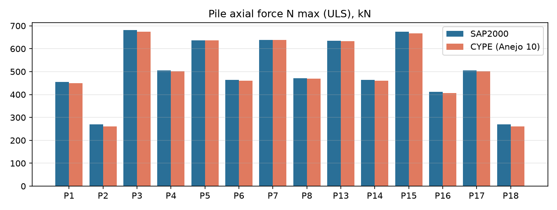
Figure 3 – Maximum ULS axial force in the 14 piles: SAP2000 vs CYPECAD.
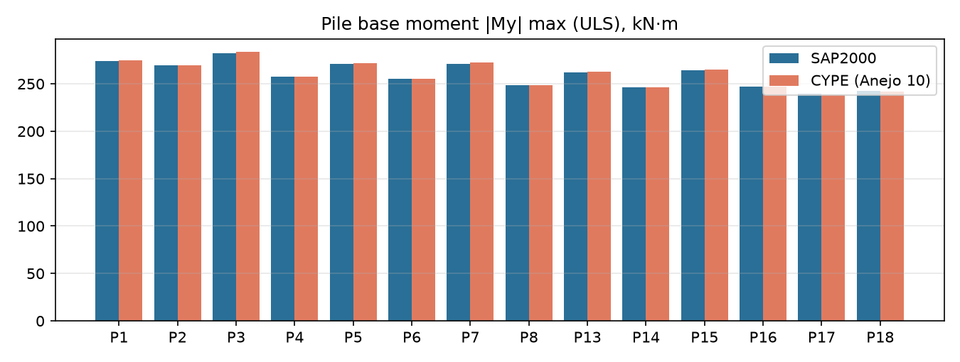
Figure 4 – Maximum ULS pile-foot moment: SAP2000 vs CYPECAD.

10.3 Pile forces – individual load cases
All 14 piles × 6 load cases × 6 components (504 values) were compared. Example for pile P3:
Load case | N SAP | N CYPE | My SAP | My CYPE
PP | 112.6 | 112.3 | −3.8 | −3.9
CM | 27.9 | 27.5 | −1.4 | −1.5
Qa | 239.1 | 235.7 | −12.0 | −13.0
TB1 | 147.0 | 146.2 | −174.8 | −175.0
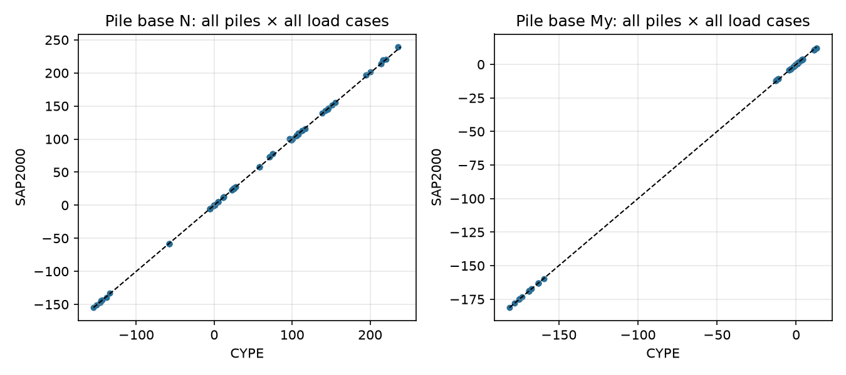
Figure 5 – Scatter of all pile-foot N and My values (each point = one pile, one load case); dashed line = perfect 1:1 agreement.

10.4 Transverse beams (ULS envelope)
Quantity | Difference vs CYPE
Hogging moment at sea-side pile face | 0.7 – 3.6 %
Sagging moment in span | 0.2 – 4.9 %
Shear at sea-side pile face | −2.6 to +1.4 %
Shear at land-side pile face | +4 to +8.5 % (SAP higher, conservative)
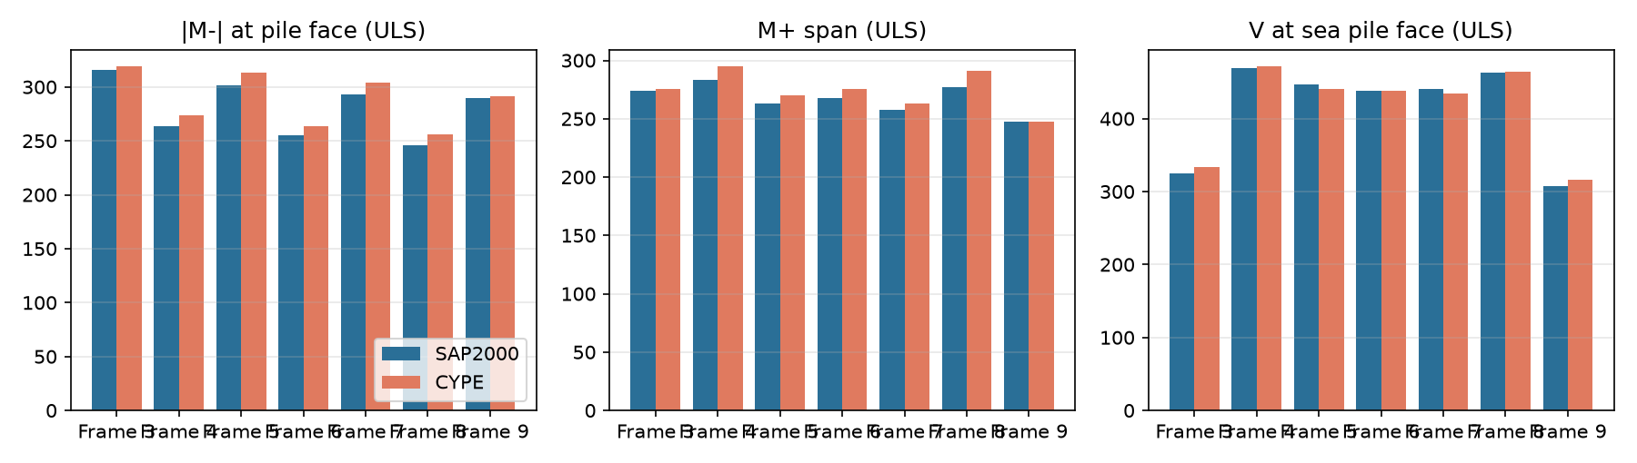
Figure 6 – Transverse beams of the 7 frames: hogging moment, sagging moment and shear.
The complete comparison (8 sheets, 21 charts) is in sap2000/output/Comparacion_SAP2000_vs_CYPE.xlsx.

11. Discrepancies and limitations
- End-pile longitudinal moment Mx (P16: 36 vs 21 kN·m). Shell elements share rotational DOFs with beams and pile heads, whereas CYPECAD alveoplaca units merely bear on the beams. The moment is small (~10 % of the governing pile moment) and conservative.
- Loaded area 172 m² vs 170 m² (+1.2 % load). The location of the 2 m² not loaded in CYPECAD could not be identified; probably next to the end beams.
- Slab moments are not directly comparable, because CYPECAD applies redistribution and minimum positive moments in the alveoplaca envelope. Slab shears do agree (72.6 / 107.9 vs 71.9 / 105.5 kN/m).
- Summary reactions in the Anejo text (400/125 kN SLS, 590/220 kN ULS) cannot be reproduced from the Apéndice 1 listing and appear to belong to a different run; the comparison is made against the listing.
- Drawings were not machine-readable; dimensions measured on Anejo figures may carry errors of a few centimetres.
- Pile model: equivalent fixity at 7.25 m, as in CYPECAD. A refined model with lateral soil springs along the full 15 m pile (subgrade moduli of Anejo 4) is recommended as further work.

12. Conclusions
- A SAP2000 v27.1 model of the 40 m Trasmallo module was built with the true inverted-T/L beam sections, an orthotropic alveoplaca slab, rigid zones, rigid diaphragm and all 52 CYPECAD combinations.
- Four implicit CYPECAD assumptions (7.25 m pile length, 24.525 kN/m³, CM 1.75 kN/m², P16 head load omitted) and the deck geometry were identified and proven numerically from the listing.
- The model imported with zero errors; results agree with Anejo 10 (Apéndice 1) within 0–5 % for all governing quantities, with the few larger differences on the conservative side.
- The model is parametric: text values (7.00 m, 25 kN/m³, 1.80 kN/m², P16 load) can be restored by changing single parameters in trasmallo.py for design use.

Appendix A. Project files
Path | Content
report/ | Anejo 10 (Word), screenshot, link to project PDF
sap2000/model/trasmallo.py | Single source of model data
sap2000/model/sections.py | Section property calculator (A, I, J by Prandtl FD, shear areas)
sap2000/output/Muelle_Trasmallo_40m.$2k | SAP2000 v27 import file
sap2000/tools/write_s2k.py | .$2k writer (--version, --decimal options)
sap2000/tools/sap_oapi_run.py | Builds and runs the model through the CSI OAPI
sap2000/tools/verify_pynite.py | Independent PyNite model
sap2000/tools/compare_sap_tables.py | Compares exported SAP tables with CYPE
sap2000/tools/excel_report.py | Builds the Excel comparison workbook
sap2000/output/Comparacion_SAP2000_vs_CYPE.xlsx | Comparison tables and charts
sap2000/ref/cype_reference.json | CYPE reference values with source line numbers
sap2000/resultados_sap/ | Actual SAP2000 v27.1 exported results
documentacion/ | Persian explanatory document, figures and this report

