DESIGN REPORT
Reinforced-Concrete Design of a 40 m Module of the Muelle de Trasmallo to the Spanish Código Estructural
Port of Cullera (Valencia, Spain) — Verification of piles, transverse beams and edge beams with SAP2000 v27.1 forces, final design, and comparison with the CYPECAD design of Anejo 10
Code: Código Estructural 2021 (RD 470/2021), Anejo 19 = EN 1992-1-1 with the Spanish values; exposure XS3
Members: 14 precast piles 40×40 HA-50, 5 inverted-T and 2 inverted-L transverse beams, 2 edge beams 25×30 (HA-35, B500SD)
Tools: SAP2000 v27.1 (forces), Python fibre-section engine (checks), CYPECAD (reference design)
Repository: Masrhalsp/MarshalSp, branch claude/add-drive-file-report-3rybju, folder diseno/
September 2026

Contents
Executive summary
1. Introduction and scope
2. Design basis
3. Reinforcement provided in Anejo 10
4. Method of verification
5. Piles
6. Transverse and edge beams
7. Final design
8. SAP2000 concrete design: inputs and expected behaviour
9. Comparison with Anejo 10 (CYPECAD)
10. Limitations and open points
11. Conclusions
Appendix A. Files and commands
Appendix B. Clause index
Notation
η = utilisation (demand/capacity; a check passes when η ≤ 1). CUMPLE / NO CUMPLE = passes / fails (the Spanish words are kept in the tables and figures). ψ0, ψ2 = combination and quasi-permanent factors. Qa = uniform quay live load; TB1–TB3 = bollard-pull load cases. ELU/ELR = ULS combinations of the CYPE / ROM basis; ELS = characteristic combinations; QP = quasi-permanent combination. Eje = axis; pórtico = CYPECAD frame; cabeza / pie / arranque = pile head / foot / fixity section; alma / alas = web / ledges; cerco / rama = closed tie / single leg; c/100 = at 100 mm centres; alveoplaca = precast hollow-core slab plate.

Executive summary
This report checks the reinforced-concrete members of the 40 m module of the Muelle de Trasmallo (Port of Cullera) against the Spanish Código Estructural (CE 2021). Anejo 19 of the CE is EN 1992-1-1 with the Spanish values written into the text. The internal forces are those of the SAP2000 v27.1 model described in the companion report (documentacion/02_Technical_Report_EN.docx). That model reproduces the CYPECAD analysis of Anejo 10 within 0–5 %. The reinforcement checked is the one on the Anejo 10 drawings and listings. All files are in the repository folder diseno/.
Scope. The work answers seven questions:
- Required pile reinforcement for axial force and biaxial bending, first and second order.
- Design of the transverse-beam and edge-beam reinforcement.
- As required against As provided, section by section.
- Resistance of the RC sections: N-M interaction, bending, shear and torsion.
- Crack control for exposure class XS3 (wmax = 0.1 mm).
- Shear design with the provided transverse reinforcement, including the suspension steel for the hollow-core plates that bear on the beam ledges.
- A final design to the Código Estructural, with the changes needed.
Method. Section resistances come from a fibre-section engine written for this project. Run with CYPECAD’s own conventions, it reproduces every capacity printed in Anejo 10 exactly (0.00 %). The formula validation gives 151 PASS and 0 FAIL (plus 25 information rows), and all 279 parity rows pass (203 for piles, 76 for beams). The verdict is then computed strictly to the code text (“Mode.CODIGO”) with the load basis recommended for port works, ROM 2.0-11 (ψ0,Qa = 1.0, ψ2,Qa = 0.8). The Anejo 10 basis (ψ2,Qa = 0.3, a building value from the CTE) is kept for parity and as a sensitivity case.
Final design. Table 1 lists the final reinforcement of each member group, the change from Anejo 10 and the governing utilisation.
Table 1 – Final design (verdict case ROM basis, Mode.CODIGO, XS3).
Element | Final reinforcement | Change vs Anejo 10 | Governing η | Verdict
Piles P1–P18 (14) | 12Ø25; 3 ties Ø10 c/150, c/100 in the top 0.40 m; fixity section 1eØ8 | ties tightened at the head (confinement, A19.7.2(2)), +2.8 kg/pile | 0.987 (N-M 2nd order, P3 head, ELR08) | CUMPLE (with confinement ties)
Inner beams, axes 2–6 | top 5Ø20; bottom 8Ø20 web + 4Ø16 ledges (33.18 cm²); sides 2+2Ø10; links Ø10 c/100 (3 legs + ledge hoop) | bottom 7Ø20 (21.99 cm²) → 8Ø20 + 4Ø16; 32.1 → 40.8 kg/m | 0.962 (wk = 0.096 mm at ψ2 0.8) | CUMPLE
End beams, axes 1 and 7 | top 5Ø20; bottom 5Ø20 + 1Ø20 | none (if the plates bear on the ledge: top 4Ø25) | 0.973 (torsion tension chord) | CUMPLE
Edge beams 25×30 | top 3Ø25 over the supports; bottom 2Ø16; tie Ø8 c/150 | top 2Ø16 → 3Ø25 (wk 0.067 mm) | 0.872 (link spacing) | CUMPLE (conditional, F5)
Key results
- Piles (12Ø25): all ULS checks pass in every basis. The governing N-M second-order utilisation is η = 0.987, at the head of P3 in the ROM basis. The required steel is 58.43 cm² against 58.91 cm² provided, so 12Ø25 is both necessary and sufficient. Shear gives η = 0.814. The piles stay uncracked under the quasi-permanent combination.
- Pile stresses: the characteristic concrete stress limit σc ≤ 0.6·fck is exceeded at the heads of P1, P2, P3 and P16. The worst ratio is 1.109 with the short-term Ecm and 0.966 with the creep-weighted Ec,eff. The final design confines the pile heads with ties Ø10 at 100 mm over the top 0.40 m.
- Inner transverse beams (axes 2–6): ULS bending (max 0.88), shear including the suspension steel (max 0.72) and deflection pass. Crack control fails with ψ2,Qa = 0.8: wk = 0.155–0.172 mm > 0.1 mm. The provided 7Ø20 bottom steel passes only for ψ2,Qa ≤ 0.58–0.70. The bottom steel becomes 8Ø20 web + 4Ø16 ledges (33.18 cm²), which gives wk = 0.096 mm.
- End beams (axes 1, 7): they pass with the provided steel. The governing check is the torsion tension chord, η = 0.973.
- Edge beams 25×30: they fail crack control under the SAP load sharing, with wk = 0.31 mm at the supports. The top steel over the supports becomes 3Ø25, giving wk = 0.067 mm. This change depends on the SAP load-sharing model.
Conclusion. With three changes the module meets the Código Estructural at ULS and at SLS for exposure XS3, under the ROM 2.0-11 port load basis. The changes are confinement ties at the pile heads, stronger bottom steel in the inner beams and 3Ø25 top bars in the edge beams. With the Anejo 10 assumption ψ2,Qa = 0.3, the original inner-beam steel passes, as CYPECAD found. The difference comes from the quasi-permanent factor of the quay load, not from an error in the analysis. The pile stress limit does not depend on the basis, and CYPECAD did not check it.

1. Introduction and scope
The Muelle de Trasmallo is a pile-supported reinforced-concrete quay. Its structural design (Anejo 10, “Cálculos estructurales”) was made with CYPECAD on a 40 m module between expansion joints. A previous stage of this work built an equivalent SAP2000 v27.1 model and verified it against the CYPECAD listing. This stage uses the SAP2000 forces to do three things: check the Anejo 10 reinforcement against the Código Estructural (CE), find the reinforcement actually required, and propose a final design.
Table 2 – Members checked.
Member | Label | Section | Remarks
Piles | P1…P18 (14) | precast 40×40, HA-50 | sea row P1, P3, P5, P7, P13, P15, P16 (Y = 0); land row P2, P4, P6, P8, P14, P17, P18 (Y = 3.45 m); flexible length 6.70 m
Inner transverse beams | VT2–VT6 | inverted T 50x55+15x30+15x30, HA-35 | axes 2–6 (CYPE pórticos 4–8); hollow-core plates bear on both ledges
End transverse beams | VT1, VT7 | inverted L 80x55+15x30, HA-35 | axes 1 and 7 (pórticos 3 and 9); one ledge
Edge beams | VBM, VBT | 25×30, HA-35 | sea edge (pórtico 1) and land edge (pórtico 10); six spans of 6.5 m

Out of scope:
- the hollow-core slab (alveoplaca P25-1 + 5 cm topping), which is a manufacturer’s product;
- the geotechnical capacity of the piles;
- seismic action, which is not required (see the analysis report);
- fatigue;
- anchorage and lap lengths, which Anejo 10 does not print.
The Anejo 10 hand check of the “viga cantil” is only commented on in §9.

2. Design basis

2.1 Code and Spanish values
The legal basis is Real Decreto 470/2021, Código Estructural. The parts used are:
- Anejo 18: basis of design and combinations;
- Anejo 19 (clauses cited as A19.x.y): concrete design, i.e. EN 1992-1-1 with the Spanish nationally determined parameters written into the text;
- Artículo 27: crack-width limits.
Table 3 lists the values that differ from the EN recommended values or from the older Spanish National Annex (AN/UNE-EN 1992-1-1). They are applied throughout. The formulas and their BOE page references are collected in diseno/investigacion/codigo_estructural_spec.md.
Table 3 – Spanish values of the Código Estructural used in the checks.
Parameter | CE value | Clause | Remark
γc, γs (persistent) | 1.5 / 1.15 | A19.2.4.2.4 | as CYPECAD
αcc, αct | 1.00 / 1.00 | A19.3.1.6 | fcd = fck/1.5
Strut angle | 0.5 ≤ cot θ ≤ 2.0 | A19.6.2.3 (6.7) | EN: 1 ≤ cot θ ≤ 2.5; CYPECAD uses cot θ = 1
VRd,c | CRd,c = 0.18/γc; k1 = 0.15; vmin = 0.035·k^1.5·fck^0.5 | A19.6.2.2 | the AN value vmin = 0.075/γc·… does not apply
ν1 and fywd | ν1 = 0.6 with fywd = 0.8·fywk = 400 MPa | A19.6.2.3, NOTA to (6.10) | as CYPECAD; torsion uses ν = 0.6(1 − fck/250) = 0.516
Beam As,min | (W/z)·fctm,fl/fyd | A19.9.2.1.1 (9.1) | Spanish formula; z = 0.8h (CYPECAD 0.9d)
Links | ρw,min = 0.08·√fck/fyk; β3 = 0.5; sl,max = st,max = 0.75d ≤ 600 mm | A19.9.2.2
Column bars | Ø ≥ 12 mm; As ≥ 0.10·NEd/fyd; As ≤ 0.04·Ac | A19.9.5.2 | CYPECAD uses the AN limits 0.004·Ac and fcd·Ac/fyd
Column ties | Øt ≥ max(6, Ømax/4); scl,max = min(15Ømin, 300 mm, b); ×0.6 near beams | A19.9.5.3 | end-zone length = larger section dimension
Slenderness limit | λlim = 20·A·B·C/√n, B = √(1 + 2ω) | A19.5.8.3.1 (5.13) | the BOE prints 1 + √(1 + 2ω), an erratum
Stress limits | σc ≤ 0.6·fck (characteristic, XS); σs ≤ 0.8·fyk | A19.7.2
Crack width | wmax = 0.1 mm (XS3, quasi-permanent) | CE Art. 27, Tabla 27.2 | strictest class of the table
Deflection | total ≤ L/250; active ≤ L/500 | A19.7.4.1

2.2 Materials
Table 4 – Materials (limestone aggregate, as listed by CYPECAD).
Material | Use | fck / fyk (MPa) | fcd / fyd (MPa) | fctm (MPa) | Ecm / Es (MPa)
HA-50 | precast piles | 50 | 33.33 | 4.07 | 33 550
HA-35 | beams | 35 | 23.33 | 3.21 (fctm,fl = 3.37, h = 550) | 30 669
B500SD | all bars | 500 | 434.78 | — | 200 000

Concrete follows the parabola-rectangle law with εc2 = 2.0 ‰ and εcu2 = 3.5 ‰. Steel has a horizontal top branch (A19.3.2.7(2)b). Ecm = 0.9 × 22·(fcm/10)^0.3 GPa, i.e. the limestone factor 0.9 (A19.3.1.3(2)). The modular ratio is αe = Es/Ecm = 6.52 for HA-35. The maximum aggregate size is 20 mm.

2.3 Exposure and cover
The exposure class is XS3 (marine tidal, splash and spray zone), as in the project specification “HA-50/F/12/XS3”. The geometric cover to the ties is 50 mm, so the longitudinal bars lie at 50 mm + tie diameter from the face (c = 60 mm in the crack-width formula). XS3 has the strictest crack-width limit of the CE: wmax = 0.1 mm under the quasi-permanent combination. In XS classes the concrete stress under the characteristic combination is also limited to 0.6·fck, to avoid longitudinal cracking.

2.4 Actions and combinations
Table 5 – Basic load cases (from the analysis model).
Case | Description
PP | self weight (RC members and hollow-core plates 4.10 kN/m²)
CM | superimposed dead load 1.75 kN/m²
Qa | uniform quay live load 15 kN/m²
TB1 | bollard pull, horizontal (75 kN per bollard), plus the pile-head loads of the listing
TB2 / TB3 | bollard pull, vertical component (±53 kN)

ULS combinations follow CE Anejo 18, expression 6.10:
Ed = Σ γG·Gk + γQ,1·Qk,1 + Σ γQ,i·ψ0,i·Qk,i, γG = 1.35 / 1.00, γQ = 1.50 / 0 (1)
There are 22 ULS combinations: ELU01–22 in the CYPE basis and ELR01–22 in the ROM basis. The ROM set has the same structure with ψ0,Qa = 1.0. For example, ELR08 = 1.35PP + 1.35CM + 1.5Qa + 1.5TB1 (CYPECAD’s ELU08 has 1.05Qa), and ELR05 = PP + CM + 1.5TB1.
The stress limits use the characteristic combinations ELS01–08, with all factors 1.0 as in the SAP model; for example ELS04 = PP + CM + Qa + TB1. Cracking and deflection use the quasi-permanent combination QP = PP + CM + ψ2,Qa·Qa + ψ2,TB·TB.

2.5 The two ψ bases (decision F0)
Table 6 – Combination factors of the two bases.
Factor | “CYPE” basis (Anejo 10) | “ROM” basis (ROM 2.0-11)
ψ0 quay load Qa | 0.7 | 1.0
ψ2 quay load Qa | 0.3 | 0.8
ψ0 bollard pull | 0.6 | 0.6
ψ2 bollard pull | 0 (entered as wind) | 0 (0.5 as sensitivity, §5.8)
Source | CTE DB SE Tabla 4.2, categories A/B (residential, offices) | ROM 2.0-11 Tabla 4.6.4.1, storage and operation loads without statistics (EN 1990 category E also gives ψ2 = 0.8)
Use | parity with CYPECAD | final verdict

Why two bases. CYPECAD’s factors are building values from the CTE. Its printed quasi-permanent combination, “…+0.3·Sobrecarga de uso”, confirms ψ2 = 0.3. The CE Anejo 18 has no appendix for port works; the sector reference is the Puertos del Estado ROM series. For a quay that stores fishing gear and carries vehicles, ROM 2.0-11 gives ψ2 = 0.8 when no load statistics exist. The quasi-permanent value drives the crack check, so the choice matters: at ψ2,Qa = 0.3 the inner beams stay uncracked, at 0.8 they crack (§6.5).
Decision F0 — verdict basis. The final verdict uses the code-strict section (Mode.CODIGO), the ROM basis, and XS3 wmax = 0.1 mm (CE Art. 27, Tabla 27.2) under the quasi-permanent combination. Two other cases are also computed. “CYPE/cype” uses CYPECAD’s section conventions with the Anejo 10 loads and is for parity. “CYPE/codigo” uses the code-strict section with the Anejo 10 loads, which isolates the effect of the section conventions.

2.6 Internal forces and design sections
The forces are the SAP2000 v27.1 results of the analysis model (sap2000/resultados_sap). The script diseno/esfuerzos.py converts them to the CYPECAD sign convention (N positive in compression, hogging moment negative) and builds the combinations of both bases.
The piles are checked at the head (z = 6.70 m, beam soffit), at the foot and fixity section (z = 0) and at intermediate stations. The beams are checked at the pile faces (y = ±0.20 m, 3.25 m and 3.65 m; A19.5.3.2.2(3)) and at the maximum span moment; shear is checked at d from the face. The moments at the pile axes (rigid node) are reported for information only (§6.9).

3. Reinforcement provided in Anejo 10
The reinforcement was transcribed from the CYPECAD listings (Apéndice 1 §2–§3) and the beam drawings (images 203–212 of Anejo 10). Each value is stored with its source in diseno/ref/cype_design_reference.json. Bar counts that come from “Área Real” are cross-checked with the drawings.
Table 7 – Reinforcement of Anejo 10 (checked as provided).
Member | Top | Bottom | Side | Transverse
Piles P1–P18, 40×40 | 12Ø25 total, 4 per face (As = 58.91 cm², ρ = 3.68 %) | — | — | 3 closed ties Ø10 (2eØ10 + 1eØ10) c/150; fixity section 1eØ8
Inner beams VT2–VT6, 50x55+15x30+15x30 | 5Ø20 (15.71 cm²) | 5Ø20 web + 2Ø20 ledges = 7Ø20 (21.99 cm²) | 2Ø10 + 2Ø10 at 235 mm (ledges / skin) | web hoop Ø10 + leg Ø10 (3 legs) + ledge hoop Ø10, c/100 (23.56 cm²/m)
End beams VT1, VT7, 80x55+15x30 | 5Ø20 (15.71 cm²) | 5Ø20 web + 1Ø20 ledge (18.85 cm²) | 1Ø20 at the ledge top + 2Ø10 at 235 mm | as inner beams
Edge beams VBM, VBT, 25×30 | 2Ø16 (4.02 cm²) | 2Ø16 (4.02 cm²) | — | 1eØ8 c/150 (6.70 cm²/m)
Table 8 – Axes, CYPECAD frames and piles.
Axis | X (m) | CYPE pórtico | Beam | Sea pile (Y = 0) | Land pile (Y = 3.45)
1 | 0.0 | 3 | VT1 (end, L) | P1 | P2
2 | 6.5 | 4 | VT2 (inner, T) | P3 | P4
3 | 13.0 | 5 | VT3 (inner, T) | P5 | P6
4 | 19.5 | 6 | VT4 (inner, T) | P7 | P8
5 | 26.0 | 7 | VT5 (inner, T) | P13 | P14
6 | 32.5 | 8 | VT6 (inner, T) | P15 | P17
7 | 39.0 | 9 | VT7 (end, L) | P16 | P18

The edge beams run along the deck edges: VBM on the sea side (CYPE pórtico 1) and VBT on the land side (pórtico 10). The transverse beams span 3.45 m between the pile axes, a clear span of 3.05 m, with a short cantilever on the sea side.

4. Method of verification

4.1 Fibre-section engine
The engine is diseno/codigo/seccion.py. It describes a cross-section as a union of rectangles plus point bars. Concrete is integrated on a 1–2 mm grid (error below 0.01 %), with the parabola-rectangle law in compression and no tension. The strain is a plane, ε(x, y) = ε0 + kx·x + ky·y. The ultimate strain planes are generated by the neutral-axis direction α and a parameter t that runs through the three pivots of A19 Figure 6.1 (Table 9).
Table 9 – Ultimate strain planes (A19.6.1).
t | Pivot | Strain plane
0–1 | A | extreme tension bar at −εsu; the extreme compression fibre goes from −εsu to +εcu2
1–2 | B | extreme compression fibre at εcu2; the neutral-axis depth goes from the A/B limit to h
2–3 | C | ε = εc2 at (1 − εc2/εcu2)·h from the compressed face; the section tends to uniform compression

For each design force S = (NEd, MEd,x, MEd,y) the engine finds the ultimate plane whose resultant R = (NRd, MRd,x, MRd,y) lies on the same ray from the origin. This is the “same eccentricities” definition that CYPECAD prints:
η = |S| / |R| = √(NEd² + MEd,x² + MEd,y²) / √(NRd² + MRd,x² + MRd,y²) ≤ 1 (2)
Before the search, moments are divided by the largest section dimension so that N and M carry comparable weight. The same engine also gives three other results: the utilisation at constant N (CYPECAD’s summary listing), the strain state under the design loads (stresses at service), and the required tension steel.

4.2 Utilisation and verdict
Every check is written as η = demand/capacity. A member passes (CUMPLE) when every η ≤ 1:
- N-M: equation (2), first and second order.
- Shear: VEd/VRd,c, VEd/VRd,s and VEd/VRd,max. For beams, also the required link area (shear plus suspension) over the provided area.
- Torsion: TEd/TRd,max + VEd/VRd,max, the link area per hoop leg, and the tension chord M/MRd + (chord share of ΣAsl,T)/As.
- Crack control: σct/fctm while the section is uncracked; wk/wmax once it has cracked.
- Stresses: σc/(0.6·fck) and σs/(0.8·fyk). Deflection: f/flim. Detailing: provided value against the limit.

4.3 CYPECAD conventions C1–C21 and the two section modes
Reproducing CYPECAD exactly required 21 conventions that the program applies but the code does not state, or states differently. The engine has a switch for them: Mode.CYPE applies them (parity) and Mode.CODIGO applies the code text (verdict). The evidence for each convention is in diseno/investigacion/codigo_estructural_spec.md.
Table 10 – CYPECAD conventions and their code-strict alternatives.
# | CYPECAD convention (Mode.CYPE) | Code-strict (Mode.CODIGO) and effect
C1 | strain limits at 99.5 %; steel strain limited to 10 ‰ | εcu2 = 3.5 ‰, no steel limit (A19.3.2.7(2)b); beam MRd +2.15 %
C2 | gross concrete area (bars do not displace concrete) | net area; pile NRd −0.9 %
C3 | two web Ø10 of the inner beam carry no stress | all bars active; MRd +3.8 %
C4 | detailed check along the ray; summary listing at constant N | ray, equation (2)
C5 | ee + ei + e2 added in both axes at once | imperfection in the worst direction only (A19.5.8.9(2))
C6 | emin only when both e0,x and e0,y are below emin | emin in the direction considered (A19.6.1(4))
C7 | d to the extreme bar row in 1/r0 (327.5 mm) | d = h/2 + is = 307 mm (5.35); e2 +6.9 %
C8 | λlim with B = √(1 + 2ω) | same (BOE erratum)
C9 | φef = 1.75 (input) | kept; conservative (open point 9)
C10 | pile shear checked only as VRd,c (Asl = 8Ø25) | VRd,c, and VRd,s with the ties in the shaft
C11 | σcp = (NEd − A’s·fyd)/Ac in αcw | αcw = 1 (no prestress); no effect here
C12 | internal lever arm z in the column VRd,max | z = 0.9d (−4.7 %, η ≈ 0.09)
C13 | θ = 45°, fywd = 400 MPa, ν1 = 0.6 | optimum 0.5 ≤ cot θ ≤ 2; same fywd and ν1
C14 | beam As,min with z = 0.9d | z = 0.8h (4.99 vs 5.09 cm²)
C15 | column As,min = 0.004·Ac, As,max = fcd·Ac/fyd (AN) | 0.10·NEd/fyd and 0.04·Ac = 64 cm² (A19.9.5.2)
C16 | clear bar spacing with 1.25·dg (EHE) | max(Ø, dg + 5 mm, 20 mm); same for dg = 20
C17 | 350 mm bar spacing applied to every beam | only for torsion (A19.9.2.3(4))
C18 | wk not checked when σct ≤ fct | same criterion, fct,eff = fctm (A19.7.1(2))
C19 | ψ factors of CTE (0.7/0.5/0.3); bollard entered as wind | ROM 2.0-11 basis (§2.5)
C20 | “Área Nec.” singly reinforced, at the node moment | reported the same way (§6.2)
C21 | crack check “N.P.” when σct < fct; inner-beam torsion “N.P.” | torsion checked on the end beams (§6.4)

4.4 Validation
- diseno/investigacion/validate_codigo.py recomputes every formula against the numbers CYPECAD printed in Anejo 10. Result: 151 PASS, 0 FAIL, 25 INFO. A PASS is within 0.5 % or half a unit of the last printed digit. INFO rows are code-strict alternatives or sensitivity runs.
- In Mode.CYPE the fibre engine reproduces all printed capacities to 0.00–0.02 %:
  - pile head, 2nd order: NRd/MRd,x/MRd,y = 679.16/387.20/−75.52 (kN, kN·m);
  - pile head, 1st order: 925.83/430.56/−5.68;
  - fixity section: 1021.59/−441.89/4.34 (1st order) and 733.05/−393.69/79.72 (2nd order);
  - beam: MRd = −325.78 kN·m;
  - required areas: 15.10 and 13.72 cm² (bending) and 22.58 cm²/m (shear).
- Parity rows written by the design scripts: piles 203/203 within tolerance. Of these, 100 compare against CYPECAD’s own data and 103 compare our results with SAP forces against CYPECAD’s results, with a 5 % tolerance. Beams: 76 PASS and 83 INFO, 0 FAIL. The workbook sheet Comparacion_CYPE lists all 368 rows (279 parity PASS, 0 FAIL).
- Unit tests: pytest diseno/tests covers the pile, beam, SAP-file and runner modules.
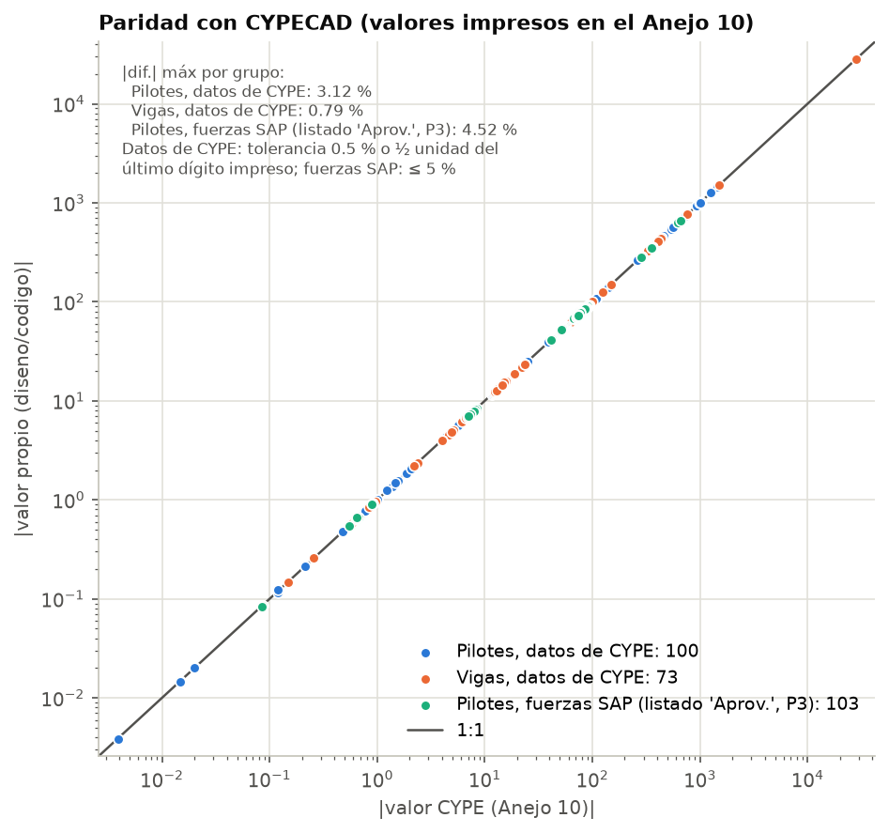
Figure 1 – Parity with CYPECAD, log-log scale: our value against the value printed in Anejo 10. Blue: piles, CYPECAD data. Orange: beams, CYPECAD data. Green: piles with SAP forces against the listing “Aprov.” (P3). The line is 1:1. Largest differences by group: 3.12 %, 0.79 % and 4.52 %; the 3.12 % is a rounded printed value (n = 0.12).

4.5 Workflow
The calculation chain has four steps:
- esfuerzos.py: SAP forces → CYPECAD convention → combinations.
- codigo/seccion.py: the fibre engine.
- codigo/pilotes.py and codigo/vigas.py: all checks, three cases each, plus a search for practical reinforcement layouts.
- run_diseno.py: final design, workbook and figures.
Every number in this report comes from diseno/output/pilotes.json, vigas.json and diseno_final.json, or from their Markdown versions.

5. Piles

5.1 Column model
Each pile is a 40×40 cm precast member with 12Ø25: 4 bars per face, bar centres at ±127.5 mm. It is fixed into the transverse beam at the top. It has equivalent fixity 7.25 m below deck level, i.e. 6.70 m below the beam soffit. As in CYPECAD, the buckling length is l0 = 6.70 m in both planes: β = 1 on the flexible length of a sway frame. The slenderness is:
λ = l0 / i = 6700 / 115.5 = 58.02, i = h/√12 = 115.5 mm (3)
Second-order effects are included wherever λ > λlim (nominal curvature method, A19.5.8.8). This is the case for the sea piles, where λlim = 38–61 under the governing combinations. For the land piles, whose axial force is low or tensile, λlim = 67–308 and e2 = 0. The checked sections are the head (Cabeza), the foot (Pie), the fixity section (Arranque, with its own Ø8 tie) and intermediate stations. In the section axes, MEd,x is the moment in the transverse (Y) direction, which carries the bollard pull, and MEd,y is the moment along the quay.

5.2 ULS axial force and biaxial bending — worked example: P3 head
The governing case is pile P3 (axis 2, sea row) at the head, for ELR08 = 1.35PP + 1.35CM + 1.5Qa + 1.5TB1, in the ROM basis with Mode.CODIGO.
- First-order forces. NEd = 736.1 kN, MEd,x = 295.3 kN·m, MEd,y = −19.5 kN·m. So e0,x = 401.1 mm and e0,y = −26.6 mm, both above emin = max(h/30, 20 mm) = 20 mm (A19.6.1(4)).
- Slenderness limit (A19.5.8.3.1). A = 1/(1 + 0.2·φef) = 0.7407 (φef = 1.75). ω = As·fyd/(Ac·fcd) = 0.480, so B = √(1 + 2ω) = 1.4001. C = 0.7 for a sway member. n = NEd/(Ac·fcd) = 0.138. Then:
λlim = 20·A·B·C / √n = 20 × 0.7407 × 1.4001 × 0.7 / √0.138 = 39.09 < λ = 58.02 (4)
- Imperfection (A19.5.2). θi = θ0·αh·αm = (1/200) × (2/√6.70) × 1 = 0.003863, so ei = θi·l0/2 = 12.94 mm. In code-strict mode it is added in the worst direction only, here x.
- Curvature and second-order eccentricity (A19.5.8.8.3). εyd = 434.78/200 000 = 0.002174. Kr = min[(nu − n)/(nu − nbal); 1] = 1, with nu = 1 + ω. β = 0.35 + fck/200 − λ/150 = 0.213, so Kφ = 1 + β·φef = 1.373. The code-strict effective depth is d = h/2 + is = 307.0 mm (CYPECAD uses 327.5 mm, C7). Then:
1/r = Kr·Kφ·εyd / (0.45·d) = 1.373 × 0.002174 / (0.45 × 0.307) = 0.0216 m⁻¹ (5)
e2 = (1/r)·l0² / π² = 0.0216 × 6.70² / 9.87 = 98.3 mm (6)
- Total eccentricities. etot,x = 401.1 + 12.9 + 98.3 = 512.4 mm and etot,y = −26.6 − 98.3 = −124.8 mm. So MEd,x = 736.1 × 0.5124 = 377.1 kN·m and MEd,y = −91.9 kN·m.
- Section capacity on the same ray. NRd = 745.4 kN, MRd,x = 381.9 kN·m, MRd,y = −93.1 kN·m. At failure the concrete resultant is Cc = 1478 kN, the compression steel Cs = 504 kN and the tension steel T = 1236 kN, so Cc + Cs − T = NRd. Then:
η = √(736.1² + 377.1² + 91.9²) / √(745.4² + 381.9² + 93.1²) = 0.987 ≤ 1 (7)
The same procedure with CYPECAD’s conventions and CYPECAD’s own forces returns η = 0.913 at the P3 head, exactly the printed value (e2 = 92.12 mm, NRd = 679.16 kN). With the SAP forces:
- the parity case (CYPE/cype) gives 0.920;
- the code-strict section with the Anejo 10 loads (CYPE/codigo) gives 0.933;
- the ROM loads, with ψ0,Qa = 1.0 instead of 0.7, raise it to 0.987.
Resistance of the pile section (12Ø25, Mode.CODIGO, uniaxial): pure compression NRd = 7493 kN; pure tension NRd = −2561 kN (As·fyd); MRd ≈ 345 kN·m at N ≈ 0; maximum MRd = 473 kN·m at N ≈ 2095 kN (balanced point). Figure 2 shows the diagram and the governing points.
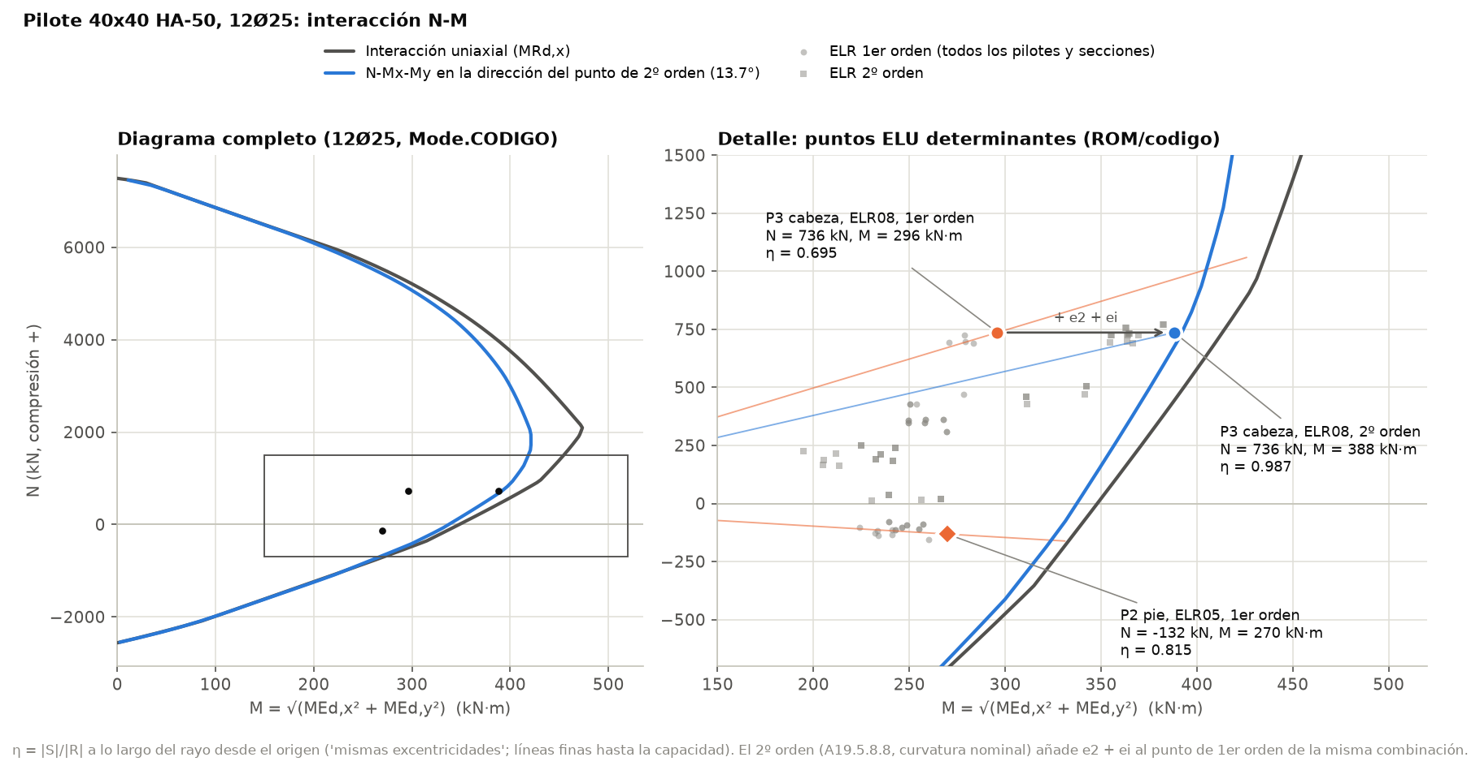
Figure 2 – N-M interaction of the pile 40×40 HA-50 with 12Ø25. Black: uniaxial diagram. Blue: N-Mx-My diagram along the governing moment direction (13.7°). Right panel: first-order point of P3 head (orange), its second-order point (blue, η = 0.987) and P2 foot in tension (η = 0.815). Grey: all other ELR points. “compresión +” = compression positive.

5.3 Results per pile
Table 11 – Pile utilisations with the Anejo 10 reinforcement, verdict case ROM/codigo, and final verdict.
Pile | Axis, row | η N-M 1st | η N-M 2nd | η shear | QP σct/fctm | σc/0.6fck Ecm | σc/0.6fck Ec,eff | As,req (cm²) | Final
P1 | 1, sea | 0.719 | 0.919 | 0.560 | 0.755 | 1.109 | 0.966 | 52.55 | CUMPLE*
P2 | 1, land | 0.815 | 0.774 | 0.814 | 0.764 | 1.055 | 0.899 | 45.84 | CUMPLE*
P3 | 2, sea | 0.695 | 0.987 | 0.538 | 0.345 | 1.010 | 0.923 | 58.43 | CUMPLE*
P4 | 2, land | 0.764 | 0.638 | 0.734 | 0.381 | 0.806 | 0.752 | 42.70 | CUMPLE
P5 | 3, sea | 0.652 | 0.915 | 0.515 | 0.160 | 0.893 | 0.836 | 52.05 | CUMPLE
P6 | 3, land | 0.763 | 0.646 | 0.745 | 0.194 | 0.799 | 0.753 | 42.75 | CUMPLE
P7 | 4, sea | 0.663 | 0.924 | 0.524 | 0.119 | 0.900 | 0.837 | 52.71 | CUMPLE
P8 | 4, land | 0.739 | 0.620 | 0.711 | 0.156 | 0.777 | 0.730 | 41.19 | CUMPLE
P13 | 5, sea | 0.630 | 0.893 | 0.499 | 0.160 | 0.873 | 0.816 | 50.24 | CUMPLE
P14 | 5, land | 0.735 | 0.618 | 0.714 | 0.194 | 0.766 | 0.720 | 40.99 | CUMPLE
P15 | 6, sea | 0.649 | 0.937 | 0.506 | 0.345 | 0.947 | 0.862 | 53.60 | CUMPLE
P16 | 7, sea | 0.659 | 0.843 | 0.519 | 0.755 | 1.034 | 0.890 | 46.16 | CUMPLE*
P17 | 6, land | 0.710 | 0.585 | 0.675 | 0.381 | 0.760 | 0.706 | 39.09 | CUMPLE
P18 | 7, land | 0.730 | 0.690 | 0.719 | 0.764 | 0.963 | 0.805 | 40.65 | CUMPLE
* CUMPLE with the confinement ties of the final design (§5.7). Detailing η = 0.920 for every pile (As = 58.91 ≤ 0.04·Ac = 64 cm²). QP is the quasi-permanent combination with ψ2,Qa = 0.8 and ψ2,TB = 0; every pile stays uncracked. As,req is the governing value of shaft and fixity section.
The sea piles at the head have the highest second-order utilisation (0.84–0.99), because the bollard pull and the quay load act together there. The land piles are governed by first-order bending at the foot in the tension combination ELR05 (PP + CM + 1.5TB1, N < 0).
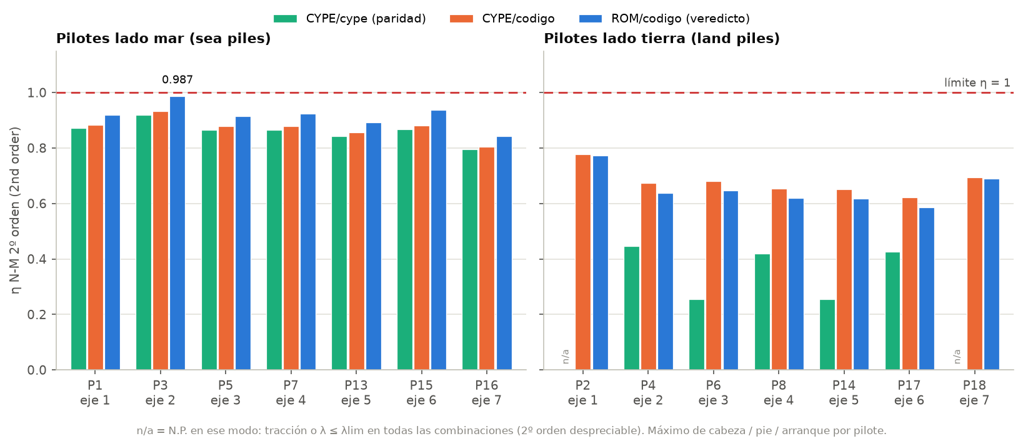
Figure 3 – Governing N-M second-order utilisation of the 14 piles, for the three cases: green CYPE/cype (parity), orange CYPE/codigo, blue ROM/codigo (verdict). n/a: second order does not apply in that mode (tension, or λ ≤ λlim in every combination). The dashed line is η = 1.

5.4 Required against provided steel
The required area keeps the provided bar positions and scales the bar diameter, on a grid of 12–36 mm with linear interpolation, until the governing utilisation reaches 1.0. It covers all combinations, all positions, and first and second order.
Table 12 – Required and provided longitudinal steel of the piles (ROM/codigo).
Group | Governing section | As,req (cm²) | As,prov (cm²) | Ratio
P3 (governing) | head, ELR08, 2nd order | 58.43 | 58.91 (12Ø25) | 0.992
Sea piles P1, P5, P7, P13, P15, P16 | head, ELR08 | 46.2–53.6 | 58.91 | 0.78–0.91
Land piles P2, P4, P6, P8, P14, P17, P18 | foot, ELR05 | 39.1–45.8 | 58.91 | 0.66–0.78
Limit | As,max = 0.04·Ac | — | 64.0 | —

Result. 12Ø25 is necessary and sufficient at P3 (ratio 0.99; η with As,req is 0.993). The land piles would need only 39–46 cm², which a 16Ø20 layout (50.27 cm²) would cover. A uniform precast pile is kept all the same (F1): there is one production type, and the position of a driven pile is not a production parameter.
A search over practical layouts, 8 to 20 bars of Ø16–Ø32, finds no layout within As ≤ 0.04·Ac that also meets the characteristic stress limit of §5.7. Only 12Ø32, 16Ø25 and 20Ø25 would meet it, and all three exceed As,max.
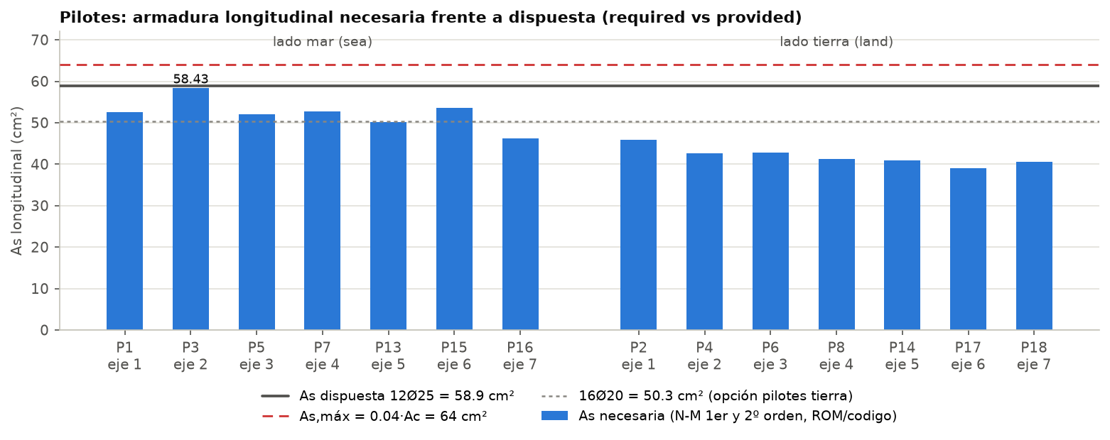
Figure 4 – Required longitudinal steel of each pile (blue bars, first and second order, ROM/codigo) against the 12Ø25 provided (58.9 cm², solid line), As,max = 0.04·Ac = 64 cm² (red dashed) and the 16Ø20 option for the land piles (50.3 cm², dotted).

5.5 Shear
Without shear reinforcement (A19.6.2.2):
VRd,c = [CRd,c·k·(100·ρl·fck)^(1/3) + k1·σcp]·bw·d ≥ (vmin + k1·σcp)·bw·d (8)
where CRd,c = 0.18/1.5 = 0.12, k = 1 + √(200/d) ≤ 2, ρl ≤ 0.02, k1 = 0.15, σcp = NEd/Ac ≤ 0.2·fcd and vmin = 0.035·k^1.5·fck^0.5. With ties (A19.6.2.3):
VRd,s = (Asw/s)·z·fywd·cot θ ; VRd,max = αcw·bw·z·ν1·fcd / (cot θ + tan θ) (9)
Biaxial shear is combined as η = √(VEd,x² + VEd,y²)/VRd, the form CYPECAD uses. In the shaft, the 4 full-depth Ø10 legs per direction at 150 mm, with z = 0.9d, fywd = 400 MPa and cot θ = 2, give VRd,s = 397.7 kN; VRd,max at θ = 45° is 949.5 kN. The fixity section has only a Ø8 tie, so it is checked as a member without shear reinforcement (VRd,c).
Results. In the shaft η ≤ 0.22. The governing value is at the fixity section of P2: VEd = 79.1 kN (ELR05, N = −131.7 kN in tension) against VRd,c = 97.2 kN, so η = 0.814. With CYPECAD’s forces and conventions, VRd,c at the P3 head is 142.85 kN with η = 0.552, as printed in Anejo 10 (C10).

5.6 Detailing
Table 13 – Pile detailing (shaft; every pile).
Check | Clause | Provided | Limit | η
Column definition h ≤ 4b | A19.9.5.1 | 400 mm | 1600 mm | 0.250
Longitudinal Ø ≥ 12 mm | A19.9.5.2(1) | Ø25 | Ø12 | 0.480
Clear bar spacing ≥ max(Ø, dg + 5, 20) | A19.8.2(2) | 60 mm | 25 mm | 0.417
Tie Ø ≥ max(6, Ømax/4) | A19.9.5.3(1) | Ø10 | 6.25 mm | 0.625
Tie spacing ≤ scl,max = min(15Ømin, 300, b) | A19.9.5.3(3) | 150 mm | 300 mm | 0.500
Tie spacing ≤ 0.6·scl,max in the end zones (0.40 m) | A19.9.5.3(4) | 150 mm (final design: 100 mm) | 180 mm | 0.833
Every bar within 150 mm of a restrained bar | A19.9.5.3(6) | all bars at a tie corner | 150 mm | OK
As ≥ 0.10·NEd/fyd | A19.9.5.2(2) | 58.91 cm² | 1.77 cm² (P3) | 0.030
As ≤ 0.04·Ac | A19.9.5.2(3) | 58.91 cm² | 64.0 cm² | 0.920
AN limits used by CYPECAD (information) | AN 9.5.2 | 58.91 cm² | ≥ 6.40; ≤ 122.67 cm² | —

5.7 Serviceability

Cracking under the quasi-permanent combination
The quasi-permanent combination is PP + CM + ψ2,Qa·Qa + ψ2,TB·TB. With ψ2,TB = 0 (F2) all pile sections stay uncracked. The largest tensile stress on the homogenised section, at the corner fibre, is 3.11 MPa at the heads of P2 and P18, against fctm = 4.07 MPa (η = 0.764). The wk check therefore does not apply (A19.7.1(2)). The steel stresses under the characteristic combinations also pass: σs ≤ 0.8·fyk, max η = 0.692.

Characteristic concrete stress and confinement (decision F1)
A19.7.2(2) limits σc ≤ k1·fck = 0.6·fck = 30 MPa under the characteristic combination in XS exposure, “in the absence of other measures, such as … confinement by transverse reinforcement”. The stresses are computed on the cracked section with αe = Es/Ecm for ELS01–08; ELS04 = G + Qa + TB1 governs.
Table 14 – Piles that exceed σc ≤ 0.6·fck with Ecm (ELS04).
Pile, section | σc with Ecm (MPa) | σc/0.6fck | σc with Ec,eff (MPa) | σc/0.6fck
P1 head | 33.27 | 1.109 | 28.98 | 0.966
P1 foot | 30.27 | 1.009 | 27.98 | 0.933
P2 head | 31.66 | 1.055 | 26.89 | 0.896
P3 head | 30.30 | 1.010 | 27.69 | 0.923
P16 head | 31.03 | 1.034 | 26.69 | 0.890

The verdict reading uses the short-term Ecm for the whole characteristic load. On that reading the limit is exceeded at the heads of P1, P2, P3 and P16 (and at the P1 foot by 0.9 %). If instead the sustained part (G + ψ2·Qa) acts on the creep-weighted modulus Ec,eff = Ecm/(1 + φ·Mqp/Mk), with φ = 1.75, all piles pass (max 0.966). The bollard pull and the quay load make up about 75–85 % of Mk, so the Ecm reading is the defensible, conservative one.
No bar layout within As ≤ 0.04·Ac removes the exceedance (§5.4). The final design therefore uses the “other measure” allowed by A19.7.2(2): confinement by the ties. The three closed Ø10 ties are spaced at 100 mm instead of 150 mm over the top 0.40 m of every pile. This is the end zone where A19.9.5.3(4) already asks for denser ties, over a length equal to the larger section dimension. The extra steel is 2.8 kg per pile.
The following estimate of the confined strength is indicative only (A19.3.1.9, (3.24)/(3.25)). The effective lateral pressure is σ2 = αn·αs·ρw·fyd, with the effectiveness factors αn = 1 − Σbi²/(6·b0²) and αs = (1 − s/(2·b0))² (EC8-1 5.4.3.2.2(8), MC2010). Here b0 = 290 mm (tie centreline) and ρw = 4 legs × Asw/(s·b0).
Table 15 – Indicative confinement of the pile head: fck,c = fck·(1 + 5·σ2/fck) for σ2 ≤ 0.05·fck, else fck·(1.125 + 2.5·σ2/fck).
Tie spacing s | αn | αs | ρw | σ2 (MPa) | fck,c (MPa) | 0.6·fck,c (MPa) | σc,max (MPa)
150 mm (Anejo 10) | 0.828 | 0.550 | 0.0072 | 1.43 | 57.1 | 34.3 | 33.3
100 mm (final) | 0.828 | 0.685 | 0.0108 | 2.67 | 62.9 | 37.8 | 33.3

With ties at 100 mm the confined limit, 37.8 MPa, is clearly above the largest characteristic stress, 33.3 MPa. With the existing 150 mm spacing the margin would be small (34.3 MPa). The estimate is indicative (open point 1). The alternative is a stronger concrete, HA-60 (fck ≥ 55.5 MPa).
Decision F1 — piles. Keep 12Ø25 and 3 closed Ø10 ties at 150 mm in the shaft. Tighten the ties to Ø10 c/100 in the top 0.40 m of every pile, as confinement under A19.7.2(2). The verdict is CUMPLE with that measure. The governing η is 0.987 (N-M second order, P3 head, ELR08).
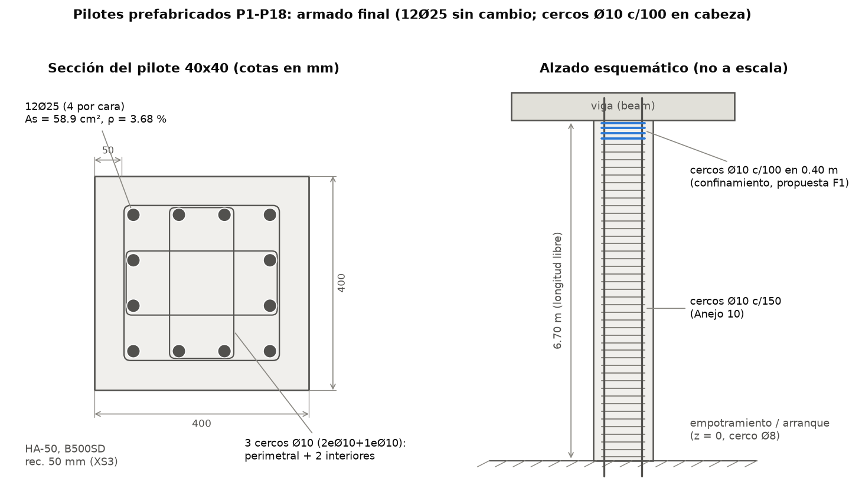
Figure 5 – Final pile reinforcement. Left: section 40×40 with 12Ø25 (4 per face, As = 58.9 cm², ρ = 3.68 %) and 3 closed Ø10 ties (one perimeter tie and two inner ties), cover 50 mm (XS3). Right: schematic elevation (not to scale) with the Ø10 c/100 confinement ties in the top 0.40 m (blue), Ø10 c/150 in the shaft, and the fixity section (arranque) with a Ø8 tie.

5.8 Bollard pull ψ2 (decision F2)
CYPECAD and the designer treated the bollard pull as a variable action with ψ2 = 0 (entered as wind). For a fishing quay the mooring pull is not quasi-permanent. ROM 2.0-11 makes its quasi-permanent value the 50 % quantile of the recorded mooring loads, which is practically zero when no records exist. ψ2 = 0 is therefore kept (F2).
Sensitivity with ψ2,TB = 0.5, the ROM 0.2-90 operational upper bound. Six piles crack: P1, P2, P3, P15, P16 and P18, with wk up to 0.153 mm > 0.1 mm. Because sr,max ≥ 3.4·c = 204 mm and εsm − εcm ≥ 0.6·σs/Es, no layout with As ≤ 0.04·Ac meets 0.1 mm; only 12Ø32 or 20Ø25 would. The same sensitivity also cracks the transverse beams (§6.5). The assumption is recorded as open point 2. If the Port Authority requires ψ2 = 0.5, the practical option is to accept wk ≤ 0.2 mm (the XS1/XS2 value) for this transient case.

6. Transverse and edge beams

6.1 Sections, cases and design sections
The three beam types are:
- Inner beams: inverted T, with a 50×55 cm web and two 15×30 cm ledges that carry the hollow-core plates.
- End beams: inverted L, 80×55 cm, with a single ledge.
- Edge beams: 25×30 cm, continuous over six spans.
vigas.py computes three cases for every member (Table 16).
Table 16 – Beam cases.
Case | Loads | Section | Shear | Use
CYPE | CYPE basis (ψ0,Qa 0.7; ψ2,Qa 0.3) | Mode.CYPE | cot θ = 1; suspension steel as information | parity with Anejo 10
CE-CYPE | CYPE basis | Mode.CODIGO | optimum cot θ in [0.5, 2] + suspension steel | effect of the code-strict section
CE-ROM | ROM basis (ψ0,Qa 1.0; ψ2,Qa 0.8) | Mode.CODIGO | as CE-CYPE | final verdict

Bending is checked at the pile faces (monolithic supports, A19.5.3.2.2(3)) and at the maximum span moment. VRd,s is checked at d from the face and VRd,max at the face. Figure 6 compares the governing ULS utilisations of the three cases.
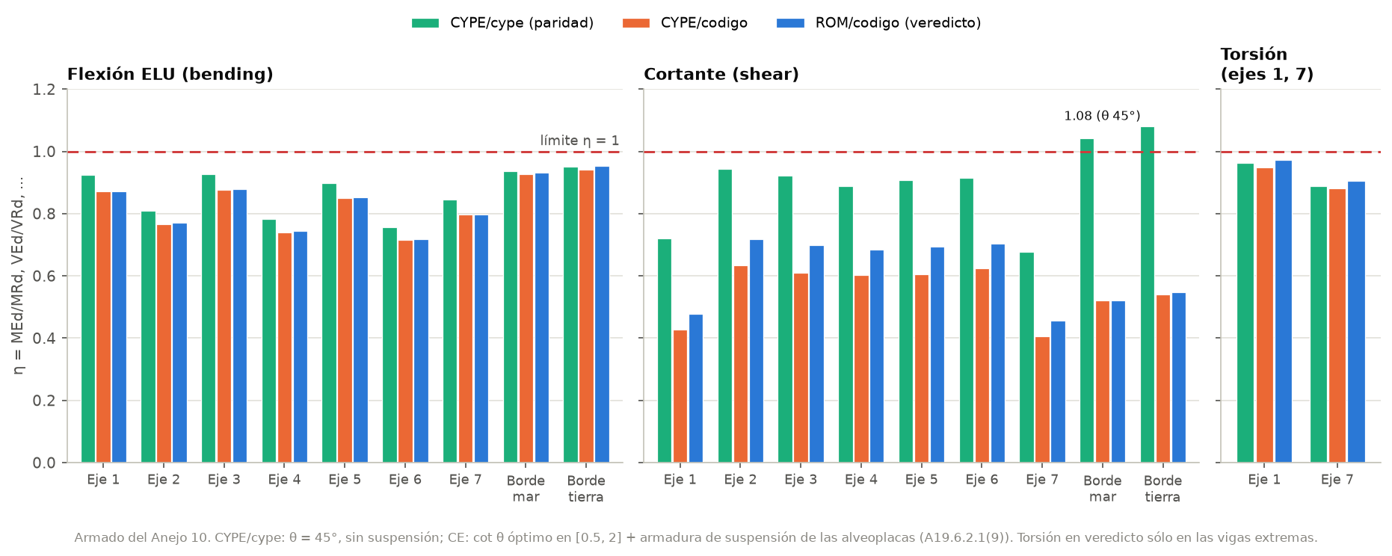
Figure 6 – ULS utilisation of the beams with the Anejo 10 reinforcement: bending, shear and (end beams only) torsion, for the three cases. The CYPE case uses θ = 45° without suspension steel; the CE cases use the optimum cot θ plus the suspension steel of the plates. “Borde mar / tierra” = sea / land edge beam.

6.2 Bending: As required against As provided
The required tension steel follows CYPECAD’s “Área Nec.” definition: singly reinforced, N = 0, the area that gives MRd = |MEd| in the fibre section. It is compared with the minimum area:
As,min = (W/z)·fctm,fl / fyd (10)
where W is the gross section modulus to the tension fibre, z = 0.8h (CYPECAD uses 0.9d) and fctm,fl = max[(1.6 − h/1000)·fctm; fctm] = 3.37 MPa for h = 550 mm.
Worked example: VT3 (axis 3), sea-pile face, hogging, ELR08. MEd = −302.8 kN·m. The required area is 15.07 cm² (As,min = 4.99 cm²), against 5Ø20 = 15.71 cm² provided (ratio 0.960). With the provided bars (top 5Ø20, side bars, bottom bars in compression) the fibre section gives MRd = 344.5 kN·m, with the neutral axis at x = 63.9 mm. So η = 302.8/344.5 = 0.879, the largest bending utilisation of the inner beams.
Table 17 – As required and provided at the governing sections (CE-ROM).
Beam | Top at sea-pile face: MEd (kN·m) | As,req / As,prov (cm²) | Ratio | Bottom in span: MEd (kN·m) | As,req / As,prov (cm²) | Ratio | η bending
VT1 | −316.3 | 15.67 / 15.71 | 0.998 | 275.8 | 13.68 / 18.85 | 0.726 | 0.873
VT2 | −265.2 | 13.14 / 15.71 | 0.836 | 316.0 | 16.18 / 21.99 | 0.736 | 0.770
VT3 | −302.8 | 15.07 / 15.71 | 0.960 | 292.7 | 14.91 / 21.99 | 0.678 | 0.879
VT4 | −256.2 | 12.68 / 15.71 | 0.807 | 298.5 | 15.23 / 21.99 | 0.692 | 0.744
VT5 | −294.0 | 14.62 / 15.71 | 0.931 | 287.1 | 14.61 / 21.99 | 0.664 | 0.853
VT6 | −247.6 | 12.24 / 15.71 | 0.779 | 307.0 | 15.69 / 21.99 | 0.714 | 0.719
VT7 | −289.4 | 14.30 / 15.71 | 0.910 | 248.8 | 12.30 / 18.85 | 0.653 | 0.798
VBM | −37.5 | 3.94 / 4.02 | 0.981 | 18.5 | 1.88 / 4.02 | 0.468 | 0.931
VBT | −38.4 | 4.04 / 4.02 | 1.005 | 18.6 | 1.89 / 4.02 | 0.470 | 0.953

As,req is singly reinforced, so a ratio just above 1 (VBT, 1.005) is not a failure: counting the compression bars, the section gives η = 0.953. The end beams need practically all their top steel at the sea face (0.998), which is why the torsion tension chord governs them (§6.4). Strength does not size the bottom steel of the inner beams; crack control does (§6.5). With the proposed 33.18 cm², the ULS utilisation of the bottom face drops to 0.49.
Table 18 – Design resistances of the beam sections (Mode.CODIGO, Anejo 10 reinforcement).
Section | MRd hogging (kN·m) | MRd sagging (kN·m) | VRd,s cot θ = 2 (kN) | VRd,max cot θ = 2 (kN) | VRd,c (kN) | TRd,max (kN·m)
Inner T (5Ø20 / 7Ø20) | 344.5 | 453.1 | 814.3 | 1209.6 | 134.6 | 199.0
End L (5Ø20 / 6Ø20) | 362.6 | 429.3 | 814.3 | 1935.4 | 184.1 | 387.0
Edge 25×30 (2Ø16 / 2Ø16) | 40.3 | 40.3 | 112.9 | 294.8 | 39.0 | 25.2

For comparison, at θ = 45° (the CYPE case) the inner beam gives VRd,s = 407.15 kN and VRd,max = 1512.0 kN, and in Mode.CYPE its hogging MRd = 325.78 kN·m. These are the values printed in Anejo 10.

6.3 Shear and suspension of the hollow-core plates
The links must carry the shear (A19.6.2.3, (6.8)). They must also carry the plate reactions: the plates bear on the ledges, near the bottom of the section, so their load has to be hung up into the web (A19.6.2.1(9)). The required link area per metre is:
Asw/s = VEd / (z·fywd·cot θ) + Σ(q·Lp/2) / fyd (11)
Here q·Lp/2 is the ULS plate reaction per bearing ledge: two ledges on inner beams, one on end beams. cot θ is the largest value in [0.5, 2] allowed at the section.
Worked example: VT2 (axis 2), sea-pile face, ELR08.
- At the face, VEd = 539.2 kN against VRd,max = 1209.6 kN (cot θ = 2), so η = 0.446.
- At d from the face, VEd = 443.2 kN. With z = 0.9d = 432 mm, fywd = 400 MPa and cot θ = 2, the shear steel is Asw/s = 443.2 kN/(0.432 m × 400 MPa × 2) = 12.82 cm²/m.
- The plates hang 176.9 kN/m from the two ledges, which needs 176.9 kN/m / 434.78 MPa = 4.07 cm²/m.
- The total, 16.89 cm²/m, compares with 3 legs Ø10 at 100 mm = 23.56 cm²/m, so η = 0.717. The shear-only check gives VRd,s = 814.3 kN, η = 0.544.
In the CYPE case (θ = 45°) the same beam gives VRd,s = 407.15 kN against VEd = 390.18 kN at 0.488 m, so η = 0.958, exactly as Anejo 10 prints. The optimum strut angle halves the link demand for shear. The suspension steel, which CYPECAD does not check, uses part of that margin.
The detailing checks also pass: ρw,min·bw = 4.73 cm²/m, and spacing 100 mm ≤ 0.75d = 360 mm, both along the beam and between legs. The maximum shear η over all transverse beams is 0.72 (inner) and 0.48 (end). The extra longitudinal tension from shear, ΔFtd = 0.5·VEd·cot θ (6.18), is discussed in §6.9.

6.4 Torsion
The end beams carry equilibrium torsion from their single ledge and from the SAP torque, so torsion is part of their verdict (A19.6.3). In the inner beams the SAP torque is compatibility torsion, which A19.6.3.1(2) allows to be neglected at ULS. It is reported as information only (0.75–0.88).
ΣAsl,T = TEd·uk·cot θ / (2·Ak·fyd) ; TEd/TRd,max + VEd/VRd,max ≤ 1 (12)
TRd,max = 2·ν·αcw·fcd·Ak·tef·sin θ·cos θ, with ν = 0.6(1 − fck/250) = 0.516 and tef = A/u. Ak and uk are the area and perimeter enclosed by the wall centre line. The link demand per hoop leg is Asw,V/(n·s) + TEd/(2·Ak·fyd·cot θ). The longitudinal torsion steel of the tension chord adds to the bending demand:
ηchord = MEd/MRd + ΣAsl,T·(bk/uk) / As ≤ 1 (13)
VT1 (axis 1), sea-pile face, ELR08. MEd = −316.3 kN·m, so M/MRd = 0.873. TEd = 26.5 kN·m, and ΣAsl,T = 5.06 cm², whose top-chord share adds 0.10. The result is ηchord = 0.973, the governing check of the end beams. The interaction TEd/TRd,max + VEd/VRd,max = 0.254 and the link demand per leg (0.54) also pass. VT7 gives ηchord = 0.906.
Decision F4 — end beams (sensitivity). CYPECAD states that the hollow-core plates bear at the pile axis, and neither SAP nor CYPECAD models them on the ledge. Suppose instead they bear on the single ledge, about 0.42 m from the pile axis. Their reaction then adds an equilibrium torque of about 56–61 kN·m at the pile faces (T = q·Lp/2·e·L/2 for 1.35G + 1.5Qa). At VT1 the total torque becomes TEd = 82.5 kN·m, ΣAsl,T = 15.76 cm² and ηchord = 1.18 (VT7: 1.12). The recommendation is to verify the bearing detail. If the plates do bear on the ledge, use top 4Ø25 (19.63 cm²) instead of 5Ø20, which gives η = 0.982. The provided design passes (0.973) on the modelled load path.

6.5 Crack control
The check has three steps:
- Quasi-permanent moment: M_qp = M(G) + ψ2,Qa·M(Qa), with the bollard at ψ2 = 0.
- Uncracked criterion (A19.7.1(2)): on the homogenised section (αe = 6.52), σct = M_qp·(h − yc)/Ihom ≤ fct,eff = fctm. If this holds, wk = 0 and the check passes.
- Cracked section: σs comes from the fully cracked elastic section. Then (A19.7.3.4):
wk = sr,max·(εsm − εcm) (14)
εsm − εcm = [σs − kt·fct,eff/ρp,eff·(1 + αe·ρp,eff)] / Es ≥ 0.6·σs/Es (15)
sr,max = k3·c + k1·k2·k4·Ø / ρp,eff (16)
with kt = 0.4, k1 = 0.8, k2 = 0.5, k3 = 3.4, k4 = 0.425, c = 60 mm, ρp,eff = As/Ac,eff, Ac,eff = b·hc,ef and hc,ef = min{2.5(h − d), (h − x)/3, h/2}.
Worked example: VT2 (axis 2), span, ψ2,Qa = 0.8, provided bottom 7Ø20.
- M_qp = 151.9 kN·m exceeds Mcr = 125.2 kN·m: σct = 3.89 MPa > fctm = 3.21 MPa, so the section is cracked.
- Cracked section: x = 136.0 mm and σs = 153.0 MPa; ρp,eff = 0.0199.
- sr,max = 3.4 × 60 + 0.8 × 0.5 × 0.425 × 20/0.0199 = 374.7 mm.
- εsm − εcm = [153.0 − 0.4 × 3.21/0.0199 × (1 + 6.52 × 0.0199)]/200 000 = 0.40 ‰. This is below the floor 0.6 × 153.0/200 000 = 0.459 ‰, so the floor governs.
- wk = 374.7 × 0.000459 = 0.172 mm > 0.1 mm (η = 1.72).
Once the section has cracked, even at M = Mcr, the floor of the εsm − εcm expression makes wk ≈ 0.14–0.15 mm with 7Ø20. With that steel, the XS3 limit can only be met by keeping the section uncracked. The largest ψ2,Qa for which each beam stays uncracked is therefore its threshold (Table 19).
Table 19 – Cracking thresholds with the Anejo 10 reinforcement (bollard ψ2 = 0).
Member | Face | Mcr (kN·m) | M_qp at ψ2 0.3 (kN·m) | M_qp at ψ2 0.8 (kN·m) | ψ2 at first cracking (fctm) | Same with fctm,fl | wk at ψ2 0.8 (mm)
VT2, VT6 | bottom | 125.2 | 90.4 | 151.9 | 0.583 | 0.634 | 0.172
VT3, VT5 | bottom | 125.2 | 81.7 | 136.8 | 0.695 | 0.751 | 0.155
VT4 | bottom | 125.2 | 83.4 | 139.8 | 0.671 | 0.726 | 0.158
VT1, VT7 | bottom | 157.0 | 48.0 | 76.1 | uncracked | — | 0
VBM, VBT | top (support) | 12.7 | −13.5 / −13.6 | −22.2 / −22.3 | 0.252 / 0.249 | 0.473 / 0.468 | 0.306 / 0.308

Decision F3 — inner beams. Bottom reinforcement 8Ø20 in the web + 4Ø16 in the ledges (33.18 cm²) instead of 5Ø20 + 2Ø20 (21.99 cm²). With ψ2,Qa = 0.8 this gives wk = 0.096 mm (η = 0.962 at VT2 and VT6; 0.867–0.885 at VT3–VT5), and the section passes up to ψ2,Qa ≈ 0.85. The top 5Ø20 and the links are unchanged: web hoop Ø10 + leg Ø10 + ledge hoop, 3 legs Ø10 c/100. Steel weight: 32.1 → 40.8 kg/m. With CYPECAD’s ψ2 = 0.3 the provided layout passes, as CYPECAD found.
The layout was chosen from 115 candidates by the lowest As·(1 + 0.002·n_bars). The next-best alternatives are 7Ø20 web + 6Ø16 ledges (34.05 cm², η 0.921), 11Ø20 with 5 in the web and 6 in the ledges (34.56 cm², η 0.926), and 3Ø25 web + 6Ø20 ledges (33.58 cm², η 0.999). The clear spacing of the 8Ø20 in the web is 31 mm ≥ dg + 5 = 25 mm (open point 6). With the ψ2,TB = 0.5 sensitivity of §5.8 the transverse beams would also crack, for example the hogging at the VT3 sea face (wk/wmax up to 1.57 even with the final layout). This is one more reason to settle the bollard ψ2 (open point 2).
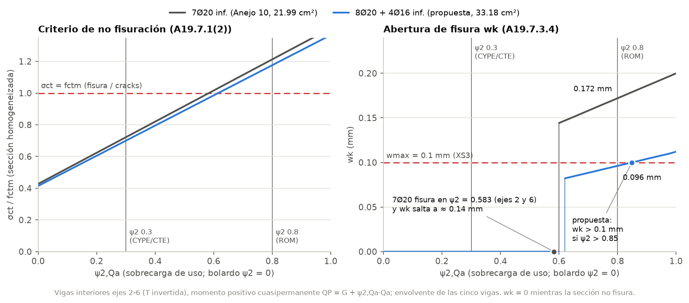
Figure 7 – Inner beams, envelope of axes 2–6: effect of ψ2,Qa (bollard ψ2 = 0). Left: σct/fctm on the uncracked section; the section cracks above 1.0. Right: crack width wk. Grey: provided 7Ø20 (cracks at ψ2 = 0.583 and wk jumps to ≈ 0.14 mm). Blue: proposed 8Ø20 + 4Ø16 (0.096 mm at ψ2 0.8; wk > 0.1 mm only above ψ2 ≈ 0.85). The vertical lines mark ψ2 = 0.3 (CYPE/CTE) and 0.8 (ROM).

6.6 Deflection
Deflections are obtained by integrating the curvature between the pile faces, using the (7.18) interpolation between the uncracked and cracked states with φ = 2.0 and β = 0.5. The limits are L/250 = 12.2 mm (total) and L/500 = 6.1 mm (active) for L = 3.05 m. For VT2 (ROM, provided steel) the total deflection is 1.21 mm and the active deflection 1.09 mm (η = 0.178). The largest deflection utilisation of all members is 0.328, in span 1 of the edge beams. For P3–P4, CYPECAD printed fT,max = 1.53 mm and fA,max = 1.33 mm.

6.7 Results per beam
Table 20 – Beam utilisations with the Anejo 10 reinforcement (CE-ROM), verdict, and final design.
Beam | Bending | Shear | Torsion | Detailing | Cracking | Stresses / deflection | Anejo 10 steel | Final design (η, governing check)
VT1 | 0.873 | 0.478 | 0.973 | 0.958 | 0 | 0.715 / 0.069 | CUMPLE | 0.973 torsion
VT2 | 0.770 | 0.717 | (0.83) | 0.542 | 1.720 | 0.622 / 0.178 | NO CUMPLE | 0.962 cracking
VT3 | 0.879 | 0.700 | (0.88) | 0.542 | 1.550 | 0.696 / 0.161 | NO CUMPLE | 0.878 bending
VT4 | 0.744 | 0.684 | (0.75) | 0.542 | 1.584 | 0.588 / 0.164 | NO CUMPLE | 0.885 cracking
VT5 | 0.853 | 0.693 | (0.86) | 0.542 | 1.550 | 0.675 / 0.161 | NO CUMPLE | 0.867 cracking
VT6 | 0.719 | 0.703 | (0.78) | 0.542 | 1.720 | 0.609 / 0.178 | NO CUMPLE | 0.962 cracking
VT7 | 0.798 | 0.456 | 0.906 | 0.958 | 0 | 0.654 / 0.069 | CUMPLE | 0.958 detailing
VBM | 0.931 | 0.522 | (1.05) | 0.855 | 3.063 | 0.771 / 0.328 | NO CUMPLE | 0.872 detailing (conditional, F5)
VBT | 0.953 | 0.547 | (1.06) | 0.855 | 3.083 | 0.789 / 0.328 | NO CUMPLE | 0.872 detailing (conditional, F5)
Values in brackets are compatibility torsion, reported as information and not part of the verdict (A19.6.3.1(2)). In the final design every beam is CUMPLE; the edge beams are conditional on F5. With the final top 3Ø25, the edge-beam torsion information drops to 0.85.

6.8 Edge beams (decision F5)
The edge beams 25×30 have 2Ø16 top and bottom and Ø8 ties at 150 mm. In the SAP model the orthotropic slab shell shares the slab load with them. Compared with CYPECAD’s strip loading, their shear is about twice as large and their moments are 13–21 % higher. The consequences in the CE-ROM case are:
- Bending passes (0.931 / 0.953). Shear passes with the optimum cot θ (0.522 / 0.547), but at θ = 45° (CYPE case) it is 1.04 / 1.08.
- Cracking fails at the supports (hogging): M_qp = −22.2 kN·m ≫ Mcr = 12.7 kN·m, and wk = 0.306 / 0.308 mm (η 3.06 / 3.08). The beams crack even with ψ2 = 0.3 (threshold ψ2 ≈ 0.25; wk = 0.156 mm).
Decision F5 — edge beams (conditional on the SAP load sharing). Top 3Ø25 over the supports (14.73 cm²), which gives wk = 0.067 mm. The governing η of the final design is 0.872 (link spacing). An alternative is a deeper edge beam. If only CYPECAD’s strip loading applies, the provided 2Ø16 is enough for ULS. Steel weight: 6.3 → 14.7 kg/m, an upper bound that assumes 3Ø25 over the full length.

6.9 Shift rule at the pile faces (decision F6, information)
At a monolithic support, A19.5.3.2.2(3) allows the design moment to be taken at the face. The extra tension from shear, ΔFtd = 0.5·VEd·cot θ (6.18), is then capped at MEd,max/z at the face, so it adds nothing there. The shift al = z·cot θ/2 (0.43 m at cot θ = 2) only matters for bar curtailment.
If the rigid-node moment at the pile axis were taken as MEd,max instead, the top tension chord at the sea face would reach η = 1.03–1.18 for VT1–VT6 (CE-ROM, cot θ = 2). For example, VT3 has an axis moment of −406.4 kN·m against MRd = 344.5 kN·m, η = 1.18; VT7 gives 0.99. With cot θ = 1 (CYPECAD) the effect is smaller. This is information and not part of the verdict.
Recommendation F6. Do not curtail the top bars within al = z·cot θ/2 ≈ 0.43 m of the pile faces, and anchor them fully over the piles. The Anejo 10 drawings already show full-length top bars with end legs.

7. Final design
The final design keeps the Anejo 10 reinforcement wherever it passes and changes three items. The verdict case is ROM basis, Mode.CODIGO, XS3 wmax = 0.1 mm (F0).
Table 21 – Final reinforcement schedule.
Element | Top | Bottom | Side | Transverse | Change vs Anejo 10 | η, governing check | Verdict
Piles P1–P18 (14, precast 40×40 HA-50) | 12Ø25, 4 per face (ρ = 3.68 %) | — | — | 3 ties Ø10 (2eØ10 + 1eØ10) c/150 in the shaft; c/100 in the top 0.40 m; fixity section 1eØ8 | ties c/150 → c/100 in the top 0.40 m (confinement), +2.8 kg/pile | 0.987, N-M 2nd order, P3 head (ELR08) | CUMPLE (with confinement ties)
Inner beams, axes 2–6 (T 50x55+15x30+15x30) | 5Ø20 (15.71 cm²) | 8Ø20 web + 4Ø16 ledges (33.18 cm²) | 2Ø10 + 2Ø10 at 235 mm | web hoop Ø10 + leg Ø10 (3 legs) + ledge hoop Ø10, c/100 | bottom 7Ø20 (21.99 cm²) → 8Ø20 + 4Ø16; 32.1 → 40.8 kg/m | 0.962, cracking VT2 (wk 0.096 mm, ψ2 0.8) | CUMPLE
End beams, axes 1 and 7 (L 80x55+15x30) | 5Ø20 (15.71 cm²) | 5Ø20 web + 1Ø20 ledge (18.85 cm²) | 1Ø20 ledge top + 2Ø10 at 235 mm | as inner beams | none (if the plates bear on the ledge: top 4Ø25, η 1.18 → 0.98) | 0.973, torsion tension chord (VT1) | CUMPLE
Edge beams, pórticos 1 and 10 (25×30) | 3Ø25 over the supports (14.73 cm²) | 2Ø16 (4.02 cm²) | — | 1eØ8 c/150 | top 2Ø16 → 3Ø25 over the supports (wk 0.067 mm) | 0.872, link spacing (VBM) | CUMPLE (conditional, F5)

There are 14 identical piles, 5 inner beams, 2 end beams and 2 edge beams per module. η is demand/capacity in the final case.
Table 22 – Steel quantities (longitudinal steel per metre of member).
Element | Provided (Anejo 10) | Proposed | kg/m provided | kg/m proposed
Pile (shaft) | 12Ø25 + 3 ties Ø10/150 | same + ties Ø10/100 in the top 0.40 m | 60.2 (bars + ties) | 60.2 + 2.8 kg per pile
Inner beam | 5Ø20 / 5Ø20 + 2Ø20 | 5Ø20 / 8Ø20 web + 4Ø16 ledges | 32.1 | 40.8
End beam | 5Ø20 / 5Ø20 + 1Ø20 | no change | 30.8 | 30.8
Edge beam | 2Ø16 / 2Ø16 | 3Ø25 top (supports) / 2Ø16 | 6.3 | 14.7 (3Ø25 over the full length, upper bound)
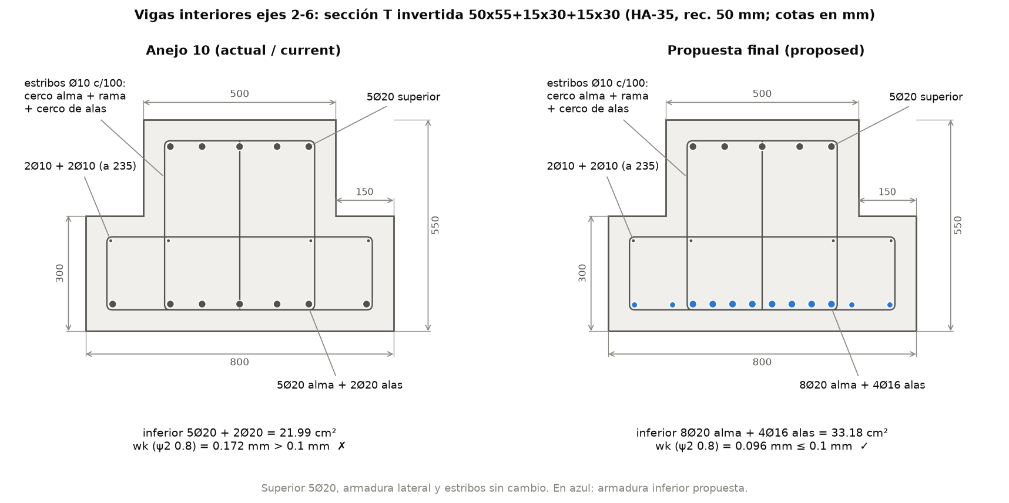
Figure 8 – Inner beams, axes 2–6: inverted-T section 50x55+15x30+15x30 (HA-35, cover 50 mm; dimensions in mm). Left: Anejo 10, bottom 5Ø20 web + 2Ø20 ledges = 21.99 cm², wk = 0.172 mm > 0.1 mm at ψ2 0.8. Right: final design, bottom 8Ø20 web + 4Ø16 ledges = 33.18 cm² (blue), wk = 0.096 mm. The top 5Ø20, side bars and links (web hoop + leg + ledge hoop, Ø10 c/100) are unchanged.
Table 23 – Verdict by basis with the Anejo 10 reinforcement, and final verdict.
Member | CYPE/cype (parity) | CYPE/codigo | ROM/codigo | Final design
Piles | P1, P2, P3, P16 fail σc ≤ 0.6fck (Ecm) | same | same | CUMPLE (confinement ties)
VT1 (axis 1) | CUMPLE | CUMPLE | CUMPLE | CUMPLE (0.973, torsion)
VT2–VT6 (axes 2–6) | CUMPLE | CUMPLE | NO CUMPLE (cracking) | CUMPLE (0.867–0.962)
VT7 (axis 7) | CUMPLE | CUMPLE | CUMPLE | CUMPLE (0.958, detailing)
VBM, VBT (edge) | NO CUMPLE | NO CUMPLE | NO CUMPLE | CUMPLE conditional (0.872)

The pile stress check does not depend on the basis, because it uses the characteristic combinations ELS01–08 in both; CYPECAD does not perform it (F8). The edge beams under the SAP load sharing fail cracking even with ψ2 = 0.3 (threshold ψ2 ≈ 0.25). In the CYPE/cype case their shear at θ = 45° is also 1.04–1.08. The inner beams fail only in the ROM basis, and their threshold is ψ2,Qa = 0.583 (axes 2 and 6).

8. SAP2000 concrete design: inputs and expected behaviour
The folder diseno/sap/ prepares the same model for SAP2000’s own concrete frame design. It has two uses: an independent cross-check, and a reference for the user’s SAP2000 workflow. A step-by-step GUI guide in Persian is in GUIA_SAP_DISENO.md. SAP2000 has no Spanish national annex, so the settings of Table 24 reproduce the CE and CYPECAD values as closely as the program allows.
Table 24 – SAP2000 v27.1 design settings written by the scripts.
Item | Setting | Reason
Design code | “Eurocode 2-2004”, Country = CEN Default; γc 1.5, γs 1.15, αcc 1.0, αct 1.0, θ0 = 0.005 | no Spain option; values set explicitly
Second order | nominal curvature (EC2 5.8.8); no P-Δ analysis | same method as CYPECAD / A19.5.8.8
Pile effective length | unbraced length ratio 6.70/7.25 = 0.924138, β = 1.0 → l0 = 6.70 m | CYPECAD l0 = 6.70 m
Creep factor Kφ | 1.1129 (= 1.373·8/π²; table field KPhi) | SAP uses c = 8 in e2; this gives e2 = 92.1 mm = CYPECAD
Strut angle | TanTheta = 1 (θ = 45°) | as CYPECAD (SAP default optimises θ)
Framing type | DC Low on every designed frame | program default is DC High
Pile section | rectangular 40×40, 4 bars per face Ø25, ties Ø10 at 0.15, check mode | 12Ø25 as provided
Beam sections | rectangles 50×55 (inner) / 80×55 (end) with property modifiers reproducing the T/L stiffness | SAP designs only rectangles; the analysis is unchanged
Designed frames | piles, transverse beams outside the piles, edge beams; 21 rigid segments “No Design”
Design combinations | ELU01–22 (CYPE basis) or ELR01–22 (ROM basis) as Strength; code combinations off

8.1 How to run
- OAPI script (recommended): python diseno/sap/sap_oapi_diseno.py [--attach] [--base ROM] [--kphi cype]. It builds or opens the model, applies and reads back every setting, and runs the analysis and the design. It checks that the analysis is identical to the SAP27 export, then writes diseno/sap/output/diseno_SAP2000.json and .xlsx.
- GUI: import diseno/sap/output/Muelle_Trasmallo_40m_diseno.$2k (the variant _overwrites.$2k adds the overwrite table; _rect.$2k only changes the beam sections, to prove that the analysis is unchanged). Then follow GUIA_SAP_DISENO.md §4 and export the Concrete Design tables.
- Comparison: python3 diseno/sap/leer_diseno_sap.py <export.xlsx | diseno_SAP2000.json> writes comparacion_diseno_SAP.md/.json. Our expected values at the SAP stations are in valores_esperados_SAP_CYPE.md and _ROM.md.

8.2 Expected behaviour (decision F7)
Table 25 – Expected SAP2000 results against this design (CYPE basis unless stated).
Quantity | This design | Expected in SAP2000 | Why
P3 pile head, P-M-M ratio | η2 = 0.933 (CE, CYPE basis); 0.987 (ROM) | ≈ 0.71 (ROM ≈ 0.73) | SAP uses M0e = 0.6·M02 + 0.4·M01 ≥ 0.4·M02 and expects P-Δ from the analysis: in a sway pile in double curvature the first-order end check governs. If SAP adds M2 to the end moment: ≈ 0.93
VT2 sea face, top As (ULS) | 13.1 cm² | ≈ 13.3 cm² | rectangular 50 cm section, rectangular stress block
VT2 span, bottom As (ULS) | 14.4 cm² | ≈ 14.4 cm²
VT2 sea face, Asw/s | 22.2 cm²/m (V at d, fywd 400, cot θ 1) | ≈ 25.0 cm²/m | SAP uses V at the face (470 kN) and fywd = 434.8 MPa; above 23.56 provided, but not a failure
Decision F7. SAP2000’s pile ratio (~0.71) is not comparable with our second-order utilisation (0.93–0.99), and our verdict governs. SAP does not check several items that this design covers: the XS3 crack width (not configured), the CE ν1/fywd convention (SAP uses fywd = fyk/γs and ν = 0.516), the Spanish As,min, the suspension steel of the ledges, the characteristic stress limits, deflection, detailing, the real T/L section shape and the lateral bending of the end beams.

9. Comparison with Anejo 10 (CYPECAD)

9.1 Parity
Table 26 – Selected parity values (this work in Mode.CYPE with CYPECAD’s inputs against the Anejo 10 print).
Quantity | This work | Anejo 10 | Source in Anejo 10
P3 head, 1st order NRd (kN) | 925.82 | 925.83 | P245 table
P3 head, λlim / e2 (mm) | 42.58 / 92.12 | 42.58 / 92.12 | P245 table
P3 head, 2nd order NRd / MRd,x / MRd,y | 679.15 / 387.19 / −75.53 | 679.16 / 387.20 / −75.52 | P245 table
P3 head, η2 | 0.913 | 0.913 | P242 table
P3 head, Cc / Cs / T at failure (kN) | 1422.96 / 536.85 / 1280.65 | 1422.97 / 536.86 / 1280.67 | P260 table
P3 head, VRd,c (kN) | 142.85 | 142.85 | P237 table
Beam P3–P4, MRd,x hogging (kN·m) | −325.78 | −325.78 | P369 table
Beam P3–P4, neutral axis x (mm) | 68.52 | 68.52 | image112
Beam P3–P4, VRd,s / VRd,max (kN) | 407.15 / 1512.0 | 407.15 / 1512.0 | P364 table
Beam P3–P4, η shear (VEd = 390.18 kN) | 0.958 | 0.958 | P364 table
“Área Inf. / Sup. / Transv. Nec.” | 15.10 / 13.725 cm²; 22.58 cm²/m | 15.10 / 13.72 cm²; 22.58 cm²/m | P1620 table
Beam top As,min (z = 0.9d) | 5.085 cm² | 5.09 cm² | P359 table
σct at M = 86 kN·m (engineer’s hand check) | −2.205 MPa | −2.20 MPa | P575

9.2 What CYPECAD did right and what it missed (decision F8)
Right.
- The analysis-to-design chain: all capacities are reproduced exactly (0.00 %).
- Second order by nominal curvature, λlim, e2, and shear with the Spanish values (CRd,c, vmin, and the ν1/fywd NOTA).
- The section conventions C1–C21 change capacities by only 0–4 %, in both directions.
Missed or questionable.
- The crack verdict relies on ψ2,Qa = 0.3, a CTE building value (residential, offices). With the port value 0.8 the inner beams crack and fail XS3.
- Three checks were not made: the suspension steel of the ledges (A19.6.2.1(9)), the characteristic stress limit σc ≤ 0.6·fck in XS exposure (A19.7.2(2)), and the torsion from the plates bearing on the single ledge of the end beams.
- The listing “Aprov.” equals 1.014 × the ray η (sd 0.002, range 1.008–1.018, 42 rows). The ratio is unexplained but slightly conservative; the detailed body values (0.913 / 0.894) are reproduced exactly.
- Two listing zones show “Área Nec.” above “Área Real” and are still reported as CUMPLE: P1–P2, 15.98 > 15.71 cm², and P5–P6, 15.75 > 15.71 cm². Our code-strict check passes those sections (0.873 and 0.879), because the compression and side bars are counted.
- The pile limits used are those of the old National Annex (0.004·Ac, fcd·Ac/fyd) instead of A19.9.5.2. With 0.04·Ac = 64 cm², the provided 58.91 cm² still passes.
- The text of Anejo 10 has an arithmetic slip in the “viga cantil” hand check: 410/4.65 = 88 kN, not the printed 83 kN. The conclusion still holds against the printed resistance of 502 kN.

10. Limitations and open points
General limitations. The analysis is linear, with equivalent pile fixity at 7.25 m; a model with soil springs along the full pile is recommended as further work. Anchorage and lap lengths, fatigue and the hollow-core slab were not checked. Some dimensions were measured on the Anejo 10 figures and may be a few centimetres off.
Open points (items 1–8 follow decisions F1–F8):
- Pile-head confinement (F1). Detail the Ø10 c/100 ties in the top 0.40 m on the precast-pile drawing. The quantitative justification of confinement as an “other measure” under A19.7.2(2) is indicative (A19.3.1.9). Alternative: HA-60 (fck ≥ 55.5 MPa).
- Bollard ψ2 = 0 (F2). Confirm with the Port Authority from mooring records. With 0.5, six piles crack (wk up to 0.153 mm) and no solution exists with As ≤ 0.04·Ac. Alternative: accept wk ≤ 0.2 mm for that case.
- Plate bearing on the end beams (F4). Verify the bearing detail: at the pile axis, or on the ledge. If on the ledge, use top 4Ø25 instead of 5Ø20.
- Load sharing of the edge beams (F5). The 3Ø25 top depends on the slab model (SAP orthotropic shell against CYPECAD strips). Confirm the model, or deepen the edge beam.
- Top-bar curtailment (F6). Do not curtail within al ≈ 0.43 m of the pile faces; anchor the bars fully over the piles.
- New bottom steel of the inner beams (F3). 8Ø20 in the web leaves 31 mm clear spacing (≥ dg + 5 = 25 mm). Check concreting and the anchorage of the bars in the pile nodes. The 4Ø16 in the ledges sit inside the ledge hoop.
- SAP2000 EC2 check (F7). The SAP pile ratio (~0.71) is not comparable with our second order (0.93–0.99); our verdict governs. See §8 for the checks SAP does not make.
- Anejo 10 (F8). The listing “Aprov.” = 1.014 × the ray η is unexplained. The arithmetic slip 410/4.65 = 88 kN (not 83). CYPECAD did not check the ledge suspension, the characteristic σc or the end-beam ledge torsion.
- φef = 1.75 (CYPECAD input) in the pile second order is conservative. A19.5.8.4 with ψ2,bollard = 0 would give φef ≈ 0. It has not been reduced.

11. Conclusions
- The Anejo 10 design was checked against the Código Estructural (Anejo 19 with the Spanish values) using the SAP2000 v27.1 forces. The engine reproduces CYPECAD exactly: 151/0 formula checks and 279/279 parity rows.
- Piles: 12Ø25 is necessary and sufficient (As,req = 58.43 against 58.91 cm²; η = 0.987 at the P3 head in the ROM basis). Shear, detailing and cracking pass. The characteristic stress limit at four pile heads is met by confinement ties Ø10 c/100 in the top 0.40 m.
- Inner transverse beams: strength, shear with suspension steel, and deflection pass. For the port quasi-permanent load (ψ2,Qa = 0.8) the bottom steel must increase to 8Ø20 + 4Ø16 (33.18 cm²) to meet wk ≤ 0.1 mm (XS3). The original 7Ø20 passes only for ψ2,Qa ≤ 0.58–0.70.
- End beams: they pass as designed (0.973). The bearing detail of the plates must be confirmed; if they bear on the ledge, the top steel becomes 4Ø25.
- Edge beams: under the SAP load sharing, the top steel over the supports becomes 3Ø25 (wk 0.067 mm). This result depends on the slab model.
- SAP2000’s own EC2 check is prepared as a cross-check, but its pile ratio is not comparable with the second-order utilisation. The verdict of this report governs.
- The main difference from Anejo 10 is the quasi-permanent factor of the quay load (0.3 for buildings against 0.8 for ports), together with three checks that CYPECAD did not make: ledge suspension, the characteristic σc in XS, and the ledge torsion of the end beams.

Appendix A. Files and commands
Table 27 – Design files in the repository.
Path | Content
diseno/esfuerzos.py | SAP2000 forces → CYPECAD convention; combinations of the CYPE and ROM bases
diseno/codigo/seccion.py | fibre-section engine (Mode.CYPE / Mode.CODIGO)
diseno/codigo/pilotes.py, armado_pilote.py | pile checks, provided and practical layouts → output/pilotes.json/.md
diseno/codigo/vigas.py, armado_vigas.py | beam checks and reinforcement search → output/vigas.json/.md
diseno/run_diseno.py | final design: workbook, diseno_final.md/.json, figures d1–d8
diseno/output/Diseno_Codigo_Estructural.xlsx | workbook (10 sheets, native charts)
diseno/output/diseno_final.md, .json | final design summary, decisions F0–F8, open points
diseno/ref/cype_design_reference.json, .md | all CYPECAD design values with sources
diseno/investigacion/codigo_estructural_spec.md | formulas, Spanish values, conventions C1–C21, ψ discussion
diseno/investigacion/validate_codigo.py | formula validation against Anejo 10 (151 PASS)
diseno/investigacion/sap_design_spec.md | SAP2000 EC2 design implementation spec
diseno/sap/ | SAP2000 design files (.$2k, OAPI script, reader, expected values, Persian GUI guide)
diseno/tests/ | pytest suite
diseno/documentacion/figuras/ | figures d1–d8 of this report
Table 28 – Commands (from the repository root).
Command | Result
python3 diseno/run_diseno.py | runs pilotes and vigas (~90 s) and writes the workbook, summary and figures
python3 diseno/run_diseno.py --reuse | same, reusing output/pilotes.json and vigas.json (~15–20 s)
python3 diseno/codigo/pilotes.py --basis ROM --mode codigo | pile checks of one basis/mode
python3 diseno/codigo/vigas.py | beam checks (three cases) and reinforcement search
python3 diseno/investigacion/validate_codigo.py | formula validation against Anejo 10
python3 diseno/sap/write_s2k_diseno.py [--base ROM] | writes the SAP2000 .$2k design files
python diseno/sap/sap_oapi_diseno.py [--base ROM] | SAP2000 design through the OAPI (Windows)
python3 diseno/sap/leer_diseno_sap.py <export> | compares SAP2000 design output with this design
pytest diseno/tests | unit tests

Appendix B. Clause index
Clause | Topic | Section
A19.2.4.2.4 | partial factors γc, γs | 2.1
A19.3.1.3, A19.3.1.6, A19.3.1.7 | Ecm (limestone), fcd, parabola-rectangle law | 2.2, 4.1
A19.3.1.8 | flexural tensile strength fctm,fl | 6.2
A19.3.1.9 | confined concrete (indicative) | 5.7
A19.3.2.7 | steel stress-strain diagram | 2.2, 4.3
A19.5.2 | geometric imperfections | 5.2
A19.5.3.2.2(3) | design moment at the support face | 2.6, 6.9
A19.5.8.3 | slenderness, effective length, λlim | 5.1, 5.2
A19.5.8.4 | effective creep ratio φef | 10
A19.5.8.8, A19.5.8.9 | nominal curvature; biaxial bending | 5.2, 4.3
A19.6.1 | ULS bending with axial force; emin | 4.1, 5.2, 6.2
A19.6.2.1(8), (9) | shear at d; suspension of loads applied near the bottom | 6.3
A19.6.2.2 | members without shear reinforcement (VRd,c) | 5.5
A19.6.2.3 | VRd,s, VRd,max, cot θ, ΔFtd (6.18) | 5.5, 6.3, 6.9
A19.6.3 | torsion (6.26)–(6.31); compatibility torsion | 6.4
A19.7.1(2) | uncracked criterion, fct,eff | 5.7, 6.5
A19.7.2 | stress limits σc ≤ 0.6fck, σs ≤ 0.8fyk | 5.7
A19.7.3.4 | crack width (7.8)–(7.11) | 6.5
A19.7.4 | deflection | 6.6
A19.8.2(2) | clear bar spacing | 5.6, 6.5
A19.9.2.1.1, A19.9.2.2, A19.9.2.3 | beam As,min/As,max; links; torsion detailing | 6.2, 6.3, 6.4
A19.9.5.1–A19.9.5.3 | column bars and ties, end zones | 5.6, 5.7
CE Anejo 18 | combinations (6.10), ψ factors | 2.4
CE Art. 27, Tabla 27.2 | wmax = 0.1 mm for XS3 | 2.1, 6.5
ROM 2.0-11 Tabla 4.6.4.1; CTE DB SE Tabla 4.2 | ψ of the quay load (ROM / CYPE bases) | 2.5

