

Green University of Bangladesh

Department of Computer Science and Engineering(CSE)

Faculty of Sciences and Engineering

Project Report

Course Title:

Course Code:

Section:242-D3

Bangladesh Smart-Logistics Network Optimizer

Student Details

Name |  | ID
 | Masrur Hossain Seaim | 242002123

Submission Date:

Course Teacher’s Name:

[For Teachers use only: Don’t Write Anything inside this box]

Report Status

Marks: ………………………………… Signature:.....................

Comments:.............................................. Date:..............................

Contents
1. Introduction ............................................................................. 3
1.1 Overview ................................................................................. 3
1.2 Motivation ............................................................................... 3
1.3 Problem Definition ................................................................. 3
1.3.1 Problem Statement ......................................................... 3
1.3.2 Complex Engineering Problem ....................................... 3
1.4 Design Goals / Objectives ..................................................... 3
1.5 Application ............................................................................. 4
2. Design / Development / Implementation ................................. 4
2.1 Project Details ......................................................................... 4
2.2 Implementation ...................................................................... 4
2.2.0 Pseudocode for Dijkstra ................................................ 5
2.2.1 Flowchart ...................................................................... 6
2.2.2 Output Screenshot ......................................................... 9
3. Performance Evaluation .......................................................... 10
3.1 Simulation Environment ........................................................ 10
3.2 Results and Discussion .......................................................... 10
4. Conclusion .............................................................................. 10
4.1 Discussion .............................................................................. 10
4.2 Limitations ............................................................................. 10
4.3 Future Scope .......................................................................... 10
Appendix: Core Algorithm (Dijkstra) .......................................... 11
5. Source Code ............................................................................ 12
5.1 Github Repository ................................................................. 18

Bangladesh Smart-Logistics Network Optimizer

1. Introduction

1.1 Overview
This project is a graph-based navigation and logistics optimization system designed to determine the shortest path between 10 major cities in Bangladesh. It uses Dijkstra’s Algorithm to compute the most efficient routes and provides estimations for travel time and fuel cost.

1.2 Motivation
In modern supply chain systems, minimizing transportation cost and delivery time is essential. The motivation behind this project is to automate route planning for logistics services so that goods can be delivered in the most cost-effective and time-efficient way.

1.3 Problem Definition

1.3.1 Problem Statement
Manual route planning often results in higher fuel consumption and delayed deliveries. A computational system is required to analyze complex road networks and determine the optimal path.

1.3.2 Complex Engineering Problem
The road network is modeled as a Weighted Undirected Graph. Computing the shortest path in such a network while ensuring proper input validation introduces significant algorithmic complexity and logical challenges.

1.4 Design Goals / Objectives
- Implement Dijkstra’s Algorithm to find the shortest path
- Provide travel time and fuel cost estimations based on vehicle type
- Ensure a professional command-line interface with strong input validation

1.5 Application
- E-commerce Logistics: Route optimization for delivery services like Daraj or Pathao
- Supply Chain Management: Efficient goods distribution from warehouses to hubs
- Emergency Services: Fast route planning for ambulances and fire services

2. Design / Development / Implementation

2.1 Project Details
The system is developed using the C programming language. An Adjacency Matrix is used to represent distances between cities.
Data Structures Used:
- Structures (struct) for city information
- Arrays for distance and path tracking

2.2 Implementation
The system is divided into three main components:

Graph Representation
- Nodes represent cities
- Edges represent distances in kilometers

Pathfinding Logic
- The algorithm selects the unvisited node with the smallest distance
- Updates distances of adjacent nodes iteratively

Estimation Logic
After finding the shortest path, the following formula is used:
Time=Distance/Speed

- Travel time is calculated
- Fuel cost is estimated based on vehicle type

2.2.0 Pseudocode for Dijkstra

FUNCTION Dijkstra(Graph, Source):
FOR each vertex v in Graph:
dist[v] := INFINITY
visited[v] := FALSE
parent[v] := -1

dist[Source] := 0

FOR count FROM 0 TO Total_Vertices - 1:
u := Vertex with Minimum dist[] and visited[u] == FALSE
visited[u] := TRUE

FOR each neighbor v of u:
IF visited[v] == FALSE AND (dist[u] + weight(u, v) < dist[v]):
dist[v] := dist[u] + weight(u, v)
parent[v] := u

RETURN dist, parent

Flowchart
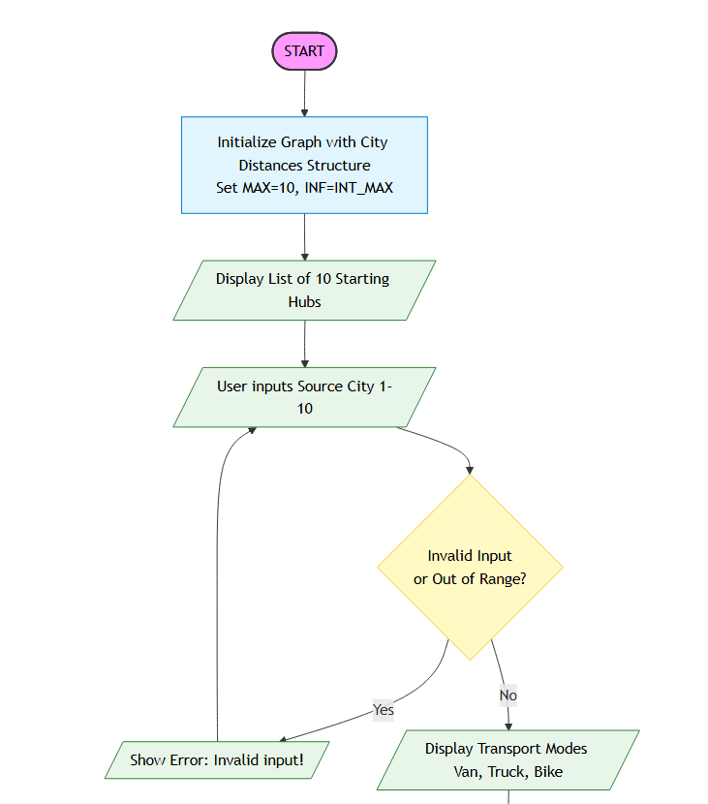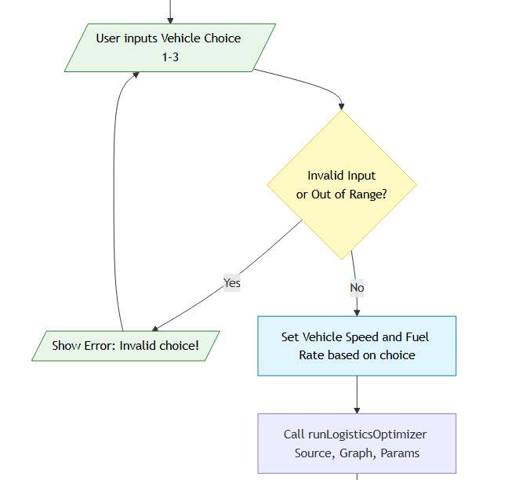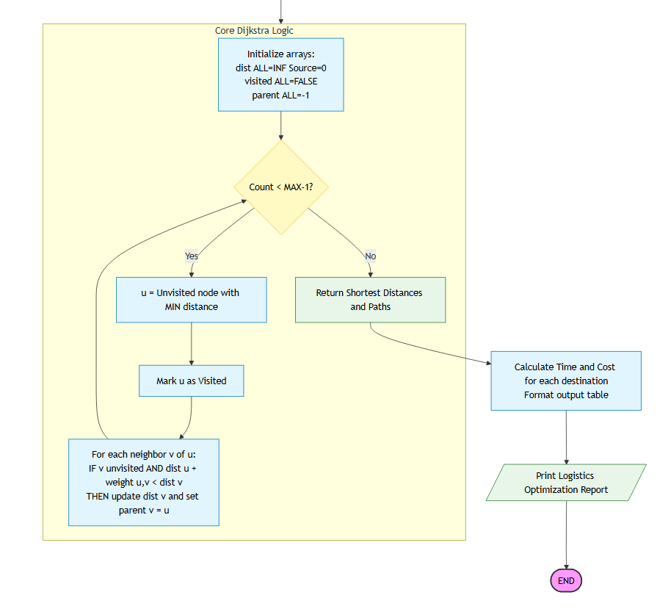

2.2.1 Output Screenshot
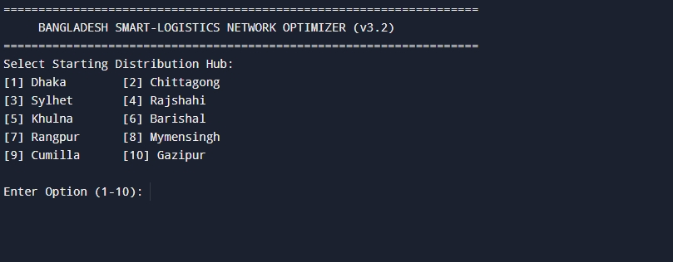
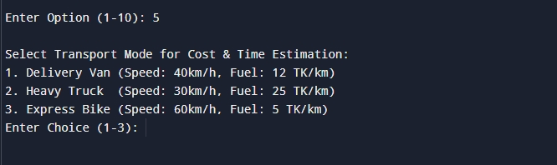
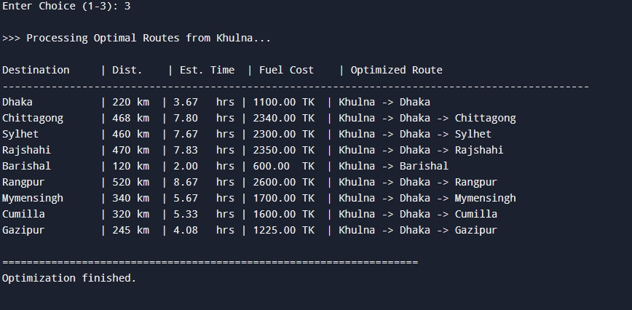

3. Performance Evaluation

3.1 Simulation Environment
- Compiler: GCC (GNU Compiler Collection)
- IDE: Code::Blocks / Dev-C++ / VS Code

Simulation Procedure
- User selects a starting city (1–10)
- Selects a vehicle type
- System validates input
- Algorithm executes and displays results

3.2 Results and Discussion
- The system successfully computes shortest paths
- Correctly identifies intermediate cities
  - Example: Dhaka → Cumilla → Chittagong
- Input validation prevents system errors
- Execution time is very fast (within milliseconds)

4. Conclusion

4.1 Discussion
This project demonstrates the practical application of a greedy algorithm in real-world logistics. It effectively bridges theoretical concepts with functional implementation.

4.2 Limitations
- Does not consider real-time traffic conditions
- Limited to a command-line interface (no GUI)

4.3 Future Scope
- Integration of real-time traffic data
- Dynamic edge weight adjustment
- Development of a graphical user interface (GUI) using OpenGL or GTK

Appendix: Core Algorithm (Dijkstra)

Steps
- Initialization
  - Source distance = 0
  - Other nodes = ∞
  - All nodes unvisited
- Update Distances
  - For each neighbor, calculate:
- Update if smaller
- Mark Visited
  - Current node becomes visited
- Repeat
  - Select the nearest unvisited node
  - Continue until all nodes are processed

Relaxation Formula

Complexity
- Time:
O(V²) using matrix
O((V + E) log V) using heap
- Space:
O(V)

5 Source Code
#include <stdio.h>
#include <stdlib.h>
#include <string.h>
#include <limits.h>
#include <stdbool.h>

#define MAX 10
#define INF INT_MAX
typedef struct {
char name[30];
} City;

int getMinDistance(int dist[], bool visited[], int n) {
int min = INF, min_index = -1;
for (int v = 0; v < n; v++) {
if (!visited[v] && dist[v] <= min) {
min = dist[v];
min_index = v;
}
}
return min_index;
}
void printPath(int parent[], int j, City cities[]) {
if (parent[j] == -1) return;
printPath(parent, parent[j], cities);
printf(" -> %s", cities[j].name);
}
void runLogisticsOptimizer(int graph[MAX][MAX], int src, int n, City cities[], float fuelRate, int speed) {
int dist[MAX];
bool visited[MAX];
int parent[MAX];

for (int i = 0; i < n; i++) {
dist[i] = INF;
visited[i] = false;
parent[i] = -1;
}

dist[src] = 0;
for (int count = 0; count < n - 1; count++) {
int u = getMinDistance(dist, visited, n);
if (u == -1) break;
visited[u] = true;

for (int v = 0; v < n; v++) {
if (!visited[v] && graph[u][v] && dist[u] != INF
&& dist[u] + graph[u][v] < dist[v]) {
parent[v] = u;
dist[v] = dist[u] + graph[u][v];
}
}
}
printf("\n%-15s | %-8s | %-10s | %-12s | %-30s\n", "Destination", "Dist.", "Est. Time", "Fuel Cost", "Optimized Route");
printf("------------------------------------------------------------------------------------------------\n");

for (int i = 0; i < n; i++) {
if (i == src) continue;

if (dist[i] == INF) {
printf("%-15s | %-8s | %-10s | %-12s | %-30s\n", cities[i].name, "N/A", "N/A", "N/A", "No Route Found");
} else {
float time = (float)dist[i] / speed;
float cost = (float)dist[i] * fuelRate;

printf("%-15s | %-3d km | %-6.2f hrs | %-7.2f TK | %s",
cities[i].name, dist[i], time, cost, cities[src].name);
printPath(parent, i, cities);
printf("\n");
}
}
}
int main() {
City cities[MAX] = {
{"Dhaka"}, {"Chittagong"}, {"Sylhet"}, {"Rajshahi"}, {"Khulna"},
{"Barishal"}, {"Rangpur"}, {"Mymensingh"}, {"Cumilla"}, {"Gazipur"}
};
int graph[MAX][MAX] = {
{0, 248, 240, 250, 220, 180, 300, 120, 100, 25},
{248, 0, 0, 0, 0, 0, 0, 0, 150, 0},
{240, 0, 0, 0, 0, 0, 0, 0, 160, 0},
{250, 0, 0, 0, 0, 0, 110, 0, 0, 0},
{220, 0, 0, 0, 0, 120, 0, 0, 0, 0},
{180, 0, 0, 0, 120, 0, 0, 0, 0, 0},
{300, 0, 0, 110, 0, 0, 0, 200, 0, 0},
{120, 0, 0, 0, 0, 0, 200, 0, 0, 100},
{100, 150, 160, 0, 0, 0, 0, 0, 0, 0},
{25, 0, 0, 0, 0, 0, 0, 100, 0, 0}
};
int sourceChoice, vehicleChoice;
float fuelRate = 0;
int speed = 0;
printf("====================================================================\n");
printf(" BANGLADESH SMART-LOGISTICS NETWORK OPTIMIZER (v3.2) \n");
printf("====================================================================\n");

printf("Select Starting Distribution Hub:\n");
for (int i = 0; i < MAX; i++) {
printf("[%d] %-12s ", i + 1, cities[i].name);
if ((i + 1) % 2 == 0) printf("\n");
}
while (1) {
printf("\nEnter Option (1-10): ");
if (scanf("%d", &sourceChoice) != 1) {
printf("Error: Invalid input! Please enter a valid NUMBER (1-10).\n");
while(getchar() != '\n');
continue;
}
if (sourceChoice >= 1 && sourceChoice <= MAX) {
break;
} else {
printf("Error: Out of range! Please enter a city number between 1 and 10.\n");
}
}
printf("\nSelect Transport Mode for Cost & Time Estimation:\n");
printf("1. Delivery Van (Speed: 40km/h, Fuel: 12 TK/km)\n");
printf("2. Heavy Truck (Speed: 30km/h, Fuel: 25 TK/km)\n");
printf("3. Express Bike (Speed: 60km/h, Fuel: 5 TK/km)\n");

while (1) {
printf("Enter Choice (1-3): ");
if (scanf("%d", &vehicleChoice) != 1) {
printf("Error: Invalid input! Please enter 1, 2, or 3.\n");
while(getchar() != '\n');
continue;
}
if (vehicleChoice >= 1 && vehicleChoice <= 3) {
break;
} else {
printf("Error: Invalid choice! Choose between 1, 2, or 3.\n");
}
}
if (vehicleChoice == 1) { speed = 40; fuelRate = 12.0; }
else if (vehicleChoice == 2) { speed = 30; fuelRate = 25.0; }
else { speed = 60; fuelRate = 5.0; }

printf("\n>>> Processing Optimal Routes from %s...\n", cities[sourceChoice - 1].name);
runLogisticsOptimizer(graph, sourceChoice - 1, MAX, cities, fuelRate, speed);
printf("\n====================================================================\n");
printf("Optimization finished.\n");
return 0;
}

5.1 Github Repository link for source code: Masrur-Siam/Bangladesh-Smart-Logistics-Network-Optimizer-ALGORITHM-project

