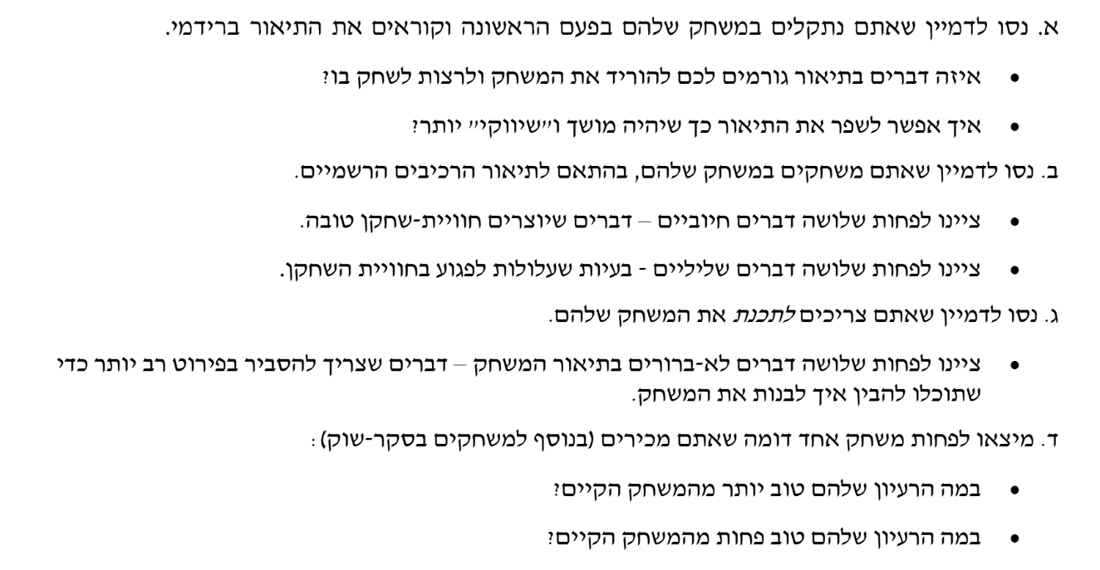

# Review on [Ghost Slayer](https://github.com/Our-Unique-Game/Ghost-Slayer)

**Question A:**

**What makes you want to download and play the game? How can the description be improved?**

The fact this game is based on a dark world in which ur mission is to turn on the lights and return hope to the ‘lost city’ is thrilling , in addition to that mentioning that there is encounters with ghosts that can temporarily be stunned makes the game more challenging and puts stress on u to stay alert about the surroundings

* though the devs mentioned puzzles that wasn’t very clear they should’ve specified what kind of puzzles, I highly encourage them to think of puzzles that add fun to the game and not something trivial & boring 😊   
  as when it comes to the tagline I honestly like it , simple and tells us exactly whats gonna happen in the game in a very brief tagline
* but when it comes to the title of the game its kind of contradicting whats happening in the game as the devs mentioned you arent going to be killing ghots but temporarily stunning them , so ‘slaying ghots’ isn’t really whats happening in this game , I would suggest names like : ‘city of the lost’ , ‘village of darkness’ etc …

**Question B:**

**What are 3 good things and 3 bad things about the game?**

**positive reviews**

1. In the description the worlds appear to be open relative to the boundaries of the village, usually open world games add fun and more integration with the atmosphere of the game
2. The fact that you’re being haunted by ghosts 24/7 and you can’t get rid of them indefinitely adds thrill and challenge to the game
3. Puzzles assuming they’re going to be fun are going to be a big-time part of the game

**Negative reviews**

1. Since the puzzles aren’t well described in worst case scenario they would turn out to be boring yet make the game not fun to play , which isn’t going to leave the player with the feeling of ‘you know what ? im going to also play tomorrow’
2. In the goals of the game its unclear where the puzzles take part in the game , it only mentions searching for switches and stunning ghosts which leaves me with unclear vision
3. The fact its described as open world (relatively to the village) makes the player uncertain where to start from maybe they’re going randomly to a complicated hard room then after it they would enter an easy difficulty room which makes it less fun and less appealing

**Question C:**

**What is not clear and needs more explanation?**

1. Puzzles aren’t described well dev has to know how the puzzles look like and how to make them more complex with time !
2. In description it says player is going to have inventory of items and tools , didn’t specifty which tools exactly in the description of the game.
3. Is the puzzle going to be before placing the fuse or after , or even when searching for the fuse?

**Question D:**

**What is a similar game? How is "Stranger Danger" better or worse?**

A similar game to "Ghost Slayer" is **"Luigi's Mansion"**:

* **Strengths of "Ghost Slayer" Compared to "Luigi's Mansion":**
  1. The darker, more serious tone of "Ghost Slayer" appeals to older players (ages 12+), whereas "Luigi's Mansion" targets a younger audience.
  2. The emphasis on lighting up an entire haunted village, instead of just a single mansion, provides a larger, more immersive environment.
  3. The constant ghost presence and inability to permanently defeat them create a higher level of tension and challenge.
* **Weaknesses of "Ghost Slayer" Compared to "Luigi's Mansion":**
  1. "Luigi's Mansion" has a highly polished narrative with clear objectives and charming characters, which "Ghost Slayer" could improve by adding memorable NPCs or story elements.
  2. The gameplay in "Luigi's Mansion" is more dynamic, with varied ghost-catching mechanics, while "Ghost Slayer" relies heavily on finding light switches, which could risk becoming repetitive.
  3. "Luigi's Mansion" has a strong progression system, where players feel a sense of achievement through upgrades and new tools, which "Ghost Slayer" currently lacks.

# Review on [Stranger Danger](https://github.com/Our-Unique-Game/Stranger-Danger/tree/main)

**Question A:**

**What makes you want to download and play the game? How can the description be improved?**

1. **What is good:**
   * The concept of defending a large mansion using traps is exciting and strategic.
   * The idea of crafting trap materials adds depth to the gameplay.
   * The fast-paced nature of the game, with no resting until victory, keeps players engaged.
2. **How to improve:**
   * The tagline could be made more engaging. For example: *"Outwit the thieves, protect your home, and survive the night!"*
   * Explain how crafting traps works—this can make the description more appealing.
   * Mention unique mechanics, like the ability to anticipate thief paths, to show how the game stands out.

**Question B:**

**What are 3 good things and 3 bad things about the game?**

1. **Good things:**
   * The crafting system makes the game more interactive and creative.
   * The confined mansion setting adds tension and excitement.
   * The constant threat of thieves creates a fast-paced and thrilling experience.
2. **Bad things:**
   * It’s unclear how varied the traps or thief behaviors are—repetition might reduce replayability.
   * The game may feel too intense for younger players without moments of relief or strategy pauses.
   * If items needed for traps are hard to find, it might frustrate players rather than challenge them.

**Question C:**

**What is not clear and needs more explanation?**

1. How does the crafting system work? Are there recipes or hints for creating traps?
2. Are the thieves’ paths randomized, or do they follow predictable patterns?
3. Does the game provide a progression system (e.g., harder challenges as the game continues)?

**Question D:**

**What is a similar game? How is "Stranger Danger" better or worse?**

A similar game is **"Hello Neighbor"**:

* **Why "Stranger Danger" is better:**
  1. It focuses on defending a mansion rather than sneaking around, making it more action-oriented.
  2. The crafting system adds a unique layer of creativity not found in "Hello Neighbor."
  3. The fast-paced gameplay appeals to players who enjoy constant engagement and strategy.
* **Why "Stranger Danger" is worse:**
  1. "Hello Neighbor" has a deeper narrative and backstory, which might make it more immersive.
  2. "Hello Neighbor" offers more environmental exploration, while "Stranger Danger" is limited to trap-based mechanics.
  3. Without a progression system, "Stranger Danger" might lack the long-term engagement of "Hello Neighbor."

# Review on [School Escape](https://github.com/Our-Unique-Game/School-Escape)

**Question A:**

**What makes you want to download and play the game? How can the description be improved?**

1. **What is good:**
   * The idea of escaping school by solving puzzles is exciting and fun.
   * Mixing education (math, English, programming) with adventure makes it useful and entertaining.
   * The part where you interact with classmates to get hints is interesting and adds teamwork.
2. **How to improve:**
   * The tagline could be more exciting, like: *"Solve, Escape, and Outsmart Your School!"*
   * Add more details about the challenges, like how avoiding security checks will be fun.
   * Say why the game is special, like how it combines education and adventure.

**Question B:**

**What are 3 good things and 3 bad things about the game?**

1. **Good things:**
   * The puzzles are educational and fun, which makes the game unique.
   * The goal of escaping the school is exciting and keeps the player focused.
   * Talking to classmates for hints makes the game feel alive and interactive.
2. **Bad things:**
   * It’s not clear if the puzzles get harder step by step. If they are too hard at the start, it might frustrate players.
   * Avoiding security checks could feel repetitive if there’s no variety in how it works.
   * The game is only set in a school, which might feel boring if the environment doesn’t change.

**Question C:**

**What is not clear and needs more explanation?**

1. How does avoiding security checks work? Do you hide, run, or use some tools?
2. Are the hints from classmates free, or do they cost something (like losing points or time)?
3. Do the puzzles change difficulty based on the player’s skill, or are they the same for everyone?

**Question D:**

**What is a similar game? How is "School Escape" better or worse?**

A similar game is **"The Escapists"**:

* **Why "School Escape" is better:**
  1. It focuses on education (math, English, programming), which makes it more useful for younger players.
  2. The story of escaping school feels relatable and fun for many people.
  3. Talking to classmates for hints adds teamwork, which is not in "The Escapists."
* **Why "School Escape" is worse:**
  1. "The Escapists" gives players many ways to escape, while "School Escape" feels more straightforward.
  2. "The Escapists" includes crafting and managing items, which makes the gameplay deeper.
  3. "The Escapists" has different levels (different prisons), but "School Escape" is only set in one school.