

toyota car repair system design

158.751 Object Oriented Software Development



Team members

Rebecca Liu 17238744

Ziyi Wang 18042783

1 Use Case Mode 2

1.1 Use Case: Confirm -Typical Flow of Events 2

1.1.1 Alternate Flow One 3

1.1.2 Alternate Flow Two 4

1.2 Use Case: Assign and Solve Jobs --Typical Flow of Events 4

1.2.1 Alternate Flow One 4

1.2.2 Alternate Flow Two 6

2 System Sequence Diagrams 7

3 Class Diagram 8

1. Use Case Mode

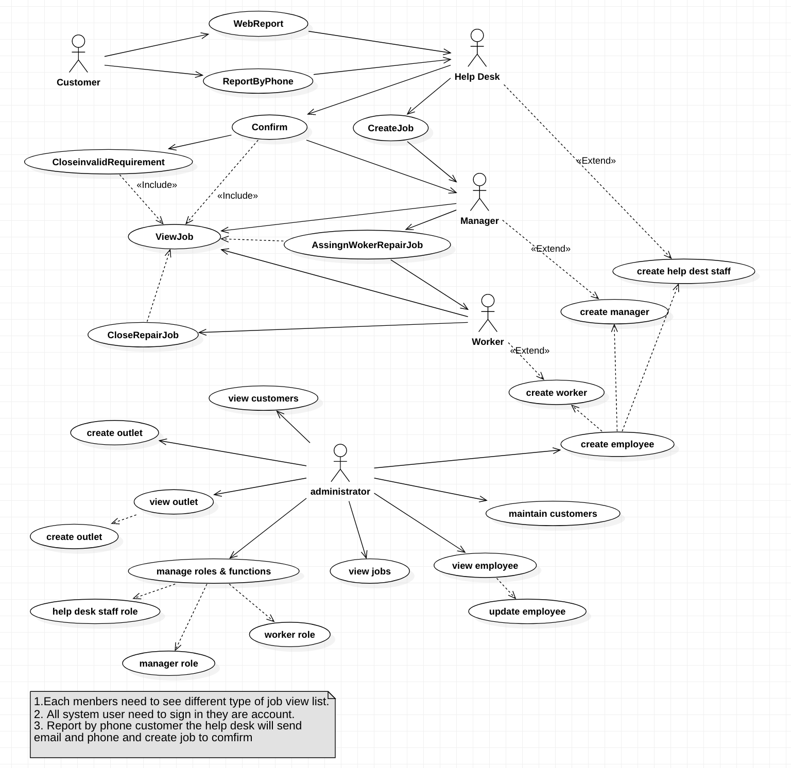

* 1. Use Case: Confirm -Typical Flow of Events

|  |  |
| --- | --- |
| Actor Intentions | System Responsibility |
| 1. Customers Sign in website report system (Add customer name, Car plates). | 1. System presents customer information (Car repair history). |
| 1. Customers create car repair request. (Car plates, Customer name, choose repair outlets, shortest problem description). | 1. System receives request and send it to Help Desk verify the request. |
| 1. Customers sent car repair request by phone to Help Desk, Help Desk will email and phone to customer and create job in system (Car plates, Customer name, choose repair outlets, shortest problem description). | 1. Presents accumulating list of unconfirmed repair request. |
| 1. Help Desk need to modify request status (usually close or open request ) | 1. If open status, system send it to manager. |

* + 1. Alternate Flow One

|  |  |
| --- | --- |
| Actor Intentions | System Responsibility |
| 1. Customers Sign in website report system (Add customer name, Car plates). | 1. System presents customer information (Car repair history). |
| 1. Customers create car repair request. (Car plates, Customer name, choose repair outlets, shortest problem description). | 1. System receives request and send it to Help Desk verify the request. |
| 1. Customers withdraw request change status to close. | 1. If close status, system will not send it to manager. |

* + 1. Alternate Flow Two

|  |  |
| --- | --- |
| Actor Intentions | System Responsibility |
| 1. Customers Sign in website report system (Add customer name, Car plates). | 1. System presents customer information (Car repair history). |
| 1. Customers create car repair request. (Car plates, Customer name, choose repair outlets, shortest problem description). | 1. System receives request and send it to Help Desk verify the request. |
| 1. Customers sent car repair request by phone to Help Desk, Help Desk will email and phone to customer and create job in system (Car plates, Customer name, choose repair outlets, shortest problem description). | 1. Presents accumulating list of unconfirmed repair request. |
| 1. Help Desk need to modify request status (usually close or open request ) | 1. If close status, system will not send it to manager. |

* 1. Use Case: Assign and Solve Jobs --Typical Flow of Events

|  |  |
| --- | --- |
| Actor Intentions | System Responsibility |
| 1. Manager signs in the website. | 2. System presents all the open jobs |
| 3. Manager assign jobs to the workers managed by him. | 4. System changes the jobs status to assigned, add the jobs to the workers’ list |
| 5. Worker signs in the website. | 6. System presents all the jobs assigned to this worker. |
| 7. Worker works on the jobs and closes the jobs which he finishes. | 8. System changes the jobs status to close. |

* + 1. Alternate Flow One

|  |  |
| --- | --- |
| Actor Intentions | System Responsibility |
| 1. Manager signs in the website. | 2. System presents all the open jobs |
| 3. Manager sees duplicated jobs and closes duplicated ones. | 4. System changes the duplicated jobs status to closed |
| 5. Manager assign jobs to the workers managed by him. | 6. System changes the jobs status to assigned, add the jobs to the workers’ list |
| 7. Worker signs in the website. | 8. System presents all the jobs assigned to this worker. |
| 9. Worker works on the jobs and closes the jobs which he finishes. | 10. System changes the jobs status to closed. |

* + 1. Alternate Flow Two

|  |  |
| --- | --- |
| Actor Intentions | System Responsibility |
| 1. Manager signs in the website. | 2. System presents all the open jobs |
| 3. Manager sees more jobs than which his workers can accomplishes during one work day. |  |
| 4.Manager changes the jobs’ priority to high if he wants his worker do them first. | 5.System changes the jobs’ priority to high. |
| 6. Manager assign jobs to the workers managed by him. | 7. System changes the jobs status to assigned, add the jobs to the workers’ list |
| 7. Worker signs in the website. | 8. System presents all the jobs assigned to this worker and emphasises the high priority ones. |
| 9. Worker works on the jobs and closes the jobs which he finishes. | 10. System changes the jobs status to closed. |

1. System Sequence Diagrams

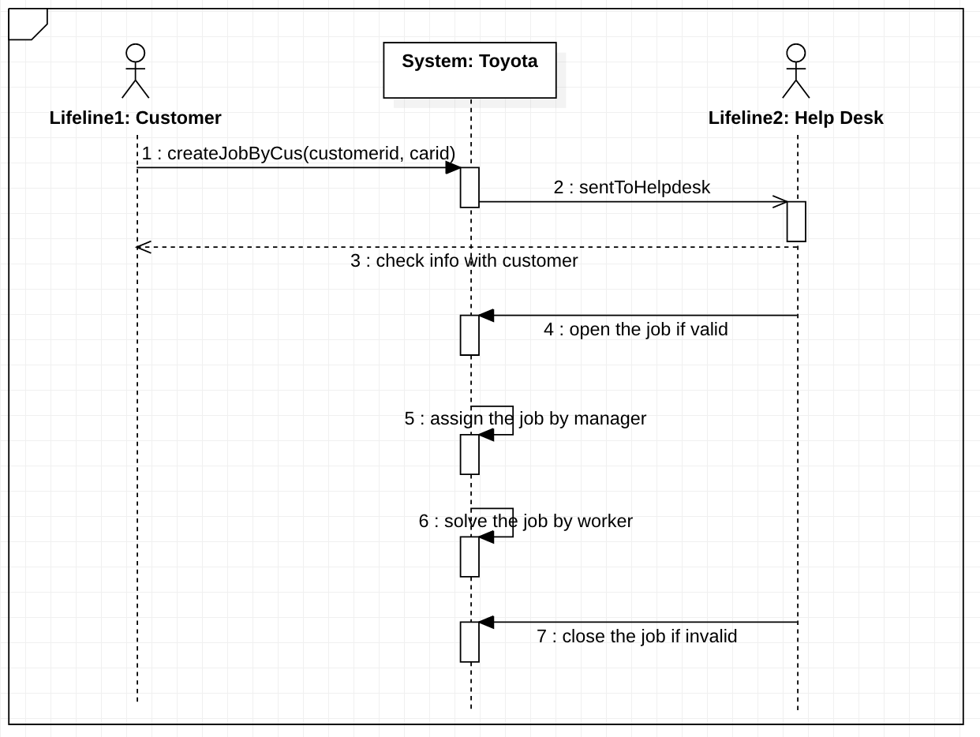

1. Class Diagram

