**Toyota Outlets Car Repair System—**Assignment1 158.751 Team Project

Team Member: Student Name +Student ID /Student Name +Student ID

Content

1. Use Case Model
   1. Use Case: Confirm -Typical Flow of Events
      1. Alternate Flow One
      2. Alternate Flow Two
   2. Use Case Basic Flow
      1. Alternate Flow One
      2. Alternate Flow Two
2. System Sequence Diagrams
3. Class Diagram
4. Use Case Model

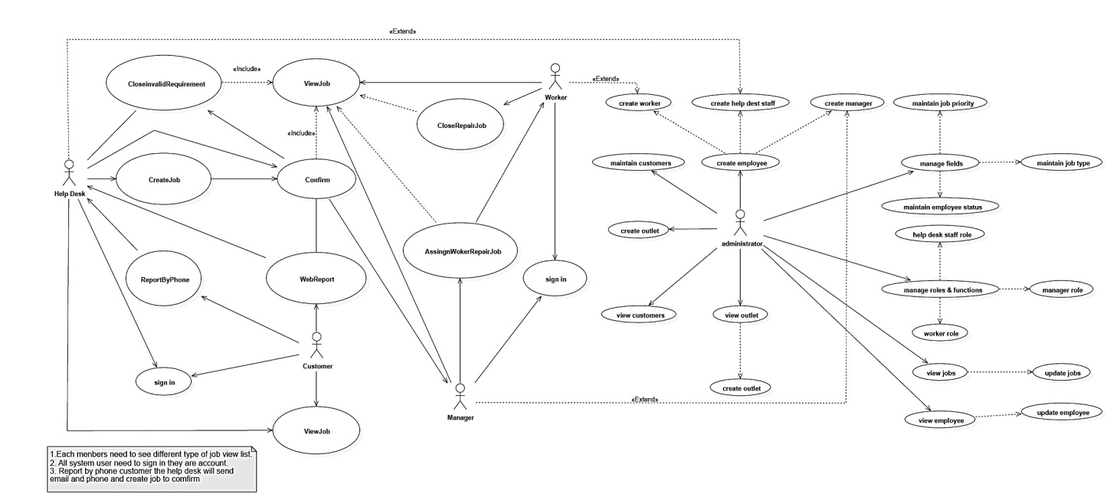

* 1. Use Case: Confirm -Typical Flow of Events

|  |  |
| --- | --- |
| Actor Intentions | System Responsibility |
| 1. Customers Sign in website report system (Add customer name, Car plates). | 1. System presents customer information (Car repair history). |
| 1. Customers create car repair request. (Car plates, Customer name, choose repair outlets, shortest problem description). | 1. System receives request and send it to Help Desk verify the request. |
| 1. Customers sent car repair request by phone to Help Desk, Help Desk will email and phone to customer and create job in system (Car plates, Customer name, choose repair outlets, shortest problem description). | 1. Presents accumulating list of unconfirmed repair request. |
| 1. Help Desk need to modify request status (usually close or open request ) | 1. If open status, system send it to manager. |

* + 1. Alternate Flow One

|  |  |
| --- | --- |
| Actor Intentions | System Responsibility |
| 1. Customers Sign in website report system (Add customer name, Car plates). | 1. System presents customer information (Car repair history). |
| 1. Customers create car repair request. (Car plates, Customer name, choose repair outlets, shortest problem description). | 1. System receives request and send it to Help Desk verify the request. |
| 1. Customers withdraw request change status to close. | 1. If close status, system will not send it to manager. |

* + 1. Alternate Flow Two

|  |  |
| --- | --- |
| Actor Intentions | System Responsibility |
| 1. Customers Sign in website report system (Add customer name, Car plates). | 1. System presents customer information (Car repair history). |
| 1. Customers create car repair request. (Car plates, Customer name, choose repair outlets, shortest problem description). | 1. System receives request and send it to Help Desk verify the request. |
| 1. Customers sent car repair request by phone to Help Desk, Help Desk will email and phone to customer and create job in system (Car plates, Customer name, choose repair outlets, shortest problem description). | 1. Presents accumulating list of unconfirmed repair request. |
| 1. Help Desk need to modify request status (usually close or open request ) | 1. If close status, system will not send it to manager. |

* 1. Use Case Basic Flow
     1. Alternate Flow One
     2. Alternate Flow Two

1. System Sequence Diagrams
2. Class Diagram