Contents

1 Problem statement 2

1.1 Customer 2

1.2 Helpdesk 3

1.3 Manager 3

1.4 Worker 4

1.5 Job 4

2 Future Enhancement 5

3 Design and Implementation 6

3.1 Model 6

3.2 View 7

3.3 DAL & BLL 8

3.4 Class Diagram 10

4 Data Structure 10

5 Lessons learned 11

Appendix A- Initialized Data 13

Appendix B- UML Diagram 16

Appendix C- Test Users 17

# Problem statement

Toyota Repairing Services provides a real time solution for the customers who have their car repairing requests. The customer can report their repairing requests online, and, see the reports about the results of their requests. The customer can also report the problems through the helpdesk of any outlet. After the confirmation of the request, a repair job can be assigned to a worker. The job can be closed by a worker after it is repaired. The following picture is the use case diagram of the system.

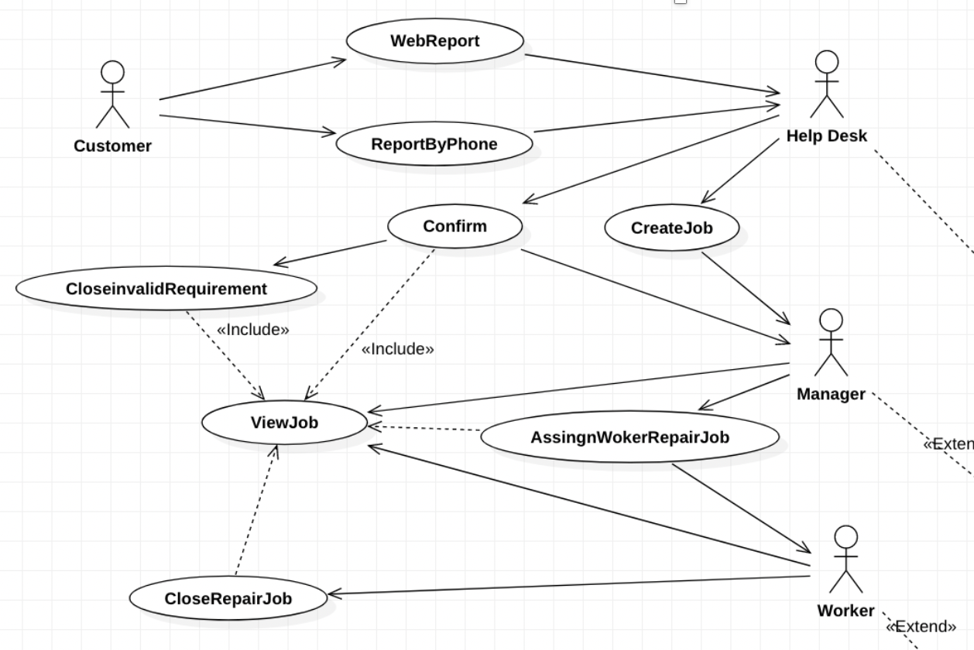

## Customer

We want the customers can freely choose the way to report their car problem and know the result of their requests in real time. So, we provide the following functions:

1. Customer can report the car repairing request online.
2. Customer can report the car repairing request through helpdesk by phone or email, etc.
3. Customer can see the result of the repairing request in real time through online service.

## Helpdesk

We want the helpdesk can record the repairing jobs fluently, and, know clearly about the jobs they need to confirm. So, we provided the following functions:

1. Helpdesk can add a job through the system if they receive the repairing job through outside the system.
2. Helpdesk can check the job details and confirm it if they saw an unconfirmed job reported by the customer through the system.
3. Helpdesk can update a job through the system.

## Manager

We want the manager can know clearly about how many jobs to be assigned, and, manage the jobs fluently. So, we provided the following functions:

1. Manager can assign/reassign jobs to the workers belong to him.
2. Manager can set the job’s priority.
3. Manager can see the report of a list of open/closed jobs assigned to a particular employee, a list of open/closed jobs, a list of jobs related to one particular car, a list of workers and the number of open jobs they have.

## Worker

We want the worker can know clearly about what they need to do, and, can show what they have done in real time in the system. So, we provided the following functions:

1. Worker can close (resolve) a job.
2. Worker can see a list of open/closed jobs assigned to him, a list of jobs related to one particular car.

## Job

The jobs are dealt in the following work flow.

# Future Enhancement

In this project, we just implemented the basic workflow of the Repair Service System. Some enhancements can be done in the future.

1. System administration

We can develop a department management function, in the future, to match the development of the organization. There will be more workers and roles.

Some more management parts can be added. For example, roles and functions configuration, system fields configuration, and data access control, etc.

1. Sign up

Now the customers are the initialization data of the system. In the future, we can add the signup function to get more and more users involved more conveniently.

1. More flexible workflow settings & strict control

Now the workflow is fixed, as shown in 2.5. We can define different workflows for different kinds of jobs. In addition, the system lacks strict control of the job process. For example, if the job comes to resolving stage, the information of the job cannot by modified, etc.

1. Better UI design

The system’s UI is functional. We can design more friendly interface to make it more enjoyable to use.

1. More analysis reports

We can add more graphs for better process management and quality control when the business becomes more complex. For example, the cost control chart, burnout chart, etc.

1. Feedback

We can add feedback function for the user to evaluate the quality of the services.

# Design and Implementation

We use Three-tier architecture in our coding design. Our application is separated into the following three components. Basically 3-Tier include presentation layer, business logic layer and data access layer. In our project we design like UI layer, BLL layer DAL layer and Model layer.

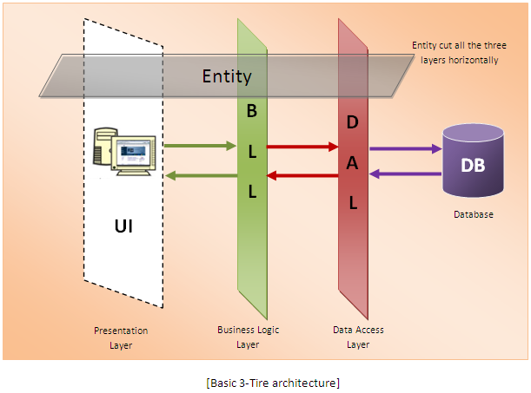

( https://stackoverflow.com/questions/13786549/how-to-implement-3-tiers-architecture-in-c-sharp )

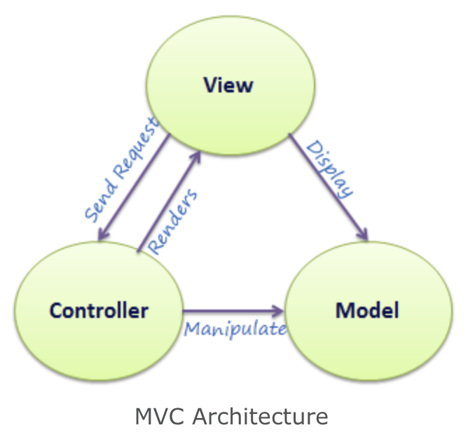

*(http://www.tutorialsteacher.com/mvc/mvc-architecture)*

## Model

Model defines all the data we use in this application. We have TcarSystemModel folder to put all of our model classes in. The major classes in this layer is JobInfo and UserInfor which are also the main tables in our database.

Some configuration items, like JobStatus, Priority, ResolveStatus, are defined as model classes which are enum-type. The rule here is that, if we do not have to change the contents of the data fields, we put them here rather than in the database.

Some model classes, like Outlet, are used for the foreign key in our application.

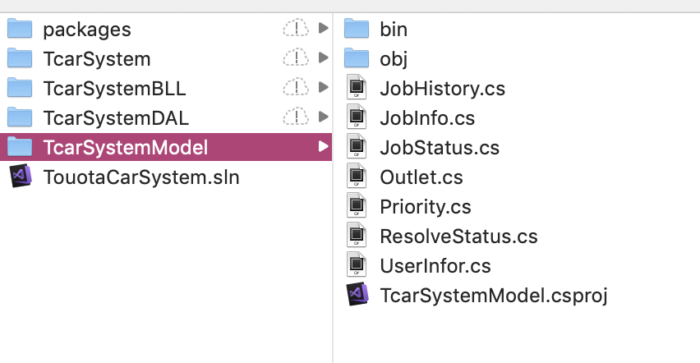

## UI

View includes all of our user interface class which is the TcarSystem folder in our application.

We put all of our window forms here. We separated the forms for different roles. For instance, we have the helpdesk form, worker form, manager form, and customer form. In this way, we can:

1. Reduce the complexity and the data traffic of putting all the things in one page. This can improve the performance of the page.
2. Generate loose coupling so that we can separate the tasks to different team player to finish. Besides, it is good for expanding different functions for different roles.
3. When we modify something, it will not influence other forms.

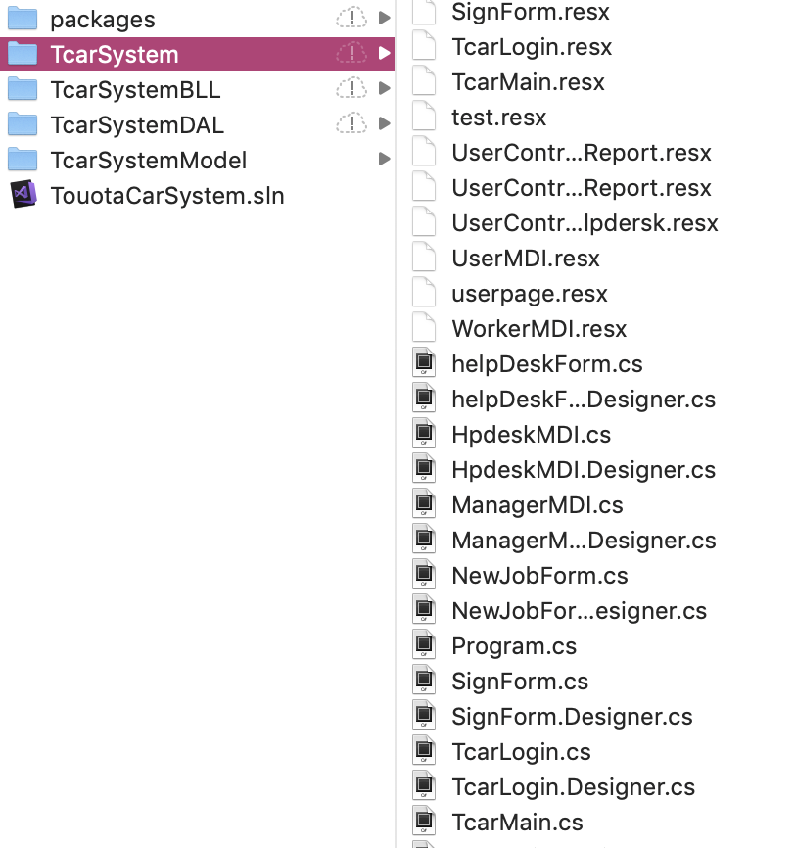

## DAL & BLL

Controller is the bridge between the model and the view. It contains all the business operations. We abstract all the actions in our applications to this layer using the Model to response the requests of the View.

We separate our controller to TcarSystemBLL folder and TcarSystemDAL folder, as the following two pictures show.

In DAL folder, there are two major classes, JobInfoManager and UserInforDAL which contain the basic operations to the related database tables, for example, the adding, searching, updating, and deleting. SqliteHelper is the support functions of the database operation. The other class’ functions are based on this. In additions, we put several classed for using foreign keys, like sys_OutletService and Sys-roleService which is used to relate the job table and the user table, outlet table.

In BLL folder which is closer to View than DAL, there are the encapsulations for DAL classes, for example, JobInfrManager, UserInforBLL. These are used by the View forms directly.

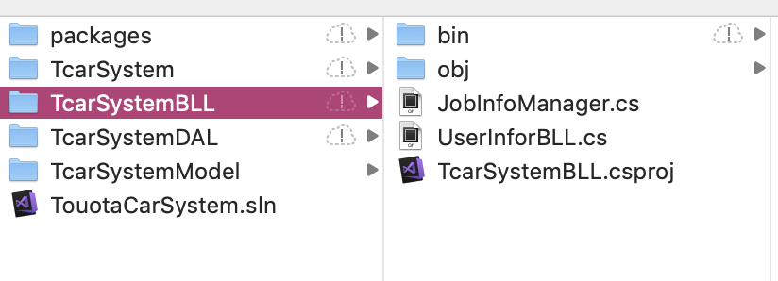

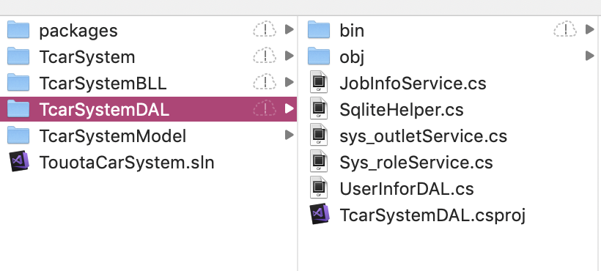

The benefits of having BLL and DAL:

1. The lower layer has the multi-use functions which reduce the maintenance costs come from the modified database or model classes.
2. Improve the code reusability, and, simplify the complexity of codes in higher layers.
3. The programing can be done from both sides which benefits group works in parallel.

## Class Diagram

Copy from visual studio

# Data Structure

Test data - Create tables:

CREATE TABLE Outlets (  
    otID    INTEGER PRIMARY KEY NOT NULL,  
    otAddress TEXT NOT NULL,  
    otName    TEXT NOT NULL  
);  
  
CREATE TABLE user (  
    userId    INTEGER PRIMARY KEY NOT NULL,  
    user_name    TEXT DEFAULT '',  
    carNo    TEXT DEFAULT '',  
    user_password    TEXT NOT NULL,  
    identity    TEXT DEFAULT '',  
    Outlet    INTEGER,  
    FOREIGN KEY(Outlet) REFERENCES Outlet(otID)  
);  
  
CREATE TABLE jobs (  
    id    INTEGER PRIMARY KEY NOT NULL,  
    closedate TEXT DEFAULT '',  
    createdate    TEXT NOT NULL,  
    carNo    TEXT DEFAULT '',  
    desk    INTEGER,  
    manager    INTEGER,  
    worker    INTEGER,  
    jobDescription    TEXT DEFAULT '',  
    resolve    INTEGER,  
    priority INTEGER,  
    comment     TEXT DEFAULT '',  
    outlet INTEGER,  
    customer INTEGER,  
    jobStatus INTEGER,  
    opendate TEXT DEFAULT '',  
    assigndate TEXT DEFAULT '',  
    FOREIGN KEY(customer) REFERENCES user(userId),  
    FOREIGN KEY(worker) REFERENCES user(userId),  
    FOREIGN KEY(manager) REFERENCES user(userId),  
    FOREIGN KEY(desk) REFERENCES user(userId),  
    FOREIGN KEY(outlet) REFERENCES Outlets(otID)  
);

Other test data is in Appendix A.

# Lessons learned

Both of our team members do not have any developing experiences before. We have learned a lot from doing this project.

Firstly, we use our in-class knowledge of use case diagram to describe the system we need to do. We used system sequence diagram (SSD), use case diagram.

Secondly, we have learned and tried MVC pattern in our project. We have low coupling and high cohesion classes in the lower layers, such as Model classes, DAL classes, BLL classes. In these layers, each class deal with all the business around it. For example, JobInfoManager which is in BLL folder has all the job-related functions, such as, adding, searching with certain conditions, updating, etc.

Thirdly, we practiced how to use Visual Studio. We used it to write C# application. Then, we use SQLite to store our data. We encountered some configuration problems, such as Sys.Data.SQLite version problem. We tried several versions and followed some forum contents to modify our project settings to solve such kind of problems.

Lastly, we also improved our first design of the classes in our implementation. The new class diagram is shown in 4.4.

In addition, in this group project, we encountered version control problems. We chose git to manage our code, to deal with the conflicts. We set up some rules like when to submit our codes and what kind of files we need to submit, etc. Through this, we understand better about the collaboration in a small developing team.

# Appendix A- Initialized Data

-- add outlets;  
INSERT INTO Outlets (otAddress, otName) VALUES ('Albany', 'Albany');  
INSERT INTO Outlets (otAddress, otName) VALUES ('Glenfield', 'Glenfield');  
  
--add users;  
INSERT INTO user(user_name,carNo,user_password,identity,Outlet) VALUES ('jay','jj334','jay1234','user',1);  
INSERT INTO user(user_name,carNo,user_password,identity,Outlet) VALUES ('zoe','AE86','zoe','hpdesk',1);  
INSERT INTO user(user_name,carNo,user_password,identity,Outlet) VALUES ('xian','BNT67','xian','user',1);  
INSERT INTO user(user_name,carNo,user_password,identity,Outlet) VALUES ('happy','75214aa','happybirthday','work',1);  
INSERT INTO user(user_name,carNo,user_password,identity,Outlet) VALUES ('worry','8585ss','123456sd','manager',1);  
INSERT INTO user(user_name,carNo,user_password,identity,Outlet) VALUES ('R','HTZ123','r123','manager',2);  
INSERT INTO user(user_name,carNo,user_password,identity,Outlet) VALUES ('Rtest','HTZ123','r123','user',);  
INSERT INTO user(user_name,carNo,user_password,identity,Outlet) VALUES ('user1','U111','r123','user',NULL);  
INSERT INTO user(user_name,carNo,user_password,identity,Outlet) VALUES ('user2','U111','r123','user',NULL);  
INSERT INTO user(user_name,carNo,user_password,identity,Outlet) VALUES ('user3','U333','r123','user',NULL);  
INSERT INTO user(user_name,carNo,user_password,identity,Outlet) VALUES ('user3','U444','r123','user',NULL);  
INSERT INTO user(user_name,carNo,user_password,identity,Outlet) VALUES ('user4','U444','r123','user',NULL);  
INSERT INTO user(user_name,carNo,user_password,identity,Outlet) VALUES ('user5','U555','r123','user',NULL);  
INSERT INTO user(user_name,carNo,user_password,identity,Outlet) VALUES ('Rde',' ','r123','hpdesk',2);  
INSERT INTO user(user_name,carNo,user_password,identity,Outlet) VALUES ('Rma',' ','r123','manager',2);  
INSERT INTO user(user_name,carNo,user_password,identity,Outlet) VALUES ('Rwo',' ','r123','work',2);  
  
--add jobs;  
INSERT INTO jobs ( closedate, createdate, carNo, desk, manager, worker, jobDescription, resolve, priority, comment, outlet,customer,jobStatus,opendate,assigndate)  
VALUES('2018-10-10','2018-5-10','jj334',NULL,NULL,NULL,'repair',NULL,2,NULL,1,2,0,NULL,NULL);  
  
INSERT INTO jobs ( closedate, createdate, carNo, desk, manager, worker, jobDescription, resolve, priority, comment, outlet,customer,jobStatus,opendate,assigndate)  
VALUES('2018-10-10','1541035846','NZT123',NULL,NULL,NULL,'Engin broke',NULL,1,NULL,1,4,0,NULL,NULL);  
  
INSERT INTO jobs ( closedate, createdate, carNo, desk, manager, worker, jobDescription, resolve, priority, comment, outlet,customer,jobStatus,opendate,assigndate)  
VALUES('','2018-11-06','HTZ123',NULL,NULL,NULL,'Rear door broke',NULL,1,NULL,2,9,0,NULL,NULL);  
  
INSERT INTO jobs ( closedate, createdate, carNo, desk, manager, worker, jobDescription, resolve, priority, comment, outlet,customer,jobStatus,opendate,assigndate)  
VALUES('','2018-11-06','U111',NULL,NULL,NULL,'Rear door broke',NULL,1,NULL,2,10,0,NULL,NULL);  
  
INSERT INTO jobs ( closedate, createdate, carNo, desk, manager, worker, jobDescription, resolve, priority, comment, outlet,customer,jobStatus,opendate,assigndate)  
VALUES('','2018-11-06','U111',NULL,NULL,NULL,'Rear door broke',NULL,1,NULL,2,11,0,NULL,NULL);  
  
INSERT INTO jobs ( closedate, createdate, carNo, desk, manager, worker, jobDescription, resolve, priority, comment, outlet,customer,jobStatus,opendate,assigndate)  
VALUES('','2018-11-06','U111',12,13,NULL,'Rear door broke',NULL,1,NULL,2,11,1,'2018-11-06',NULL);  
  
INSERT INTO jobs ( closedate, createdate, carNo, desk, manager, worker, jobDescription, resolve, priority, comment, outlet,customer,jobStatus,opendate,assigndate)  
VALUES('','2018-11-06','U111',12,13,NULL,'window broke',NULL,1,NULL,2,11,1,'2018-11-06',NULL);  
  
INSERT INTO jobs ( closedate, createdate, carNo, desk, manager, worker, jobDescription, resolve, priority, comment, outlet,customer,jobStatus,opendate,assigndate)  
VALUES('','2018-11-06','U444',12,13,NULL,'back window broke',NULL,1,NULL,2,15,1,'2018-11-06',NULL);  
  
INSERT INTO jobs ( closedate, createdate, carNo, desk, manager, worker, jobDescription, resolve, priority, comment, outlet,customer,jobStatus,opendate,assigndate)  
VALUES('','2018-11-06','U555',12,13,NULL,'back window broke',NULL,1,NULL,2,16,1,'2018-11-06',NULL);  
  
INSERT INTO jobs ( closedate, createdate, carNo, desk, manager, worker, jobDescription, resolve, priority, comment, outlet,customer,jobStatus,opendate,assigndate)  
VALUES('','2018-11-06','U666',12,13,14,'back seat broke',NULL,1,NULL,2,17,1,'2018-11-06','2018-11-06');  
  
INSERT INTO jobs ( closedate, createdate, carNo, desk, manager, worker, jobDescription, resolve, priority, comment, outlet,customer,jobStatus,opendate,assigndate)  
VALUES('','2018-11-06','U667',12,13,14,'back seat broke',NULL,1,NULL,2,18,1,'2018-11-06','2018-11-06');  
  
INSERT INTO jobs ( closedate, createdate, carNo, desk, manager, worker, jobDescription, resolve, priority, comment, outlet,customer,jobStatus,opendate,assigndate)  
VALUES('','2018-11-06','U668',12,13,14,'back seat broke',NULL,1,NULL,2,18,1,'2018-11-06','2018-11-06');  
  
INSERT INTO jobs ( closedate, createdate, carNo, desk, manager, worker, jobDescription, resolve, priority, comment, outlet,customer,jobStatus,opendate,assigndate)  
VALUES('','2018-11-06','U669',12,13,14,'back seat broke',NULL,1,NULL,2,16,1,'2018-11-06','2018-11-06');

# Appendix B- UML Diagram

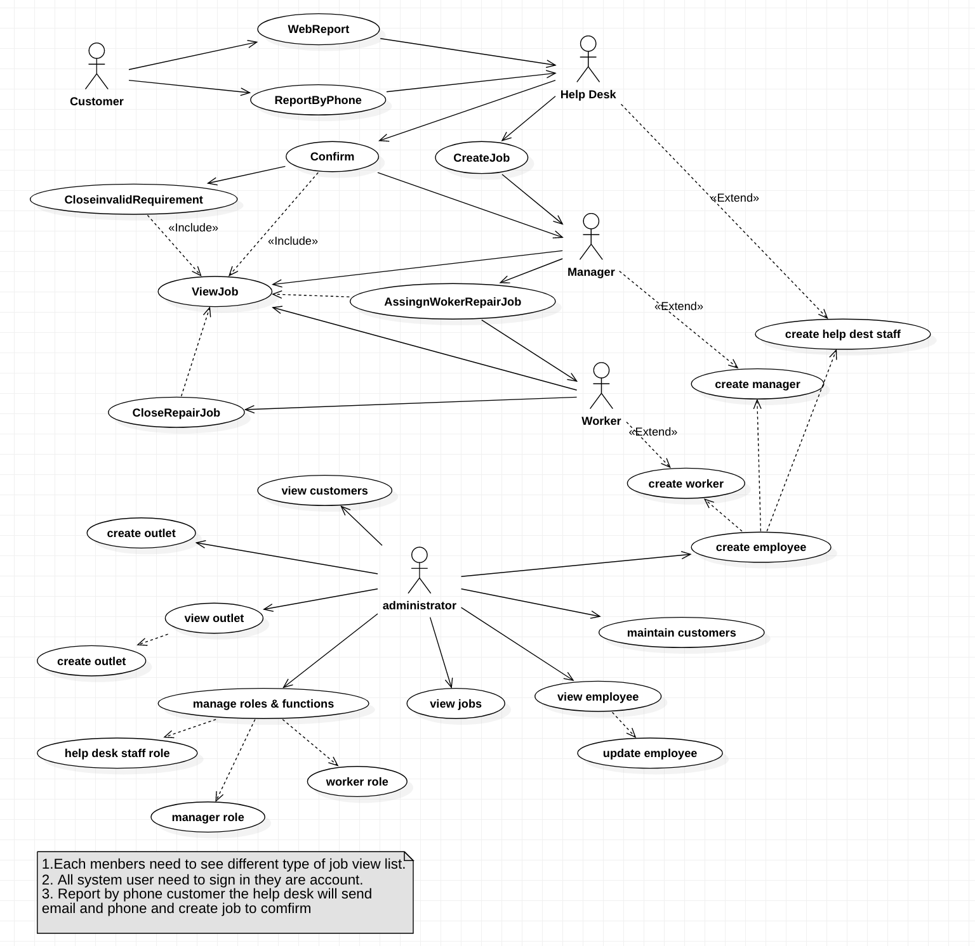

# Appendix C- Test Users

|  |  |  |  |
| --- | --- | --- | --- |
| Role | Use Name | Password | Actions |
| Customer |  |  | Add a new repair job |
| Help Desk |  |  | Add a new repair job  Update a job  Confirm a job  Close an invalid job |
| Manager |  |  | Assign a job & set the priority |
| Worker |  |  | Close a job |