Robot Path-Planning Algorithms for Fully Dynamic Shortest Path Problems Report

//署名+Student ID

# Abstract

D start Lite and A start path-planning algorithms used heuristic method to find shortest path, for this purpose experiment will use D* Lite replanning algorithm compared to A* algorithm. Frome Euclidean distance and Manhattan-8 distance

# Contents

1.1 Related Work

A．Data structures of D* Lite LPA* and IDA

B．C++ cod skeleton

C．Detail of D* Lite LPA* and IDA algorithm

1.2 Result Table

1.3 Experiments summary

1.4 User’s Guide

## 1.1 Related Work

### A．Data structures of D* Lite LPA* and IDA

#### Main.cpp

DStarLite* g_dsl = nullptr;

LpaStar* g_lpas = nullptr;

bool findPath();

void updateData(bool fromMazeToMap);

// modify copyMazeToDisplayMap &copyDisplayMapToMaze, if fromMazeToMap is ture, copy date from maze to //map,flase, copy data from map to maze.

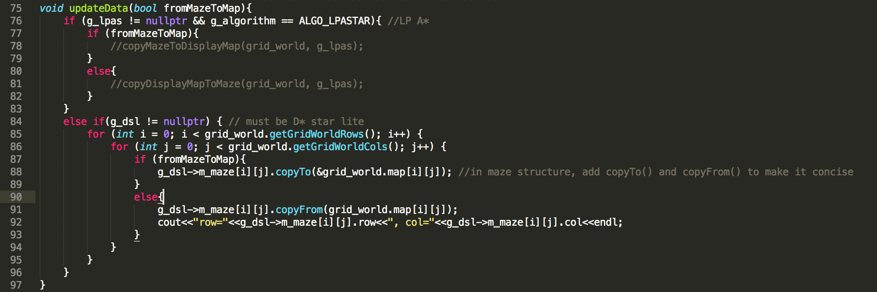

void updateH(); // call D*Lite updateH()

void updateKey();//calle D*Lite updateKey()

#### Gridworld.h

char m_searchStatus; //-1 not found, 0 reset, 1 found the path show

void setSearchStatus(char status); // set m_searchStatus

#### PriorityQueue

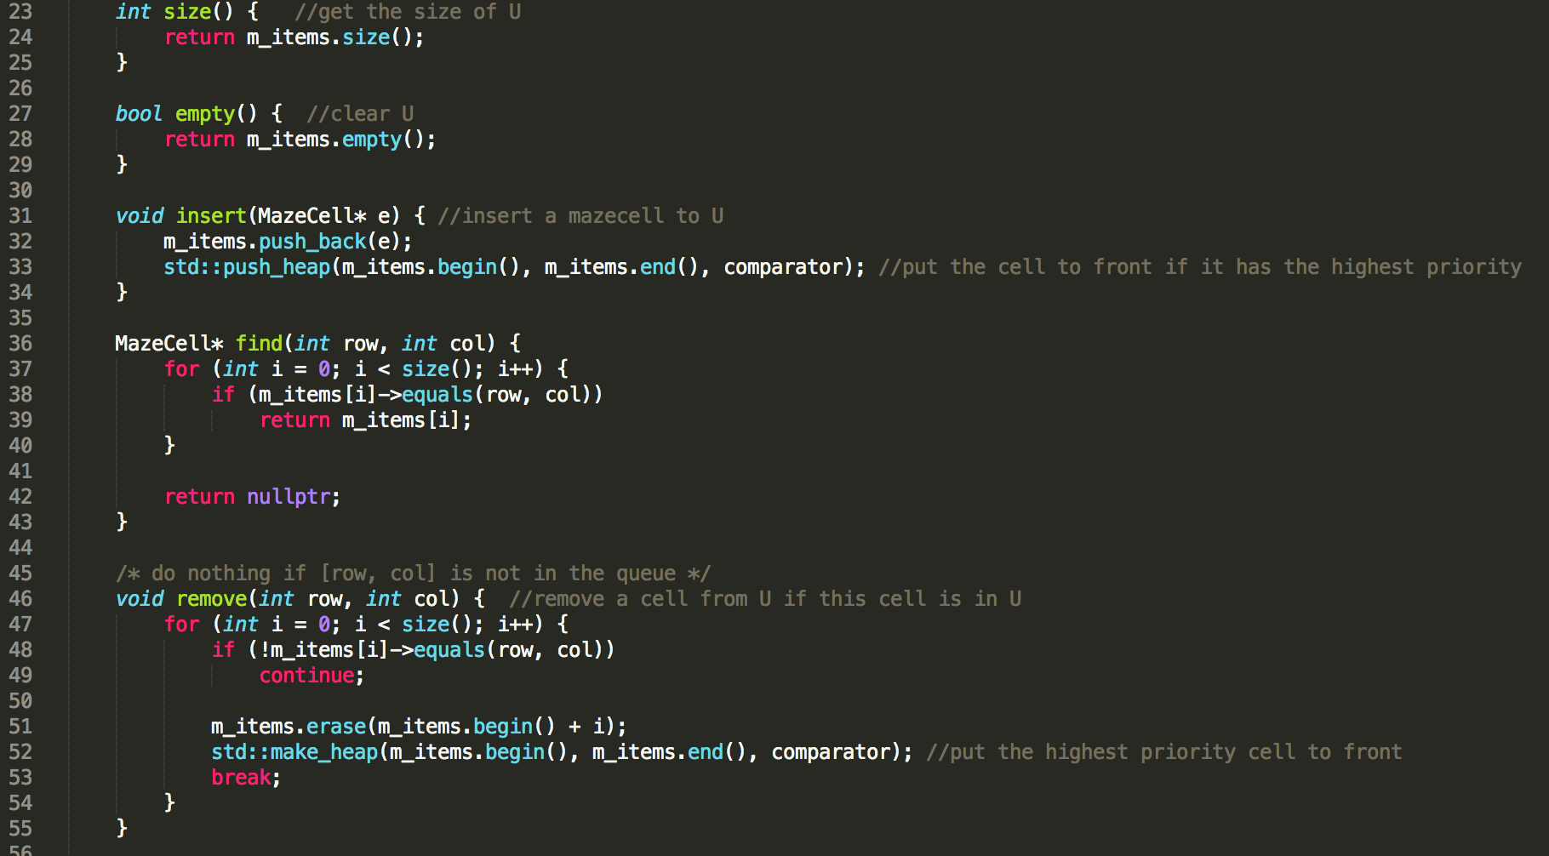

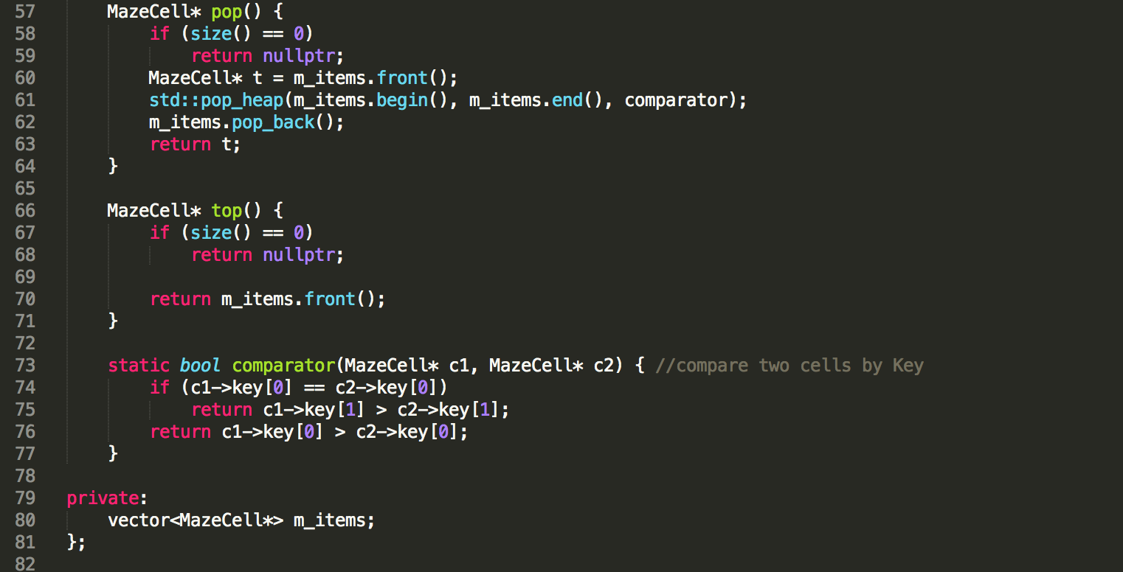

#### globalVariables.h

We create a struct MazeCell in globalVariables for all of algorithms:

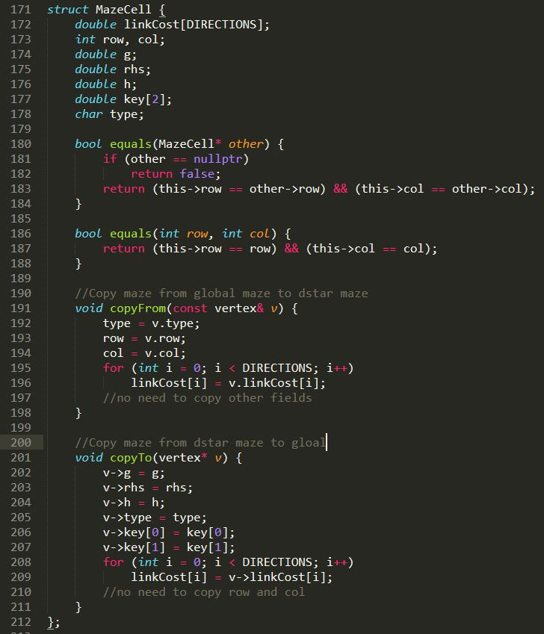

### B． C++ code skeleton

#### Main.cpp

We modified some parts of Main.cpp to call our algorithm.

Changes in runsimulation():

case 1001: //press Enter key to calculate the shortest path.

If (findPath()=1) show the path;

// we define a new member m_searchStatus(-1,0,1) to define the finding result status.

Else show “the goal can not be reached”; //

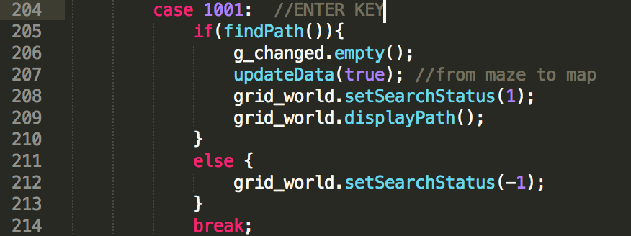

Case 108:

// call D*Lite final algorithm, set m_searchStatus to 0, be ready to calculate the shortest path.

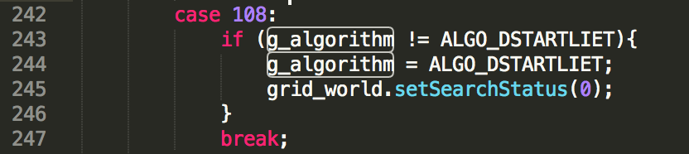

Add a new function

bool findPath(): this findPath() is defined and used by the main function to tell if the g_dsl->findPath() has successfully executed. If g_dsl->findPath() found the shortest path, it returns ture.

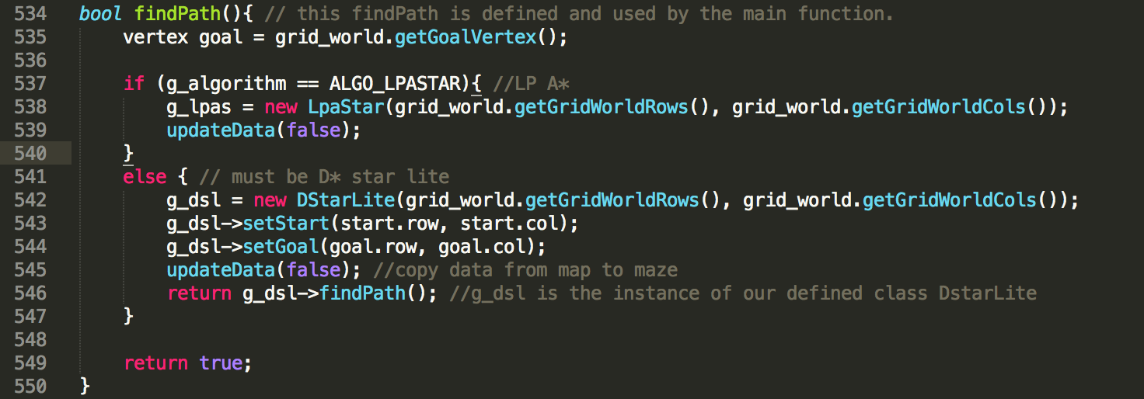

#### Gridword.cpp

In displayHeader(): add m_searchStatus,

m_searchStatus=0,reset and press enter to run;

m_searchStatus=1, show the path;

m_searchStatus=-1, can not find the path.

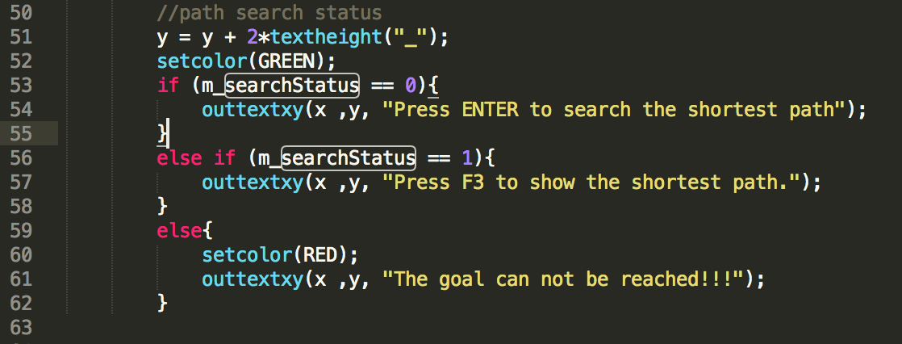

#### Dstart Lite.cpp

Step1 Create grildword maze vector:

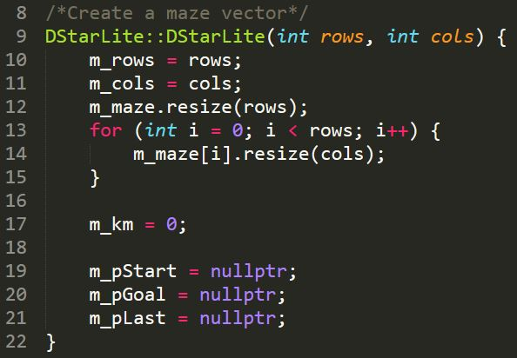

Step2 set start and set goal:

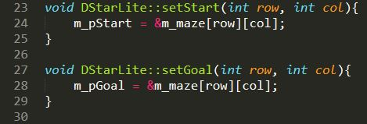

Step3 create initialize function:

m_U.empty(); // Empty priority queue

m_km = 0;// Set km value equal to zero

m_pGoal->rhs = 0;// rhs(Sgoal)=0;

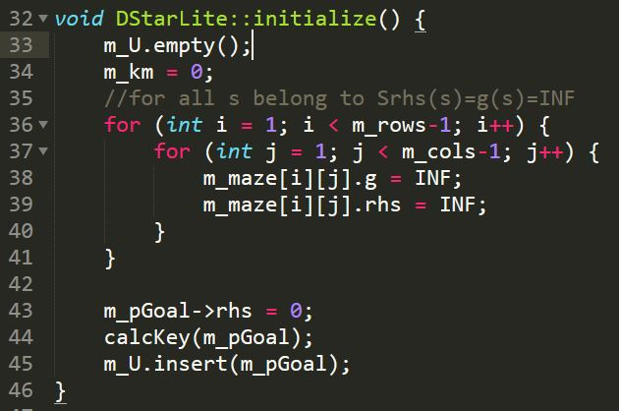

Step4 calculate heuristic value and update heuristic value:

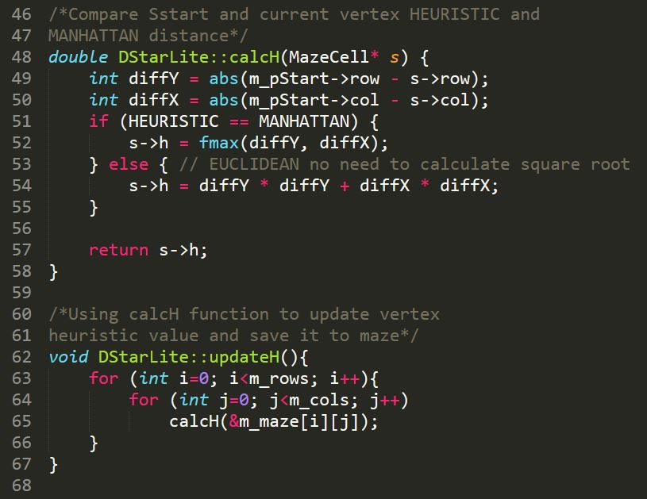

Step5 calculate c(u,s’) value:

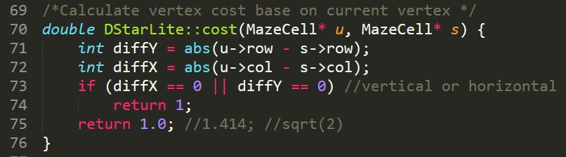

Step6 calculate Key value and update Key value:

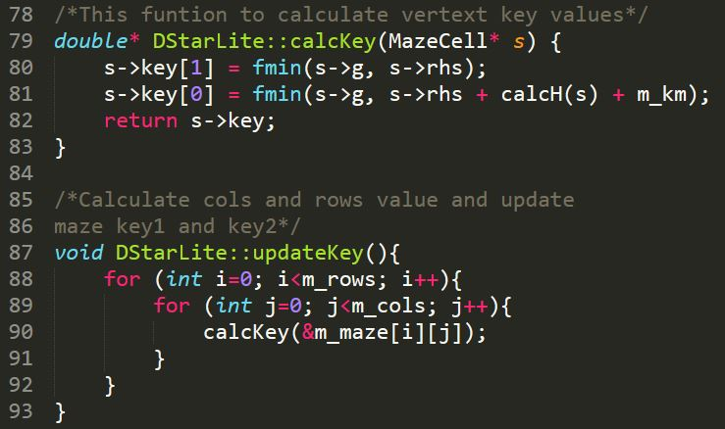

Step7 function for compare the smallest key value:

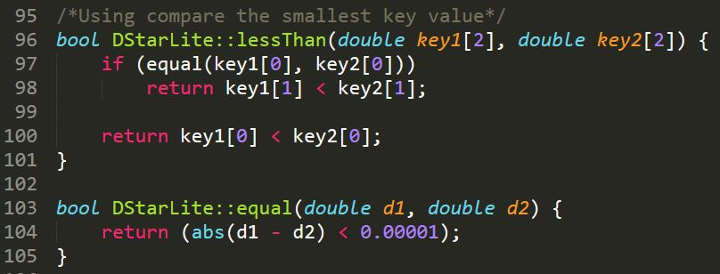

Step8 copy Kold to U.TopKey:

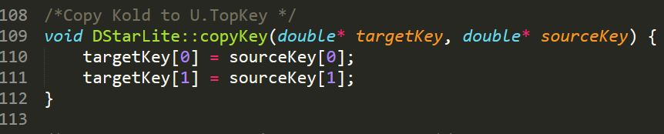

Step9 compare two vertext is same one or not:

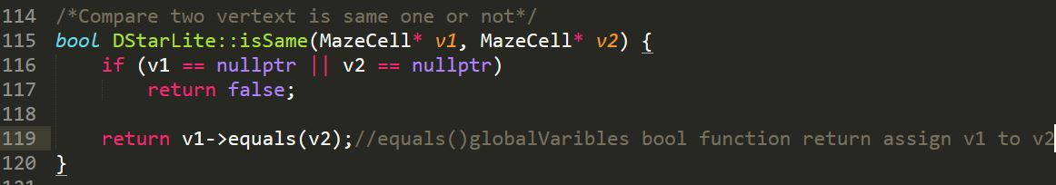

Step10 find all neighbours of current vertex:

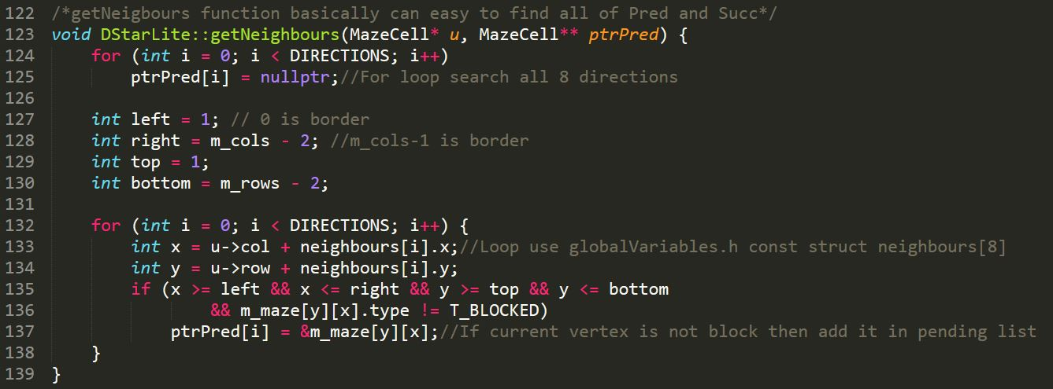

Step11 calculate minin cost pluse g-value:

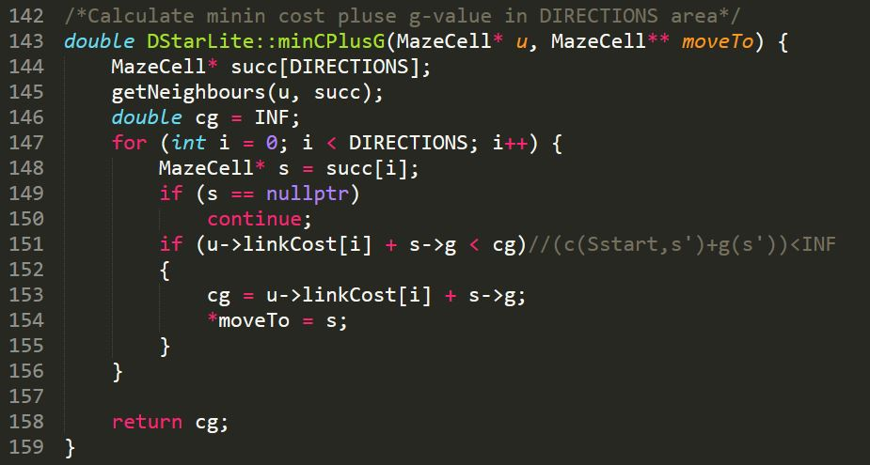

Step12 create function for update vertex:

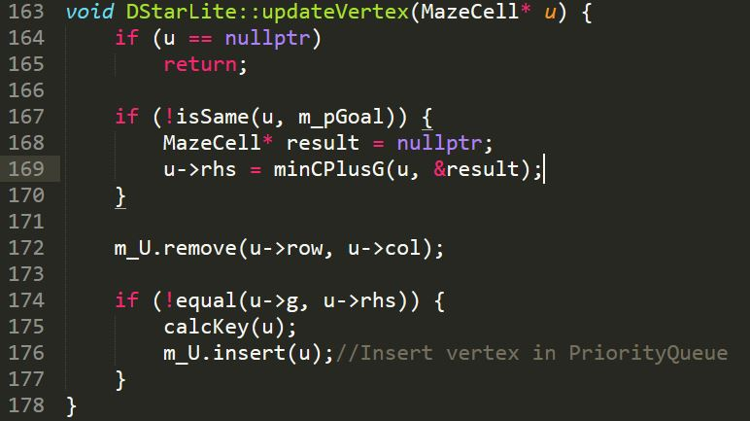

Step13 create function for compute shortest path:

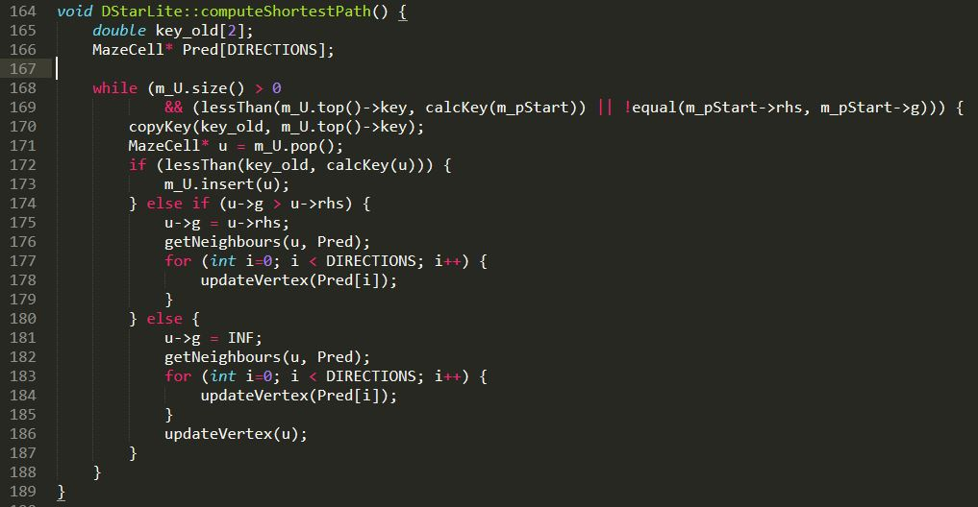

Step 14 create findPath function to replaced Main function in pseudocode:

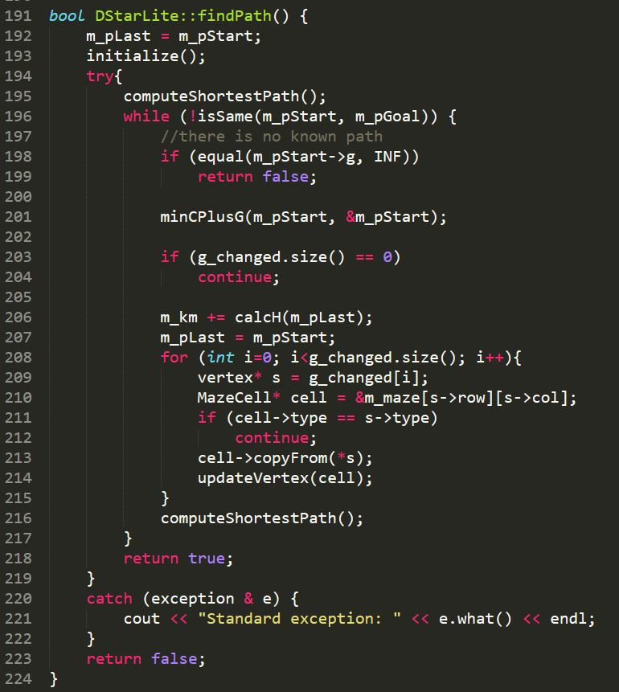

#### DStarLite.h

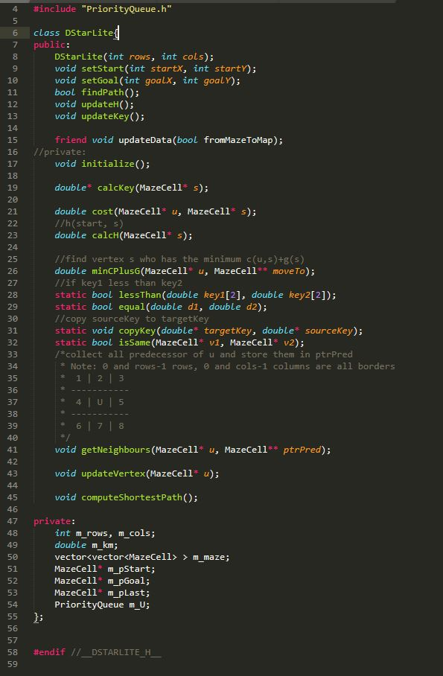

### C． Detail of D* Lite Algorithm, LPA* and IDA

D*Lite

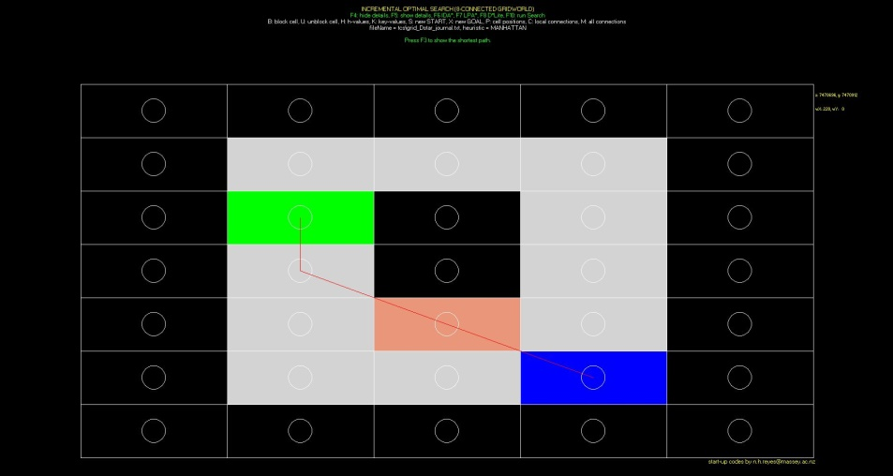

g-value, rhs-value and h-value



Key values

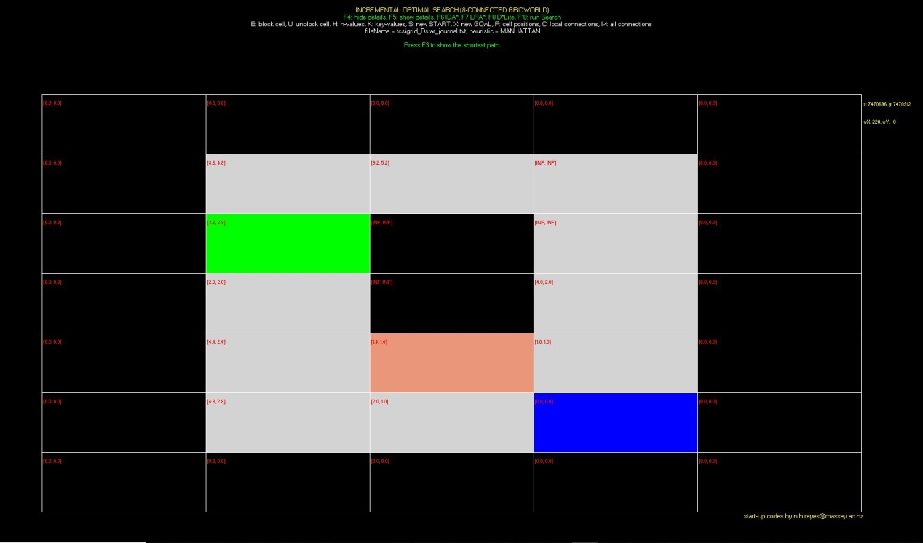

Path:

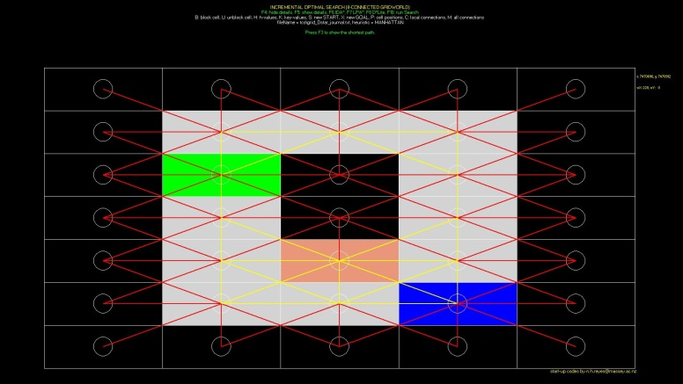

LPA*

IDA:

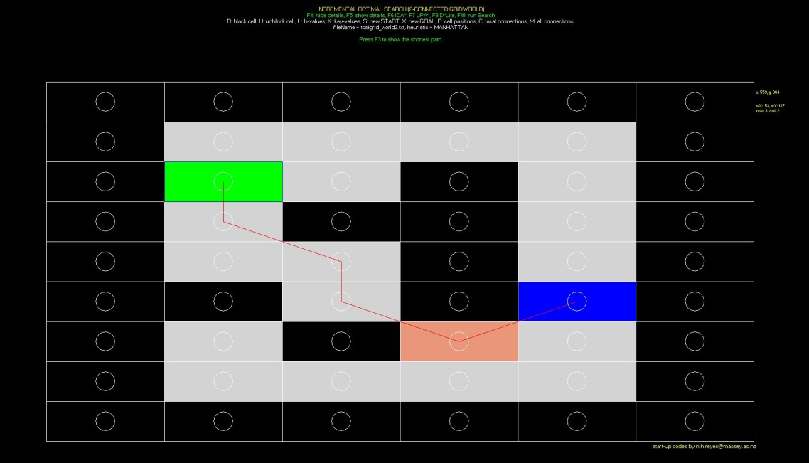

h-value:



Path:

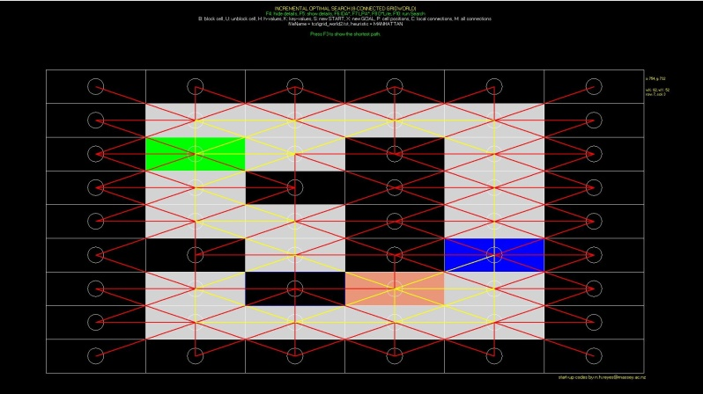

## 1.2 Result Table

Gridworld: _____________

Heuristic: Euclidean distance

|  |  |  |  |  |  |  |
| --- | --- | --- | --- | --- | --- | --- |
|  | **Algorithm** | **Max. Queue length** | **Path length** | **No. of state expansions** | **Vertex accesses** | **Actual Running Time (msec.)** |
| 1 | A* using the Strict Expanded List | Initial search, second search | Initial search, second search | Initial search, second search | Initial search, second search | Initial search, second search |
| 2 |  |  |  |  |  |  |
| 3 | D* Lite Final Version | Initial search, second search | Initial search, second search | Initial search, second search | Initial search, second search | Initial search, second search |

Gridworld: _____________

Heuristic: Manhattan-8 distance

|  |  |  |  |  |  |  |
| --- | --- | --- | --- | --- | --- | --- |
|  | **Algorithm** | **Max. Queue length** | **Path length** | **No. of state expansions** | **Vertex accesses** | **Actual Running Time (msec.)** |
| 1 | A* using the Strict Expanded List | Initial search, second search | Initial search, second search | Initial search, second search | Initial search, second search | Initial search, second search |
| 2 |  |  |  |  |  |  |
| 3 | D* Lite Final Version | Initial search, second search | Initial search, second search | Initial search, second search | Initial search, second search | Initial search, second search |

## 1.3 Experiments summary

## 1.4 User’s Guide

1. **Press ENTER**

When you change any algorithm or cell position need press ENTER first to initialize the calculation.

1. Can not change map cell position and algorithms during the calculation.

|  |  |  |
| --- | --- | --- |
| Name | Keyboard | Description |
| D*Lite | F8 | Initialize the map and change to D*Lite algorithms |
| LPA* | F7 | Initialize the map and change to LPA* algorithms |
| IDA | F6 | Initialize the map and change to LPA* algorithms |
| Show path | F3 | Show shortest path |
| Show detial | F5 | Show g-value, rhs-value and h-value in map |
| Hide detial | F4 | Hide g-value, rhs-value and h-value in map |
| Block Cell | B | Block map cell |
| Unblock Cell | U | Unblock map cell |
| Heuristic value | H | Show heuristic value |
| G value | G | Show g value |
| Key value | K | Show key value |
| Start | S | Change start cell |
| Goal | X | Change goal cell |
| axis value | P | Show cell axis value |
| Cell connection | C | Show map cell connetion relationship |
| All cell connection | M | Show all cell connection relationshop on the map |

Specify the data structures used in the different algorithms. //指定不同算法使用的数据结构

Provide a skeleton C++ code for each algorithm (more detailed than the pseudocode of the algorithms provided in class). //提供c++代码的框架流程参照伪代码，比伪代码详细

Using the sample gridworld defined in the D*Lite journal (and also used in the D*Lite tutorial) Include a snapshot of each algorithm run, indicating graphically the path generated, the map of the g-values, rhs-values, keys, and the vertices expanded. //使用D * Lite日志中定义的示例gridworld（也用于D * Lite教程）2. 包括每个算法运行的快照 3. 截图这些值在路径地图中的样式，g值的映射，rhs值，键 ，并扩展顶点（图带不同的点值）。

Tabulate the results of all experiments performed according to the format given. //将程序运行结果制表并列举出所有结果

Discuss briefly the results of all the experiments.//讨论总结实验结果

User’s Guide (simple guide on how to operate the simulation system, short cut keys) //用户指南（关于如何操作模拟系统的简单指南，快捷键）