

Department of Information Engineering and Computer Science

Bachelor’s Degree in

Software engineering

final dissertation

Autonomous Quadcopter Flight

|  |  |
| --- | --- |
| Supervisor  Prof./Dott. Luigi Palopoli | Student  Massimo Girardelli |

Academic year 2019/2020

* **Abstract**

*This thesis is the design and development of a software application for controlling quadcopters and other flying drones.*

*Quadcopters have gained more attention in the past years due to their versatility and potential in various fields, including surveillance, aerial photography and small object transportation and delivery.*

*Although ready to use solutions and similar open source projects exist, an easily configurable, with a graphical interface and indoor capabilities that responds to external inputs doesn’t and this project aims to provide a working example of all these features that can be customized for different application fields.*

*The project was developed around the ROS2 middleware, PX4 flight control software and the OptiTrack mocap system; the drone can work in conjunction with other robots that support either of those platforms and in a modular fashion, where each component can be substituted with a similar one and expanded with more functionality.*

*The final result is a working flying autonomous drone that can be interfaced both via software directly or through a graphical interface to perform various basic tasks like taking off, landing in a specific location, orbiting around a point, following a path, or be controlled manually from the pc.*

* All the code developed for this thesis is available in the following GitHub repositories:
* Main repository <https://github.com/Massiccio1/px4-py>
* Docker image repository: <https://github.com/Massiccio1/px4-22>
* Commander messages repository <https://github.com/Massiccio1/px4_msgs>
* Optitrack client repository <https://github.com/Massiccio1/optitrack_interface>
* Rviz visualizer (fork) <https://github.com/Massiccio1/px4-offboard>

**Chapter index**

1 Introduction 5

1.2 Background and motivation 5

2 Hardware 6

2.1 Holybro X500 V2 Development Kit 6

2.2 5000 mAh Li-Po batteries 6

2.3 ROCK 4 C+ (Companion) 6

2.4 Commander computer 7

2.5 OptiTrack 7

3 Software 8

3.1 System 8

3.1.1 Ubuntu 22 8

3.1.2 Docker 8

3.1.3 ROS2 Humble 9

3.1.4 Python 3.10.12 10

3.1.5 PX4 10

3.2 Companion 11

3.3 Commander 12

3.3.1 px4-py.py 12

3.3.2 gui.py 13

3.4 Tracking 15

3.4.1 Motive 16

3.4.2 optitrack_interface 16

3.4.3 opti-to-px4.py 16

3.5 Extra 17

3.5.1 QGroundControl 18

3.5.2 PlotJuggler 18

4 Simulation 19

4.1 Gazebo 19

4.2 RVIZ 20

5 Flying 21

5.1 Arming 22

5.2 Takeoff and routine 22

5.3 Landing 22

6. Conclusions and Discussions 22

6.1 Software choice 22

6.2 Performance 23

6.3 Virtualization 23

6.4 Indoor flight 23

6.5 Challenges 23

6.6 Future work and possible implementations 23

Table of Figures

Figure 1: Holybro X500 V2 Development Kit [01] 6

Figure 2: ROCK 4 Model C+ 4GB Single Board Computer 7

Figure 3: tracking marker on top of the drone 7

Figure 4: My Commander pc specifications 8

Figure 5: Snippet from the core Dockerfile 9

Figure 6: PX4 Multicopter Control Architecture 11

Figure 7: MicroXRCEAgent scheme 12

Figure 8: GUI main screen 13

Figure 9: GUI manual controlls 14

Figure 10: Comamnder message structure for mode selection 15

Figure 11: Motive software 16

Figure 12: QGC interface to change flight controller paramethers 18

Figure 13: PlotJuggler interface 19

Figure 14: Fully functional drone simulation. 20

Figure 15: *NED to ENU coordinate conversion* 20

Figure 16: Raw local position message from PX4 21

Figure 17: RVIZ screen 21

Acronyms, Abbreviations and important terms



|  |  |  |
| --- | --- | --- |
| * PX4 | * PX4 is the Professional Autopilot. Developed by world-class developers from industry and academia, and supported by an active world wide community, it powers all kinds of vehicles from racing and cargo drones through to ground vehicles and submersibles. |  |
| * ROS2 | * robot Operating System version 2, middleware that enables fast and easy messages communications between different nodes on a network |  |
| * NED | * North-East-Down coordinate system where the X-axis is pointing towards the true North, the Y-axis is pointing East and the Z-axis is pointing Down, completing the right-hand rule. |  |
| * FRD | * Front-Right-Down coordinate system where the X-axis is pointing towards the Front of the vehicle, the Y-axis is pointing Right and the Z-axis is pointing Down, completing the right-hand rule. |  |
| * ENU | * xEast-yNorth-zUP coordinate system, the classic Cartesian coordinate system |  |
| * FLU | * xFront-yLeft-zUp coordinate system, coordinates from the drone point of view |  |
| * SITL | * Software in the Loop, a simulation tool that reproduces the flight controller behavior |  |
| * LTS | * “Long Term Support”, an LTS version of software receives supports for many years to come and thus is more preferred for compatibility |  |
| * GUI | * Graphical User Interface |  |
| * OptiTrack | * Motion capture system, used to detect the drone position with a tracker |  |
| * Commander | * Main computer from where the drone is controlled |  |
| * Companion | * Single board computer mounted on the drone |  |

1 **Introduction**

This is the list of components used and some reasons behind the choices that were made.

This hardware can be swapped with other alternatives, depending on the availability of the components.

1.2 **Background and motivation**

* asdasdad

2 **Hardware**

This is the list of components used and some reasons behind the choices that were made.

This hardware can be swapped with other alternatives, depending on the availability of the components.

2.1 **Holybro X500 V2 Development Kit**

Main frame of the drone, it’s a good all-in-one solution for a quadcopter, it mounts 4 920 Kv motors, perfect for this application, lower Kv motors offer more torque and less fan speed, which is desired in this application give the weight of the whole system, a higher Kv motor would strugle more.

The Pixhawk 6C flight controller offers the right connectivity that we need for this esoteric application and easily provides the CPU and RAM that we need.

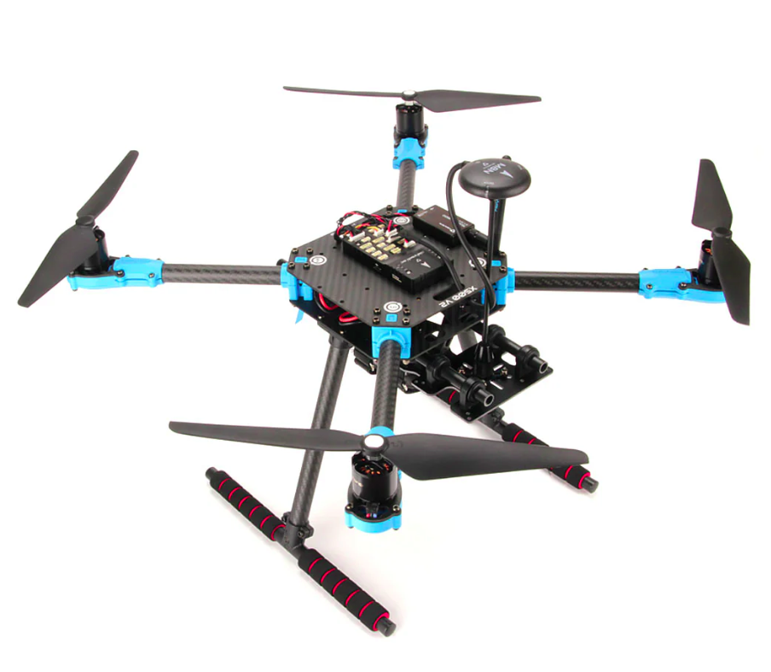Figure 1: Holybro X500 V2 Development Kit

2.2 **5000 mAh Li-Po batteries**

* A massive 5000 mAh Li-Po battery powers the motors, the flight controller and the companion computer.
* The 4S configuration offers 14.8V, when charged it can reach 16.8V, the drone will strugle to lift below 14V.

The exact model used is: “Dinogy Ultra Graphene 4S 5000mAh 80C”

2.3 **ROCK 4 C+ (Companion)**

A single board computer, similar to a Raspberry PI but with a 64-bit architecture. It's a hexacore ARM processor with 4GB of LPDDR4 RAM, which is plenty for our needs.

The GPIO PINS are used for serial communication with the flight controller. Connection is done with WiFi and a SSH shell, power is delivered via USB.

The main issue with this board is the connectivity, like many other single board computers, a big part of the I/O is connected through a shared bus and this lowers the overall throughput of data; for this particular application the network connectivity was consistently low with random spikes in latency.

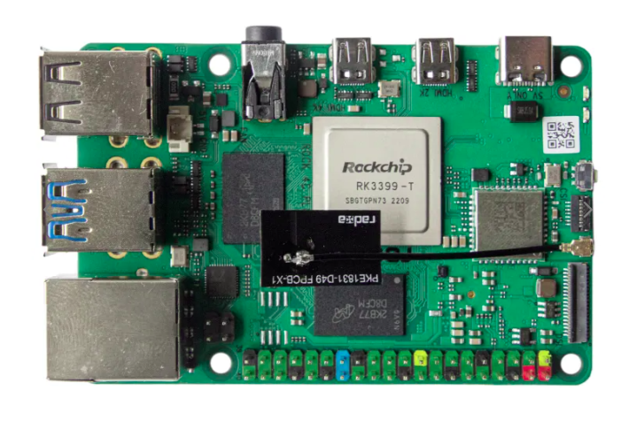Figure 2: ROCK 4 Model C+ 4GB Single Board Computer

The problem was not the WiFi module itself because alternatives adapters and Ethernet cables were used and the underlying problem was still present.

In the end the limited networking was a compromise that caused troubles in development but the final result is almost unaffected since the system can operate at a slow speed and even with 100ms of delay in time the system was stable.

* 1. Another problem was the old operating system: the company behind this board only supported version of Ubuntu up to the version 20.04, to keep this project up to date a Docker container was used to run Ubuntu 22 and ROS2 Humble.

2.4**Commander computer**

* Any computer that can run the commander programs, preferably linux with Ubuntu 22 (reasons at Chapter 2.1), alternatively a computer that can run Docker.
* It’s possible to use the Companion itself also as a commander.

2.5 **OptiTrack**

* Motion Capture Systems mounted in the laboratory, the precision is <1 cm, latency is around 30ms, publish rate is 360Hz by default but the drone remains stable up to 50 Hz of data received in case of network congestion.

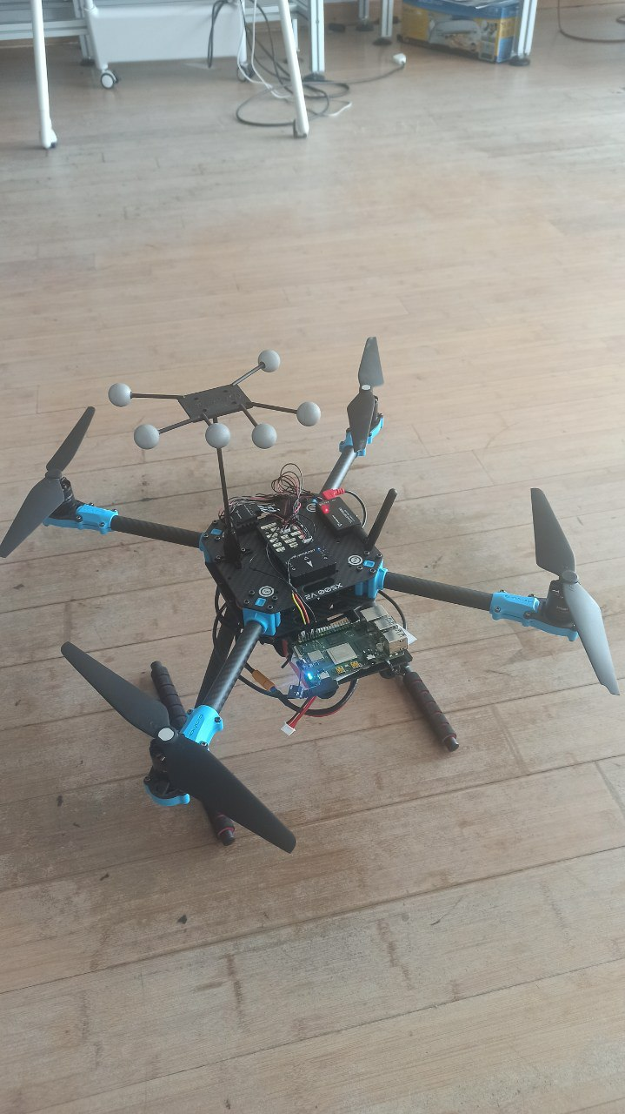Figure 3: tracking marker on top of the drone

* Tracking is done by recognition of a special tracking marker placed on the drone, each model saved has it’s own ID that will be transmitted with the data.
* The 8 cameras placed around the flying area, provide an accurate position estimation. The position is sent through the network and must be decoded by a client.
* This system is heavily dependent on a proper configuration of the cameras and a correct model of the tracking marker.

3 **Software**

* In this software chapter I will explain the systems and tools used to bring this project to life and the inner workings of the components necessary to make the the drone fly.

3.1**System**

* In this section I will focus on the operating system and system-wide tools, operating systems and software used, every other program runs on top of these:

3.1.1 **Ubuntu 22**

* This was a very important decision since every distribution of Ubuntu has it’s own ROS2 distribution and the latest LTS (for now) only supports Ubuntu 22.
* It’s possible to run ROS2 Humble on other distributions but it must be compiled from source likelihood of error or incompatibilities grows bigger, especially on embedded systems.

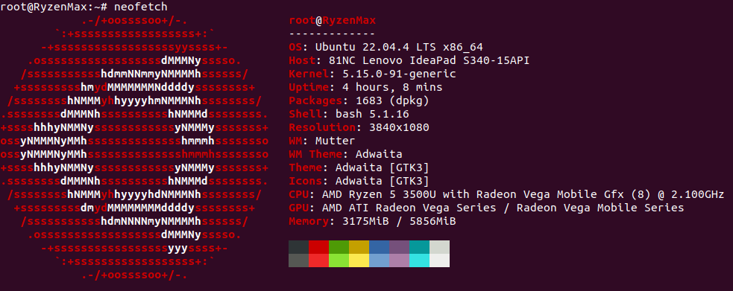Figure 4: My Commander pc specifications

3.1.2 **Docker**

* Docker is an amazing tool for virtualization and portability; with docker it’s possible to create an image of a system and run a container almost like a lightweight virtual machine.
* The container has all the libraries needed to run an entire system and is widely used for testing and compatibility since it’s possible to run a completely different operating system inside a container.
* In docker you can change and customize a base image by running shell commands declared in a **Dockerfile**, each line of command produces a **layer** that contains the changes tin the filesystem, then all the layers are stacked together to produce the new **image**.
* If it’s impossible to use or install Ubuntu 22 a good alternative is a docker container, like I did.
* Two main docker images were built, one for the commander and the other one for the companion.
* The base image is the official ros:humble, it supports both amd64 and arm64/v8; a core image with PX4 dependencies and messages installed is built on top, this middle step was useful in development to speed up future builds.
* On top of the core, two separate images for companion and commander were built.

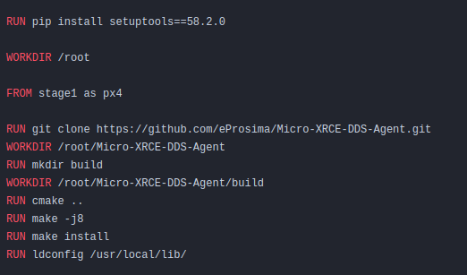Figure 5: Snippet from the core Dockerfile

Dockeruses the **docker build cache**, this smart caching system allows the build to reuse an already created layer without the need to run the command again; to optimize for this technology, we can apply some best practices like splitting commands into multiple smaller commands, put the less likely to change commands at the beginning and delaying as much as possible the COPY docker commands.

This way we can have better build times after the first one at the cost of higher disk usage but it’s a worth trade while developing; for a release build we can use the experimental –squash tag to compress all the layers into one, saving disk space and improving performance.

For my system I used this 3 stage build:

* **core**: common image with all the PX4 libraries
* **companion** or **commander**: platform specific image
* **update**: always pulls the up to date code written by me

3.1.3 **ROS2 Humble**

* Middleware used to share all messages between applications and to launch most of the applications, ROS resolves around Nodes, Topics and Messages:
* **Nodes:** a process interfacing with the ROS libraries, different nodes can run on different machines while being connected through networking and be visible to each other.
* **Topics:** a pipe-like virtual structure within ROS that can be used to share messages between different nodes, it can be interfaced as a publisher or as a subscriber, each topic routes one specific message type.
* **Messages:** data structures that travel through the nodes, it is not system-dependent and provides primitive types like booleans, integers, floats, arrays and nested messages types.  
  Custom messages were built for this project.

The optimal QoS (Quality of service) options were used:

**Best effort**, to reduce network congestion, most messages are ephemeral and gets overridden a few milliseconds later, therefore if some messages are dropped it doesn’t affect the system

**Transient local**: the publisher is responsible for delivering the last message tho subscribers who joined after it was published

**Keep last**: only keeps the last message, previous values are invalid anyway

3.1.4 **Python 3.10.12**

Python was used for the ease of development and speed of deployment as it doesn’t need compilation; python with PX4 has also much more documentation and examples than any other language.

* Other programming languages that have better performance like c++ were considered but discarded due to minimal documentation, much more developing time and a very slow overall development experience and unpleasant experience:
* ROS2 compilations have massive overheads, even for well written cmake and headers files while python has none;
* a part of the code runs on the companion computer that, while powerful, is not really suited for continuous compilations (installing all the PX4 dependencies and building the OptitTrack package took more that 1 hour and a half)
* The runtime overhead of python gets completely eclipsed by the network delay.

The version 3.10.12 is the officially supported by ROS2 Humble.

3.1.5 **PX4**

Open source flight control solution for drones.

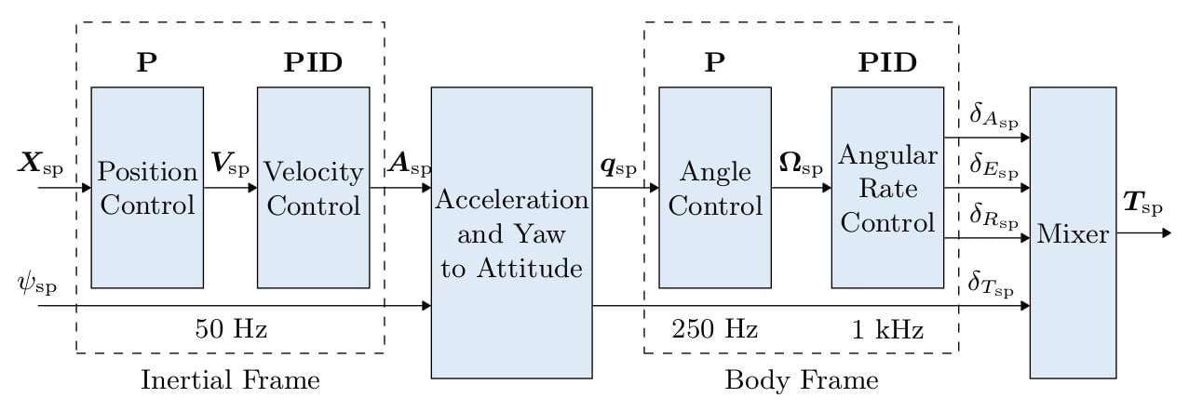Figure 6: PX4 Multicopter Control Architecture

* the position X and angle ψ are processed into acceleration A and then into thrust force T

PX4 use a combination of P and PID controllers:

The P controller (Proportional Controller) is a simple feedback controller that adjusts the output based on the current error between he desider setpoitn and the current position, it provides a fast start while slowing down when close to the target. It only has one paramether P that regulates the strength.

The PID controller (Proportional-Integral-Derivative Controller) on the other hand is the most common controller for drones and it’s widely used in the UAV field; it is based on tree parameters:

* P: proportional term, similar to theP controller, it porvides an output proportional to te position error;
* I: integral term, it takes in consideration the past errors and reduces steady-state errors
* D: derivate term, predicts the future error based on the rate of change, providing a damping effecct before reanching the destination, reducing over shooting
* PID setting were slightly changed in favor of a more steady system sacrificing responsiveness to prevent problems in case of delays in the tracking signals.
* Sensor data is processed by **EKF** (Extended Kalman Filter) that combines all the data from sensors to produce the state of the vehicle, including and not limited to: position, rotation quaternions, velocity acceleration, magnetic field and wind velocity.

ROS is used by PX4 to provide an offboard control functionality, with a Linux companion computer. In this way its possible to control the PX4 flight stack using a software outside of the autopilot. PX4 supports both versions of the robotic operating system, but while the communication between ROS2 and the autopilot is done through a ROS2-PX4 bridge (MicroXRCEAgent).

There are 2 ways to connect and read messages: ROS2-PX4 bridge or MavLink

MavLik has a slight different notation and needs it own libraries and messages while the ROS2-PX4 bridge only requires sourcing the message (done automatically when sourcing the whole ROS environment).

The custom PX4 messages are used by most of the software used.

3.2 **Companion**

The companion is a single board computer mounted on the drone, it’s role is to run the **MicroXRCEAgent** service, the command to run is:

sudo MicroXRCEAgent serial --dev /dev/ttyS2 -b 921600

* The MicroXRCEAgent starts a ROS2 node that published topics with information like current position, velocity, status, and subscribes to other topics to receive commands, tracked position and keep-alive signals.
* Communication with the flight controller is done on the serial port ttyS2 with a baud rate of 921600 to transmit all the data.

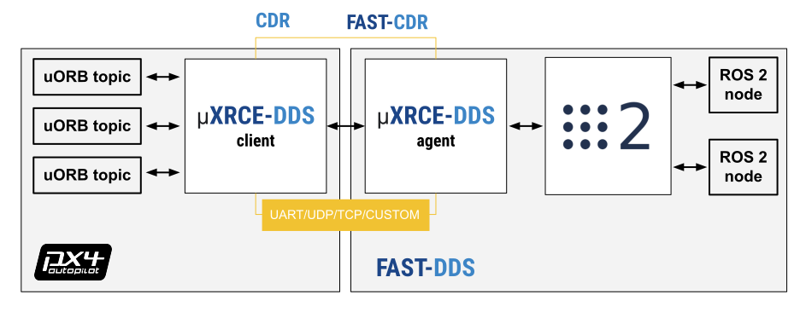Figure 7: MicroXRCEAgent scheme

* flight controller on the left and companion *board* on the right
* For this particular use case a custom firmware was build to access particular information like land detection, battery status.

3.3 **Commander**

The commander computer is the main computer from where the drone is controlled, it’s role is to run the following software:

3.3.1 **px4-py.py**

(also known as **controller** from her on) The main process of the system, keeps the connection with the companion, receives updates on position, velocity, status etc. from the companion, receives data from the GUI, and most importantly elaborates all the data and messages to produce an action to send to the drone.

To control the companion, a 2 Hz message must be kept alive, this signal tells the companion that the connection is healthy and sets the PX4 mode to **Offboard**, this mode allows the drone to be controlled remotely without a radio.

This process is an infinite loop with callbacks when a new message from the drone is detected, the main class OffboardControl(Node) keeps a record of the latest received in global variables so any part of the system has access to them.

Tasks and actions are processed in separate threads and only one action can be executed at a time, if a new actions comes, the previous one is canceled.

Some actions are simply redirected to the companion (like arm, disarm, shutdown), other action that continue over time start and are handled by a thread.

If there is no GUI (set in config.py), it proceeds with the selected mode in the configuration file, otherwise it listens for action messages.

The controller is the only one who sends commands to the companion, this way the GUI becomes an extension of the program and can be closed/relaunched at will without causing problems to the main process.

3.3.2 **gui.py**

* This graphical interface is a quality of life tool that considerably speeds up testing and validation since it makes possible to interface (in a human mode) with the controller, enabling runtime changes to the operating mode without editing and restarting the whole system.
* It was built from scratch using the python library PySimpleGUI version 4.60.5, which is free to use and the window can be passed through docker with the X11 compositor.
* It has many functionalities and offers all the relevant information on screen:
* **ARM** arms the drone if the above conditions are met

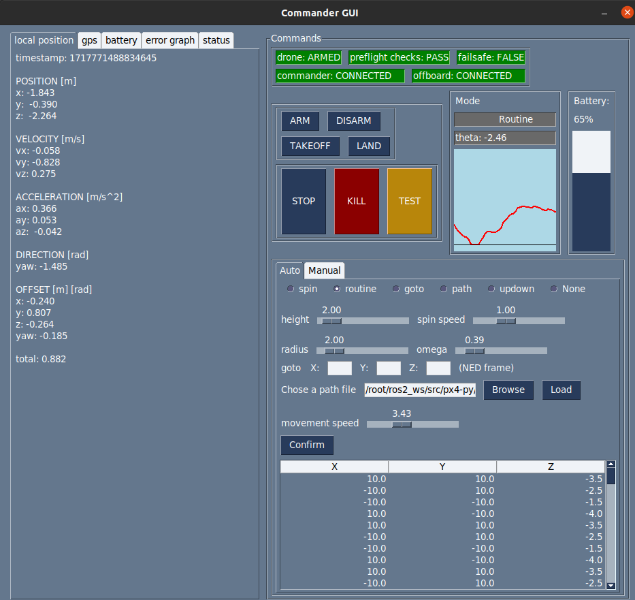Figure 8: GUI main screen

* **DISARM** disarms the drone before it takes off or when it landed, does not work mid flight
* **TAKEOFF** takes of to the height declared in src/config.py by the variable takeoff_height
* **LAND** lands at (0,0) local frame, position cannot be overridden, this is a limitation of the offboard mode because it would require a different mode to land normally on location, disconnecting from the commander
* **STOP** stops any activity and hold the position
* **TEST** button to test features, currently lands on a random position
* **KILL** emergency stop, terminates the flight immediately and stops the propellers, even mid air (USE WITH CAUTION)
* **SPIN** spin on self with omega = spin speed slider
* **ROUTINE** starts hovering in circle around (0,0), at height = height , omega = omega slider,radius = radius
* **GOTO** goes to position x,y,z in NED frame (CAUTION WITH Z COORDINATES)
* **PATH** load a path file like src/medium.json and the drone fill follow all points with speed = movement speed slider
* **UPDOWN** goes up and lands, mainly for testing
* **NONE** default, no activity, the drone will hover
* **GRAPH** shows a simple graph of position offset between the set position and the current position, gives a rough estimate of the offset, X axis is time while the Y axis is the euclidean distance between the set point and the current position. I doesn’t offer a 3D representation but a quick visual information which can be useful for the user

There is also a simple console to control the drone manually with simple 3D positioning and 2D rotation, with speed sliders and transmission rate, this is very useful while testing, allowing the user to reposition the drone and validate the tracking.

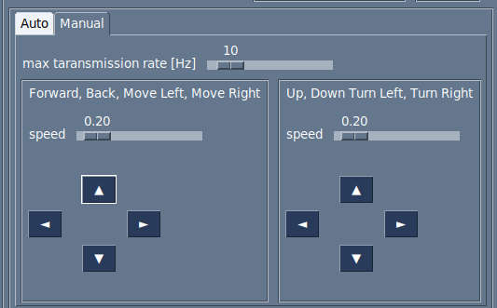Figure 9: GUI manual controlls

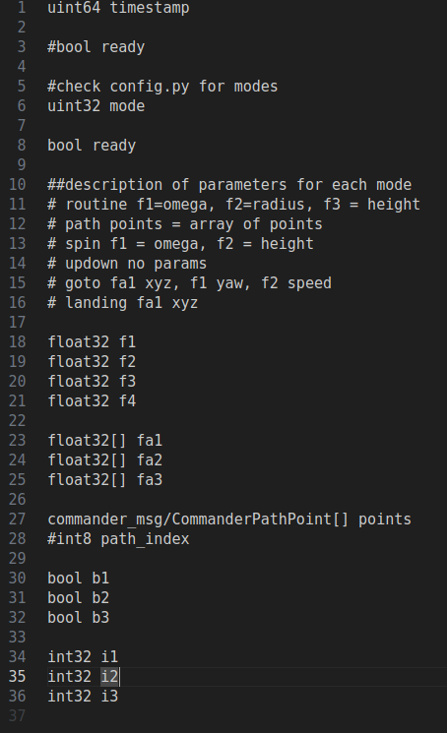Figure 10: Comamnder message structure for mode selection

* The GUI and the controller communicate with custom Commander messages made by me, the style is similar to the original PX4 messages with an integer defining the mode and a series of arrays where to pass thee data, it’s up to the receiver to correctly parsing the meaning.
* This program is independent and the whole system can work without this piece of software since it doesn’t communicate directly with the companion but only to the commander, this is a design choice to improve compatibility and automation.
* Every information is accessible with the command line or a program with a ROS2 interface and every action is applicable with a script.

3.4 **Tracking**

* The tracking component is needed for indoor flight and is expected by default, GPS flight need a change in the parameters of the flight controller.
* As previously mentioned the tracking system used for this project is the **OptiTrack** as it offers a sub-centimeter precision when correctly calibrated, but any other tracking device can be used as long as it can publish ROS pose messages directly or indirectly works.
* The software needed to run the tracking system are:

3.4.1 **Motive**

* The proprietary software that is physically attached to the cameras, it published multicast messages int he network, must be configured with the shape of the tracker used.
* Must be interfaced with a client to access the date published.

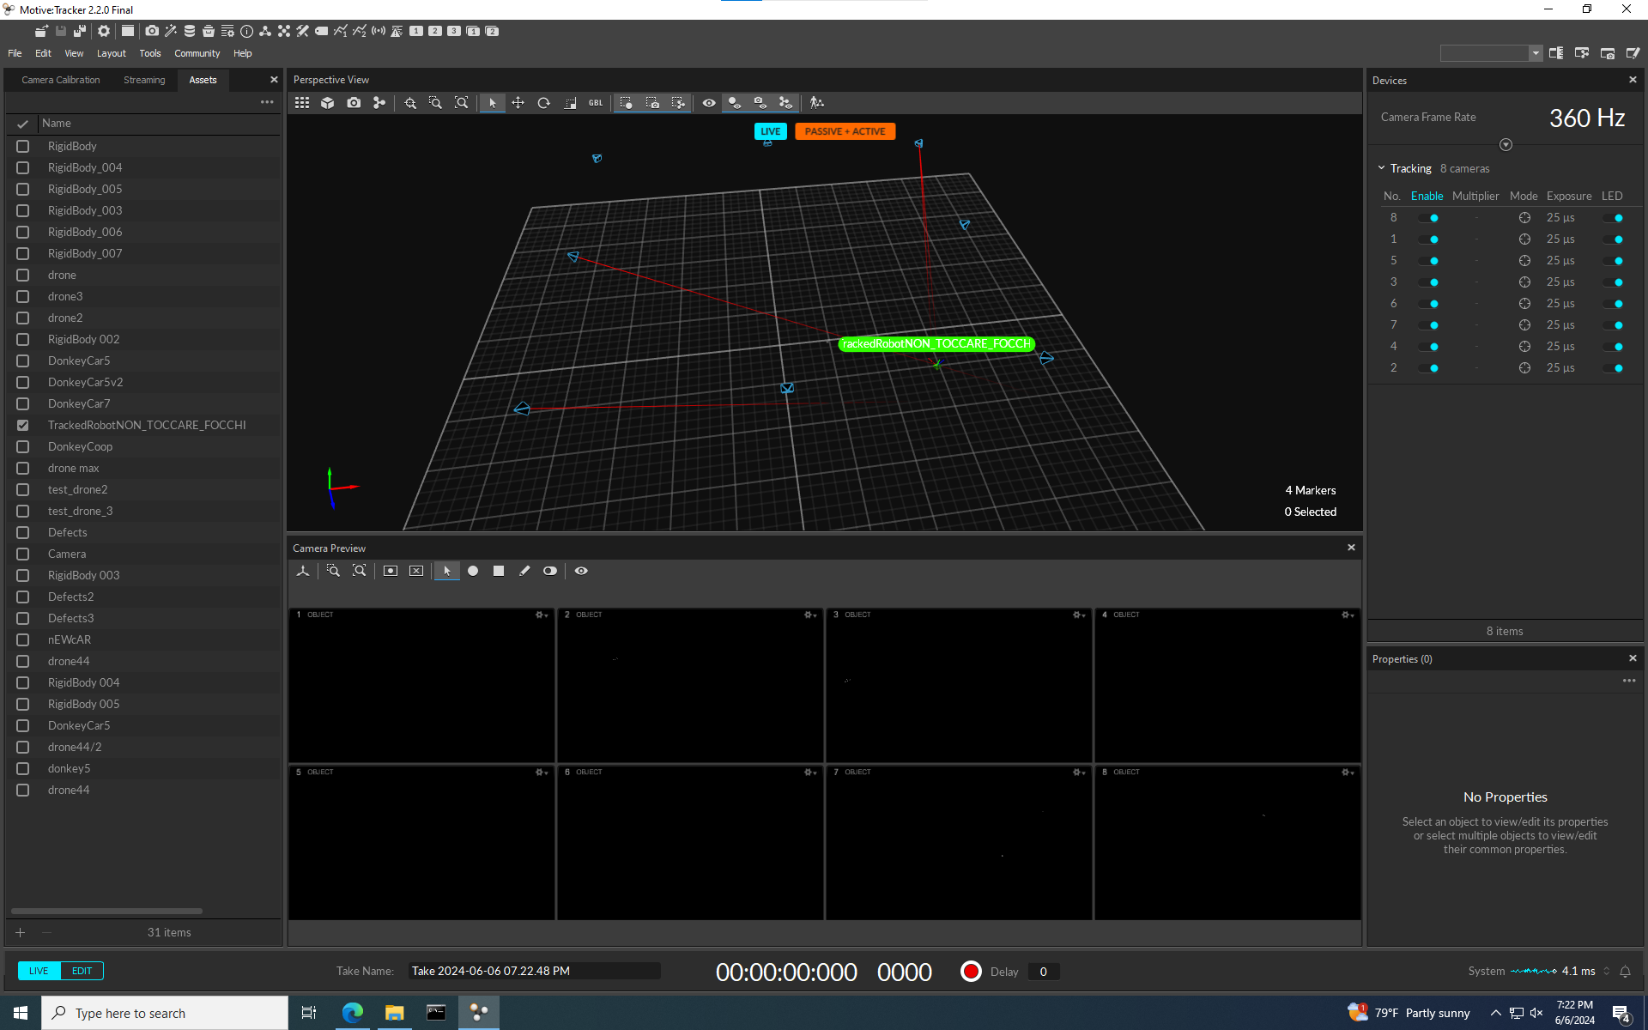Figure 11: Motive software

3.4.2 **optitrack_interface**

* python nat net client, it decodes the OptiTrack messages and publishes geometry_msgs.PoseStamped, a standard ROS message that can be accessed from the other programs.
* It’s configured with the ID of the tracking device registered in Motive to avoid publishing messages from a wrongly detected body.

3.4.3 **opti-to-px4.py**

Python program listens to the OptiTrack messages and converts geometry_msgs.PoseStamped to VehicleOdometry messages, a PX4 message type and throttles the output to a stable 100Hz

* **WHY?**
* Why doing all these conversion of messages?
* Let’s procede with steps: the first conversion from Motive to optitrack_interface is need because Motive is a general pourpose trackign system and publishes it’s own format and not designed to work out of the with ROS2 so this step is unavoidable.
* But in the second part from optitrack_interface to PX4 we convert ROS2 message to ROS2 message, can’t we just skip the middle part and do Motive-PX4?
* The answer is yes, but not always.
* Let me explain, this setup was done in an existing laboratory and a standard PoseStamped is recognized by any ROS2 program and is the most suitable for the data transferred, so an existing setup might alerady have this system setup.
* So a PoseStamped message is more likely to be supported by existing setups and it’s more easily replicable and faked for testing purposes.
* In any case I developed an all in one solution for a direct Motive-PX4 and it’s called **all_in_one.py**

This is all the software that is used to make the drone fly which is either proprietary software, forked and modified code or developed from scratch by me, all details are in the main repository.

* More programs are used in the simulation section but it’s not directly needed for the drone to fly.

3.5 **Extra**

* A listo of other programms necessary for the setup, developement and debug of this project

3.5.1 **QGroundControl**

QGroundControl or QGC, is an software for UAVs, it’s an interface tot he flight controller and it was used to set parameters and retrieve flight logs, install firmware and PID tuning.

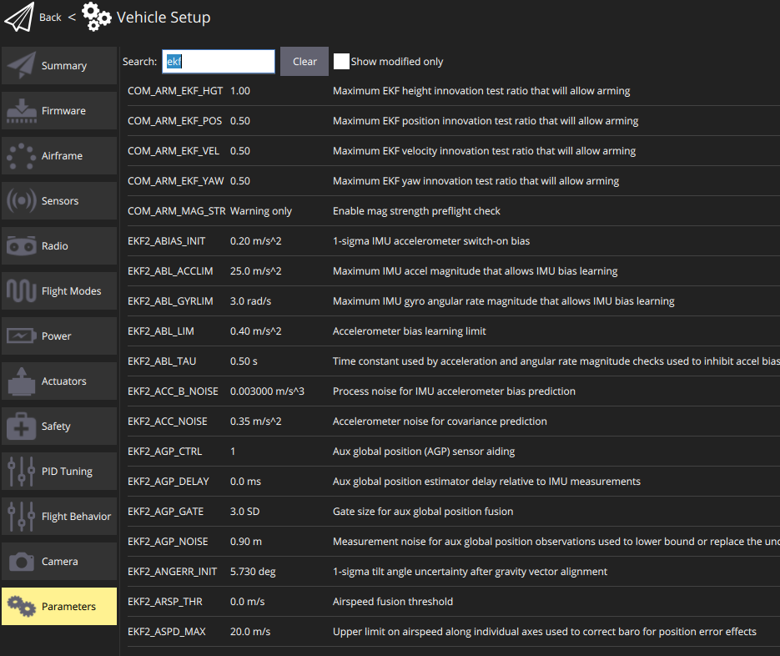Figure 12: QGC interface to change flight controller paramethers

3.5.2 **PlotJuggler**

A graphical interface to plot and filter flight logs and ROS messages, analyzing the logs is an essential steps for debugging and prevent crashes.

4 **Simulation**

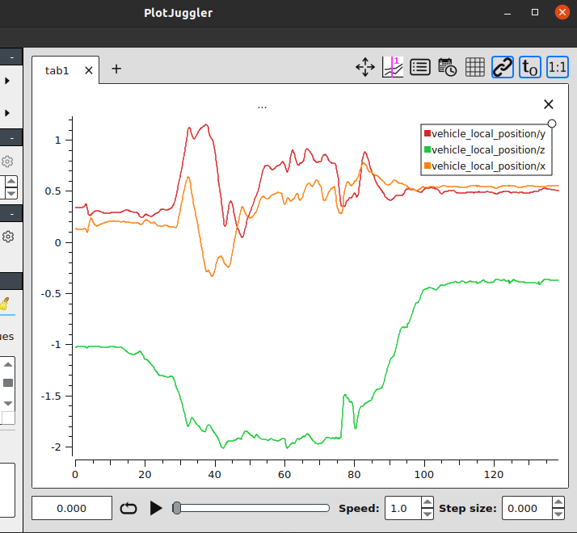Figure 13: PlotJuggler interface

* Small flight sample

Flying simulations offer numerous advantages, the most important is being able to test new code in a safe virtual environment, there are zero consequences for a crash; meanwhile flying a real drone in a close environment while testing functionalities is definitely a recipe for disaster.

The simulator used is **Gazebo**

4.1 **Gazebo**

Gazebo is a collection of open source software libraries designed to simplify development of high-performance applications.

It’s widely used in robotics because it supports many plugins that can be developed for each system, it’s very modular and offers a fine customization.

Gazebo supports the SITL drone simulation that was needed directly from the PX4 package.

This simulator was used to verify the response of the drone to the different commands and possible situations that might occur.

Gazebo could not be used alongside with the physical tracking system due to the discrepancy between the simulated position and the real position while, so a loopback of the current simulated position was used to simulate an external tracking.

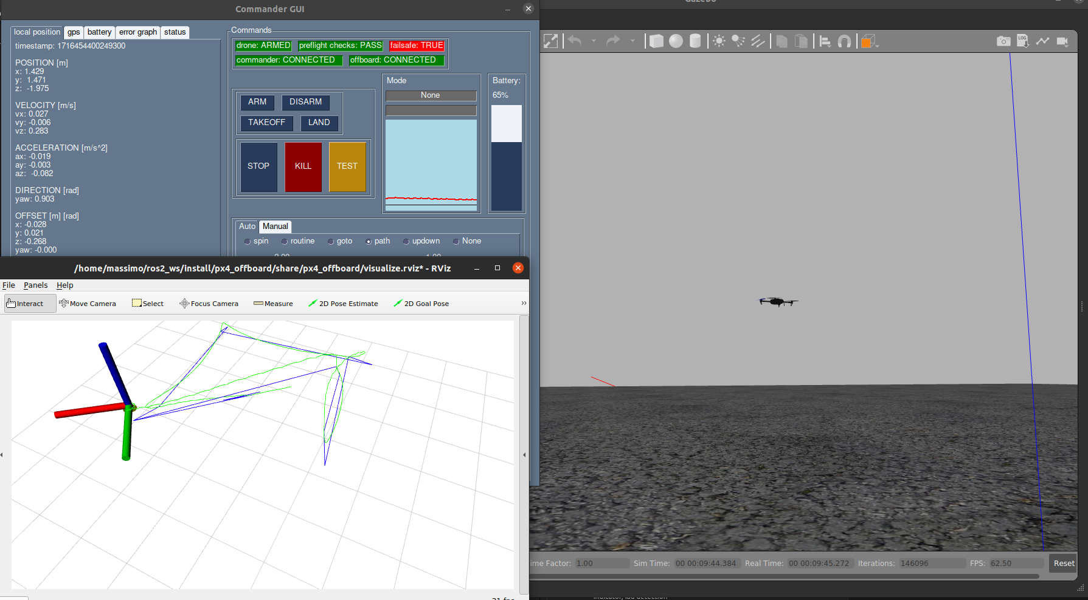Figure 14: Fully functional drone simulation.

* Gui on top left, RVIZ in bottom left and Gazebo on the right

4.2 **RVIZ**

* RVIZ is another program usually paired with Gazebo, it doesn’t directly simulate but allows the user to visualize ROS messages in a very convenient way.
* This tool was really useful when debugging the tracking system because I could overlay the tracking position wht the current drone position and visually validate the if the tracking was correct.

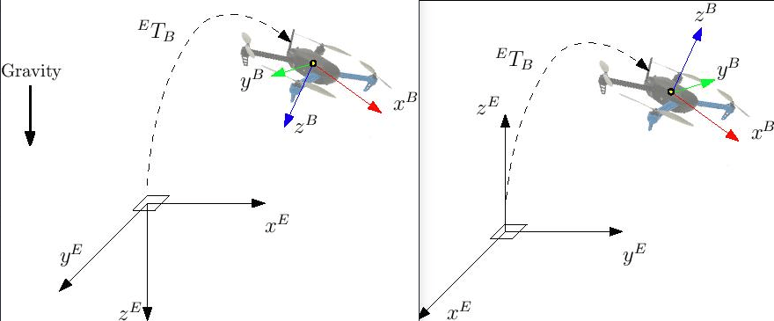Figure 15: *NED to ENU coordinate conversion*

* While the front end displays the evolution of the system, the backend is a fork of an existing project, properly changed to receive PX4 messages, organizes a history of messages and set, converts the coordinates from NED and FRD frames to ENU and FLU, the former are commonly used with flying vehicles where the Z axis represents the negative distance from the ground while the latter are the common coordinates; this step is done for visualization purposes, every aspect of the flying drone is done in NED and FRD frames.

5 **Flying**

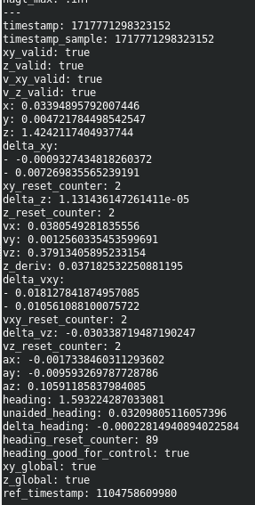Figure 16: Raw local position message from PX4

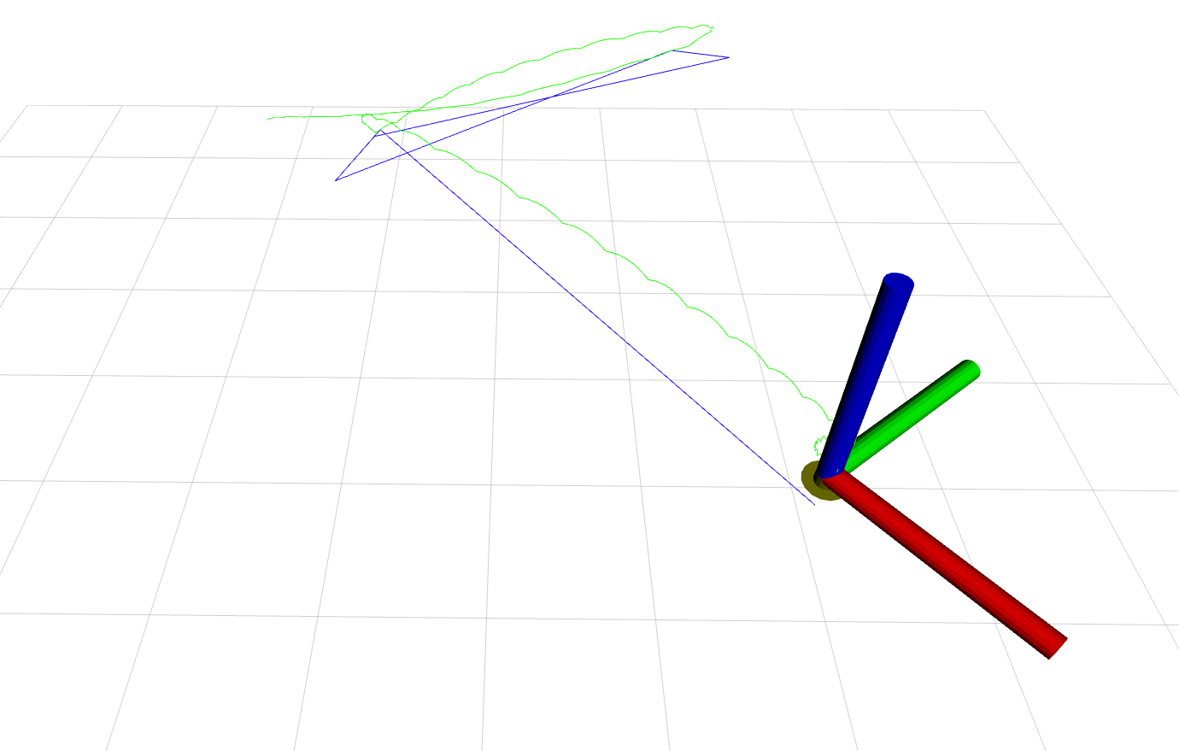Figure 17: RVIZ screen

* the blue line is the theoretical path, the green line is the real path taken

Now that we know what each component does I will explain the whole procedure to launch the drone and the connections between all the software:

* Start Motive and the OptiTrack system.
* From the companion MicroXRCEAgent to interface the flight controller with ROS.
* From the companion launch optitrack_interface and px4-py.py to connect the drone with the optitrack.
* From the companion launch the controller px4-py.py
* (optionally) launch the gui.py
* set the action through gui or ROS2 message

For ease of use I created the 2 aliases *dockerdrone* and *dockercommander* to launch everything in one go.

5.1 **Arming**

The arming is the process of activating the propellers so the drone can take off, the arming could also be denied by ste system if the pre-flight checklist didn’t complete or the system has some error; for example a missalignment of the tracking position, missing heartbeat signal from the commander, hardware problems.

5.2 **Takeoff and routine**

Once the dorne is armed a simple setpoint action will trigger the propeller to speed up and lift the drone. The motors on a hardware level are controlled by the ESC (Electronic speed controller) directly wired to the PixHawk flight controller that handles the logic and flight control,stabilizatioon and planning.

All the commands that we send are high level interfaces that are processed by the flight controller; for example if a signal to go forward 50cm comes, an idela path is produced and the motorss are tuned to follow this path, adjusting in real time based on the PID parameters.

Two types of movements are implemented: one for direct position control if the goal is to get to the destination and noting else, and a planned movement; the latter is based on the former but inrtoduces steps in the path, planned delays and a final positin adjustment.

In the circling routine, the drone constanly follows a virtual point orbiting around the center.

The goto and path routine follow a planned path and the speed can be regulated.

5.3 **Landing**

The landing uses the vehicle_land_detected message of the drone messages, when the drone touches the ground the propellers naturally slow down because there is no resistance and is detected by the has_low_throttle flag, if the flag stays on and the drone doesn’t move the drone is marked as landed.

When landed the drone shuts down and the flight is terminated.

6.  **Conclusions and Discussions**

* The goal of creating a working system to control a flying quadcopter was achieved, and this work can be used as a tempalte for the future and modified at will.
* In this section I will go over some of the afterthought on the design of the system and the choices I made

6.1 **Software choice**

I wanted to keep the system requirement as wide as possible but some choices had to be made, I settled for these three components as the foundation:

* **Linux**: the suitable operating system for support, documentation and ease of use on small single board computers
* **PX4**: pretty much a anecessity for programming a drone on a high level, without interfacing with the hardware direcly
* **ROS2**: allowed the connection of all the componets and can easily communicate with other robots on the same system, gives an abstraction layer that was necessary to unify the whole project.
* Other for the other components I offered my solution and what worked best for me

6.2 **Performance**

The main bottleneck of the system was the network connectivity as the laboratory and the university itself produces a lot of WiFi pollution that degrades performance, the network necessary throughput was measured ad around 4Mbps of data stream and the tolerated delay was round 100ms.

This was never met to be a racing drone and the speed of movement was kept low on purpose, this also helped the stability of the system absorbing delays and avoid disaster.

6.3 **Virtualization**

The use of docker is not itself necessary but it was a decision that was made to better interface with the existing equipment in the laboratory but also came with the benefit of replication on other systems.

6.4 **Indoor flight**

This was a tough topic to solve and a lot of the time and testing involved was around the OptiTrack system integration.

6.5 **Challenges**

* Most of the challenges came fro the lack of existing similar projects, the existing one provided a similar choiches for the conrtoller but the overall system had quite a bit of differences. A big problem was agreeing on a communication type between all programs and ROS was a great help since I just needed to create a converter of messages from alost any system to ROS. In the end I managed to unify many different platforms signals and protocols onto a working system.
* I built many custom tools for my specific need, some from scratch , some as a a fork of an existing software which helped me to develope a better understanding of software engineering; also a lot of tools that were developed were discarted or replaced with others.

6.6 **Future work and possible implementations**

The drone can be equipped with other instruments and tools like a depth camera to create a 3D map, with a tool like ORB SLAM paired with the inertial measurements of the local position and orientaton; or a net-like containers that can be released with a software trigger.

Bibliography

[01] Holybro X500 v2 Developement Kit - https://holybro.com/products/px4-development-kit-x500-v2