Project 1

**Overview**

The goal of the project is to create a system for wireless contacts tracing inside a given location. The system must be able to collect contacts and persist them into the application backend. Also, it must provide to users the ability to trigger an event of interest, which is then notified to all users who has been in contact with the user who just triggered the event.

The application client is implemented in Contiki-NG, and it will be deployed (in production) in small low power microcontrollers (held by customers) with wireless communication capabilities (we used Cooja for simulating real world environment). The application backend is implemented in Node-RED, which exchanges messages with Contiki nodes using a Contiki RPL border router, which acts as a bridge between the two subsystems.

**Contiki subsystem**

As mentioned above, the Contiki subsystem includes one standard RPL border router, which is basically using RPL transport protocol to handle application MQTT messages between user nodes and an MQTT broker, which is a Mosquitto broker process running in the Cooja virtual machine.

Contiki user nodes are considered in contact when they are in the wireless communication range; each personal device identifier is realized by a function of the link address of the node.

To capture most of the contacts, user nodes signal their identity (and receive others) with a higher frequency (n time higher) with respect to backend update; contacts are saved in an array list (size of n contacts) which is then flushed when sending to the backend; node already perceived are not appended; therefore, each node can detect up to n different other nodes for each backend update (in the implementation n is set to 2).

User nodes are of two types: client and client-triggerer. They are basically the same program: they both detect contacts, send them to the backend, and receive an event of interest triggered by someone else; client-triggerer also have a periodic event of interest triggering function (simulates user intention of notify the event).

All the nodes are made by two cooperatively scheduled Contiki protothread:

* **Broker process** handles the TCP connection with the MQTT broker, as well as MQTT message send/receive.
* 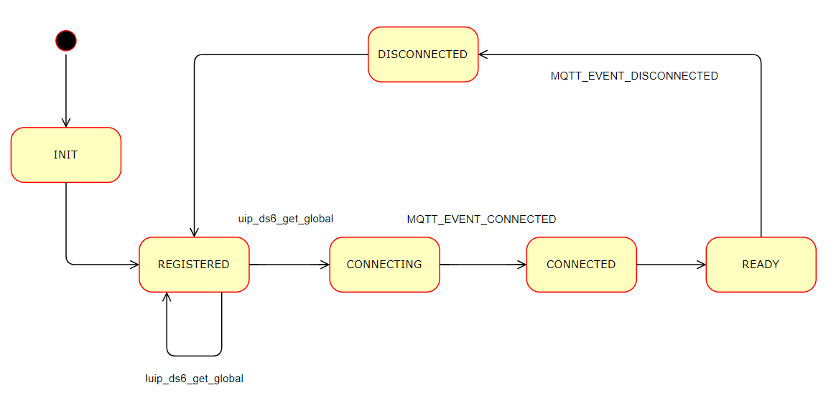**Broadcast process** handles contact tracing, by signaling itself to neighbor nodes using a UDP multicast transmission and listening for neighbors on the same connection.

State diagram of broker_process of client.c

Client-triggerer node in addition:

* Have a **signal process** which triggers an event of interest to be sent.
* Use broker process in turns to flush contacts, then send (if signaled) the event.

State diagram of broker_process of client-triggerer.c

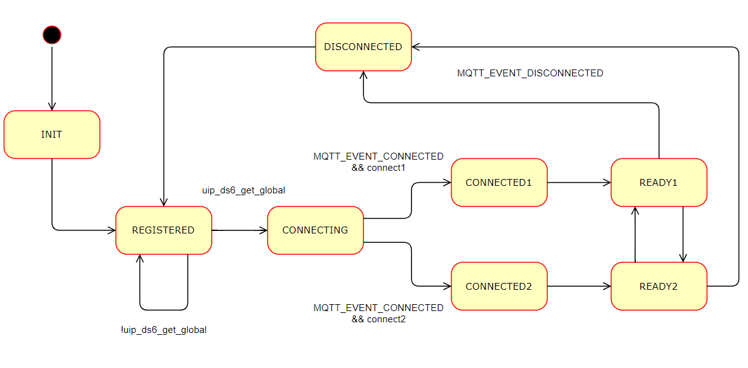

QoS of sending contacts is set to 0; assuming contact dynamic last at least few seconds, and that detection has much higher frequency, we do not care losing few messages (we can detect again it later, while decreasing broker utilization).

QoS of sending events of interest is set to 1; we need to ensure that an event is actually sent to the backend; the event of interest is an important information, it can be a danger signal to other users (Immuni app analogy).

For the same reason, QoS of receiving an event is set to 2; we need to guarantee that the event is received, but we do not want to dispatch it multiple time (no fake event of interest).

**Node Red**

The backend section is responsible of two main things:

* Saving in a database the contact between two user nodes.
* Retrieving the list of user nodes to notify as soon as one node triggers an event of interest.

These operations are managed by two different flows, which have in common the access to the database (represented in Node Red by the global context). The global context allows to create a key-value correspondence between one variable (in our case the id of one node) and another (in our case the list of nodes it has been in contact with).

Flow1

Responsible for the first operation, make these computations:

* Receives from the broker the message notifying that a node (called **node1**) is in proximity of another (called **node2**).
* Retrieve from the message the IDs corresponding to the two nodes.
* Checks if the id of node1 is already saved in the global context. If it is not, creates a new key-value pair. Then adds node2 to the list of nodes in contact.

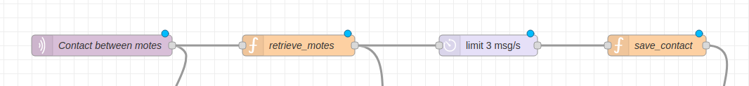

Flow2

Responsible for the second operation:

* Receives from the broker the message notifying an event of interest for a node.
* Retrieve the Id of the said node.
* Access the global context to retrieve the list of nodes it has been in contact with.
* For each node in the list sends an MQTT publish message addressed to the node which must be notified of the event of interest.
* Resets the global context for the node that triggered the event of interest.

