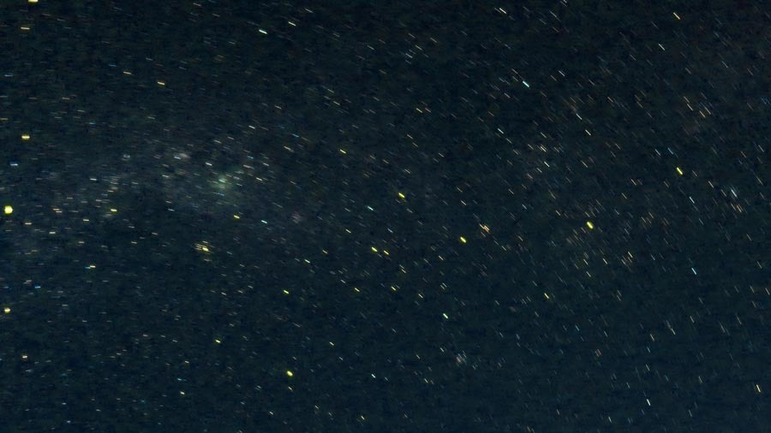

Are They Stars? (October 2025) - Massimo Ferragamo

Are They Stars? is a 2:55 Frequency Modulation (FM) etude inspired by the sounds and works of John Chowning. The piece explores gesture and movement reminiscent of swimming at night, where the line between the sky and the water is blurred.

In the spirit of John Chowning, all the sounds were created using computer-based FM synthesis in Max/MSP. The gestural nature of this composition is expressed through spatialization and panning, as well as the counterpoint between brass-like melodic tones and bright percussive textures. These elements evolve and intertwine throughout, mimicking the body’s movement through water – as we drift into a lull, surrounded by stars.

