
IrisBiome

GUT MICROBIOME ANALYSIS

Full-format demonstration report · Portfolio preview
Sample DEMO001 | Language: English
A view of the reporting workflow from taxonomic abundance to the integrated presentation of results and anamnesis.
SYNTHETIC DATA. Taxonomic abundances come from the demo dataset. Functional evaluations, status and comments illustrate a fictional scenario: private rules are not executed. All reference intervals are masked as xx–xx.

Report structure
1. Sample details · 2. Anamnesis · 3. Result and observations · 4. Biodiversity · 5. Phyla and genera · 6. Enterotype · 7. Functions · 8. Associated genera · 9. Taxa of interest · 10. Integrated comments · 11. Gut–brain axis · 12. Abundances and references

1. Sample details
Field | Value
Sample code | DEMO001
First name | Infinia
Last name | Undari
Sex | F
Date of birth | 2000-05-03
Tax code (fictional) | UNDINF00E23D615X
Address (fictional) | Via delle piastrelle 25
Referring professional | Paola Ronchelli
Parameter | Value
Total reads | 12,070
Observed genera | 10
The demo identity uses details that the author confirmed were fictional in the reference report. The original reference PDF is not included.

2. Anamnesis
Field | Value
Age | 25
Weight (kg) | 58
Height (cm) | 160
Bowel regularity | Regular
Bristol scale | 4
Antibiotics | No
Reflux | No
Bloating | No
Dyspepsia | No
Flatulence | No
Smoking | No
Alcohol | No
Physical activity | 2 volte a settimana
Diet | Dieta varia
Sleep | Buono
Allergies | Not provided
Symptoms | Not provided
Medication | Not provided

3. Result and observations


Intermediate profile — demonstration scenario
The icon illustrates result presentation. It is not a health classification of the input.
Area | Observation
Biodiversity | 10 classified genera observed
Composition | Most abundant genus: Faecalibacterium
Functional groups | Evaluations illustrated with synthetic data; ranges xx–xx
Anamnesis integration | Metadata displayed; personalization rules withheld

4. Biodiversity
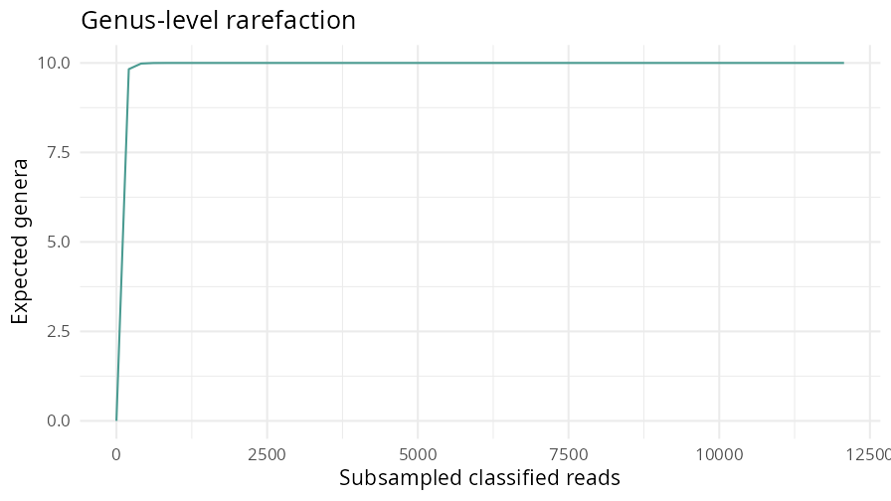
The curve shows expected genus richness as read subsampling depth increases. It uses genus-aggregated counts, excluding unclassified reads; it does not represent ASV richness.
Observed genera / interval / evaluation
10
xx–xx
Withheld

5. Phylum and genus
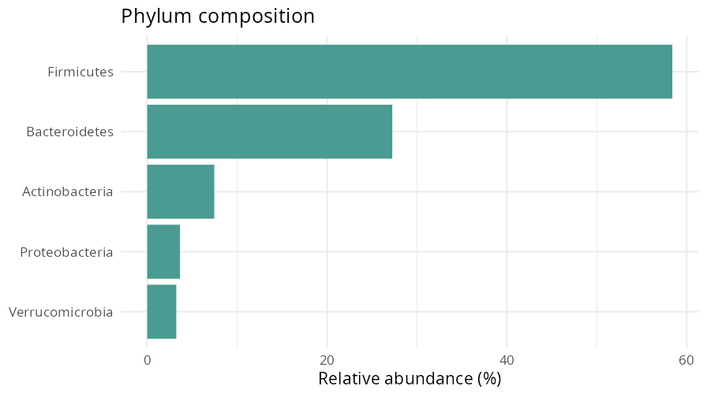
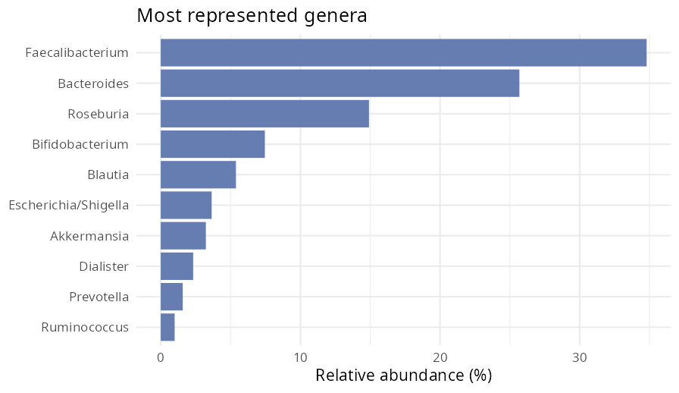
Phylum | Abundance | Reference
Firmicutes | 58.41% | xx–xx
Bacteroidetes | 27.26% | xx–xx
Actinobacteria | 7.46% | xx–xx
Proteobacteria | 3.65% | xx–xx
Verrucomicrobia | 3.23% | xx–xx

6. Enterotype
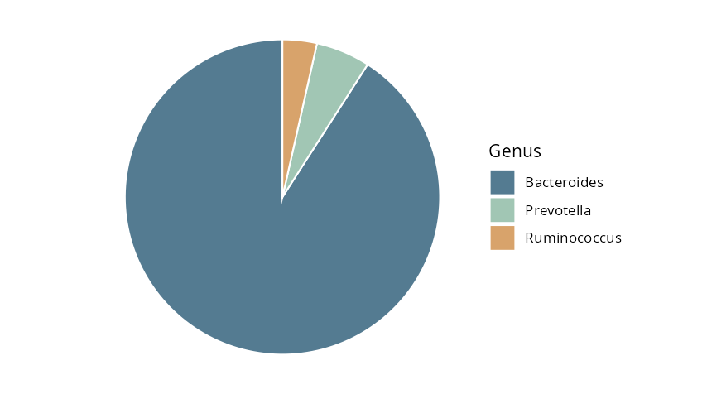
Genus | Abundance of total | Threshold
Bacteroides | 25.68% | xx–xx
Prevotella | 1.57% | xx–xx
Ruminococcus | 0.99% | xx–xx
The chart compares only these three genera and renormalizes their proportions. The table uses percentages of total reads. Enterotype assignment and its thresholds remain withheld.

7. Microbiome functions
Full-format showcase: demo percentages and evaluations are invented independently of taxa. They do not represent measured or inferred metabolic activity. Curated mappings are not included.
Function | Demo value | Interval | Demo evaluation
Butyrate-associated group | 18.4% | xx–xx | Typical (demo)
Acetate-associated group | 37.2% | xx–xx | High (demo)
Propionate-associated group | 21.6% | xx–xx | Typical (demo)
Vitamin B-associated group | 14.8% | xx–xx | Low (demo)
Vitamin K-associated group | 29.3% | xx–xx | Typical (demo)
Histamine-associated group | 4.7% | xx–xx | High (demo)
Gluten degradation-associated group | 8.2% | xx–xx | Low (demo)
Lactose degradation-associated group | 24.5% | xx–xx | Typical (demo)
TMA-associated group | 6.3% | xx–xx | Typical (demo)
LPS-associated group | 11.9% | xx–xx | High (demo)
Mucin-associated group | 17.8% | xx–xx | Typical (demo)
Serotonin-associated group | 19.4% | xx–xx | Typical (demo)
Dopamine-associated group | 12.6% | xx–xx | Typical (demo)
GABA-associated group | 22.1% | xx–xx | Typical (demo)
Noradrenaline-associated group | 3.8% | xx–xx | Low (demo)
Fermentation-associated group | 41.7% | xx–xx | High (demo)

8. Genera in functional groups
Function | Associated genera
Butyrate-associated group | Mappings withheld
Acetate-associated group | Mappings withheld
Propionate-associated group | Mappings withheld
Vitamin B-associated group | Mappings withheld
Vitamin K-associated group | Mappings withheld
Histamine-associated group | Mappings withheld
Gluten degradation-associated group | Mappings withheld
Lactose degradation-associated group | Mappings withheld
TMA-associated group | Mappings withheld
LPS-associated group | Mappings withheld
Mucin-associated group | Mappings withheld
Serotonin-associated group | Mappings withheld
Dopamine-associated group | Mappings withheld
GABA-associated group | Mappings withheld
Noradrenaline-associated group | Mappings withheld
Fermentation-associated group | Mappings withheld

9. Taxa of interest
Genus | Abundance | Interval
Escherichia/Shigella | 3.65% | xx–xx
Klebsiella | 0.00% | xx–xx
Enterococcus | 0.00% | xx–xx
Fusobacterium | 0.00% | xx–xx
This is a descriptive taxonomic selection. Genus-level abundance does not identify a pathogenic species or establish infection. No private clinical lists or rules are applied.

10. Integrated comments and nutrition

Example comment structure
Anamnesis / threshold / recommendation
No
xx–xx
Withheld
DEMO SCENARIO — The complete report connects microbiological observations and anamnesis. Here the visual link between a metadata field and an interpretation section is illustrated; personalized wording and decision criteria are withheld.

11. Gut–brain axis
Function | Demo value | Interval | Demo evaluation
Serotonin-associated group | 19.4% | xx–xx | Typical (demo)
Dopamine-associated group | 12.6% | xx–xx | Typical (demo)
GABA-associated group | 22.1% | xx–xx | Typical (demo)
Noradrenaline-associated group | 3.8% | xx–xx | Low (demo)
These values are synthetic presentation elements: they do not measure neurotransmitters, neurological status or symptoms. Complete-version rules are not distributed.

12. Detected genus abundances
Genus | Abundance | Interval | Evaluation
Faecalibacterium | 34.80% | xx–xx | Withheld
Bacteroides | 25.68% | xx–xx | Withheld
Roseburia | 14.91% | xx–xx | Withheld
Bifidobacterium | 7.46% | xx–xx | Withheld
Blautia | 5.39% | xx–xx | Withheld
Escherichia/Shigella | 3.65% | xx–xx | Withheld
Akkermansia | 3.23% | xx–xx | Withheld
Dialister | 2.32% | xx–xx | Withheld
Prevotella | 1.57% | xx–xx | Withheld
Ruminococcus | 0.99% | xx–xx | Withheld

Bibliography and complete version
The extended bibliography, functional knowledge base, intervals and interpretation criteria belong to the private version. For information contact Massimo Guazzini: https://github.com/MassimoGuazzini

