|  |
| --- |
| **Moody’s : B2, Stable | Fitch : B+, Stable | S&P : B+, Stable** |

|  |  |
| --- | --- |
| **Strengths**   * **Good relations with its neighbors (especially Saudi Arabia) embodied by significant support from the CCG** * **A more diversified economy than that of other countries in the region** * **No major political and social instability to be expected in the short term** | **Weaknesses**   * **Current oil prices are far from the level that would allow it to balance its books** * **Significant public debt** * **There is a need for the government to find new sources of revenue** |

**Abstract : Last year, Bahrain's real GDP grew by 2.4%. This growth was supported by tourism, transport and real estate, and was possible despite a 2.4% contraction in the oil sector. Also, Bahrain benefits from good relations with its neighbors, in particular thanks to the support of the Gulf Cooperation Council (GCC) which facilitates access to liquidity and provides logistical support for the implementation of large-scale projects. Bahrain's economy is more diversified than that of other countries in the region, and the country is politically stable in the short term. However, Bahrain faces major challenges: current oil prices are well below the level needed to balance its budget, public debt is high, and new sources of revenue are needed to compensate for declining oil revenues. The implementation of key reforms announced by the government, such as those concerning the electricity and water authority, will be decisive in making economic prosperity possible.**

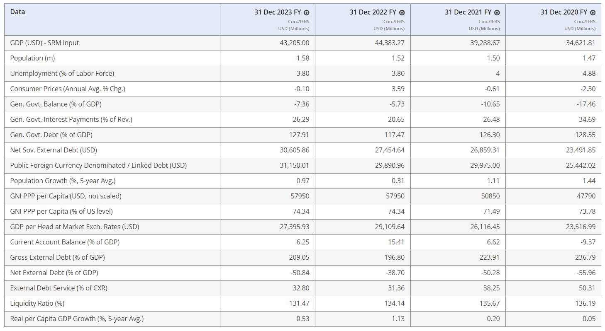

Table and datas are from **Fitch Connect**

Important reminders

Bahrain is a country of 1.472 million inhabitants (half of whom are expatriates), with an area of ​​765 km² spread over 33 islands, some of which are uninhabited. Bahrain has a GDP per capita of $28,781, an unemployment rate of 3.80% and an HDI of 0.875 which places it 35th in the ranking.

After having been a British protectorate, Bahrain gained independence peacefully in 1971.

Bahrain is a monarchy, led by King Hamad bin Issa el-Khalifa. The parliament is made up of two chambers, Majlis an-Nouwwab (chamber of deputies) and Majlis ach-Shura, with 40 seats each, since the proclamation of the new Constitution by Hamad Al Khalifa on February 14, 2002.

According to this constitution, the title of the sovereign changed from emir (title dating from 1971) to king. Since independence in 1971, the Prime Minister has been Khalifa bin Salmane Al Khalifa, uncle of the king.

The legal opposition was represented by two parties: the Shiite Wefaq and the secular left-wing Waad. The latter, however, has always been deprived of even the slightest seat in Parliament. Both were banned after the 2011 uprising which was part of the Arab Spring movement.

Context

Bahrain's parliament is functioning and no major political tensions are expected in the short term. The Sunni Al Khalifa family has ruled since 1783. Hamad bin Isa bin Salman has been king since February 2002. The political scene appears complicated in the long term, due to the feeling of political and economic marginalization of the Shiite population, which represents around 60% of the population. population.

With the United States, the privileged relationship is officially described as “strategic”. Washington also granted the Kingdom of Bahrain the status of “major non-NATO ally” in 2001. The United States maintains a close military alliance with Bahrain, with the signing of a defense cooperation agreement in 1991. Bahrain hosts the American Fifth Fleet.

Additionally, growing economic dependence on Saudi Arabia, ineffective separation of powers, and limited civil liberties will pose challenges in the years to come.

The normalization of diplomatic relations with Israel in 2020 will continue to improve their trade ties through the planned signing of a free trade agreement.

The recent rapprochement between Saudi Arabia and Iran could prompt Bahrain to follow suit, even as Bahrain accuses Iran of supporting subversive elements within its Shiite population. For now, both countries are keeping a low profile.

Economic facts

In 2023, Bahrain's real GDP grew by 2.4% thanks to growth in regional tourism, transport and real estate. This growth was partially offset by a 2.4% contraction in the oil sector, due to temporary maintenance of the Abu Safa oil field (150,000 barrels per day).

Despite Bahrain's dependence on oil for its tax and foreign revenues, the contribution of hydrocarbons to GDP is around 16%, which is lower than for other countries in the region.

S&P forecasts growth of 2.5% on average over the period 2024-2027. This future growth will be driven by the government's economic recovery plan targeting non-oil activity, which will surely attract investment in sectors such as tourism, housing, roads, airports and electricity. For example, its good relations with the Saudi monarchy have enabled it to be granted $5 billion in investments in these sectors.

Bahrain can count on the Gulf Cooperation Council (an organization bringing together six Arab and Muslim monarchies from the Persian Gulf) to have easier access to liquidity. Thanks to this organization, it was able to benefit from a support program of 10.2 billion dollars.

Inflation in Bahrain remains moderate by global standards, averaging 0.1% in 2023. Bahrain's track record of price stability benefits from ongoing government subsidies and the strength of the US dollar, which helps to contain imported inflation. Fitch forecasts that inflation will normalize to historical averages of 1-2% over the period 2024-2027.

However, the contribution of public consumption will gradually decline, in line with the balanced budget program and the government's commitment to implement spending reduction measures in exchange for financial assistance from its neighbors.

On the budgetary level, the government has quite limited room for maneuver due to the high debt burden and its significant dependence on hydrocarbon revenues which represent nearly 70% of total budgetary revenues. The price of a barrel of oil which would allow a balanced budget is around 126USD, a level well above recent prices which are between 80 and 90 dollars per barrel.

This situation forces the Bahraini government to find new sources of revenue. These were present in the 2023 forecast budget, although they did not materialize. This is notably due to the delay in implementing a key reform concerning Bahrain's Electricity and Water Authority, which alone was expected to cause an increase in revenues of 3 to 4% of GDP by the end of 2024. The establishment of a corporate tax is also under discussion.

In 2023, public debt reached 126% of GDP despite the budgetary consolidation plans announced by the government. Fitch forecasts a public deficit of 135% of GDP for 2025, which is well above the median of 56% of countries with the same rating.

Concerning the public deficit, it reached 7.8% in 2023, and is expected to worsen slightly in the medium to long term. This forecast is made based on an anticipation of a drop in oil prices in the coming years.

The significant increase in interest costs due to the increase in outstanding debt and the rise in interest rates should also help maintain the deficit at a high level.

Despite a volume of oil production which will remain stable due to compliance with the quotas imposed by OPEC+, Bahrain will experience an increase in its current account due to the increase in hydrocarbon prices in force this year.

Increased revenues from aluminum and steel exports will also be a key factor in widening the goods trade surplus.

Remittances from migrant workers will continue to widen the secondary income deficit as foreign workers continue to return to Bahrain. Services exports, mainly in the form of resilient tourism, will also contribute to the current account surplus, which will remain above its historical level.

Bahrain's banking sector assets represented 543% of GDP in 2023. The sector is shared between retail banks which mainly serve the local market and wholesale banks, which conversely have almost no retail activity. According to Fitch, retail banks are well capitalized and able to absorb NPL resulting from the widespread rise in interest rates.

The replenishment of Bahrain's foreign exchange reserves has historically come from government external issuance and fiscal support from other GCC states. Gross foreign exchange reserves expected to remain at $4.7 billion over the period 2024-2027.

Written on 26th July 2024.

*Sources :*

*<https://www.moodys.com/credit-ratings/Bahrain-Government-of-credit-rating-600018600/summary>*

[*https://app.fitchconnect.com/article/RPT_10264396*](https://app.fitchconnect.com/article/RPT_10264396)

[*https://disclosure.spglobal.com/ratings/en/regulatory/article/-/view/type/HTML/id/3183128*](https://disclosure.spglobal.com/ratings/en/regulatory/article/-/view/type/HTML/id/3183128)

[*https://www.coface.com/fr/actualites-economie-conseils-d-experts/tableau-de-bord-des-risques-economiques/fiches-risques-pays/bahrein#:~:text=Dans%20le%20cadre%20d'une,environ%2020%20%25%20des%20exportations%20totales*](https://www.coface.com/fr/actualites-economie-conseils-d-experts/tableau-de-bord-des-risques-economiques/fiches-risques-pays/bahrein#:~:text=Dans%20le%20cadre%20d'une,environ%2020%20%25%20des%20exportations%20totales)*.*

[*https://www.diplomatie.gouv.fr/fr/dossiers-pays/bahrein/presentation-du-bahrein/*](https://www.diplomatie.gouv.fr/fr/dossiers-pays/bahrein/presentation-du-bahrein/)

[*https://www.tresor.economie.gouv.fr/Pays/BH/situation-economique-et-financiere-decembre-2017*](https://www.tresor.economie.gouv.fr/Pays/BH/situation-economique-et-financiere-decembre-2017)