|  |
| --- |
| **Moody’s : Baa1, Positive | Fitch : A-, Stable | S&P : A, Stable** |

|  |  |
| --- | --- |
| **Strengths**   * **Dynamic growth well ahead of other countries in the zone** * **The country is on a path of fiscal consolidation (debt and deficit reduction)** * **Comparative advantage in renewable energies** | **Weaknesses**   * **The ruling coalition is fragile and could be jeopardized by Catalan independence aspirations.** * **Despite historically low unemployment to date, the job market is still facing major structural difficulties.** * **High dependence on energy imports** |

**Abstract : Spain is currently experiencing growth that is reflected in an improvement in most of its macroeconomic indicators (fiscal consolidation, reduction in public debt). This growth is rooted in private consumption, which has been reinforced by a more efficient labor market and rising real incomes at a time of inflation (expected to return to 3% in 2024, 2.3% in 2025). However, there are several factors that could worsen the situation in the medium term, including: the issue of Catalan independence, which could lead to a major political reshuffle; difficulties in eliminating structural unemployment, and heavy dependence on energy imports.**

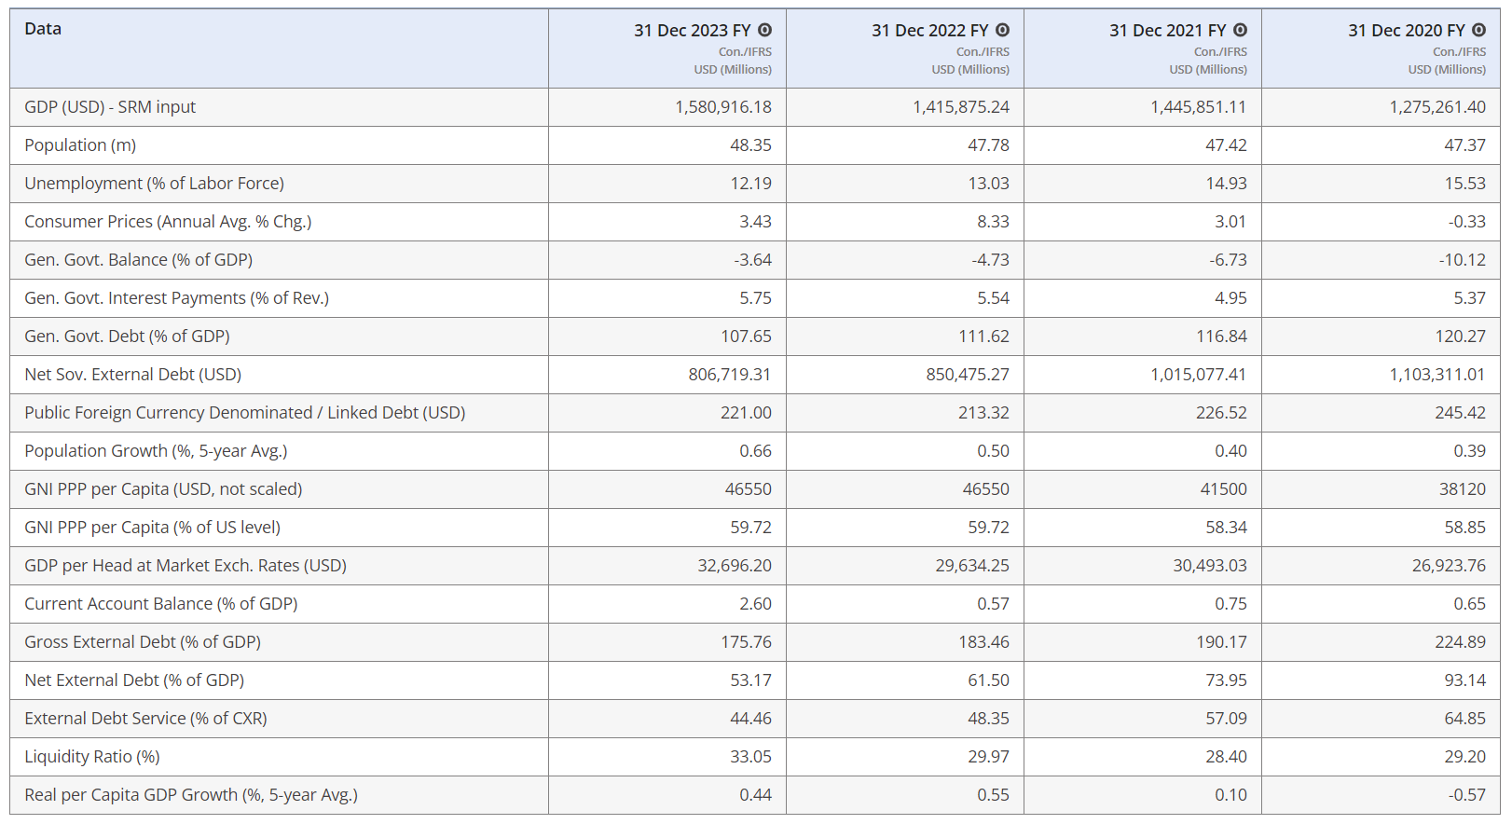

Table and data are from **Fitch Connect**

Important reminders

Spain has a population of **47 million**, is the **fourth largest country in Europe in terms of surface area**, and has a **GDP per capita of €30,300**. The country contributes **8.3% of the European Union's total GDP**, had an unemployment rate of **12.29% in Q1 2024**, and an **HDI of 0.905 in 2021** (ranked 27th in the world).

The 1978 Constitution in force today states that the "Spanish nation" is "indivisible", but also recognizes "the right of nationalities to autonomy", which could allow us to describe **Spain as a "semi-federal" state.**

Spain is a constitutional parliamentary monarchy. King Felipe VI, reigning since June 19, 2014, is head of state, while Prime Minister Pedro Sánchez (from the Spanish Socialist Workers' Party) has been heading of government since June 2, 2018.

After a **major recession in the early 2010s** (subprime crisis and bursting of the real estate bubble in 2008, sovereign debt crisis in 2012), the **Spanish economy has since experienced a period of catch-up that began in 2014**, with growth above the eurozone average.

The **Covid crisis brought this positive momentum to a halt**, with GDP falling by 11.3% in 2020, the steepest drop among eurozone countries. This was due in particular to the closure of Spain's borders, which deprived it of revenue from tourism, which accounts for around 13% of the country's wealth.

**Since then, the Spanish economy has been on the rebound, with GDP set to grow by 5.5% in 2021, 5% in 2022 and 2.5% in 2023, well above the European average (0.8%).**

News

On Tuesday June 25, 2024, the Spanish National Institute of Statistics published **an estimate of growth in the Spanish economy. It reached 0.8% in the first quarter, 0.1 points higher than initially forecast, thanks to strong consumption and dynamic exports.**

On Wednesday April 24, 2024, the head of the Spanish government announced **that he was considering resigning because of a preliminary investigation into his wife for** corruption. In the end, he decided to remain Prime Minister.

On Thursday May 30, 2024, **Spanish deputies definitively adopted an amnesty law for Catalan independence leaders.** This measure will allow pro-independence fighters still in exile after the 2017 secession attempt, such as former Junts leader Carles Puigdemont, to return to the country.

Context

Following his party's debacle in the 2023 local elections, **Pedro Sánchez decided to dissolve the party and call early general elections for July 2023.** The Popular Party, led by Albert Nunez Feijoo, came out on top, while the incumbent Prime Minister's PSOE surprised everyone by coming in second, just two points behind the PP, thwarting predictions of an electoral landslide.

Although King Felipe VI nominated the PP leader as his candidate, he failed to gather enough support to secure a majority in Congress.

**Sánchez was in turn nominated and managed to form a coalition comprising the PSOE, Sumar (radical left), peripheral nationalist parties and Catalan independence fighters (in return for the amnesty law mentioned above).**

Economic facts

**After the various crises of the early 2010s, Spain returned to growth between 2015 and 2019, with GDP increasing by an average of 2.82% over this period, a much better result than other countries in the region.**

This positive momentum has also been reflected in the labor market, **with unemployment divided by two from its previous endemic level (26.1% in 2013) to 12.92% by 2022.**

Despite this improvement in the labor market, **it remains plagued by major structural difficulties, such as the high proportion of fixed-term contracts (25.8% in Q1 2020), youth unemployment (28.2% in February 2024, the worst score in the EU) and long-term unemployment (36.1% of the unemployed had been looking for work for over a year in 2019).**

After being severely impacted by the Covid crisis **(in 2020, the Spanish economy contracted by 11.2%, the biggest fall in the entire Union)**, the country has enjoyed a strong recovery and proved highly resilient in the wake of the pandemic and the war in Ukraine. **Economic activity should slow in 2024, but remain above the eurozone average (forecasts suggest growth of around 2%).**

General inflation is forecast to average around 3% in 2024, falling gradually to 2.2% in 2025. As far as food prices are concerned, the base effect resulting from last year's sharp rises and data on agricultural costs, which have been showing a negative annual variation for several months, should relieve pressure on prices.

As regards its external position, the **country has been running a current account surplus since 2013.** **Projections as to whether this surplus will increase or decrease in the coming years are difficult to make, as it depends on external demand that is particularly sensitive to geopolitical factors,** evolving at a time of great uncertainty. The country also has one of the highest levels of net foreign debt in the EU (57.4% of GDP), although this has been falling in recent years.

Due to its lack of conventional energy resources, **Spain is highly dependent on energy imports (71.9% of its imports are energy-related). By 2022, it would rank 7th in the world in crude oil imports, and 9th in natural gas imports.**

On the other hand, **Spain is a benchmark for renewable energies** **(3rd European country with the largest renewable energy production capacity)**, benefits from more hours of sunshine than any other member state, as well as one of the continent's largest lithium deposits, creating optimal conditions for the exploitation of wind and hydro power.

**The large surplus on the balance of services (expected to be close to 6% of GDP in 2023) offsets the structural deficits on the balance of goods,** largely attributable to the country's energy dependence, and on the balance of income (remittances from the Latin American and Moroccan diasporas to their countries of origin). This will partly offset the rise in imports due to dynamic domestic demand (stimulated by wage increases imposed by the socialist government, the minimum wage has jumped 47% over the last five years) and capital imports.

**As for public finances, the public deficit has fallen sharply (to 6.9% of GDP in 2021 and 4.8% in 2022) thanks to a record recovery driven by the upturn in activity and the gradual end of emergency measures.**

Forecasts anticipate a **public deficit of 3% of GDP in 2024 (3.6% in 2023). The implementation of the Stability Pact reform, which will come into force in 2025, should facilitate the reduction of this deficit.**

**Similarly, public debt reversed its upward trend of 2020, recording a slight decline in 2021 (118.4% of GDP), which continued in 2022 (113.2%) and 2023 (107.7%).**

**Spain's public debt ratio fell by 12.6 points from its pandemic peak of 120.3% (2020),** thanks to high nominal GDP growth.

However, **Spanish debt levels remain the 4th highest among Eurozone countries** (behind France, Italy and Greece).

**For 2025, the Spanish government is forecasting a deficit of 2.5%, which would mean that for the first time since 2007, Spain would achieve a primary budget surplus.**

Written on June 28, 2024

*Sources :*

[*https://disclosure.spglobal.com/ratings/en/regulatory/article/-/view/type/HTML/id/3139611*](https://disclosure.spglobal.com/ratings/en/regulatory/article/-/view/type/HTML/id/3139611)

[*https://app.fitchconnect.com/article/PR_10271498*](https://app.fitchconnect.com/article/PR_10271498)

[*https://www.coface.com/fr/actualites-economie-conseils-d-experts/tableau-de-bord-des-risques-economiques/fiches-risques-pays/espagne*](https://www.coface.com/fr/actualites-economie-conseils-d-experts/tableau-de-bord-des-risques-economiques/fiches-risques-pays/espagne)

[*https://www.tresor.economie.gouv.fr/Pays/ES/situation-macroeconomique-de-l-espagne#:~:text=En%202021%20et%202022%2C%20le,de%20fin%202019%5B1%5D*](https://www.tresor.economie.gouv.fr/Pays/ES/situation-macroeconomique-de-l-espagne#:~:text=En%202021%20et%202022%2C%20le,de%20fin%202019%5B1%5D)

[*https://www.diplomatie.gouv.fr/fr/dossiers-pays/espagne/presentation-de-l-espagne/#:~:text=Le%20stock%20d'investissements%20fran%C3%A7ais,filiales%2C%20et%2056%20900%20salari%C3%A9s*](https://www.diplomatie.gouv.fr/fr/dossiers-pays/espagne/presentation-de-l-espagne/#:~:text=Le%20stock%20d'investissements%20fran%C3%A7ais,filiales%2C%20et%2056%20900%20salari%C3%A9s)

[*https://www.boursorama.com/actualite-economique/actualites/espagne-la-croissance-du-premier-trimestre-revisee-a-la-hausse-a-0-8-eb6dba032cc5503d1d6ba13beaa3356f*](https://www.boursorama.com/actualite-economique/actualites/espagne-la-croissance-du-premier-trimestre-revisee-a-la-hausse-a-0-8-eb6dba032cc5503d1d6ba13beaa3356f)

[*https://etudes-economiques.credit-agricole.com/Publication/2024-avril/espagne-les-carburants-et-l-electricite-soutiennent-l-inflation-de-mars*](https://etudes-economiques.credit-agricole.com/Publication/2024-avril/espagne-les-carburants-et-l-electricite-soutiennent-l-inflation-de-mars)

[*https://www.oecd-ilibrary.org/sites/bd18c5ae-fr/1/3/2/17/index.html?itemId=/content/publication/bd18c5ae-fr&_csp_=623453836f16e0c026165f9490b092dd&itemIGO=oecd&itemContentType=book*](https://www.oecd-ilibrary.org/sites/bd18c5ae-fr/1/3/2/17/index.html?itemId=/content/publication/bd18c5ae-fr&_csp_=623453836f16e0c026165f9490b092dd&itemIGO=oecd&itemContentType=book)

[*https://www.touteleurope.eu/economie-et-social/le-taux-de-chomage-des-jeunes-en-europe/#:~:text=Selon%20les%20derni%C3%A8res%20statistiques%20d,Italie%20(22%2C8%20%25)*](https://www.touteleurope.eu/economie-et-social/le-taux-de-chomage-des-jeunes-en-europe/#:~:text=Selon%20les%20derni%C3%A8res%20statistiques%20d,Italie%20(22%2C8%20%25))