|  |
| --- |
| **Moody’s : Baa1, Positive | Fitch : BBB, Stable | S&P : BBB-, Stable** |

|  |  |
| --- | --- |
| **Strengths**   * **Benefits from a strategic geographical location, at the crossroads of Europe, Russia and China** * **Significant oil, gas and mining potential** * **Significant foreign exchange reserves of the Central Bank (NBK) and the National Oil Fund (NFRK)** | **Weaknesses**   * **The economic environment will be very sensitive to the evolution of its relations with China and Russia** * **The 2022 revolt testifies to the uneasiness of the population, suggesting a scenario of political instability** * **Fragile banking system and significant dollarization** |

**Abstract :** **Kazakhstan benefits from a strategic geographic location between Europe, Russia and China and the Middle East. Also, the country has significant oil, gas and mining potential, which provides it with a substantial income. The significant foreign exchange reserves of the Central Bank and the National Petroleum Fund are major assets for the country's economic stability. However, its economy remains dependent on its good relations with China and Russia. For example, 80% of the country's total oil exports pass through the Caspian Pipeline Consortium which passes through Russian territory. The 2022 revolt has highlighted internal tensions that could threaten political stability, and the country's banking system is weakened by high dollarization. Despite these challenges, Kazakhstan displays real potential, solid economic growth, supported by the expansion of its hydrocarbon exports. The economic future relies on income diversification and improved infrastructure.**

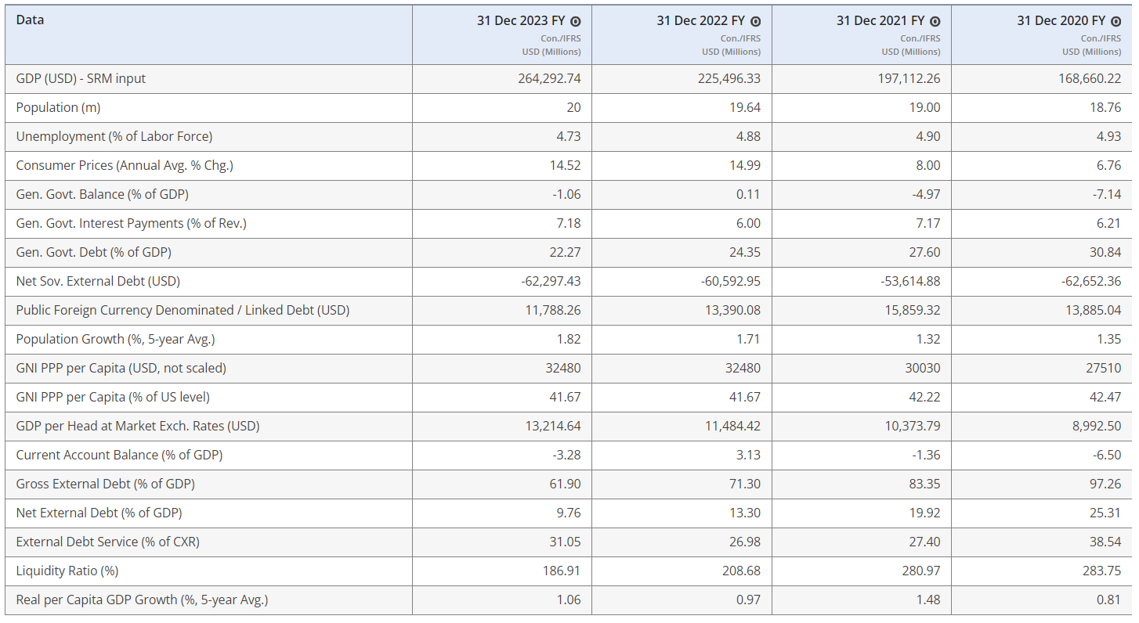

Table and datas are from **Fitch Connect**

Important reminders

Kazakhstan acquired its independence on December 16, 1991, at the time of the dislocation of the USSR of which it was a member. Since then, the country has been engaged in a process of liberalization of its economy (wave of privatization, creation of a national currency, signing of an oil exploitation contract with Chrevron). Following the oil crisis of 1998 which had a major impact on Russia (with which it still maintains strong ties), Kazakhstan decided to turn economically towards China.

Kazhakstan has an area of ​​2.7 million square kilometers (the 9th largest in the world) and has 20 million inhabitants. The country has an HDI of 0.81, which places it in 56th place in the ranking.

Politics in Kazakhstan is based on a state model of a semi-presidential republic with the head of state being the president and the head of government being the prime minister. The regime in Kazakhstan remains characterized as authoritarian. The current president is Kassym-Jomart Tokaïev (in office since March 20, 2019) and the head of government is Oljas Bektenov (since February 6, 2024).

Rich in natural resources (uranium, oil, natural gas, coal), and with fertile lands, Kazakhstan attracts major world powers. This Central Asian country is geographically stuck between two powers, Russia and China, with a view on India, Turkey and Iran which gives it a strategic positioning.

News

In January 2022, a protest movement broke out across the country following the sudden rise in fuel prices. The demonstrations began in the oil town of Janaozen but quickly spread to other towns, and turned into riots during the night of January 4-5, leading current President Kassym-Jomart Tokayev to declare state emergency, initially in Almaty and in the Manguistau district, then throughout the territory. The government submits its resignation, and the head of state takes the head of the national security council.

These events, described as an attempted coup d'état, led President Tokayev to undertake a series of reforms, relying on a new advisory body, the National Council of Public Trust. This program includes budgetary, economic and financial transparency measures, the relaxation of the regime for authorizing demonstrations on public roads, and the abolition of the death penalty (effective since January 4, 2021).

Economic facts

With a GDP exceeding 225 billion USD in 2023, and a GDP per capita of 11,500 USD, Kazakhstan accounts for almost 50% of Central Asia's GDP.

The Kazakh economy is mainly based on the export of hydrocarbons. A member of OPEC, the country is the 9th largest exporter of crude oil and coal in the world. Hydrocarbons represented around 60% of total exports by value last year. However, a risk weighs on crude oil exports, in the event that Russia decides, as it did twice in 2022, to cut off Kazakhstan's access to the Caspian Sea Pipeline (CPC), which somewhat conditions the relationship that Kazakhstan must maintain with Russia.

The government has announced that it wants to increase revenues associated with non-oil revenues by 60% in 2022, for a target of 78% in 2025. More spending will be devoted to the real economy, such as the construction of new roads (the Corridor project of the Middle will be decisive) or even real estate projects...

After the global Covid-19 crisis (which also caused a fall in oil prices), Kazakhstan experienced a solid rebound. GDP increased by 4.3% in 2021, 3.2% in 2022 and 5.1% in 2023 (its best result in 11 years). The government plans growth between 3.5% and 4.5% for the current year, while the IMF forecasts growth of 3.1%.

The S&P agency forecasts annual growth averaging around 3.6% over the next four years. The expansion of the Tengiz oil field (postponed to mid-2025) is expected to be a key factor in this future growth. Indeed, in the absence of disruptions, this should make it possible to considerably increase the country's oil production, increasing it from 85.9 million tons in 2021 to 103 million tons when the project is completed.

Over the period 2014-2022, the Kazakh tenge (KZT) depreciated by -14% on an annual average. This currency is particularly vulnerable to external shocks. Over the year 2022, the KZT exchange rate has been quite volatile, but aligned with the price of oil. It ultimately lost -8% in value against the US dollar.

Like most countries in the world, Kazakhstan has not escaped the inflationary wave, which has started to rise again since 2020, going from an average of 6.8% to 14, 9% in 2023 against a backdrop of rising energy and food prices. This has fallen slightly since then.

In response to this, the National Bank of Kazakhstan maintained its benchmark interest rate at 14.75% at its meeting on April 12, 2024, opting for stability after five consecutive reductions.

In 2020, the public deficit reached a historically high level with -6.40% of GDP, largely due to the sudden fall in oil prices. It has improved since then since it was at -2.1% of GDP. GDP in 2022, and -2.5% in 2023.

After the fall in oil prices in 2015, the country recorded successive annual current account deficits between 2015 and 2021 (on average -3.4% of GDP). Only high oil and gas prices in 2022 allowed Kazakhstan's external account to return to a surplus of around +3% of GDP. Observers predict that these surpluses will continue in the years to come, although they should be smaller.

As for external debt in relation to GDP, this fluctuated between 80% and 120% over the period 2015-2022 and should be around 75% in 2024 (which would represent the equivalent of 40% of government revenues from exports).

Foreign exchange reserves and foreign currency assets of the National Fund of the Republic of Kazakhstan reached 36% of GDP at the end of March, despite a current account deficit that fell to 3.3% of GDP in 2023.

The Kazakh banking sector is plagued by structural difficulties despite the measures undertaken in recent years aimed at strengthening supervision and development of the financial market. This is undersized and does little to fulfill its role of financing the economy; banks are reluctant to finance businesses and other private actors more actively. Indeed, business loans are considered riskier to grant than loans intended for individuals. This situation mainly arises from certain persistent structural weaknesses in the local banking environment. Among these weaknesses, we can cite a significant dollarization of loans which is today estimated at 37%, (even if this trend is downward), a high concentration of borrowing by a small number of actors in restricted sectors .

Written on 26th July 2024.

*Sources :*

*<https://disclosure.spglobal.com/ratings/en/regulatory/article/-/view/type/HTML/id/3133510>*

[*https://www.moodys.com/research/Government-of-Kazakhstan-Baa2-positive-Regular-update-Credit-Opinion--PBC_1406464#fc6127bd5e4d37a246d4c73579791d51*](https://www.moodys.com/research/Government-of-Kazakhstan-Baa2-positive-Regular-update-Credit-Opinion--PBC_1406464#fc6127bd5e4d37a246d4c73579791d51)

[*https://app.fitchconnect.com/article/RPT_10273300*](https://app.fitchconnect.com/article/RPT_10273300)

[*https://www.tresor.economie.gouv.fr/Pays/KZ/la-situation-economique-et-financiere-du-kazakhstan-2#:~:text=Avec%20un%20PIB%20d%C3%A9passant%20225,exportations%20en%20valeur%20en%202023*](https://www.tresor.economie.gouv.fr/Pays/KZ/la-situation-economique-et-financiere-du-kazakhstan-2#:~:text=Avec%20un%20PIB%20d%C3%A9passant%20225,exportations%20en%20valeur%20en%202023)*.*

[*https://www.coface.com/fr/actualites-economie-conseils-d-experts/tableau-de-bord-des-risques-economiques/fiches-risques-pays/kazakhstan*](https://www.coface.com/fr/actualites-economie-conseils-d-experts/tableau-de-bord-des-risques-economiques/fiches-risques-pays/kazakhstan)

[*https://www.allianz-trade.fr/etudes-economiques/risque-pays/kazakhstan.html*](https://www.allianz-trade.fr/etudes-economiques/risque-pays/kazakhstan.html)

[*https://perspective.usherbrooke.ca/bilan/servlet/BMAnalyse/1086*](https://perspective.usherbrooke.ca/bilan/servlet/BMAnalyse/1086)