|  |
| --- |
| **Moody’s : A2, Stable | Fitch : A-, Stable | S&P : A-, Stable** |

|  |  |
| --- | --- |
| **Strengths**   * **Member of NATO and growing weight within the European Union** * **Fairly robust domestic demand** * **Public debt will remain at a sustainable level for at least the medium term** | **Weaknesses**   * **Tensions between President and Prime Minister may hinder implementation of reforms** * **Heavy dependence on the German economy** * **Geographical and economic proximity to the Russian-Ukrainian war** |

**Abstract: The outlook for the Polish economy has deteriorated due to the war in Ukraine. After a strong post-Covid-19 rebound, with real GDP growth of +6.9% in 2021 and +8.8% year-on-year in Q1 2022, economic activity has slowed markedly since Q2 2022, as production has been hit by supply chain disruptions and rising input costs, including soaring energy prices. The tug-of-war between President Duda (conservative, eurosceptic) and Donald Tusk (liberal, pro-European Union) is creating uncertainty about the country's direction in the years ahead. The presidential elections in May 2025 should give us a clearer picture.**

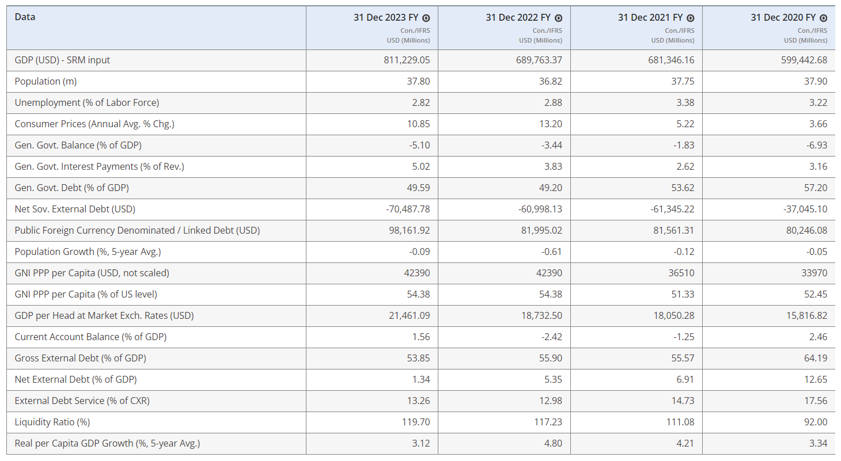

Important reminders

Poland is a country of **38 million inhabitants**, the sixth largest in Europe in terms of surface area, with a GDP per capita of **19,920 euros**, and the **largest economy among the Central and Eastern European Countries** (CEEC).

In 2023, the country's **unemployment rate stood at 2.8%**, one of the best figures among European union member states, and its **HDI was 0.876 in 2021** (34th worldwide).

Poland is a **semi-presidential republic**, in which the President, elected for a five-year term by universal suffrage, enjoys extensive powers. However, the Prime Minister is accountable to the two chambers of Parliament, the Sejm and the Senate, both of which are elected by direct universal suffrage.

**Poland joined NATO in 1999 and the European Union in 2004.**

**Poland's currency is the złoty (or PLN), and the country is still not eligible for entry into the euro zone, as it does not meet all the convergence criteria imposed by the European Union.**

Context

The last parliamentary elections held in October 2023 once again **gave the highest number of votes to the Law and Justice party (right-wing conservative, PiS)**. President Duda reappointed Mateusz Morawiecki, from the party with the most votes, as candidate for Prime Minister.

However, **he did not survive the vote of confidence in the Sejm**, as the opposition coalition of Civic Coalition (KO, liberals), Third Way (center-right) and Left (left) has 248 seats out of 460 in the party's lower house. Parliament. **Donald Tusk, already twice Prime Minister, former President of the European Council (2014-2019) and KO leader, has been appointed Prime Minister.**

So far, **the government is gradually implementing its reform program because of clashes with President Andrzej Duda**, theoretically unaffiliated but originally from the PiS. **The President has veto power and refers legal acts to the Constitutional Council with a number of PiS-appointed judges, hampering the new government's political effectiveness, especially as the coalition does not have the required number of votes to defeat him.** These quarrels could last until the next presidential election in mid-2025, when a liberal candidate could well become president.

Economic facts

**Since joining the EU in 2004, Poland has consistently outperformed the European average**. Despite this, Poland's GDP has still not caught up with the European average, although the gap is narrowing over the years.

Poland is one of the EU economies to **have best withstood the Covid-19 pandemic**, experiencing only a **-2% GDP recession** (EU average: -5.6%). This is the result of an improved trade balance: from -€4.4 billion in 2019 to +€6.7 billion in 2020. At that time, Polish imports fell by 4.3%, while exports remained stable (+0.12%).

For the year 2022, Poland recorded growth of 5.1%, well ahead of other European countries. **Then the effects of the Russian-Ukrainian war began to take their toll on the Polish economy**, fuelling high inflation, and causing an overall slowdown in the economy (growth fell from 10.7% in Q1 2022 to 0.6% Q4 2022).

**Consumer price inflation peaked at 18.4% year-on-year in February 2023. Since then, inflationary pressures have gradually eased**, but will remain high in 2023-2024, necessitating the maintenance of a cautious monetary policy. **We expect inflation to average around 12% in 2023 and 6% in 2024.**

Also in 2022, Poland saw a **sharp deterioration in its trade balance** (-24.3 billion) and balance of payments (-19.5 billion), against a backdrop of rising import prices, particularly for energy products. **Until the invasion of Ukraine, Poland imported 57% of its gas and 60% of its oil from Russia.**

This **deterioration in the macroeconomic climate forced the Polish government to take measures to restore confidence and support the purchasing power of the Polish people** (introduction of an anti-inflation shield), which contributed to a **widening of the public deficit which reached -3.7% of GDP in 2022, -5.1% in 2023.** Public debt continues to fall to 49.1% of GDP.

After three years of relative stability between 2017 and 2019, the PLN has shown volatility and vulnerability to external shocks since 2020. It lost an average of -3% of its value against the euro in each of the years 2020-2022 and -15% against the USD in 2022. **The darkening economic outlook in the wake of the war in Ukraine and the tightening of global financial conditions, notably the Fed's interest rate hikes, have contributed to the weakening of the PLN.**

**The government anticipates a budget deficit of 4.5% in 2024, well above the 3% target set by the Maastricht criteria.** Several factors will **weigh on public accounts in the short term.** For example, **military spending** is set to rise sharply in the coming years, due to the army modernization plan. This item of expenditure is likely to reach 4% of GDP in 2024, a record among European Union countries, and will remain at around 2-3% in subsequent years.

**Interest expense has increased with the rise in government bond yields since 2022. As a result, interest charges on the debt as a proportion of government revenues will rise to 4.1% in H1 2023 (after 3.6% in 2022 and 2.8% in 2021).**

**However, public finances are not a cause for concern. The debt profile is solid, as most of it has been contracted at fixed rates, and above all has an average maturity of 5 years**. Moody’s forecast he government debt burden to rise to close to 59% of GDP by 2027. Similarly, fiscal discipline is enshrined in the country's constitution, which stipulates that public debt must not exceed 60% of GDP.

Also, **the EC unlocked RRF and MFF funds of up to €137 bn in February**, announcing that Poland had met three so-called 'super milestones', including two related to the independence of the judicial system. The first RRF payment of €6.3bn (after €5 bn of pre-financing flowed in December) is expected in April once the Council of the EU endorses the EC's decision, with total disbursements expected to reach around € 17bn in 2024 and further increase to around €20bn in 2025 and 2026, respectively. Furthermore, Poland is set to obtain EU funds under the Cohesion Policy of €5 bn and €8 bn in 2024 and 2025, respectively, with a jump to €14-16 billion annually expected over 2026-29. **Altogether these correspond to inflows of around 3% of GDP until 2026.**

*Written on June 27, 2024*

*Source :*

[*https://app.fitchconnect.com/article/PR_10270633*](https://app.fitchconnect.com/article/PR_10270633)

[*https://disclosure.spglobal.com/ratings/en/regulatory/article/-/view/type/HTML/id/3169184*](https://disclosure.spglobal.com/ratings/en/regulatory/article/-/view/type/HTML/id/3169184)

[*https://www.moodys.com/research/Government-of-Poland-A2-stable-Update-following-rating-affirmation-outlook-Credit-Opinion--PBC_1401546*](https://www.moodys.com/research/Government-of-Poland-A2-stable-Update-following-rating-affirmation-outlook-Credit-Opinion--PBC_1401546)

[*https://www.tresor.economie.gouv.fr/Pays/PL/situation-economique-et-financiere-de-la-pologne-a-l-automne-2021*](https://www.tresor.economie.gouv.fr/Pays/PL/situation-economique-et-financiere-de-la-pologne-a-l-automne-2021)

[*https://www.coface.com/fr/actualites-economie-conseils-d-experts/tableau-de-bord-des-risques-economiques/fiches-risques-pays/pologne*](https://www.coface.com/fr/actualites-economie-conseils-d-experts/tableau-de-bord-des-risques-economiques/fiches-risques-pays/pologne)

[*https://www.imf.org/external/pubs/ft/fandd/fre/2000/09/pdf/balcerow.pdf*](https://www.imf.org/external/pubs/ft/fandd/fre/2000/09/pdf/balcerow.pdf)

[*https://economic-research.bnpparibas.com/html/fr-FR/Pologne-Quelques-defis-futur-gouvernement-16/10/2023,48974*](https://economic-research.bnpparibas.com/html/fr-FR/Pologne-Quelques-defis-futur-gouvernement-16/10/2023,48974)