MAPPING_DEVELOPER:

SOURCE:

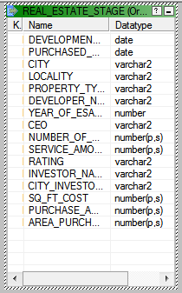

TARGET:

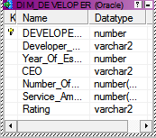

M_DIM_DEVELOPER:

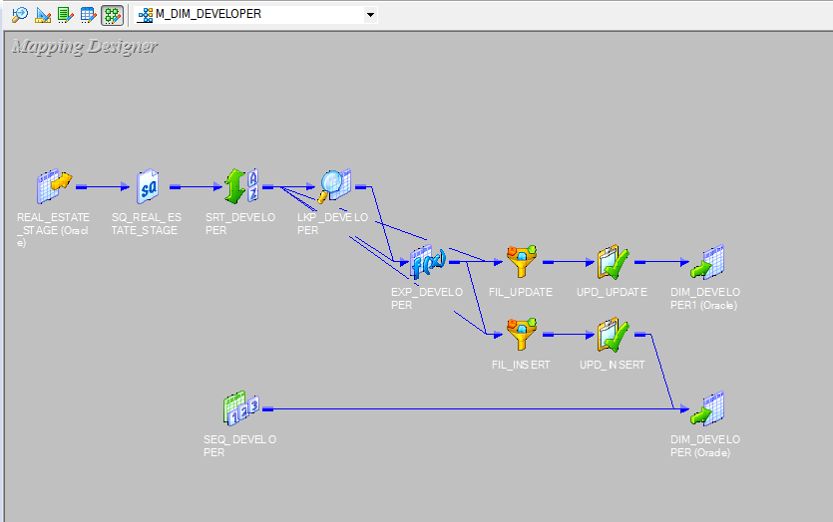

SORTER TRANSFORMATION:

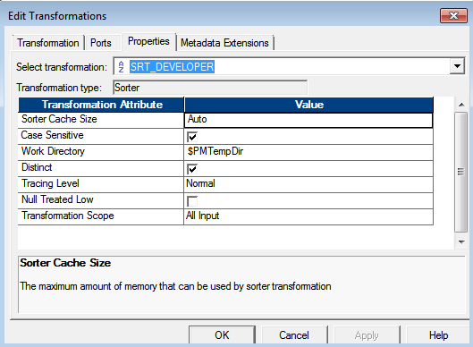

LOOKUP TRANSFORMATION:

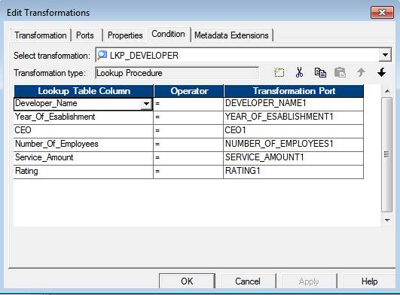

EXPRESSION TRANSFORMATION FOR CHANGED FLAG:

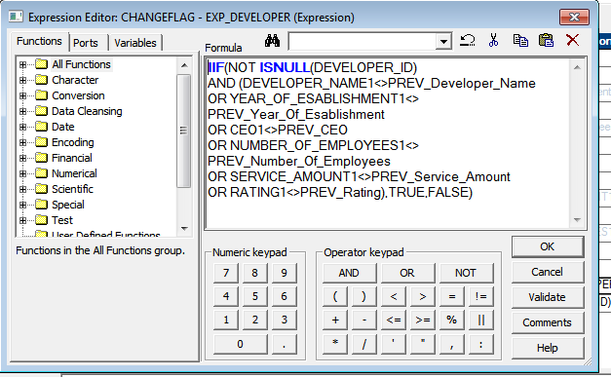

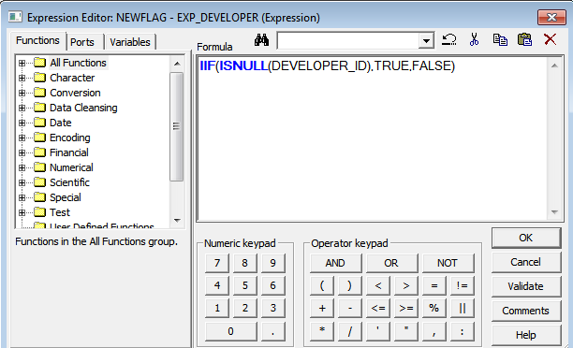

FILTER TRANSFORMATION FOR UPDATE:

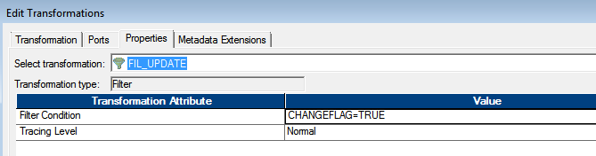

UPDATE STRATEGY TRANSFORMATION FOR UPDATE:

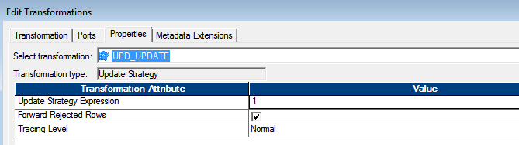

FILTER TRANSFORMATION FOR NEW FLAG:

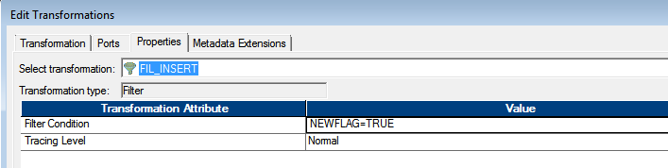

UPDATE STRATEGY TRANSFORMATION FOR INSERT:

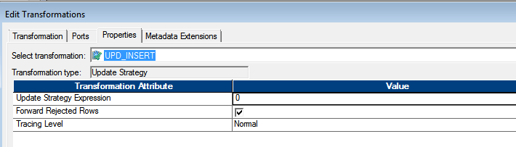

SEQUENCE GENERATOR TRANSFORMATION:

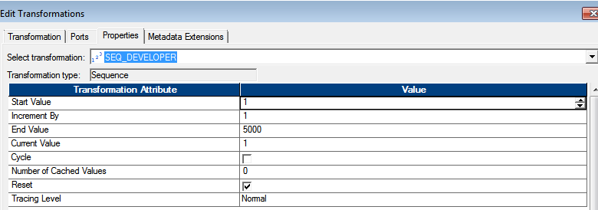

OUTPUT:

