FACT_MAPPING:

SOURCE:

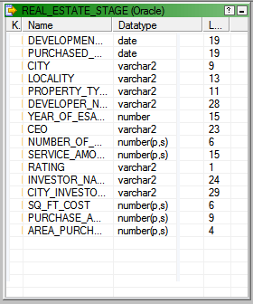

TARGET:

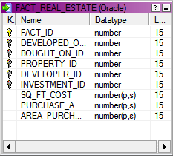

M_REAL_ESTATE_FACT:

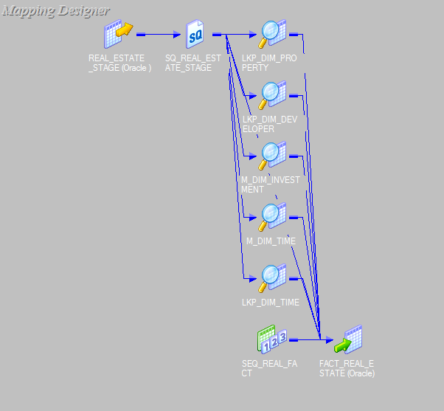

LOOK UP FOR DIM_PROPERTY:

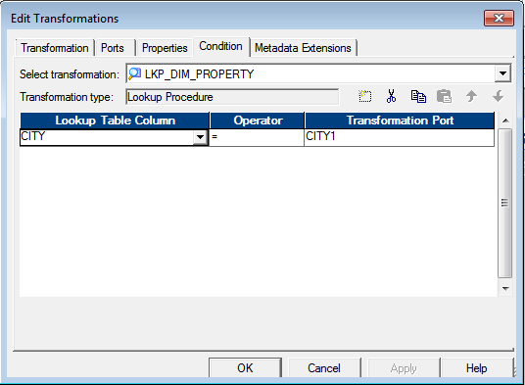

LOOKUP FOR DIM_DEVELOPER:

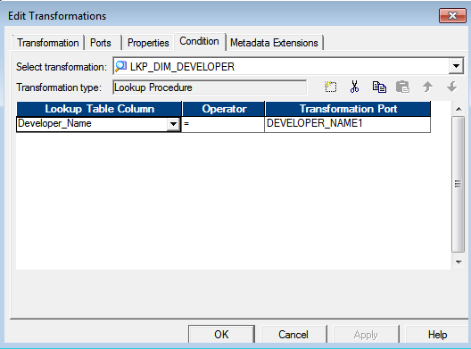

LOOKUP FOR DIM_INVESTOR

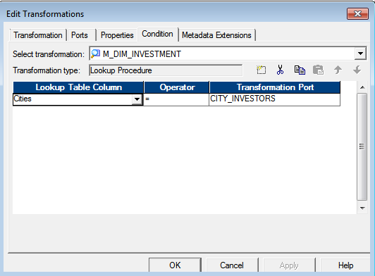

LOOKUP FOR DIM_TIME

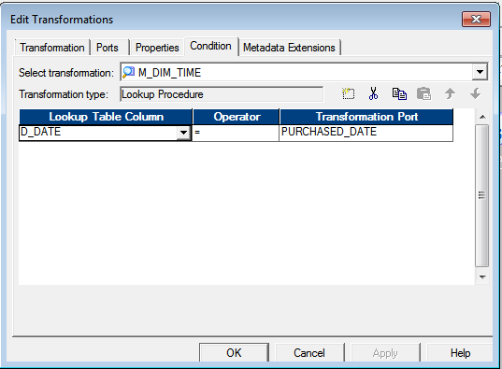

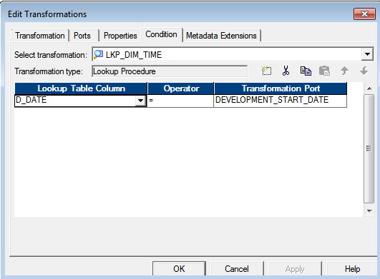

SEQUENCE GENERATOR

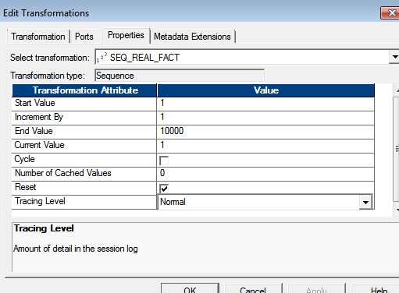

FINAL OUTPUT

