MAPPING_INVESTMENT:

SOURCE:

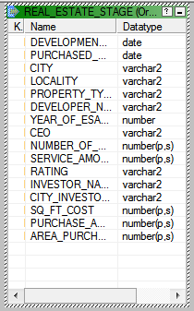

TARGET:

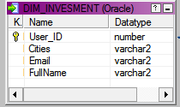

M_DIM_INVESTOR:

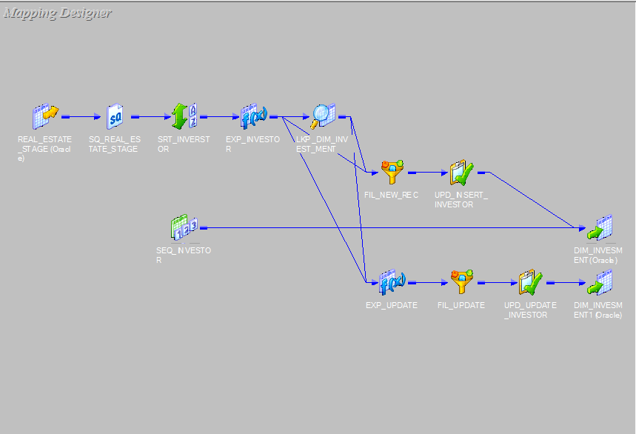

SORTER TRANSFORMATION:

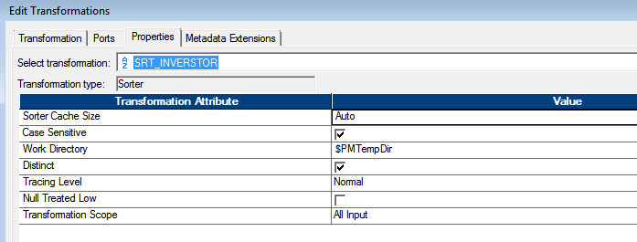

EXPRESSION TRANSFORMATION :

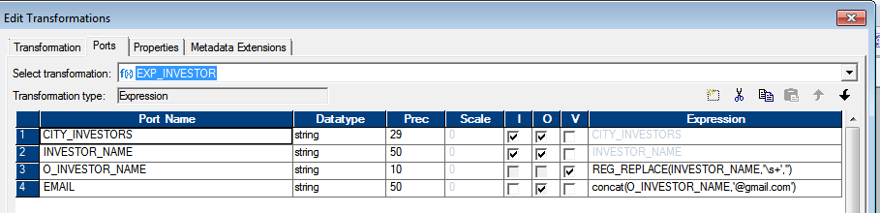

LOOKUP TRANSFORMATION:

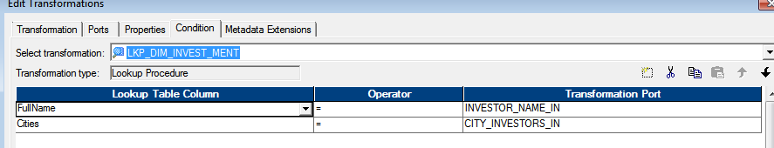

FILTER TRANSFORMATION FOR NEW_REC

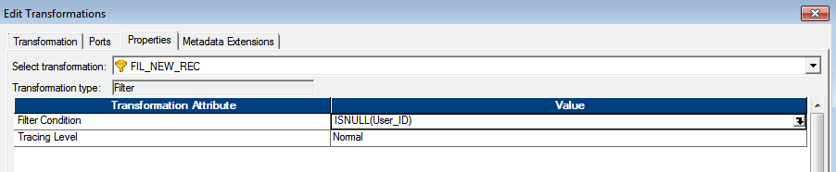

UPDATE_STRATEGY TRANSFORMATION FOR INSERT:

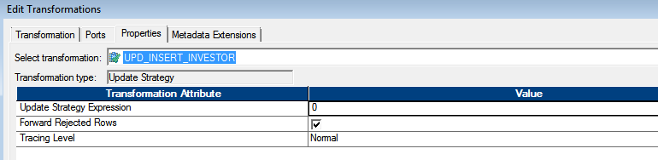

SEQUENCE GENERATOR TRANSFORMATION:

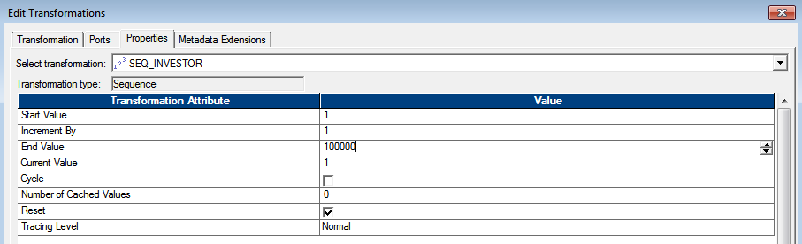

EXPRESSION TRANSFORMATION FOR UPDATE

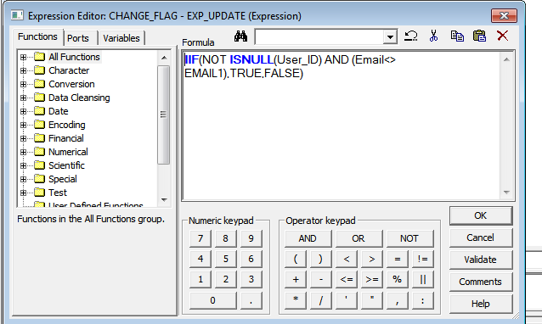

FILTER TRANSFORMATION FOR CHANGED FLAG:

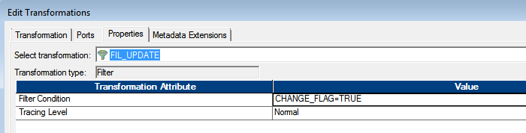

UPDATE TRANSFORMATION FOR CHANGED FLAG:

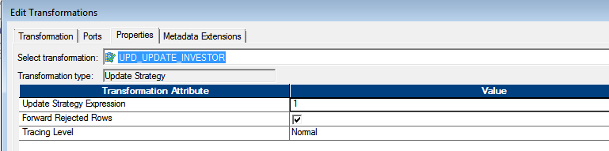

OUTPUT:

