DIMENSION TABLE:

SOURCE:

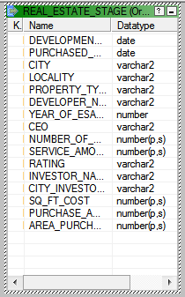

TARGET:

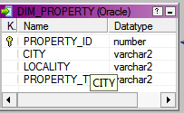

M_DIM_PROPERTY:

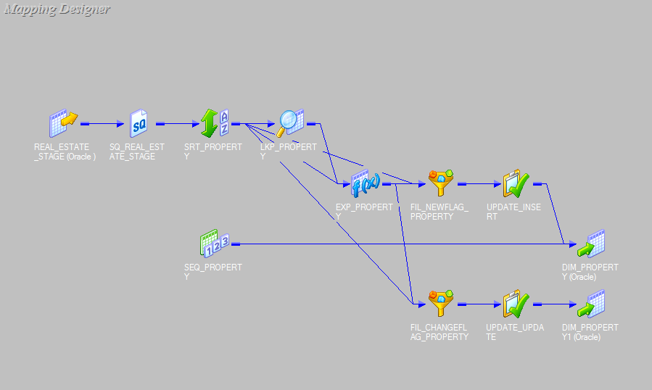

SORTER TRANSFORMATION:

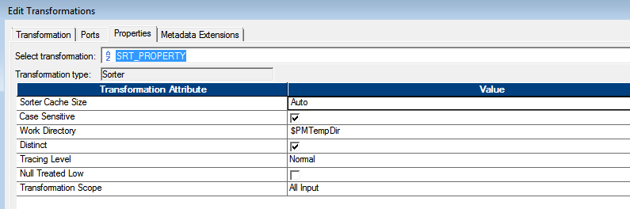

LOOKUP TRANSFORMATION:

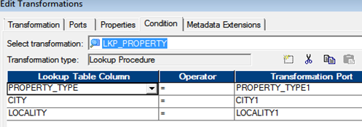

EXPRESSION TRANSFORMATION:

NEW_FLAG

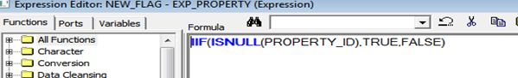

CHANGED_FLAG

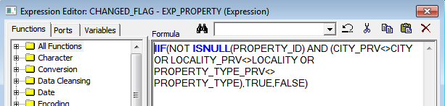

FILTER TRANSFORMATION FOR NEW_FLAG:

[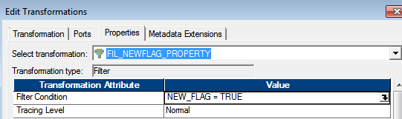](teradata%20questions.docx)

FILTER TRANSFORMATION FOR CHANGED_FLAG:

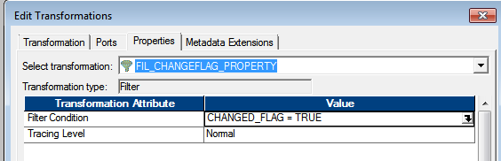

SEQUENCE GENERATOR TRANSFORMATION:

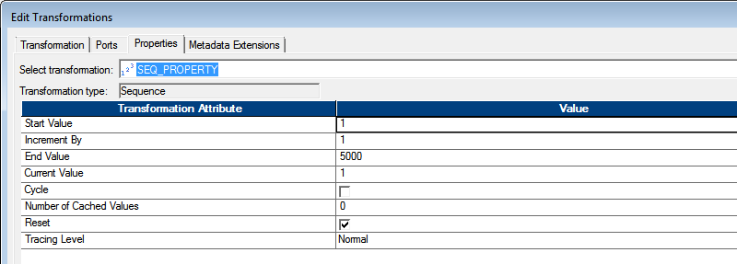

OUTPUT:

