MAPPING OF STAGE TABLE

SOURCE:

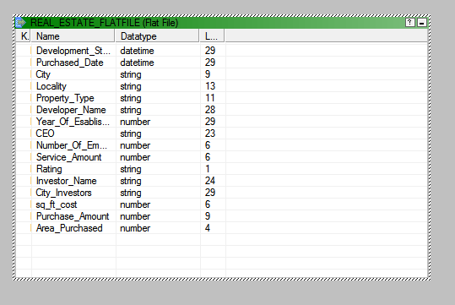

TARGET:

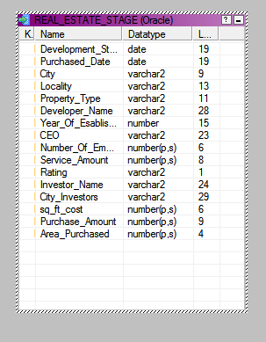

M_STAGE…(ICONIZED):

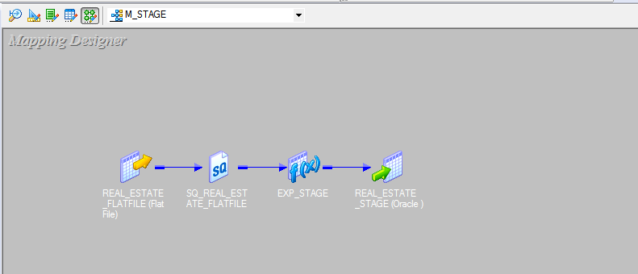

M_STAGE:

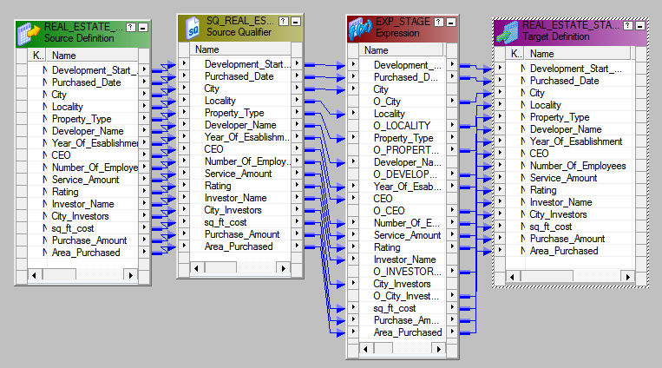

EXPRESSION TRANSFORMATION:

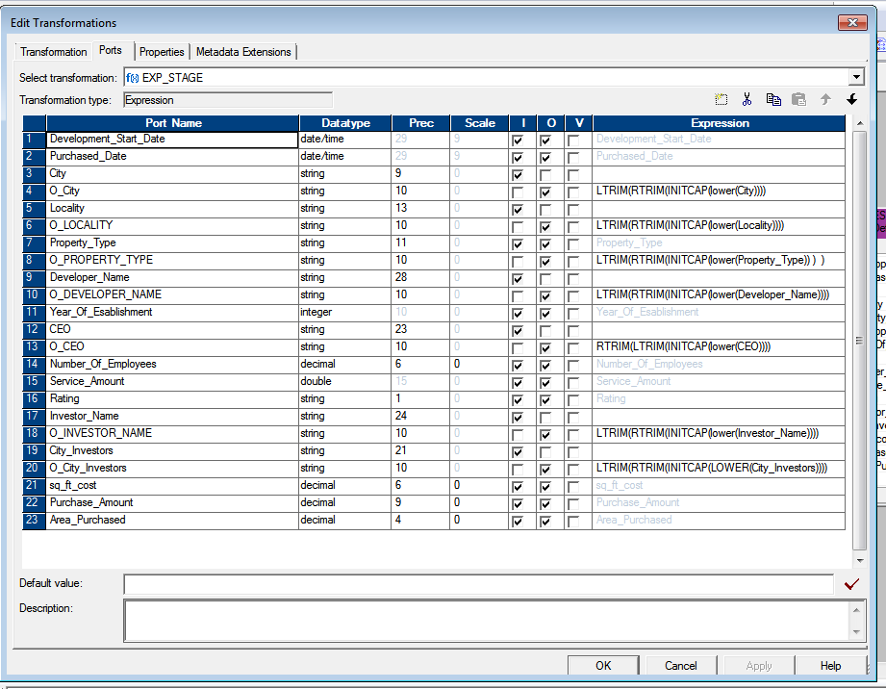

OUTPUT:

