**DIM_TIME:**

SOURCE:

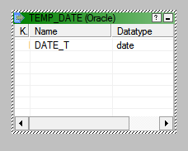

TARGET:

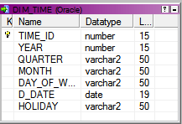

PROCEDURE:

CREATE OR REPLACE PROCEDURE DATE_GEN

AS

V_Start_Date VARCHAR2(30)=’01-JAN-2010’;

V_End_Date VARCHAR(30)=’31-DEC-2015’;

BEGIN

INSERT INTO Temp_date(date_t)

SELECT TO_DATE(V_Start_Date,’DD-MON-YYYY’)+ROWNUM-1

FROM All_Objects

WHERE ROWNUM<= TO_DATE(V_End_Date,’DD-MON-YYYY’)- TO_DATE(V_Start_Date,’DD-MON-YYYY’)+1;

END;

/

MAPPING(ICONIZED):

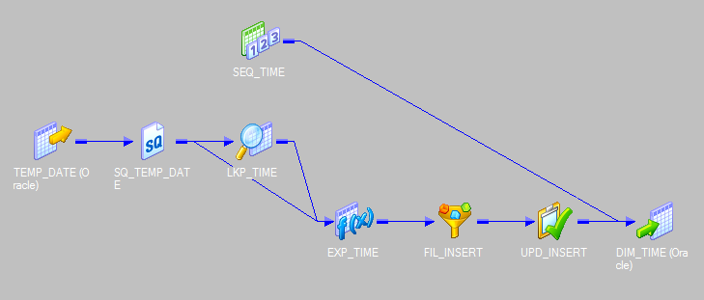

MAPPING:

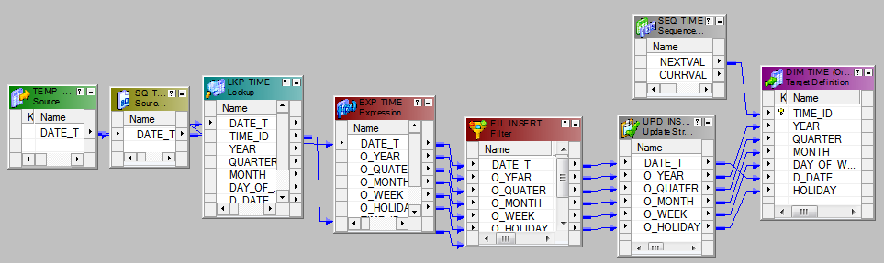

TRANSFORMATION USED:

1.LKP_TIME TRANSFORMATION:

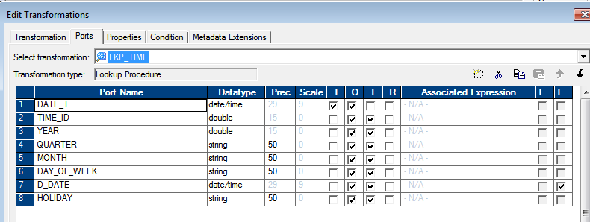

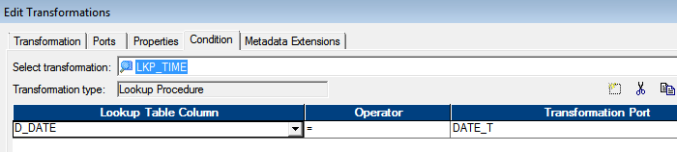

2. EXP_TIME:

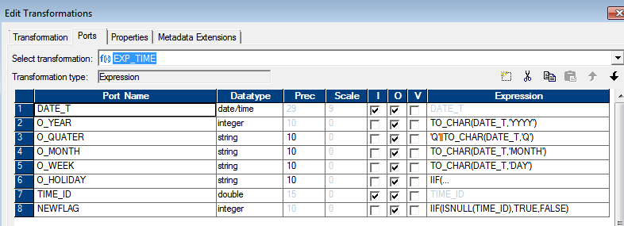

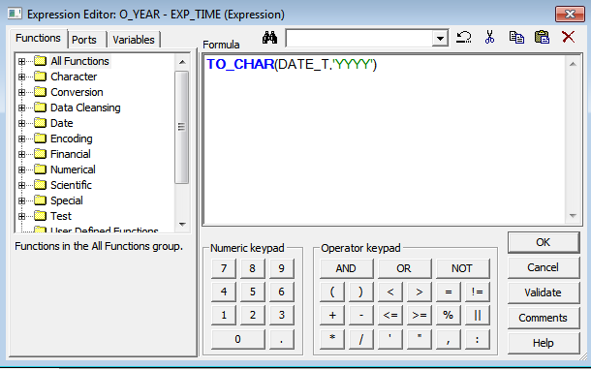

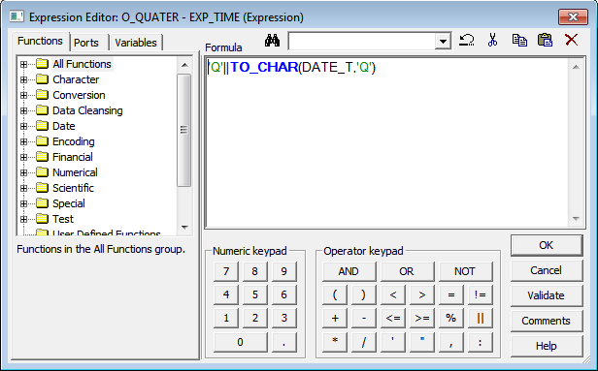

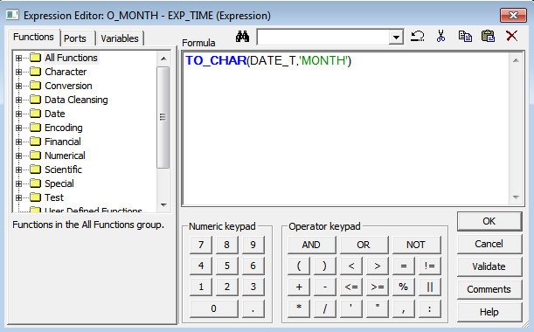

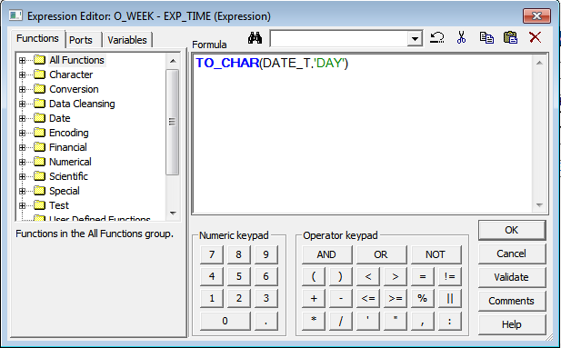

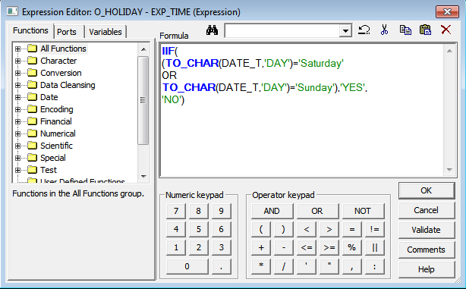

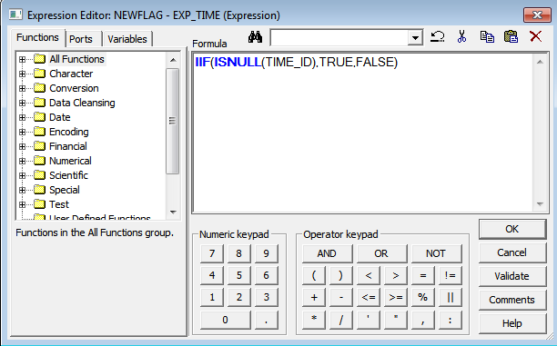

3.FIL_INSERT:

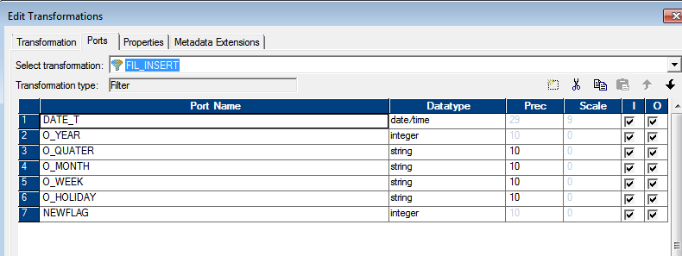

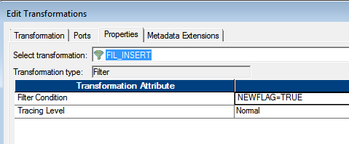

4.UPD_INSERT

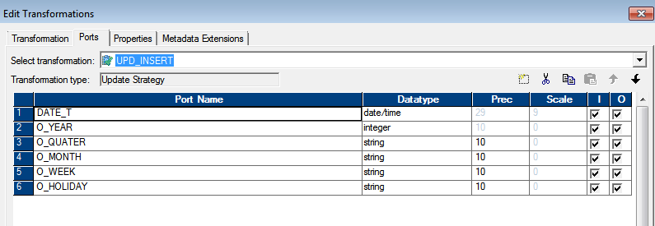

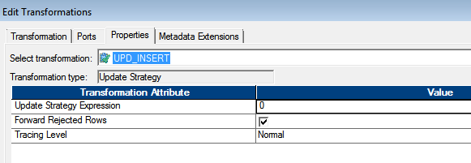

5. SEQ_TIME

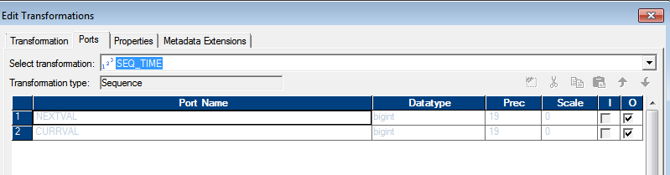

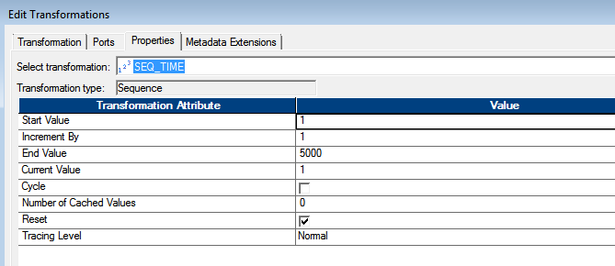

Target:

OUTPUT: DIM_TIME

