Q1. find the cumulative sum or running total of NetPay on Salary table.**[5]**

create table em3

(

Emplyeeno numeric(10),

gross numeric(10) format 'Z9,999',

deduction numeric(10) format 'Z,999',

netpay numeric(10) format 'Z9,999'

)

insert into em3 values(101,40000,4000,36000);

insert into em3 values(102,80000,6000,74000);

insert into em3 values(103,90000,7000,83000);

insert into em3 values(104,75000,5000,70000);

SELECT

EmployeeNo, NetPay,

SUM(Netpay) OVER(ORDER BY EmployeeNo ROWS

UNBOUNDED PRECEDING) as TotalSalary

FROM Salary;

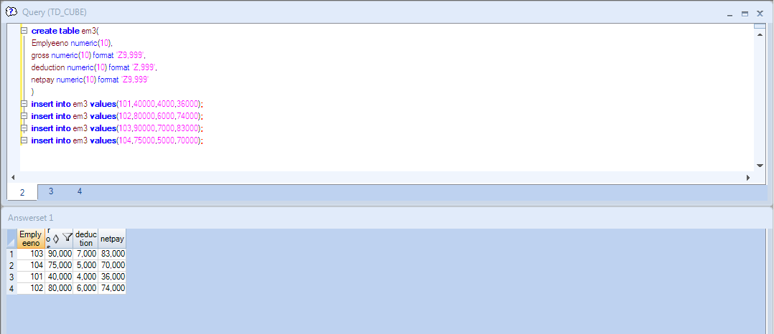

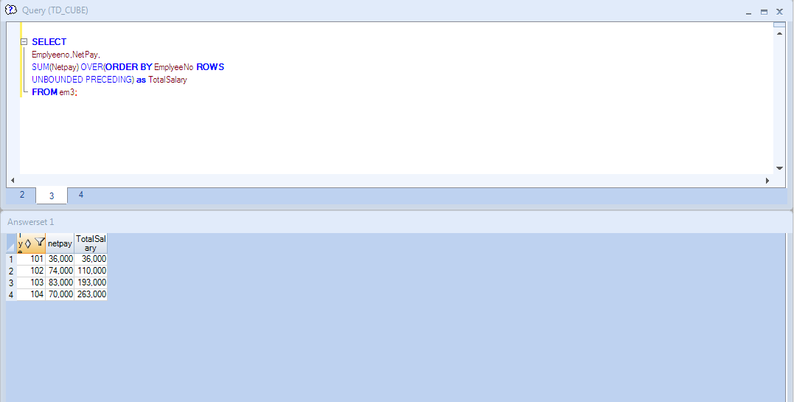

Q2.

select dept_no,avg(salary) as avg_sal

from emp2

group by dept_no

having avg_sal < (select avg(salary) from emp2);

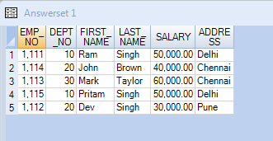



Q3.

select COALESCE(emp_FN, 'NO EMPLOYEE'),dept_no

from emq



Q5.

**CREATION:**

.LOGON 10.74.161.248/td_user24,td_user24

drop table bala_employee;

create table bala_employee

(

EMPNO INTEGER,

LOCATION VARCHAR(20),

EFF_DATE DATE format 'dd-mm-yyyy',

END_DATE DATE format 'dd-mm-yyyy'

);

insert into bala_employee(empno=10,location='Bangalore',EFF_DATE='13-12-2017',END_DATE='12-03-2018');

insert into bala_employee(empno=20,location='Mumbai',EFF_DATE='14-12-2017',END_DATE='13-03-2018');

select * from bala_employee;

.LOGOFF

.EXIT

**EXPORT:**

.LOGON 10.74.161.248/td_user24,td_user24;

.EXPORT FILE = d:\out1.csv;

.SET SEPARATOR ','

.SET WIDTH 300;

SELECT * FROM bala_employee;

.LOGOFF