Spring Boot

Course: <https://youtu.be/vtPkZShrvXQ>

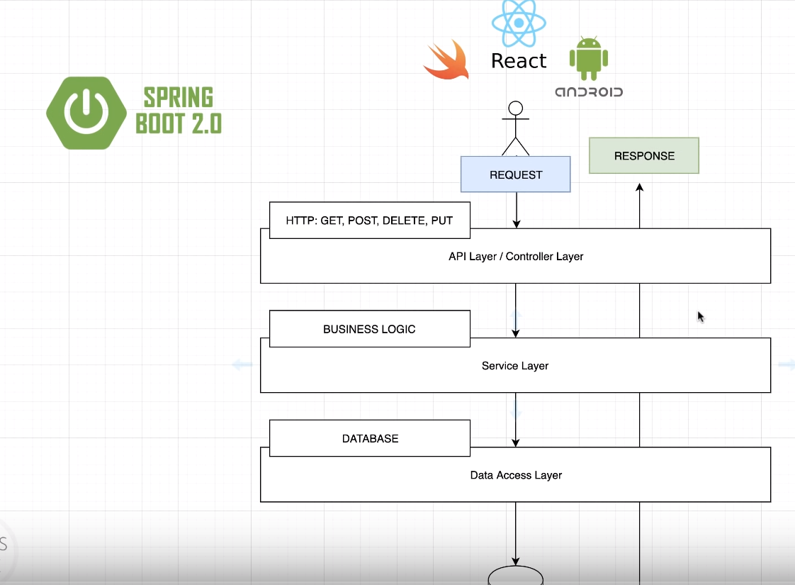

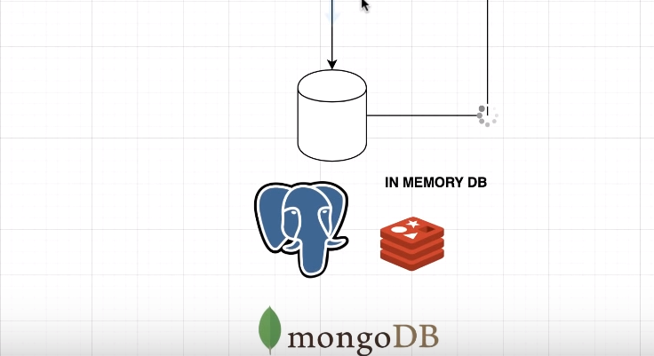

* **API Layer/Controller Layer** is where we can receive the request.
* **Service Layer** is where we handle the request and all business logic that you may have within your application.
* **Data Access Layer** is where you use DBs to perform some various credit operations.

**Go for the spring initializer :** <https://start.spring.io/>

After initializing, we will start from bottom to top. We will create multiple packages as follows:

* com.freeCodeCamp.demo.api : where the API will leave
* com.freeCodeCamp.demo.model
* com.freeCodeCamp.demo.service
* com.freeCodeCamp.demo.dao

These packages represent the previous diagram. We will start with the model. Our model will be a person with these properties. So, we created **Person.class** in **model**.

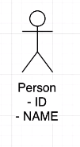

Now, we will create interface called **PersonDao.I** in **dao in** which we will define the operations allowed or the actual contract for anyone wishes to implement this interface. One more advantage, we can later use the dependency injection to switch between implementations with just one line of code.



Now, we will create a class called “FakePersonDataAccessService” to implement our methods in **dao**.package.