Swift Framework – HTML Reports

Document Version [0.1] and Date [02nd Sept 2016]

Amitkumar.Rasal@mastek.com

Table of Contents
1 Purpose 4
2 HTML Reports 4
3 Configuration 5
4 HTML Reports Generation 5
5 Future Enhancements 7

Template Amendment History
Ver. No. | Date  (dd/mm/yyyy) | Amendment History | Remarks
0.1 | 02/09/2016 | Draft Version

Purpose
The purpose of this document is to understand why and how HTML reports add value to Swift Framework Enhancement. The Swift Lite framework generates test results at the end of execution. User able to view “Report.xls” and “DetailedResult.xls” files in folder structure.
Now in competitive world, clients are more focused on the test results in HTML format with graphical representation about the status of execution. Currently we have extended the existing Swift Framework in order to get the test execution result in HTML format & user can able to view the status in runtime. Another advantage is that, HTML reports can be generated from remote machines provided HTML Reports are configured.

HTML Reports
HTML reports extension is developed in PHP & HTML. It reads test results file generated as result of test execution & converts it in the HTML view. HTML Reports extension has predefined folder structure as below which needs to be placed on the machine from where reports to be generated.
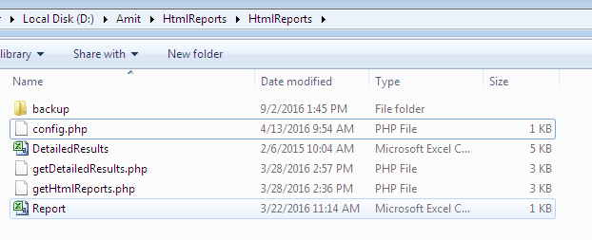

Configuration

The pre-requisite is PHP Server to be installed on the machine. Ensure that PHP server is running.


The HTML Reports folder will be present on the machine.
It consists of 3 PHP files. (Config, GetDetailedResults, GetHTMLReports)
In Config file, you need to define Result folder location path as below

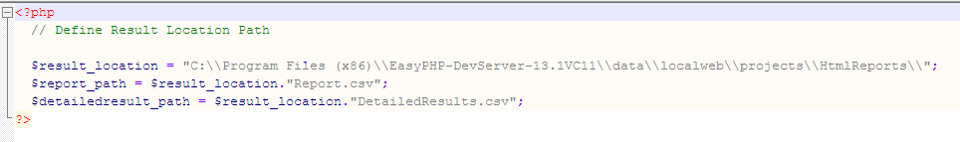

Result location will be location results folder where Reports & DetailedResults are stored.
Report Path & Detailed Result Path will be location where Report.csv & DetailedResults.csv is placed.No need to change this path.

HTML Reports Generation
Once the configuration has been done, you can generate the HTML Reports by navigating to URL (localhost in case running it from same machine)
http://localhost/
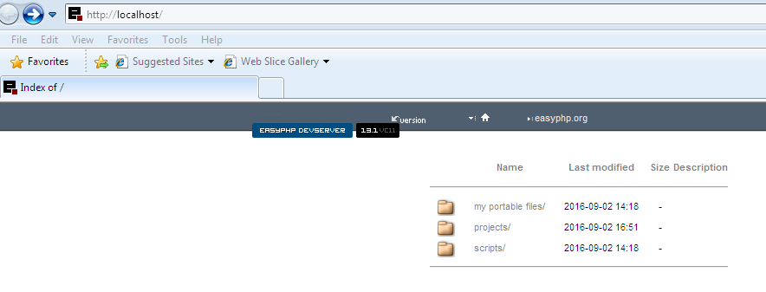

Select the HTML Report folder under Projects. Then you can generate HTML reports by clicking on “getHtmlReports.php”. Below Summary Report will get generated.

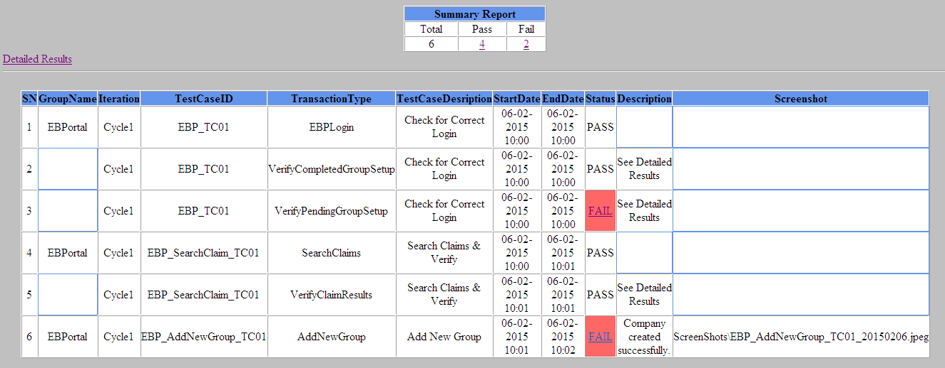

You can view the individual failed case by clicking on its link.
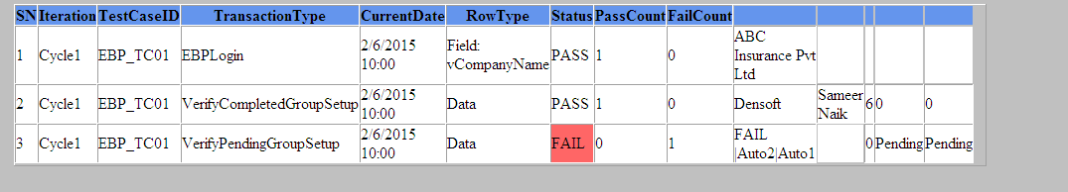

Summary report further drill down for Pass Cases.
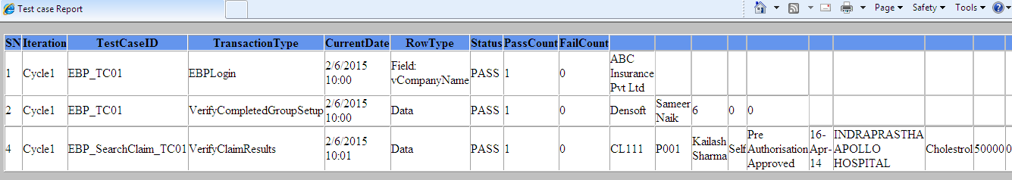

Similarly you can further drill down Failed Cases.
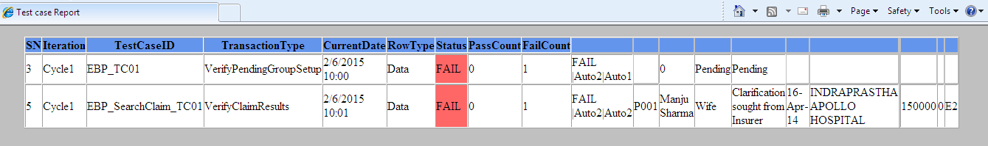

Also you can able to view detailed report.
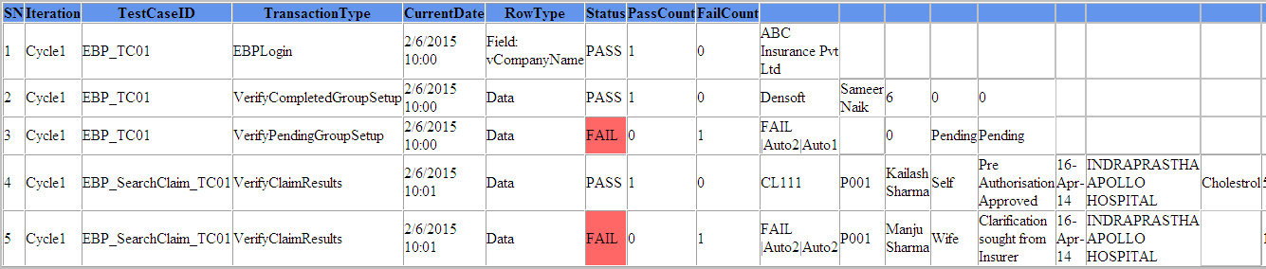

Future Enhancements
As we have achieved the HTML Report generation with Swift Framework Extension. We are planning to enhance this further in order to achieve graphical representation of execution status, better UI look, Pagination.

