R-26.3

Goal to minimize the cost. Requirement:

1. >= 15000 hits/min
2. >= 10 servers in one rack

Dara: One rack can have 44 shelves and 12200W

1. Standard
   1. Cost: $400
   2. Power: 300W
   3. Handle: 1000 hits/min
   4. Space: two shelves of a server rack
2. Cutting-edge
   1. Cost: $1600
   2. Power: 500W
   3. Handle: 2000 hits/min
   4. 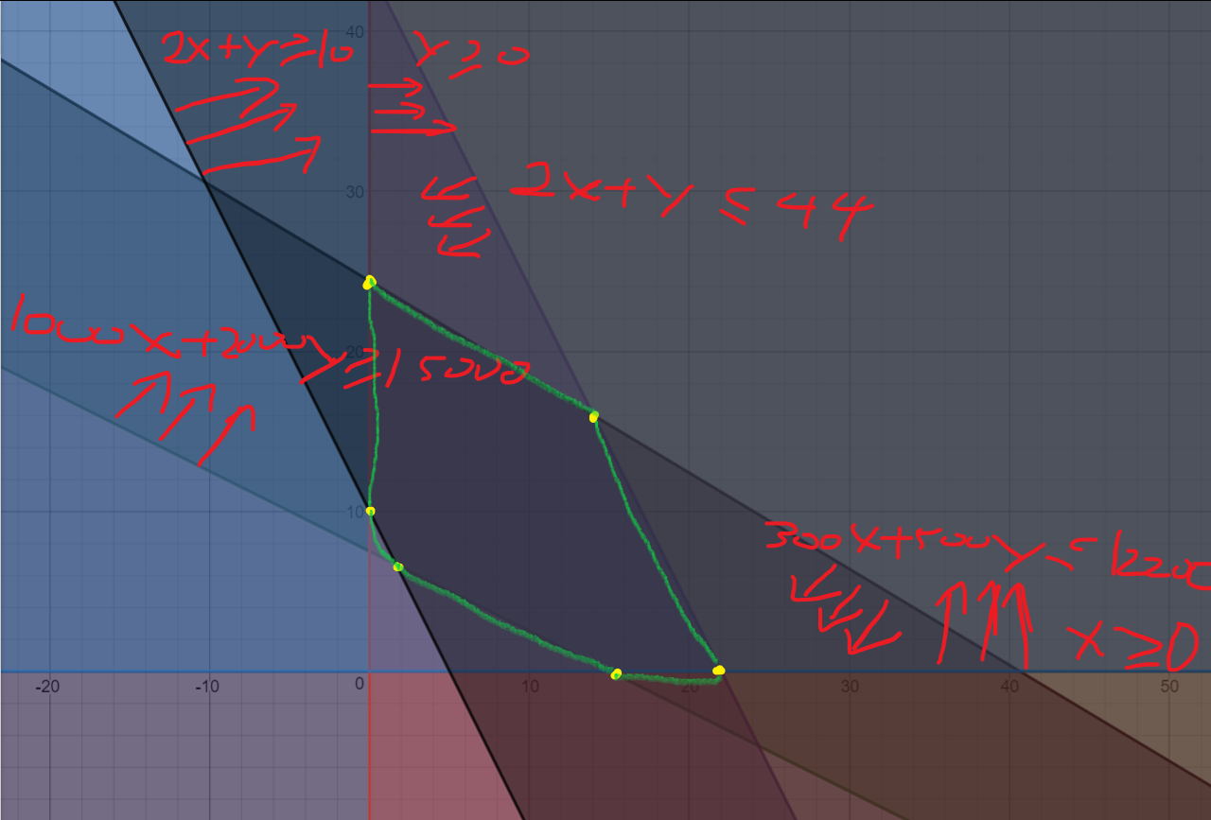Space: one shelf of a server rack

x is the number of Standard modules, y is the number of Good module. We want to minimize:

c = 400x + 1600y, which is the red line in next figure:

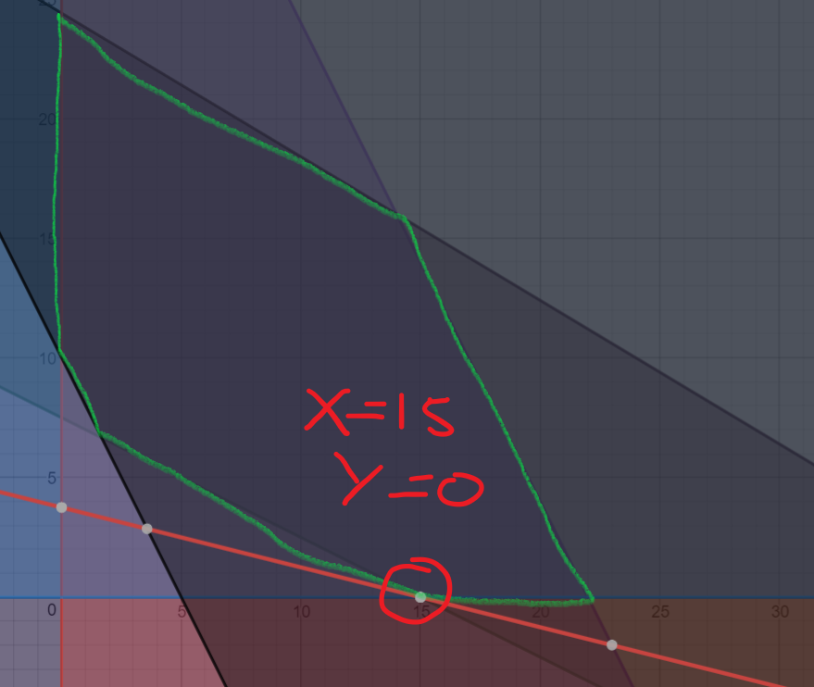Thus, when we use 15 Standard modules, all requirements met and we got a minimized cost of $6000.

R-26.7

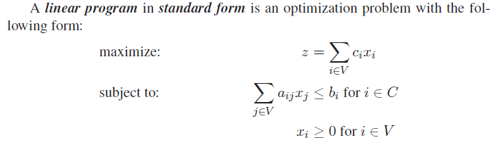

maximize: z = -3y1 – 2y2 – y3

subject to: 3y1 – y2 – y3 <= -1

-2y1 – y2 + y3 <= -2

y1, y2, y3 >= 0

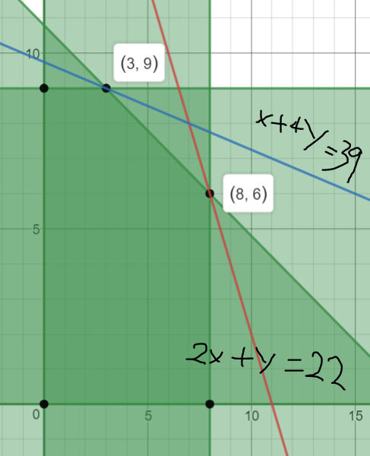R-26.10

The function to maximize is called the objective function, which is the z=Sum(ci xi) in standard form.

As shown in the figure, z=x+4y and z=2x+y can satisfy the requirement. Thus, for vertex (3,9) with objective function:

maximize: z=x1+4x2

we have z=39 as optimal solution; for vertex (8,6) with objective function:

maximize: z=2x1+x2

we have z=22 as optimal solution.