Inhalt

Contents 1

Introduction 1

Data representation 1

# Contents

This document contains analytics of Rubik’s Cube geometrics (2x2x2) and explores possibilities to build a graph (search tree).

# Introduction

There is less special knowledge necessary to understand. What needs to be known are the established standards for Rubik’s Cube notation of actions.

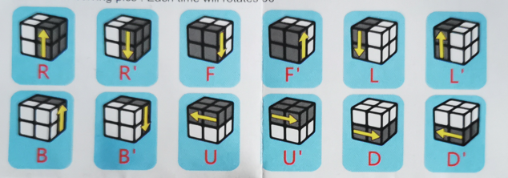

## Data representation

Between the possible representations of a Rubik’s cube, the “facemap” is used in this document.

Facemap means the 2D representation (unrolling of the the cubes faces)

Representation in memory is not discussed in this document, colored plots are used to show the behaviour.

This example pic shows the 2D facemap plot of a solved cube

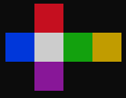

It’s common to use the white face as the “UP” side.