ASSG 2

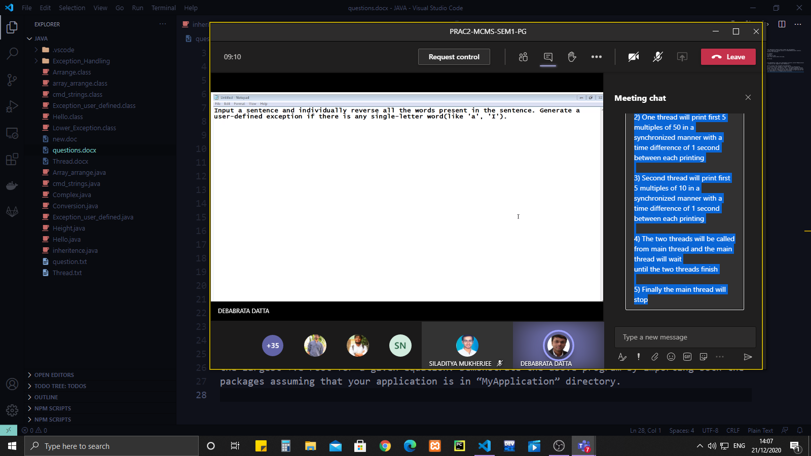

Assg 1

Write a Java Program where

1) Two threads will be created  
2) One thread will print first 5 multiples of 50 in a synchronized manner with a  
time difference of 1 second between each printing

3) Second thread will print first 5 multiples of 10 in a synchronized manner with a  
time difference of 1 second between each printing

4) The two threads will be called from main thread and the main thread will wait  
until the two threads finish

5) Finally the main thread will stop