Research:

1. **Is there any market for this app? Is there even a need for it?**

According to the study done by Michigan State University psychology professor William J. Chopik on people around the world at different ages shows that from age 65 onwards, people value friendship higher than those who are younger. Thus showing the importance of friendship for the elderlies.

Additionally, from our research, we found out that One in five elderly persons in Singapore aged 75 and above show signs of depression, this statistics is taken from the Singapore Longitudinal Ageing Study done in 2012 by the National University of Singapore’s Yong Loo Lin School of Medicine. This statistic suggests that there are lot of elderly in singapore that are diagnosed with depressed. The NUS’ Singapore Longitudinal Ageing Study in 2004 found that widowed or divorced persons above 65 were more likely to experience depression (22 per cent) than widowed or divorced persons between the ages of 55 and 65 (13 per cent). This suggests that older people are more prone to getting depression. These statistic shows that the elderly gets depressed easily and there are a lot of elderlies in Singapore that have depression where is it usually caused by loneliness.

The graph below shows the number of people that live in one-person household.

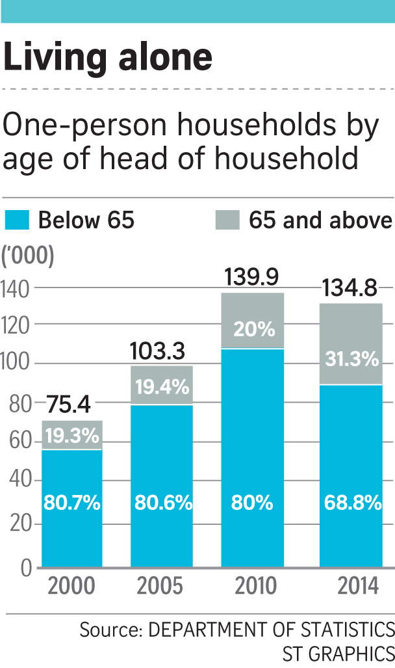

As evident from the graph above, the number of people aged >=65 living alone is on the rise as the years passed.

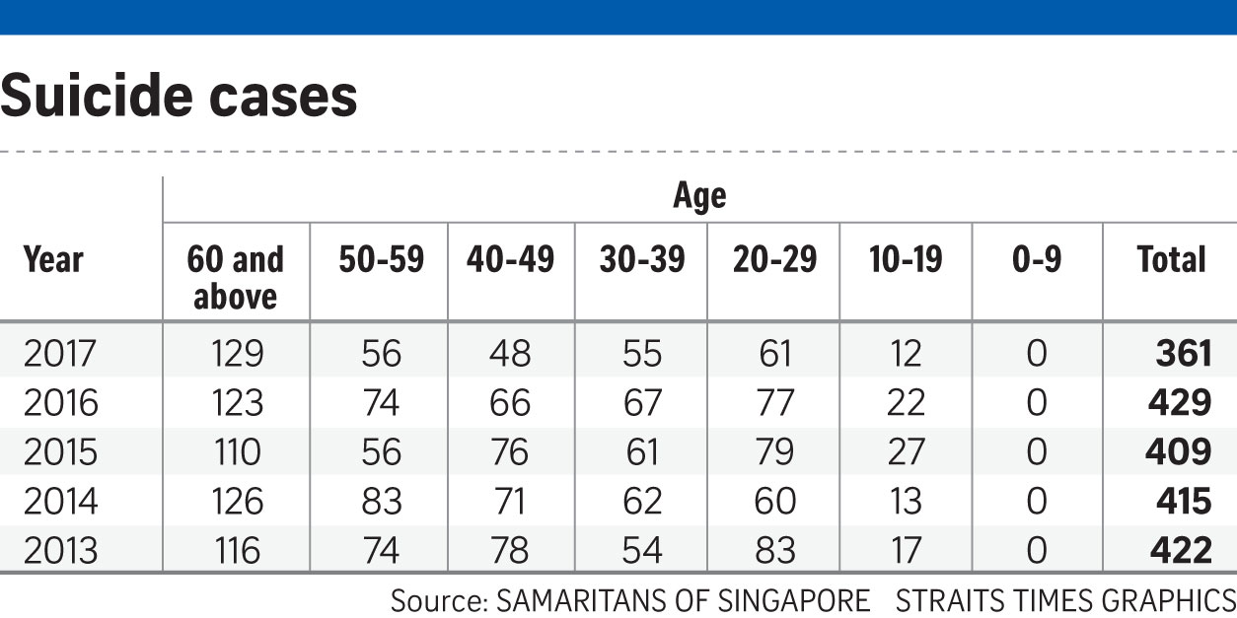

From the dataset above, visualizations were done to better show the number of suicide cases over the years.

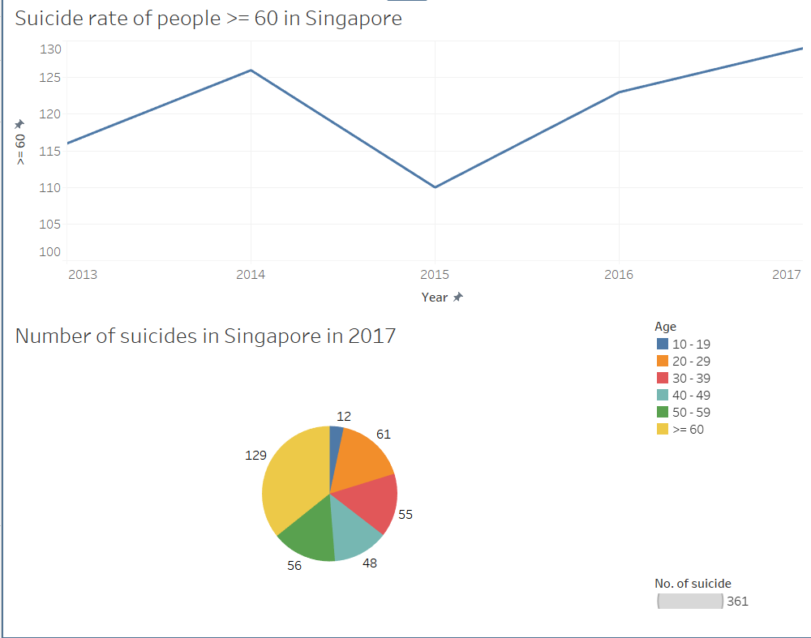

As evident from the bar graph, the number of people >= 60 committing suicide is on the rise in recent years. The pie chart shows that majority of the people that committed suicide in 2017 are people >=60 and reasons for them are mostly due to loneliness which lead to depression.

Hence, with friendship being important to elderlies and with higher amount of elderlies having depression due to being lonely, there is a need for our app as we can help elderlies to widen their social circle so that they will no longer be lonely anymore.

**2) Will this app really work when social media apps like Facebook (which has an older demographic) exists? How will it compete with Facebook?**

Although there are news that Facebook is getting popular among the elderly, there are actually still a lot of elderly that are not comfortable using it. An example from the Today paper is Madam Yang, 59. She has a Facebook account because she is following the trend but she does not really uses it as she is not familiar with the features on Facebook - she do not even know how to change her profile picture and thus is not comfortable using it. Hence, even though there are a lot of elderly with Facebook account, it might not necessarily mean that they actually enjoy using it.

The design of Ol’Friends is different from Facebook as Ol’Friends is specially

catered for the elderlies. The colours that was used in the app are pastel colours

which is shown to be more pleasing to the elderlies as they get to feel a sense of comfort and the fonts in the app are bigger than the other social media app out in the market.

With an app interface that is easier for the elderly to comprehend and get used to, the elderlies will be more likely to use our app. In case, the elderlies are to get confused or forget how to use the app, our app have the help feature that consists of words and images to guide the elderlies to use the app.

**3) Is there a demand for this app⇒ Are the elderly that tech advanced that they would have a need/want for an app like this?**

According to IDA Infocomm usage in households in 2014 from data collected from 3500 households via face-to-face interviews. **75%** of those age **50-59**, **31%** of those age **>=60** surfed the web regularly via their smartphone which was an increase from previous years.

The pie charts below show the results collected from the interview that IDA conducted.

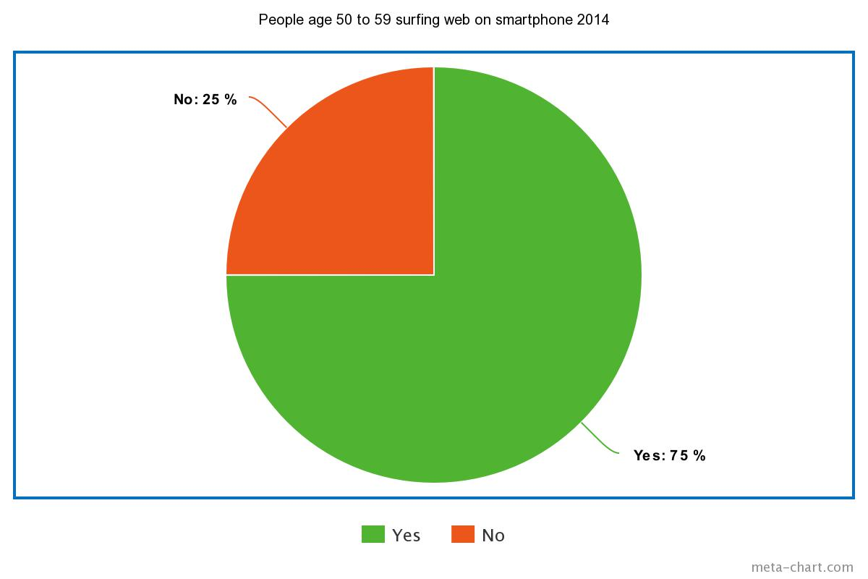

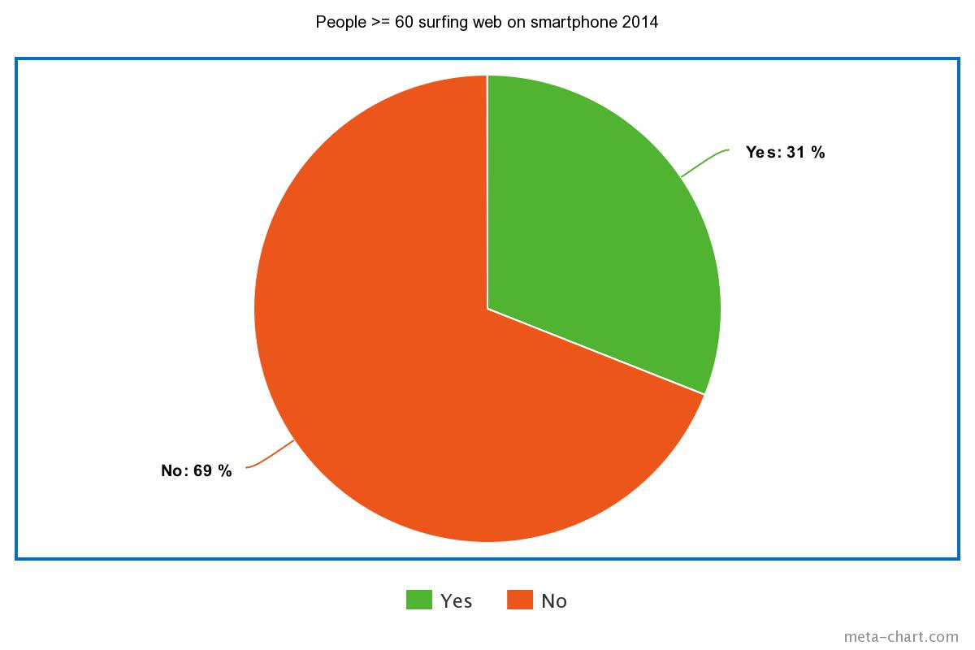

Since the target audience of Ol’Friends are people >= 50, it can be concluded that elderly in Singapore are generally technologically advanced enough to use Ol’Friends.

**4) How will this app benefit the elderly community?**

As the people grow older, they will not be as fit as they were when they were younger. Hence, mobility might be an issue for the elderlies. With Ol’Friends, elderlies will be able to make new friends at home and with more friends, they will be happier and is unlikely to fall into depression - which could help to reduce the suicide rates of elderly in Singapore.

**5) You talk about a simpler interface, but can’t that be addressed with the changes in Facebook’s settings.**

In Facebook’s setting, all the user could do is to filter out things. However, with our app the user interface is specifically designed up for the elder so that they will be comfortable using it and is able to get use to using it easily.

**6) How can we sell our app?**

We can sell our app by collaborating with the elderly home/ old folks home to promote our app there. For instance, introducing and teaching the elderlies there how to use the app and they can start by adding their friends at the center on the app. This would encourage the elderlies to use Ol’Friends to keep in contact with their friends.

**7) Do similar apps that target the elderly already exist? If yes, how do we differ from them?**

Similar apps that target the elderly are: Stitch.

Stitch allows elderlies from all over the world to look for friendship and romance.

For adding friends on stitch, the user cannot search or add their friends, they can only add or view the profile of people that are randomly matched by the app, and the number of profile that the user can view is limited to their rank.

The users of stitch are categorized into basic, bronze, silver, gold and diamond. In order for one to have a higher rank, the user have to pay a sum of money monthly.

Ol’Friends is targeted at the elderly in Singapore, the user of Ol’Friends are able to search for their friends and add them. Additionally, Ol’Friends will recommend people for the user to add as friends based on the hobbies that the users have indicated that they have interest in. Unlike stitch where there is a ranking of membership, Ol’Friends is free for all to use.

**8) Are we able to deliver a prototype in the given amount of time?**

Yes, we would be able to deliver a prototype with the main features - feed, messages, friends, new, help features done.

**9) What is unique about our app that will make the elderly use it?**

Our app is unique in the sense that the user-interface is specially catered for the elderly - with simple design that is clear-cut, colours used that is pleasing to the elderly, bigger fonts. Our app also have an help feature that the elderly is able to access anytime they want if they need help with using the app. Additionally, in order to have a neater interface and to solve the issue of the font of the feed being too small for the elderly to see, we implemented the feature of when the elderly clicks on a particular feed the pop-up of the feed with bigger font will appear. Lastly, our app allows user to read news on the app itself and this feature is yet to be implemented on other social media apps.

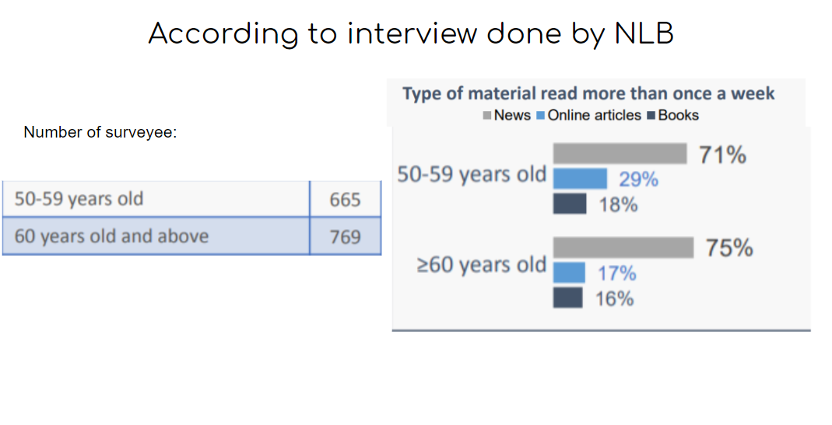

The news includes both hardcopy and online news.

As evident from the graph above, people >= 50 read the news a lot thus we decided to implement a news feature that would allow the elderlies to read news on the app which would bring about convenience for them as they do not have to search for different news websites themselves.

**10) Analysis on features of similar apps:**

Analysis was done on Facebook, Stitch and instagram to find out what features should be implemented in Ol’Friends. Even though the target audience of instagram is not the elderly, it was used for analysis as it is one of the popular social media apps.

|  |  |  |  |  |  |  |
| --- | --- | --- | --- | --- | --- | --- |
|  | Friend search | Posting content | Message | News | Setting | Help |
| Facebook | ✅ | ✅ | ✅ | ❌ | ✅ | ✅ |
| Stitch  (web) | ❌ | ✅ | ✅ | ❌ | ✅ | ✅ |
| Instagram | ✅ | ✅ | ✅ | ❌ | ✅ | ✅ |
| Ol’Friends | ✅ | ✅ | ✅ | ✅ | ✅ | ✅ |

Since most of the apps, have the features of friend search, posting of content, message, setting and help. We decided to include these features in Ol’Friends as well, as they are deemed to be important features in social media app.

# References

Board, N. L. (2017). *2016 NATIONAL READING.* From https://www.nlb.gov.sg/Portals/0/Docs/AboutUs/National%20Reading%20Habits%20Study%202016%20-%20Adults%20-%20full%20report.pdf

Ehrenfeld, T. (2017, 06 19). *To Age Well, You Need Friends*. From Psychology Today: https://www.psychologytoday.com/us/blog/open-gently/201706/age-well-you-need-friends

MING, T. E. (2017, 07 28). *The Big Read: Feeling lost in a digital world, some elderly shun technology*. From Today: https://www.todayonline.com/singapore/big-read-feeling-lost-digital-world-some-elderly-shun-technology

Paulo, D. A. (2018, 04 22). *Like a knife poking my heart': Loss, loneliness and the killing pain of elderly depression*. From Channel NewsAsia: https://www.channelnewsasia.com/news/cnainsider/elderly-depression-lonely-dementia-chronic-illness-treatment-10159670

Tai, J. (2015, 08 17). *Old and home alone in Singapore*. From The Straits Times: https://www.straitstimes.com/singapore/old-and-home-alone-in-singapore

Tham, I. (2015, 11 27). *More seniors surf via smartphone: Poll*. From The Straits Times: https://www.straitstimes.com/singapore/more-seniors-surf-via-smartphone-poll