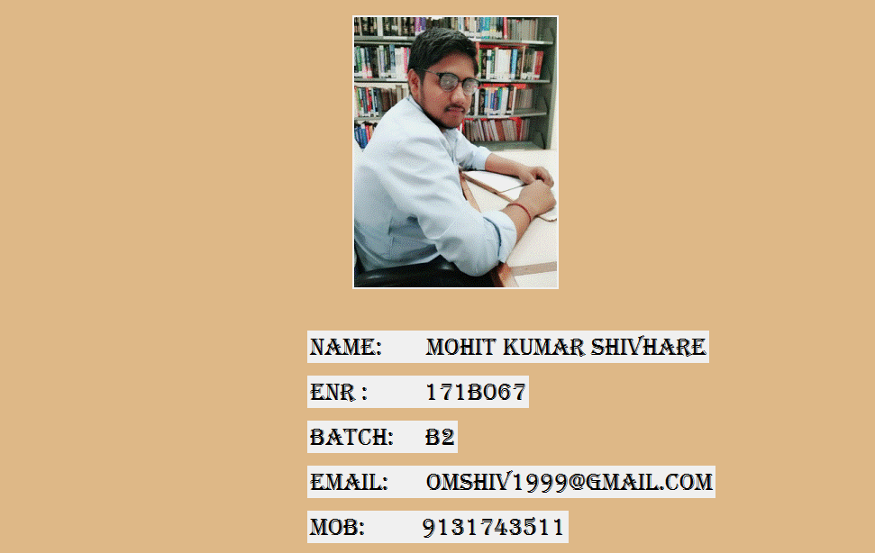DOCUMENTATION OF PYTHON PROJECT

This is my splash screen which shows details about me,and when I move cursor on my image, a new window open i.e. also a splash screen

Which shows my project title i.e. MASTERTYPE as:-

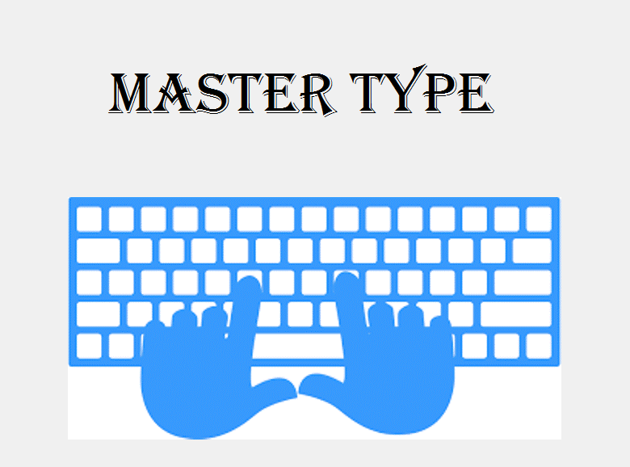

**OBJECTIVE:-**

Here my objective is to improve the typing skills of users.

They can learn through tutorial how to do good typing with basic slides and also judge them by facing typing test

As its also a splash screen it holds for 2 secconds then a new window appears which is a login page as shown below:-

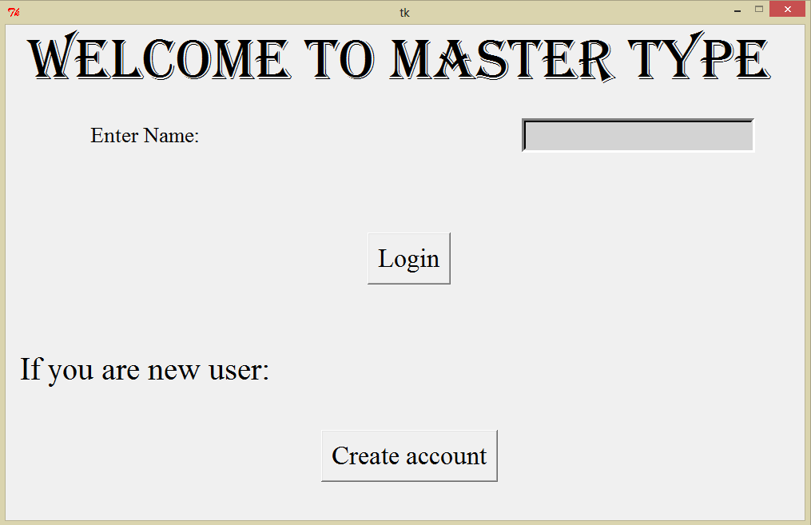

First it welcomes you

If you are already a user enter your name in entry box and press ‘Login’ button to move to next window

And if you are a new user click on ‘Create account’ a new window opens as:-

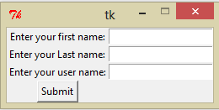 enter your first name,last name and username and press submit. Your account created

And then you have to login again as I discuss above and when I press ‘Login’ button then next window appear as:-

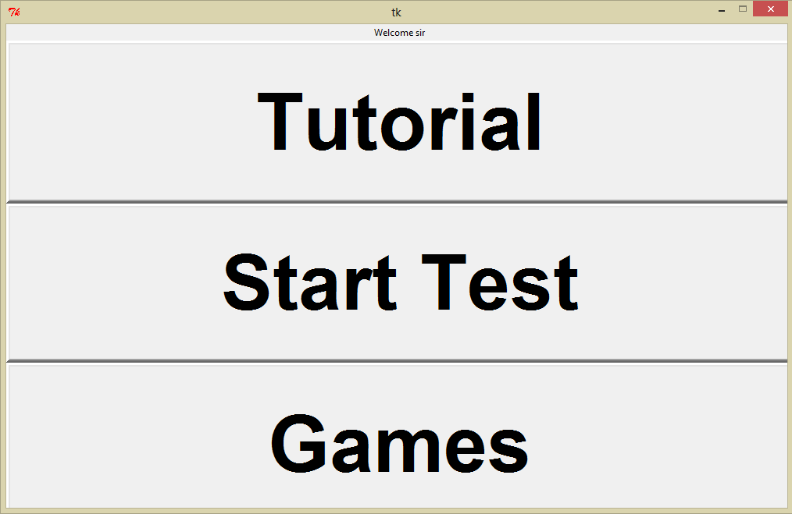

This screen contain three buttons:-

1)Tutorial

2)start test

3)games

When I click on ‘tutorial’ and ‘games’ a new window appear as:-

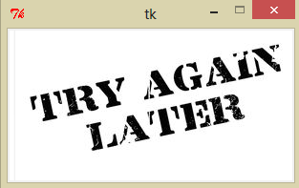

We try this next time.

And when I click on start test a new window appear as:-

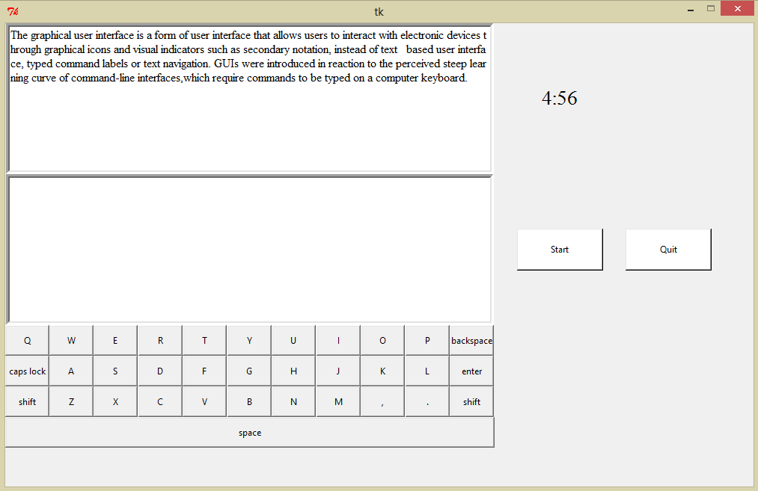

Which shown content written there on top which we have to type by clicking on start button.

When I press click button timer start you have to type above content it stops when time is over and you can also stop by pressing ‘quit’ button

**NOTE:-don’t press double spaces and also**

**Don’t click on below Textbox.**

When I press quit finally the last result window apears as:-

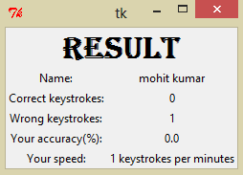

Which shows final output as shown above…