BugBounty Bot Pro
HackerOne & Bugcrowd — User Guide
Local · Single-user · Scope-guarded · Draft-only reporting · UI + CLI

⚠ Safety model: the tool only tests hosts you explicitly declare in scope. Reports are drafts — nothing is ever auto-submitted. You always submit manually.

Table of Contents

(Right-click → Update Field to refresh the table of contents in Word.)

1. What This Tool Is
BugBounty Bot Pro is a local, single-user bug bounty platform that tracks programs, discovers attack surface (recon), runs scoped security tests with a built-in payload engine, and generates submission-ready report drafts for HackerOne and Bugcrowd. Everything lives on your machine under data/, and nothing is shared with any cloud service.
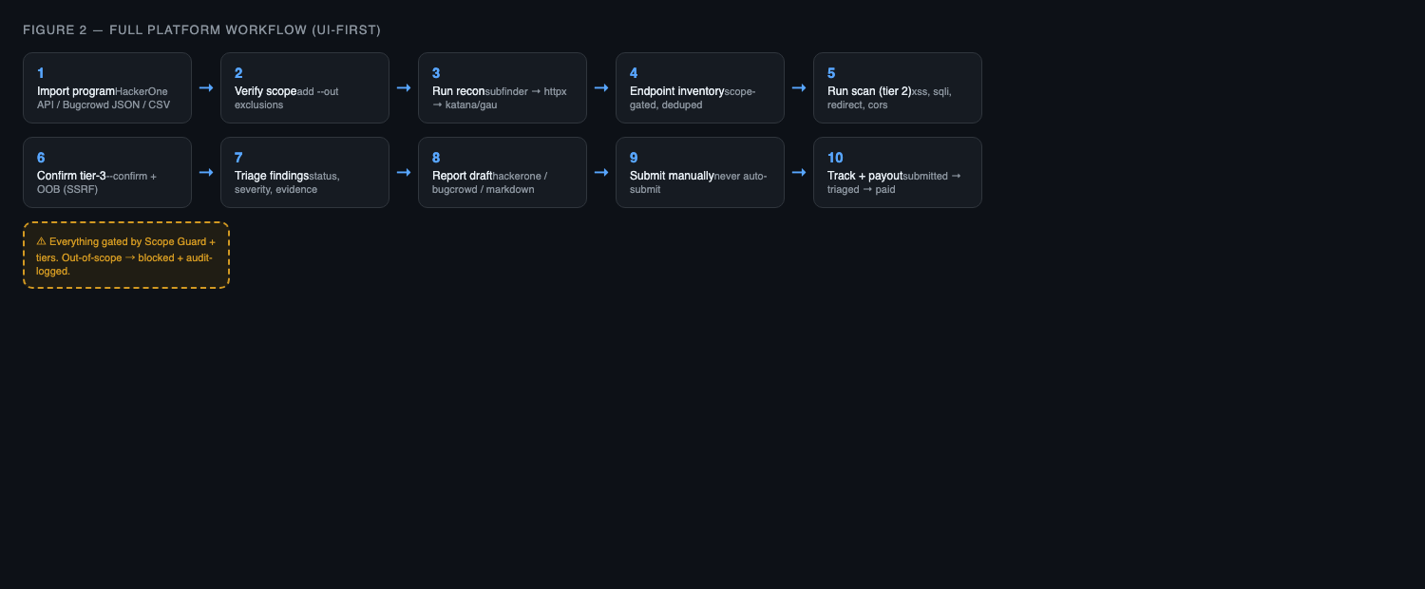
Figure 1 — The full workflow: import → recon → scan → triage → report → track.
What ships today:
- Tracker — track programs, scope rules, submissions, findings, payouts
- Recon pipeline — subfinder → httpx → katana/gau → endpoints in DB, scope-gated
- Platform import — HackerOne API / Bugcrowd JSON / CSV program import
- 6 vuln modules — xss, sqli, idor, redirect, cors, ssrf with payload engine
- OOB listener — local OOB callback listener for SSRF/blind confirmation
- Report generator — evidence-backed drafts in markdown / hackerone / bugcrowd formats
- Web UI — full-featured dashboard at http://127.0.0.1:8787 (UI = CLI parity)
- Audit log — append-only record of every request (allow/block)

2. Installation & First Run
Requires Python 3.11+.
cd ~/BugBountyBot
python3 -m venv .venv
.venv/bin/pip install -e ".[dev]"
.venv/bin/bugbounty --help
What | Where
SQLite DB (programs, findings, submissions, audit) | data/bugbounty.db
Evidence artifacts (request/response, OOB callbacks) | data/artifacts/
Payload library | payloads/
Secrets (API keys) | Keychain via keyring, or .env — never the DB

Two ways to use it — they share one engine and one DB:
- Web dashboard — the recommended way; all screens below
- CLI — identical commands for every action
.venv/bin/bugbounty serve # then open http://127.0.0.1:8787

3. Onboarding a HackerOne or Bugcrowd Program
The tool imports a program's scope from the platform so you don't hand-type it.

3.1 HackerOne (API, needs credentials)
.venv/bin/bugbounty program credentials hackerone # one-time, stored in keychain
.venv/bin/bugbounty program import acme --platform hackerone --handle security

3.2 Bugcrowd (public JSON, no credentials)
.venv/bin/bugbounty program import acme --platform bugcrowd --handle acme

3.3 CSV (any scope table)
# columns: pattern,kind,in_scope (kind: domain|wildcard|ip|cidr)
.venv/bin/bugbounty program import acme --platform csv --csv ~/scope.csv
From the dashboard: Programs → Import from Platform → HackerOne/Bugcrowd/CSV → handle/path.
Important: HackerOne's API returns in-scope assets only — add policy exclusions manually with --out. Bugcrowd's out-of-scope section is imported automatically.

3.4 Verify and adjust scope
.venv/bin/bugbounty program show acme
.venv/bin/bugbounty program add-scope acme "*.acme.com" --kind wildcard
.venv/bin/bugbounty program add-scope acme "admin.acme.com" --kind domain --out

4. Recon — Find the Attack Surface
Recon discovers subdomains → live hosts → endpoints + params automatically and stores them in the DB, scope-gated. This makes scans cover real attack surface instead of just the URLs you type.
brew install subfinder httpx katana gau ffuf # missing tools are skipped + reported
.venv/bin/bugbounty scan recon acme
.venv/bin/bugbounty scan recon acme --tools subfinder,httpx
.venv/bin/bugbounty scan list acme
.venv/bin/bugbounty scan list acme --source recon
Dashboard: Recon screen → pick program + tools → Run Recon. Shows hosts discovered, live hosts, new endpoints, blocked (out-of-scope), per-tool availability, and the endpoint inventory.
Every discovered host is checked against the scope guard before it is probed or stored. Out-of-scope subdomains are dropped and audit-logged as BLOCK.

5. Running Scans

5.1 Optional manual endpoint registration
.venv/bin/bugbounty scan discover acme "https://api.acme.com/search" --params "q,page"

5.2 Safe scan (tier 2)
.venv/bin/bugbounty vuln run --program acme --modules xss,sqli,redirect,cors \
--target "https://api.acme.com/search?q=test" --tier 2
Module | Tests | Notes
xss | Reflected XSS via param reflection | confirm re-injects a full script tag
sqli | Error-based + boolean-diff probes | safe probes only; sqlmap manual confirm
idor | ID substitution (/users/12345 → /users/2) | candidate — needs 2-account confirm
redirect | Open redirect on redirect-ish params | checks Location header
cors | Attacker Origin, ACAO reflection/credentials
ssrf | OOB callback via local listener | tier 3 — needs --confirm + OOB

5.3 Tier-3 confirm + SSRF from the UI
Run Scan screen: set the OOB port (default 8080), click Start OOB, tick --confirm, run the scan with ssrf in modules. The scan reuses the listener you started.
# CLI equivalent — terminal 1
.venv/bin/bugbounty oob start --port 8080
# terminal 2
.venv/bin/bugbounty vuln run --program acme --modules ssrf \
--target "https://api.acme.com/fetch?url=..." --tier 3 --confirm --oob 8080
A confirmed SSRF is one where the target actually fetched the listener's callback URL — recorded as evidence.

6. Reviewing Findings & Triage
.venv/bin/bugbounty finding list --program acme
.venv/bin/bugbounty finding show 1
Dashboard Findings screen: click a finding to open the detail modal — change status (candidate → confirmed → in_report → submitted → accepted/rejected) and severity, view evidence inline (request/response pairs), and generate a report draft for just that finding.

7. Tracking Submissions & Payouts
.venv/bin/bugbounty submission new acme "Reflected XSS on api.acme.com/search"
.venv/bin/bugbounty submission list acme
.venv/bin/bugbounty submission update 1 submitted
.venv/bin/bugbounty submission update 1 paid
Statuses: draft → submitted → triaged → accepted|rejected → paid. Dashboard Submissions screen: new submission, filter by program, edit status and payout.

8. Generating Report Drafts
.venv/bin/bugbounty report generate 3 --template hackerone
.venv/bin/bugbounty report generate --program acme --template bugcrowd
.venv/bin/bugbounty report generate --program acme --template markdown
Dashboard Report screen: pick program + template, see stats cards (findings by severity, submissions by status, total payout, dupe signal), generate and preview inline. Copy the draft into the platform manually. Internal payload IDs and artifact paths are stripped.

9. The Dashboard at a Glance
Screen | What you can do
Dashboard | stats: programs, findings, payloads, submissions, blocks
Programs | add, import from platform, scope rules (in/out), endpoints
Recon | run discovery, per-tool availability, endpoint inventory
Findings | list, detail, status/severity editor, evidence, per-finding report
Submissions | new, filter, status + payout
Run Scan | modules, tier, --confirm, OOB start/stop/status, live results
Report | stats cards, template, generate + preview
Payloads | browse/search the 163 built-in payloads
Audit Log | append-only request log with allow/block flags

10. Safety Tiers vs Platform Rules
Tier | Runs when | Examples | Typical platform clause
T1 — Passive | auto | header checks, passive probes | passive testing allowed
T2 — Safe active | auto (rate-limited) | reflected XSS, open redirect, CORS, IDOR read | safe active testing allowed
T3 — Exploit confirm | only with --confirm | SSRF callback, SQLi confirm | no active exploitation
T4 — Restricted | blocked by default | brute-force, DoS, data destruction | no DoS / no brute-force

11. HackerOne vs Bugcrowd Differences
 | HackerOne | Bugcrowd
Report template | --template hackerone | --template bugcrowd
Import | API (username + token) | public JSON (no auth)
Out-of-scope import | manual --out | automatic
Submission statuses | New → Triaged → Resolved | Open → Investigating → Resolved

12. The Audit Log — Proof of Scope Discipline
.venv/bin/bugbounty audit recent
Every request: URL, payload hash, tier, scope snapshot, ALLOW/BLOCK — append-only.

13. Realistic Expectations & Known Limitations
- Payload depth: 163 built-in payloads for the 6 MVP classes — a solid starter set, not SecLists-scale. Importing SecLists/PayloadsAllTheThings is planned.
- IDOR findings are candidates: substitute IDs + 200 = candidate; prove cross-tenant access with two accounts before reporting.
- SQLi confirm is boolean-diff based: targets that don't differentiate 1=1 vs 1=2 aren't confirmed. sqlmap is manual confirm only.
- SSRF needs the OOB listener: start it in the UI (or `oob start`) before running ssrf; without it the module reports nothing.
- Recon needs the tools installed: missing binaries are skipped and reported; install subfinder/httpx/katana/gau/ffuf for full coverage.
- HackerOne import: API returns in-scope only — add exclusions by hand with --out.

14. Quick Reference — Every Command
# Programs & scope
bugbounty program add <name> [--platform X] [--url U] [--allowed-tiers "1,2,3"]
bugbounty program import <name> --platform hackerone|bugcrowd|csv [--handle H] [--csv FILE]
bugbounty program credentials hackerone
bugbounty program list | show <name>
bugbounty program add-scope <name> <pattern> --kind domain|wildcard|ip|cidr [--out]
# Recon & inventory
bugbounty scan recon <name> [--tools subfinder,httpx,katana,gau] [--wordlist FILE]
bugbounty scan list <name> [--source all|manual|recon]
bugbounty scan discover <name> <url> --params "q,page"
# Testing
bugbounty vuln run --program <name> --modules xss,sqli,idor,redirect,cors,ssrf \
--target <url> [--tier 2] [--confirm] [--oob 8080]
# OOB listener
bugbounty oob start --port 8080
bugbounty oob status
# Findings & reports
bugbounty finding list [--program <name>]
bugbounty finding show <id>
bugbounty report generate [<id>] [--program <name>] [--template hackerone|bugcrowd|markdown]
bugbounty report stats <name>
# Submissions
bugbounty submission new <name> "<title>"
bugbounty submission list <name>
bugbounty submission update <id> submitted|triaged|accepted|rejected|paid
# Payloads
bugbounty payloads list [--category xss] [--max-tier 2]
bugbounty payloads search "alert(1)"
bugbounty payloads stats
# Audit & UI
bugbounty audit recent
bugbounty serve # web dashboard at http://127.0.0.1:8787

15. Step-by-Step: Your First HackerOne Program (UI-first)
1. Read the policy — Note scope entries and prohibited testing on the HackerOne program page.
2. Store credentials — bugbounty program credentials hackerone — one-time, saved in keychain.
3. Import the program — Dashboard → Programs → Import from Platform → HackerOne → handle → Import.
4. Add exclusions — Add any policy exclusions as out-of-scope rules.
5. Run recon — Recon screen → run discovery → endpoints land in the inventory.
6. Run a tier-2 scan — Run Scan → program, target, xss,sqli,redirect,cors, tier 2.
7. Triage findings — Findings → open each candidate → set status, view evidence, verify manually.
8. Confirm SSRF — Run Scan → Start OOB → tick confirm → add ssrf → run.
9. Track a submission — Submissions → new submission.
10. Generate the draft — Report → pick program/template → generate → preview.
11. Submit manually — Copy the draft into HackerOne, submit by hand — never auto.
12. Track to payout — Submissions → update status → triaged → accepted → paid.

Remember: read the program policy first, test only declared scope, and never submit without human review.

